Our Ref: NM/LHH/KW
Teacher of History
March 2018

Dear Colleague

Thank you for your interest in the one year fixed term post of Teacher of History (maternity cover) to teach up to and including KS5 at our vibrant oversubscribed Worcester City school that opened its sixth form in September 2015. This is a major opportunity for the right candidate to make a real impact. You would be joining a strong, well run, committed department that continues to make a significant contribution to the school’s continuing success.

Christopher Whitehead Language College is an 11-18 school ‘in pursuit of excellence' in all areas of its community's life. Near to the cricket ground, on the west bank of the River Severn in Worcester, it is a larger than average, inclusive and community-focused comprehensive school with over 1300 students. The school was awarded International School status and became a phase two academy in July 2011, and judged to have “outstanding behaviour” from Ofsted in their last 3 inspections. The school has 121 students on the AN register and 185 students on the SEN register, with currently the highest number of LAC, EAL children in the county and was re-awarded the prestigious Inclusion Quality Mark Centre of Excellence in June 2017. Our provision for AN, SEN and EAL has been described by the last three Ofsted inspections as ‘outstanding’ and we are the lead school for EAL in the county. In the last five years, the school has enjoyed a huge rise in popularity amongst the local community.

In the additional pages here I have included:

- job description
- person specification
- departmental information

I would obviously encourage you to read our Ofsted report in detail and visit our informative website at www.christopherwhitehead.co.uk to develop an understanding of our ethos. You may like to visit my blog too at www.neilmorriscwlc.wordpress.com

If you wish to apply, please complete the self disclosure form, application form and include a letter detailing your previous educational experience and stating how you would make a difference in the classroom. Please email your completed forms to recruitment@cwlc.email Please do not enclose a CV.

Informal visits are welcomed, please contact the Head of History, Mrs Gemma Hagon, g.hagon@cwlc.email. The deadline for receipt of applications is 10.00am on Thursday 26th April 2018 with interviews being held on Wednesday 9th May 2018.

Please would you ensure you provide email addresses for your referees and perhaps alert them to this fact.

As I will only be contacting short-listed candidates, I would like to thank you for your time and effort, and if unsuccessful, wish you well in your future career.

I look forward to hearing from you.

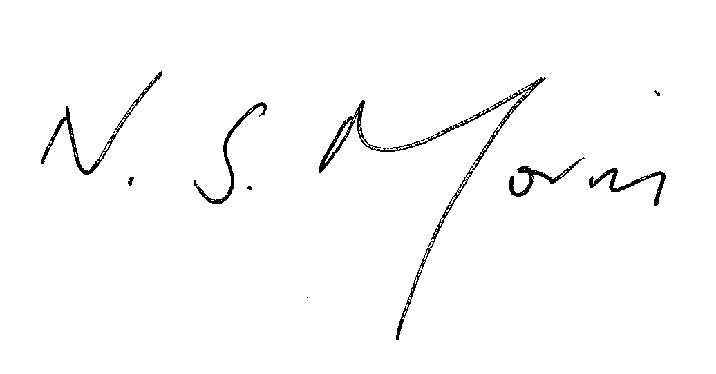
Yours sincerely

Neil S Morris
Headteacher

Job Description

Post Title: | Generic Class Teacher
Terms & Tenure: | Full Time
Line Manager: | Head of Department (in the first instance)
Staff Supervised: | None

Purpose of the Role

A teacher with a suitable teaching qualification, who teaches classes in Years 7 – 13, with responsibility for the preparation and delivery of a two weekly timetable of lessons as determined by the Headteacher.

The job description should be read alongside the range of professional duties as set out in the DfE Teachers’ Standards document. All staff need to have regard for their personal and professional conduct defined in the Teachers’ Standards and have proper regard for Christopher Whitehead’s ethos as a tolerant, inclusive, multi-faith school where staff and students follow the mission statement ‘In pursuit of excellence’ in all that they do.

Main Duties – Teaching and Managing Student Learning

- The teacher provides well planned lessons suitable to the learners’ experience, ability and following the Department agreed scheme of work.
- The teacher provides a learning environment that is safe, inspiring and conducive to the students’ learning needs.
- The teacher assists all students in the development of citizenship, responsible and ethical values and basic communication skills.
- The teacher provides, whenever possible, appropriate individual and small group instruction in order to adapt the curriculum to the needs of the students with varying intellectual abilities, attitudes, and cultural backgrounds.
- The teacher adapts their teaching to respond to the strengths and needs of all.
- The teacher establishes and maintains standards of student behaviour needed to provide an orderly and productive classroom environment, with lesson by lesson registration that ensures monitoring of attendance can be maintained.
- The teacher regularly evaluates each student’s development in the course being taught, prepares progress reports and reports grades as required by the school procedure.
- The teacher gives regular, constructive feedback, both orally and through accurate, diagnostic marking that follows the school’s policy.
- The teacher ensures homework is set/recorded by the students and regular feedback is provided to students as agreed by the Department policy.
- The teacher ensures that student reports follow the school format, are error free, on time and individualised.
- The teacher makes a positive contribution to the ethos of the school, forming effective, professional relationships with colleagues.

Other Duties and Responsibilities

- Aids in selection and requisition of books, instructional aides, supplies and has responsibility for ensuring the stock is maintained in a satisfactory state;
- Communicates with parents and external agencies to further the individual student’s progress;

Post Title: | Generic Class Teacher (continued)

Other Duties and Responsibilities (continued)

- Identifies student needs, and cooperates with other professional staff members in assessing and helping students solve health, attitude and learning problems.
- Supervises the prompt safety and welfare of students in out-of-classroom activities as equitably assigned.
- Shares in the participation and supervision of approved student activities as equitably assigned;
- Participates in faculty/departmental committees and in curriculum and other developmental programs within the school of assignment and/or on a County level. These may include TED/City Groups or other opportunities to further progress.
- Maintains professional appearance and attitude.
- Meets assigned classes, attends committee meetings, faculty meetings and school appointments in a punctual professional manner.
- Maintains accurate records and provides reports to students, parents and/or administration as required by his assignment.
- Cooperates with other staff members and the administration for the general welfare of the students, parents, school, administration, and the community.
- Maintains a professional relationship with students, staff members, parents and the community.
- Participates in the evaluation of the total school programme.
- Assists in planning and coordinating the work of learning support assistants and support staff who are under his/her direct supervision.
- Must be aware of cultural and ethnic groups.
- Expected to promote correct standard of uniform when dealing directly with students.

General and review

To understand and be prepared to support the ethos of the school by:

- Promoting good relationships with students, parents, colleagues, governors, LA and agency staff and visitors to the school;
- Promoting high standards of student behaviour inside the classroom and around the school generally, following the school’s behaviour policy;
- Promoting high standards of personal presentation and conduct, including being punctual and using social network media appropriately;
- Completing training in the relevant areas to meet all safeguarding and health and safety standards as advised by CWLC and government policy.
- Being aware of all matters of health and safety related to the working environment.

This job description is not necessarily a comprehensive definition. It will be reviewed periodically and when appropriate. It may be subject to change or modification at any time after consultation.

Christopher Whitehead Language College and Sixth Form has a strong commitment to achieving equality of opportunities in its service to the community and the employment of people and expects all employees to understand, comply with and promote its policies in their own work.

Christopher Whitehead Language College and Sixth Form is committed to safeguarding and promoting the welfare of children and young people and expects all staff and volunteers to share this commitment.

Person Specification

Teacher of History | Essential | Desirable | Evidenced  (Application Form, Interview, References)
Qualifications and Training
DfE recognised Qualified Teacher Status |  |  | A
Appropriate degree |  |  | A, I
Evidence of recent and relevant professional development |  |  | A
Experience
Successful teaching experience of History KS3/4/5 (including teaching practice) |  |  | A, R
Skills and Abilities
Commitment to working as part of a team, including the sharing of successful teaching and learning strategies |  |  | A, I, R
Contributing to the development of the department’s curriculum and resources |  |  | A, I, R
Ability to teach good or outstanding lessons |  |  | A, I, R
Strong classroom management skills |  |  | A, I, R
Effective communication skills |  |  | A, I, R
Ability to use innovative and interactive teaching methods |  |  | A, I, R
Uses ICT as an innovative tool for learning |  |  | A, I, R
Contribute to the improvement and implementation of assessment for learning within the department |  |  | A, I, R
Other Factors
Mark work regularly and set achievable and aspirational targets for students |  |  | A, I, R
Demonstrate enthusiasm for and enjoyment of teaching |  |  | A, I, R
Willingness and ability to play a key role in delivering extra-curricular activities for students |  |  | A, I, R
A passion for helping young people to develop their understanding and experiences to reach their full potential |  |  | I, R
Well organised with good time management skills |  |  | I, R
Meets tight deadlines with attention to detail |  |  | I, R
High degree of personal integrity |  |  | A, I, R
Hardworking, energetic and cheerful |  |  | I
Excellent attendance record |  |  | R
A thorough understanding of a teacher’s role in safeguarding young people |  |  | A, I, R

This post is exempt from the Rehabilitation of Offenders Act 1974 and as such all applicants who are appointed to this post will be subject to an Enhanced Disclosure from the Disclosure and Barring Service before the appointment is confirmed. This check will include details of cautions, reprimands or warnings, as well as convictions and non-conviction information. Once provisionally appointed, the successful applicant may also be required to apply for an Enhanced Disclosure at predetermined intervals during the course of their employment whilst in this post.

Departmental Overview

The History Department

We are a strong department that contains six history specialists and one none specialist teacher. There is a great team ethic and responsibility for the design and development of the curriculum is shared amongst the department, which is reviewed annually. It is important for students to develop a greater understanding of their past and how it fits in to the wider context of the world and current affairs. We aim to build upon the vital skills students will need in order to be successful at GCSE, A-level and beyond with KS3 providing a platform to introduce and hone the skills necessary for success.

As of this year we have changed to a three-year approach to GCSE, the department has created a new pathway for years 7 and 8. Year 7 follow a chronological route with the key focus being on the factors that made Britain. Students study Invaders and answer ‘whether invasion has ever been good’? They then look at the Battle of Hastings and how William kept control, the power of the Church, monarchy and people, including a case study on King John and Medieval Life, before considering the impact of warfare. Study outside the school environment is encouraged and an enquiry based approach is followed. Students are put in to sets as they arrive in year 7. Sets 1-3 are mixed ability and sets 4-5 are streamed. Students remain in ability sets throughout KS3 and these are reviewed every term, with students being regularly assessed in order to aid set changes; these follow a variety of formats, such as formal assessments, enquiries and issues analysis.

Year 8 students again follow a largely chronological time frame beginning with Slavery. Students then study the Industrial Revolution, the British Empire, a depth study on America and the Slave Trade, the Civil Rights Movement, before ending the year looking at the Holocaust.

Year 9 is a vital year where we equip students with the skills for their GCSEs. Students study Conflict and Change, beginning with Ireland in the 20th century and the Suffragettes to decide “what is terrorism?” Students then consider democracy in the world before looking at World War One. We then follow on from this by doing our first GCSE case study; Medicine in World War One. The summer term begins with the start of the GCSE course Medicine Through Time.

At GCSE we currently follow Edexcel 9-1, Medicine Through Time with a depth study looking at Medicine on the Western Front, American West 1835-1895, Anglo-Saxon and Norman Britain as well as Weimar and Nazi Germany 1919-1939. The paper on Nazi Germany is a source based paper and requires a wide skill set, which will be developed across KS3 in years 7 and 8. Students in GCSE are taught in mixed ability groupings.

At A-level students follow the AQA syllabus, Russian Revolution and Dictatorship 1917-53 and Industrialisation in Britain 1783-1885. Coursework on Ireland starts in the summer of year 12 and continues into year 13. Students are examined at the end of year 13.

Students also have the option to study Politics at A-level. We are following the Edexcel specification. With exams to be taken in year 13. This year students have already taken part in a discussion at the University of Worcester and we hope to create additional opportunities.

The department takes an active role in giving the students many extra-curricular opportunities, with multiple trips; our favourite being the year 9 and 10 World War One Battlefields trip, GCSE revision and skills workshops and Politics Society.

For further information please contact g.hagon@cwlc.email

Mrs Gemma Hagon
Head of History and Politics

