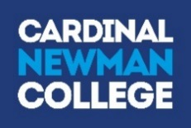

Larkhill Road
Preston
PR1 4HD

Tel: 01772 460181
Fax: 01772 204671
Email: hr@cardinalnewman.ac.uk
Web: www.cardinalnewman.ac.uk
Dear Applicant

We are delighted that you are considering applying for the post of Senior Site Supervisor to take up post as soon as possible.

Cardinal Newman is a wonderful place to work and we welcome applications from those who are keen to gain a broad experience of working in an outstanding institution. We are a happy and thriving Catholic Sixth Form College and welcome colleagues and students into our community regardless of their religion or belief, ethnicity, gender, gender identity, age, disability, sexual orientation, marital or pregnancy status.

At Cardinal Newman, we are committed to the development of the whole person and we value each student as an individual, with a unique mix of skills and talents. Our students achieve outstanding results, which consistently place Cardinal Newman amongst the top four Colleges nationally for Value Added. We were awarded Beacon Status in 2010 and the College was awarded an ‘outstanding’ Inspection in May 2009. However, we are as proud of our students’ social, cultural and spiritual achievements as we are of their outstanding exam results. We have a fabulous team of colleagues who give up an extraordinary amount of time to support their students and their fellow members of staff. The dedication and attention to quality they exhibit is what makes our College so successful.

If you meet the criteria of the post advertised and feel that you would enjoy working here and are suitably qualified and experienced, then we hope you will make an application to join us.

Completed application forms should be returned to the Human Resources Department (via email or post) by 8.00 am on 16th November 2018. We do ask that you accept, in the interests of economy, that if you have not heard from us by the beginning of November 2018 that you have not been selected for interview on this occasion.

We will confirm receipt of all applications by email within one working day of receipt. Please call the HR team if you have not received a confirmation email by the closing date.

Should you have any questions, which are not covered in the enclosed information, please do not hesitate to contact the Human Resources Department.

Yours faithfully

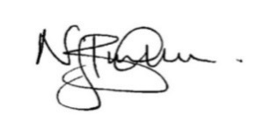
Nick Burnham
Principal

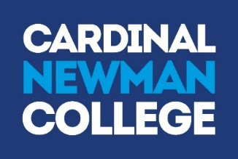

Mission Statement

As a Catholic Sixth Form College, we strive to be a centre of educational excellence for the community built on faith, respect and trust. We celebrate diversity amongst all our students and staff and seek to nurture the gifts of each individual through high quality teaching and learning and dedicated pastoral care.

Values Statement

Cardinal Newman College is a community, which aims to live out the gospel values of service and love. This means that:

- The individual student is central to all our endeavours
- The College values each individual as a unique person irrespective of gender, race, belief or ability and regards each person, made in the image and likeness of God, as worthy of the utmost respect
- The College strives to develop each person intellectually, socially and spiritually through an inclusive programme of study and enrichment
- The College values the spiritual journey of each individual and will offer opportunities for each to engage appropriately in their spiritual search
- The College is committed to creating a culture that is open and welcoming, free from fear and from violence of any kind, in which all individuals feel safe, happy and secure
- The College provides learning environments that are stimulating, enjoyable and challenging to students, fostering their creativity, imagination and search for truth
- The College encourages individuals to contribute positively to the world in which they live, to challenge injustice and to seek out more co-operative, just and peaceful forms of human existence.

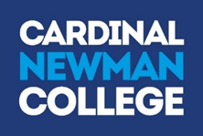

JOB DESCRIPTION

Post Title: Senior Site Supervisor

Responsible to: Estates Manager

Main Duties and Responsibilities:

To work alongside and lead the Assistant Site Supervisors and the Cleaning Team, providing a high quality service and support in all aspects of estates functions, general maintenance and operational Health & Safety.

- To have responsibility for key holding and the security of all buildings including but not limited to, lockup and unlocking, out of hours call outs, CCTV, alarm systems, windows and lighting.
- To conduct performance management reviews annually and review as necessary for the cleaning team and site supervisors.
- To contribute operationally to the College’s Disaster Recovery Plan.
- To carry out specific risk assessments and permits to work which relate to maintenance jobs, ensuring relevant information is disseminated to the relevant team member.
- To liaise with the cleaning supervisor on matters relating to planning, assigning and monitoring of cleaning areas as well day-to-day issues to ensure effective operational management of the cleaning team.
- To actively participate in team training sessions.
- To deal with the receipt and distribution of deliveries.
- To collect, prioritise, assign and monitor all aspects of minor maintenance repairs and requests via the online cedar ticket system ensuring that jobs are completed or referred to the relevant person.
- To ensure the effective operation of the heating system and boilers, including the Building Management System (BMS), ensuring buildings are heated and cooled as necessary allowing climate change.
- To carry out necessary grounds maintenance including but not limited to, litter picking, leaf clearing, snow and ice clearance.
- Assume the responsibilities of a fire officer during fire alarm activations
- Respond to first aid requests and administer first aid as necessary
- Drive the college minibus in accordance with driver’s licence categories set out by the DVLA
- Control of contractors in line with college procedures to adhere to CDM Regulations 2015, ensuring they have the relevant ID pass and documentation i.e. risk assessments and method statements (RAMS)
- Undertake safety inspections including but not limited to the minibus, emergency lighting, Legionella, fire extinguishers, fire doors and exits.
- Assist in all aspects of Health & Safety awareness and react and report as necessary
- To have a willingness to undertake appropriate training in relation to Health & Safety and Estate operational management related skills
- To undertake other duties that may reasonably be requested from time to time by the College management

PERSON SPECIFICATION

All staff must make a positive contribution to:
- the Catholic ethos of the College and its distinctive nature;
- the College Equality and Diversity, Health and Safety and Safeguarding Policies and Procedures;
- the pursuit of excellence and the highest standards of quality in all aspects of College life;
- their own professional development, in accordance with the needs of the College.
 | Essential | Desirable
Relevant experience | - At least 2 years’ previous experience in a similar role  - Experience in supervising staff  - Experience and a broad understanding of Health and Safety in the Workplace  - Ability to prepare and deliver Health & Safety presentations and training to the team
Qualifications / Education and Training | - Qualified first aider, or prepared to train as  - Full drivers licence  - Carry out and review risk assessments and permit to work as necessary  - Control of contractors in line with CDM 2015 | - NEBOSH General Certificate  - Time served trade
Knowledge and Skills | - Excellent communication skills  - Excellent use of Microsoft office, excel, outlook & PowerPoint  - Effective organisational skills and attention to detail  - Ability to prioritise work load  - Ability to undertake manual tasks eg maintenance repairs/DIY  - Ability to undertake heavy lifting duties
Personal qualities | - Self-motivated, proactive and flexible  - An enthusiastic individual with an aptitude for team-working and good interpersonal and communication skills.  - Ability to work under pressure and make decisions  - Ability to work as a team  - Flexible attitude to working hours  - Follow agreed procedures and standards on your work and ensure you produce a safe and effective service to others  - Disclosure and Barring Service Clearance*  - Medical clearance*  - Provision of two references which are deemed as satisfactory to the Principal*  - The ability to meet the requirements of the fluency duty in accordance with the provision of The Equality Act 2010.  - The ability to meet the requirements of the Asylum and Immigration Act (to be eligible to work in the UK)  - Good record of attendance and punctuality, subject to the provision of the Equality Act 2010.  - Suitability to work with children

*Following an initial offer of appointment.
Cardinal Newman College has a commitment to safeguarding and promoting the welfare of students and expects all staff and volunteers to share this commitment. All posts are subject to Enhanced Disclosure
Clearance through the Disclosure and Barring Service. Please note candidates’ suitability to work with children will be explored at interview and confirmed through references for the appointee.

SUMMARY OF MAIN TERMS AND CONDITIONS
SUPPORT STAFF

Salary | The post will be paid on the Sixth Form Colleges’ Support Staff Pay Spine at points 25 - 28 Pro rata to £20,458 to £22,490 per annum.
Payment of salary | Your salary will be paid by BACs transfer into your bank account on the last banking day of the month (except at Christmas when payment is made before the holiday)
Pension Scheme | You will automatically become a member of the Local Government Pension Scheme (unless you opt-out). Further details are available at www.lancs-pensions.org.uk
Working Hours | 37 hours per week for 52 weeks – starting and finishing times arranged within the department
Holidays | Holiday entitlement is pro rata to 22 days annual leave plus 8 statutory and 4 concessionary days. After 5 years’ continuous services the annual leave entitlement increases to pro rata to 25 days annual leave.
DBS Clearance | This post requires Disclosure and Barring Service clearance as well as a range of other safer recruitment checks.

About Cardinal Newman College

Based in the heart of Preston city centre, Cardinal Newman College is a Catholic Sixth Form College. Our core activity is to provide education for students aged 16-18, offering a range of A Level and BTEC courses, at both level 2 and 3. The College also offers a Foundation Learning course for young people with specific learning needs. In addition to the 16-18 provision, Cardinal Newman also offers a range of University courses, including Foundation Degrees in Teaching and Learning Support and Early Years, as well as the School Direct Programme, offering Initial Teacher Training for graduates looking to get into teaching.

Cardinal Newman College is the post-16 provider for the Newman Partnership, a working group consisting of the College and ten Catholic Partner High Schools. The location of these schools demonstrates the wide area from which the College draws a significant proportion of its full time 16–18 learners. Because of its distinctive ethos, its reputation, the levels of achievement, the support the College offers students and its provision of high quality courses, Cardinal Newman College is an attractive option for learners who attend other high schools in Preston and the surrounding area as well. Year-on-year applications from these schools have increased significantly.
An Outstanding College

The latest Ofsted Inspection in the summer of 2009 graded all areas of the College as ‘outstanding’. It confirmed that there is a culture of high expectations and rigorous quality improvement in all areas. Standards, expectations and processes have continued to improve since then. Students achieve well above their (high) target grades and make a positive contribution to the College and its wider community. Student attendance and behaviour are exemplary, illustrating that the Catholic mission and ethos of the College is lived out at all levels.

Every year, the vast majority of the College’s students, progress to Higher Education with almost 40% of those taking up places at Russell Group Universities.

Our Community

Links with the local and Catholic partner high schools are very strong. The Principal meets regularly with Head Teachers and the Newman Partnership Head Teachers meet to discuss and share a wide range of curriculum, pastoral and strategic issues. Relationships with College trustees, and with the Diocese of Lancaster are maintained through the foundation governors.

The College has outstanding links with both the local and wider community. Learners and staff fully contribute to this for example students at the College are continually seeking to engage in volunteer work within the community. Voluntary work is carried out in the local community by the CAFOD Group; Foundation Learning students; Health and Social Care students; the Medical Society and Chaplaincy. The curriculum departments also contribute widely to the links with local community groups, charities and local primary schools.

As a Catholic Sixth Form College we strive to be a centre of educational excellence for the community built on faith, respect and trust. We celebrate diversity amongst all our students and staff and seek to nurture the gifts of each individual through high quality teaching and learning and dedicated pastoral care.

Students study in a purposeful and diverse environment with a strong focus on respect in which every learner genuinely does matter. The team of specialist RE teachers live out the college’s commitment to ‘valuing the spiritual journey of each individual and offering opportunities for each to engage appropriately in their spiritual search’.

College Facilities

At Cardinal Newman College, we are blessed with wonderful surroundings for our students to work, learn and relax in. The College contains Lark Hill House, which was built in 1797 as a private house for Samuel Horrocks, a cotton manufacturer and later Mayor and Member of Parliament for Preston. In 1919 it became Lark Hill Convent Grammar school, which began taking sixth form students in 1967 from other local Catholic Secondary Schools. It finally became Cardinal Newman College in 1978, when it merged with Winckley Square Convent School and Preston Catholic College, taking its name from Cardinal John Henry Newman.

Over the past few years the College has embarked on an extensive redevelopment programme with approximately £16 million worth of investment in state-of-the-art facilities, which perfectly combine the old with the new.

In 2009 we saw the addition of the St Cecilia Building and the St Augustine’s Building in 2010, which was renovated and refurbished to house classrooms, drama/dance studios, as well as the original sports facilities. 2015 saw the addition of yet another new building in the form of St Francis, which is home to new classrooms for Sociology and Maths, as well as Open Learning Centres, Seminar rooms and a Mango Bean Coffee shop.

A further addition to the College’s already outstanding facilities, in the form of a brand new state-of-the-art gym in the St Augustine building, opened in October 2016. This was accompanied by a complete refurbishment of the social space and café area of the St Augustine’s building. This site also added a new modular building within its grounds, where RE lessons are now delivered from the eight classrooms it has provided.

Staff at Cardinal Newman College

Cardinal Newman College has achieved all of its success through the hard work, skills and commitment of its 300 plus staff. We seek to work with an inclusive and transparent style of management, which is open, consultative and encourages all staff to participate in the leadership and management of the College. The development of staff skills is a priority for the College and teams are encouraged to innovate and continuously improve Cardinal Newman’s curricular and pastoral offer to its students.

What our staff say about working at Cardinal Newman College

Over the last five years staff have been asked to take part in an annual staff survey. The college’s score, as determined by staff, has improved year on year and we are pleased that the scores for all areas (culture, demands, control, relationships, change, role, support, personal wellbeing and work-life balance) places the college at or above the top 10% of employers who take part in the same survey.

What our students say about Cardinal Newman College

Name: David Corr
Previous School: Astley Park
Programme of Study: Foundation Learning
“I wanted to come to Newman because my brother came here and I had heard good things about the course from people I know who were already studying it. I like meeting old friends and making new ones as well as being challenged by my work. I have lots of fun making clubs at lunchtime so that me and my friends can do things that we enjoy like dancing!”

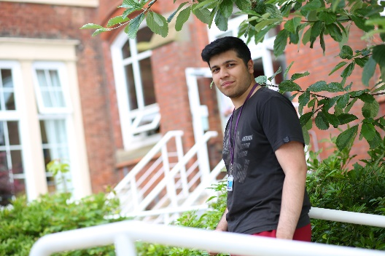
Name: Adil Lakha
Previous School: Archbishop Temple
Programme of Study: A Levels in Biology, Chemistry, Maths and Physics
“There are plenty of excellent enrichment opportunities available at Newman where you can stretch yourself beyond the standard course syllabus. All of my teachers have been enthusiastic and engaging and they are always willing to give me extra help outside of my lessons. I have really enjoyed my subjects and I have met some great friends here at Newman.”

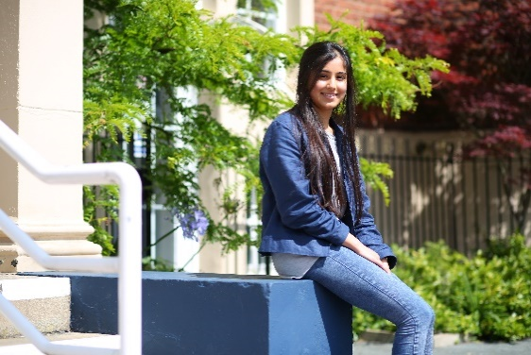
Name: Henna Reddy
Previous School: Westholme
Programme of Study: A Levels in Biology, Chemistry and Maths
“Newman has opened my eyes to lots of opportunities and has allowed me to grow so much as a person, both academically and socially. I’ve had the chance to meet so many different people and the teaching here is excellent.”

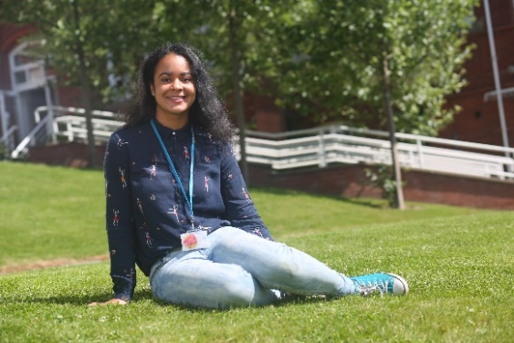

Name: Ella Shaw
Previous School: Leyland St Mary’s
Programme of Study: A Levels in French, Spanish, English Literature
“I have been able to develop my own interests and I have loved the independence that college has given me. Newman is definitely an amazing College and you feel part of something when you’re here. There hasn’t been a day where I have regretted coming to Newman, it’s everything I hoped College would be.”

Name: Abbie Lund
Previous School: Clitheroe Royal Grammar School
Programme of Study: A Levels in Maths, Physics and Further Maths
“I decided to come to Newman because I wanted a change of scene and the chance to meet new people. Throughout my two years here I have always been encouraged to excel. When choosing which college to attend, make sure to go somewhere you feel comfortable and choose subjects you enjoy, success comes a lot more easily when you’re happy!”

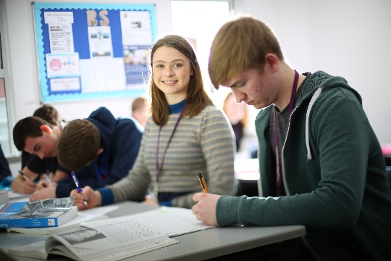
Isabella Raven
Previous School: Broughton
Programme of Study: Religious Studies, Philosophy, English Literature and EPQ
“I felt that coming to Newman would be a big step up from high school but Newman has made the transition much easier. You have a lot more independence when you come to College but the teachers are really supportive and welcoming. They will help you whenever you need it, but also push you to achieve your best. Newman has changed my life!”

Temiloluwa Onilogbo
Previous School: Lancaster Royal Grammar
Programme of Study: A Levels in Maths, Chemistry, Physics and French
“The most important thing is picking courses that interest you and if a College you like has these subjects; go for it! For me, Newman has been a great step up from High School. You can meet people from all over Lancashire, who are actually interested in the subjects that they take, creating a welcoming learning environment.”

Matthew Holden
Previous School: Holy Cross
Programme of Study: A Levels in Economics, Modern World History, English Literature & Business Studies
“After researching local colleges and attending several open days, I was impressed by Newman’s facilities and friendly atmosphere. Their reputation as a brilliant college and their position in Sixth Form College League Tables also helped me decide that Newman was the right college for me.”

Privacy Notice – Job Applications
As part of any recruitment process, Cardinal Newman College collects and processes personal data relating to job applicants. The College is committed to being transparent about how it collects and uses that data and to meeting its data protection obligations.
What information do we collect?
The College collects a range of information about you. This includes:
- your name, address and contact details, including email address and telephone number;
- details of your qualifications, skills, experience and employment history;
- information about your current level of remuneration, including benefit entitlements;
- whether or not you have a disability for which the College needs to make reasonable adjustments during the recruitment process; and
- information about your entitlement to work in the UK.
The College may collect this information in a variety of ways. For example, data might be contained in application forms, obtained from your passport or other identity documents, or collected through interviews or other forms of assessment.
We may also collect personal data about you from third parties, such as personal and employment references. We will seek information from third parties only once a job offer to you has been made and will inform you that we are doing so.
Data will be stored in a range of different places, including on your application file and on other IT systems including email.
Why does the College process personal data?
We need to process data in order to consider your application and, if appropriate, your appointment.
In some cases, we need to process data to ensure that we are complying with the College’s legal obligations. For example, it is mandatory to check a successful applicant's eligibility to work in the UK before employment starts.
The College has a legitimate interest in processing personal data during the recruitment process and for keeping records of the process. Processing data from job applicants allows us to manage the recruitment process, assess and confirm a candidate's suitability for employment and decide to whom to offer a job. We may also need to process data from job applicants to respond to and defend against legal claims.
The College may process special categories of data, such as information about ethnic origin, or religion or belief, to monitor recruitment statistics. We may also collect information about whether or not applicants are disabled to make reasonable adjustments for candidates who have a disability. This is within context of the College’s commitment to equality and diversity as well as its public duty under the Equality Act.
Who has access to data?
Your information may be shared internally for the purposes of the recruitment exercise. This includes the HR team, interviewers involved in the recruitment process, and managers in the area with a vacancy.
We will not share your data with third parties, unless your application for employment is successful and we make you an offer of employment. We will then share your data with former employers to obtain references for you, employment background check providers to obtain necessary background checks.
How does the College protect data?
We take the security of your data seriously. We have internal policies and controls in place to ensure that your data is not lost, accidentally destroyed, misused or disclosed, and is not accessed except by our employees in the proper performance of their duties.
For how long does the College keep data?
If your application for employment is unsuccessful, the College will hold your data on file for six months after the end of the relevant recruitment process. At the end of that period, your data is deleted or destroyed.
If your application for employment is successful, personal data gathered during the recruitment process will be retained during your employment and for a period after the end of that employment, in accordance with our retention policy.
Your rights
As a data subject, you have a number of rights. You can:
- access and obtain a copy of your data on request;
- require the College to change incorrect or incomplete data;
- require the College to delete or stop processing your data, for example where the data is no longer necessary for the purposes of processing; and
- object to the processing of your data where the College is relying on its legitimate interests as the legal ground for processing.
If you would like to exercise any of these rights, please contact dataprotection@cardinalnewman.ac.uk
What if you do not provide personal data?
You are under no statutory or contractual obligation to provide data to the College during the recruitment process. However, if you do not provide the information, we may not be able to process your application properly or at all.

