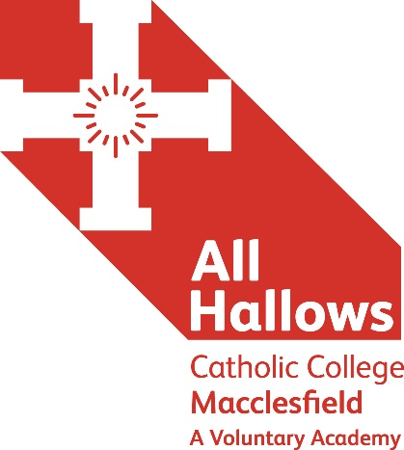
HISTORY TEACHER
Main Pay Scale Range

We are seeking to appoint an inspirational, enthusiastic and committed individual, to teach History across all levels within the Humanities department in an Outstanding 11-18 Catholic Academy, whist also making a contribution to the Catholic life and ethos of the College.

It’s about us and it’s about you…

All Hallows has built sustainable school improvement on a passionate focus on teaching and learning together with highly effective leadership and a high value placed on the young people’s personal development and spiritual well-being. These are the ingredients for the successive outstanding Ofsted judgements that recognise the superb achievements of our students.

As a National Teaching School and SSAT National TEEP Champion School, we offer excellent professional development opportunities for all our staff in structured programmes of high value. As a Lead Practitioner Accreditation Centre we actively encourage professional reflection and research so that our teachers constantly deepen their knowledge and fine-tune their practice. Leadership development is actively encouraged through NAML, NPQML and NPQSL programmes, which are delivered on site by our own accredited trainers.

Working at All Hallows Catholic College and within our Multi Academy Trust is an opportunity to join a progressive teacher-learning community, inspired by Christian values, which focuses on the art, craft and science of teaching, as a noble vocation, in a place where students enjoy learning.

Application documents can be found on the Catholic Education Service website: http://www.catholiceducation.org.uk/
Please go to: Employment Documents / Application Forms
You are required to complete the following documents:
Teacher Application Form / Recruitment Monitoring Form / Rehabilitation of Offenders Disclosure Form
All posts are offered subject to agreement to sign the CES contract of employment with the Holy Family of Nazareth Catholic Academy Trust and enhanced DBS clearance suitable for working with children and young adults.

Applications to the HR Manager at:
All Hallows Catholic College, Brooklands Avenue, Macclesfield, Cheshire SK11 8LB
HR@allhallows.org.uk

CLOSING DATE: Tuesday 19 June 2018 at 12 noon
INTERVIEW DATE: To be confirmed

‘Aspire not to have more, but to be more’
Blessed Oscar Romero
☩ Honourable purpose ☩ Respect ☩ Compassion ☩ Cooperation ☩ Stewardship ☩

A Member of The Holy Family of Nazareth Catholic Academy Trust

