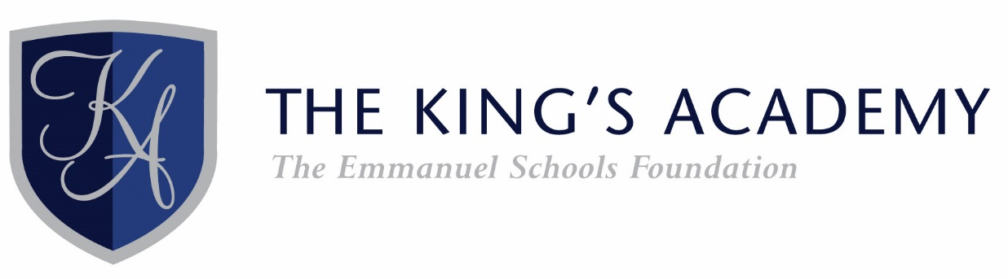

Standard responsibilities for all

Standard Responsibilities for all Teachers

All teaching staff are responsible, through their line manager, to the Principal for:

- the detailed knowledge and understanding of the Schemes of Work and Assessment Criteria for all classes for which they have responsibility;
- an awareness of the general requirements and standards of work required by their classes in the years before and after the year in question, thus ensuring a professional sensitivity to matters of progression, development and preparedness for future study;
- detailed record of the prior attainment and target levels / grades / outcomes for each child in each class for which they are responsible, and the ongoing recording of performance against these measures;
- the effective teaching, setting, assessment and marking of appropriate classwork and homework in line with the Schemes of Work provided by their Line Manager / Head of Department;
- the planning and delivery of differentiated work suitable to stretch all students in every teaching group, with particular reference to students with Individual Education Plans (IEPs);
- the planning and delivery of appropriate opportunities to contribute to students’ spiritual, moral, social and cultural development;
- clear, accurate and informative reporting to parents, whether oral or written, on students’ progress as directed by their Line Manager / Head of Department;
- the proper preparation of students, including revision advice, for internal and external examinations;
- a full account of the attendance / absence of all students in all lessons for which they have a responsibility;
- the good order, appearance and discipline of all students within and beyond the classroom;
- an active involvement in the cover and duties programmes as directed by the Principal;
- familiarity with and adherence to Academy policies as detailed within the professional Handbook for staff;
- liaison with their Line Manager / Head of Department with regard to any student whose progress is the cause of some concern;
- attend courses and undergo training as necessary and train any relevant personnel as required;
- be aware of the School’s Equal Opportunities Policy and report any needs that are not being met or if advice is required;
- any other reasonable duties as required by the Principal.

The King’s Academy is committed to the safeguarding of children and all staff are expected to ensure that The King’s Academy is a safe and secure environment for our students.

Please note that this detail is indicative and can be amended, updated or replaced as felt appropriate at any time and in order to remain in line with any future legal requirements or expectations.

