Isca Academy

Teacher of English
Permanent, Full-Time, Starting September 2018

Table of Contents

Contextual Information
Copy of advertisement
Job description
Person Specification

To start: September 2018
Closing date: 10am on Friday 23rd March 2018

Contextual Information

Welcome to Isca Academy.
Our school has been located on its very impressive and attractive site with a freshly designed campus and entirely new buildings since 2006. This was part of major re-organisation in Exeter with a PFI scheme that re-built all 5 Exeter secondary schools and one primary school. The Academy was built with a capacity for 950 students and the current roll is 750. We expect and need this number to rise and have an ambitious collaborative strategy to improve and strengthen relations with our feeder primary schools.
Students come to the Academy from a large number of primary schools that span the city, though 4 primary schools account for 70% of the intake, these are Wynstream, St Leonards, Countess Wear and Topsham, all within close proximity to the academy. In total the 2017 intake will come from 23 primary schools.
About Our Students
The academy maintains a tradition of being an inclusive community school that serves the variety of family contexts in its immediate neighbourhood. The most distinctive feature of the academy is the very broad range of student abilities and aspirations on entry. Higher ability students have always done extremely well academically, in the activities beyond the formal curriculum and in their progression to further education. We have large numbers participating in the Reach Academy Programme run by Exeter College for able, gifted and talented students. Our intake also presents the challenge of a number of students who join us with low literacy and social skills. At present 32% of students in the academy are ‘disadvantaged students’. 7% of students have English as a foreign language and many of these have their families linked to the University.
Our Curriculum
We keep our curriculum under review and endeavour to construct one which meets the needs of our diverse student body. In Years 7 and 8 there is a traditional curriculum in terms of subjects taught with a good balance of time allocated to each subject to prepare students effectively for Key Stage 4.
At Key Stage 4 we are continually looking to provide the courses and routes necessary and appropriate for all students. There is a blend of core subjects and the EBacc subjects together with a range of options that include vocational courses, sometimes delivered by external providers.
Our latest destination data shows that 80% of leavers go to Further Education (FE), and we are proud that 73% of our disadvantaged students went to FE. Our percentage of those not in education, employment or training has fallen to a figure of 3%. Apprenticeships account for around 2%.
Beyond the Classroom
Whilst important, success at school is not just about examination credentials and we believe in the immeasurable value of activities beyond the classroom to promote self- belief and confidence. Our growing extra-curricular programme offers a huge range of activities. If you look on our web site you will see there is a daily programme of activities offering a Before School Club for those who need a bit of calm and time to organise themselves (staff included!) and then lunchtime and after school activities including a regular After School Study Club, range of sports clubs, choir, samba band, community work and science clubs.
There is also a calendar of Outdoor Education Events, with activities such as Ten Tors, Exmoor Challenge, Exe Valley Challenge and Duke of Edinburgh award scheme led by dedicated and long standing teachers.
We strive to ensure these activities and opportunities are taken up by students from all backgrounds and abilities so they are not exclusive to those fortunate to have very supportive families. Where necessary we will assist students to enable them to participate.
Our Facilities
We are proud of our buildings and even though we all know that buildings alone do not make a good school, they do give a flying start! Wide corridors, spacious classrooms and a welcoming atrium greet our visitors.
As would be expected there are specialist rooms; science laboratories, ICT rooms, technology spaces, music rooms and practice facilities, drama studio, and an impressive hall with moveable seating. There are generous office spaces for support staff, subject staff and middle leaders.
Outside there is a floodlit all weather pitch and extensive grassed areas for sport and recreation (large enough for 2 full sized football pitches ) as well as hard court spaces and plenty of outside seating for students.
The Governing Body
The Local Governing Body operates with full delegated authority from the Ted Wragg Multi Academy Trust and is directly accountable to the Trust. The governors understand well their statutory duties to hold leaders to account as well as setting the strategic direction of the academy and ensuring the academy has a sound financial footing. Their commitment is absolute, believing in social justice, they bring a rich background of experience beyond education. They are led by a chair determined for the academy to be a first choice for parents and where every child is given the opportunity to fulfil their potential.

The Ted Wragg Multi Academy Trust is a values driven, rapidly growing 2 – 16 Trust with a relentless focus on transforming lives through learning by delivering outstanding outcomes for every pupil, regardless of background.
With a reputation for highly successful school improvement in very challenging circumstances, we are passionate about
driving up standards and raising the aspirations of all our pupils.

Isca Academy
Teacher of English
Permanent, Full-Time, Starting September 2018

Do you have a relentless drive to achieve outstanding progress and attainment
with children regardless of their background and prior learning?

We are seeking to appoint a highly motivated, capable and innovative teacher, with a proven commitment to inclusive and inspiring teaching where each and every child can succeed. You will be an enthusiastic specialist able to teach English across KS3 and KS4. The post represents an exciting opportunity to be part of a vibrant, ambitious and growing Academy working within the Ted Wragg Multi-Academy Trust.

Our school is located on a recently designed campus with purpose-built accommodation, offering spacious and excellent teaching and learning facilities. We currently have a roll of 750 students, rapidly building up to a capacity of 950. Isca Academy prides itself on providing high quality comprehensive education. Our students have a broad range of abilities and aspirations on entry, from able, gifted and talented to students needing more support with literacy and social skills. Beyond academic credentials, we firmly believe in the value of a more rounded education which promotes creativity, self-belief and confidence, and as such, offer an exceptional extra-curricular and outdoor education programmes. At a recent Ofsted inspection, Isca Academy was found to be ‘good’ in all categories and our focus will remain on every student in our school exceeding expectations, whatever their starting point.

The English department at Isca Academy is a friendly, motivated team of specialists who love their subject and who are always looking for creative ways to deliver the curriculum. The team plan together and have a culture of sharing resources and best practice as well as supporting each other and solving problems in collegiate ways. We operate a two year KS3 curriculum which develops students’ skills and knowledge, together with a passion for English, in preparation for the start of their GCSEs in Year 9. The three year KS4, studying both Language and Literature, allows students to fully develop their ideas and consolidate their learning, whilst also making time for fun and creativity.

The Ted Wragg Multi Academy Trust is committed to safeguarding and promoting

the welfare of children and young people and expects all staff and volunteers to share this commitment. All applicants will be subject to a full Disclosure and Barring Service check before appointment is confirmed.
Application forms and further information are available from our website:
www.iscaexeter.co.uk or by email to bharrad@iscaexeter.co.uk

Closing date for application: 10am on Friday 23rd March 2018
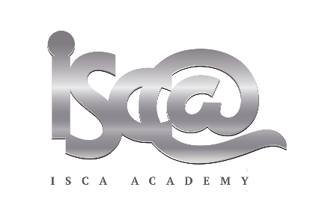

ISCA ACADEMY – JOB DESCRIPTION

Post: Subject Teacher (KS3 and KS4) -English
Line Manager: Head of English

KEY PURPOSE
- To effectively plan, teach and evaluate the impact of lessons and schemes of learning thus enabling students to make exceptional progress, whilst taking into account exam specifications, curriculum and Academy requirements.

- To provide effective supervision, challenge and support for students at the Academy.

KEY TASKS

- To work as reasonably directed by the Headteacher in fulfilling all the requirements of Academy policy and in compliance with the Teachers Pay and Conditions Document and Teachers Standards.

- To plan and teach lessons and support in developing Schemes of Learning that facilitate effective learning for all students in their care.

- To mark, record and report student achievement (progress and attainment) in line with Academy and national policies.

- To create and maintain a positive classroom environment / ethos conducive to effective and engaging learning for all students.

- To take responsibility for one’s own personal professional development within the context of Academy aims and priorities as well as National Teacher Standards.

RESPONSIBILITIES

- To plan and teach lessons that are based upon clear learning objectives in accordance with schemes of learning and Academy policies.

- To plan and teach lessons that stimulate, challenge and sustain student interest, and that develop self-esteem and confidence; ensuring that each and every student is able to reach their full potential.

- To maintain good order in the classroom, in a way that enables students to work in a secure, safe environment where positive relationships and purposeful activity can be sustained.

- To effectively prepare students for national assessments at KS4.

- To enable students to take increasing responsibility for their learning through constructive and timely assessment, marking and feedback.

- Identify appropriate targets for individual students, and through effective and engaging curriculum delivery, work to ensure progress is achieved by each and every student in your class.

- To systematically monitor and evaluate the effectiveness of your teaching on students learning and progress to identify personal development targets.

- To make effective use of Academy resources and maintain a stimulating learning environment.

- To contribute positively to the development of the subject area and to the preparation of schemes of learning and resources.

- To make a full commitment to maintain a high level of subject knowledge and subject application, including the effective use new technologies to engage students in the learning experience.

- To contribute to the development of departmental policy through attendance and active participation at team meetings.

ALL STAFF SHOULD

- Ensure the aims, priorities and policies of the Academy are adhered to, including the staff Safeguarding Code of Conduct.

- Attend parents, staff and year team meetings as required, making a valued and professional contribution.

- Undertake break, lunch and after school supervision as agreed, according to Academy policy.

- Encourage the good conduct of all students and at all times on the Academy site and within its vicinity.

- To make a full commitment to personal professional development, engage positively in organised professional development activity and staff appraisal procedures.

- Maintain respectful and effective communication with students and other staff, including attendance at morning briefings and through completing student report cards and logs as appropriate.

- Maintain respectful, positive and effective communication with parents, including phone calls and letters home, as appropriate.

- Maintain positive and effective communication and liaison with partner schools and the wider community, as appropriate.

- Act as an advocate of the Academy and its pupils in all circumstances, ensuring every opportunity is taken to celebrate our success.

- Undertake the responsibilities of being a Tutor as required.

- To carry out other duties as reasonably requested by the Headteacher.

THIS JOB DESCRIPTION IS SUBJECT TO REVIEW BY CONSULTATION

Isca Academy
Teacher of English: Person Specification

ESSENTIAL | DESIRABLE | How Assessed
 |  | App Form | References | Interview
Experience  - Teaching experience in a state comprehensive school  - Experience in planning and teaching English at KS3 and KS4  - Experience of analysing pupil data to inform planning, leading to excellent student progress | - Experience of contributing to and delivering strategies to raise achievement across English, including assessment for learning
Qualifications  and training  - Qualified teacher status  - Educated to degree level | - Further qualifications relevant to the role
Skills  - Highly effective classroom practitioner (teacher)  - A desire to teach English in an exciting and engaging manner  - Good planning skills  - Ability to sustain positive relationships with staff, students and parents  - Good ICT skills to support teaching  - Good organisation and time management skills  - Meets all relevant national teaching standards  - Good understanding of the National Curriculum and assessment requirements in English at GCSE Level  - The ability to fulfil all spoken aspects of the role with confidence and fluency in English | - A gifted manager of student behaviour and learning  - Able to analyse data effectively to inform planning
Qualities  - Very good communicator and team player  - Energetic and committed  - Ability to work under pressure  - High level of integrity  - Positive role model  - Able to demonstrate commitment to safe school culture | - Keen to develop further through active participation in CPD
- Must pass relevant  safeguarding of children checks |  | DBS checks and interview

Isca Academy
Contacts and information
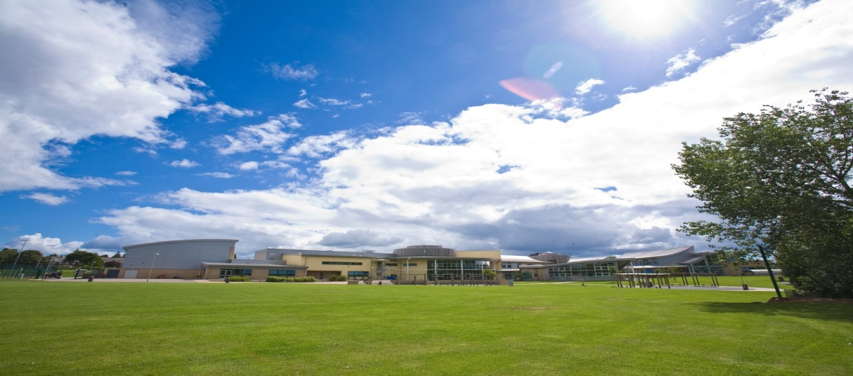
Contact Details: bharrad@iscaexeter.co.uk
Website: www.iscaexeter.co.uk
Isca Academy
Earl Richards Road South
Exeter EX2 6AP
Tel. 01392 204082
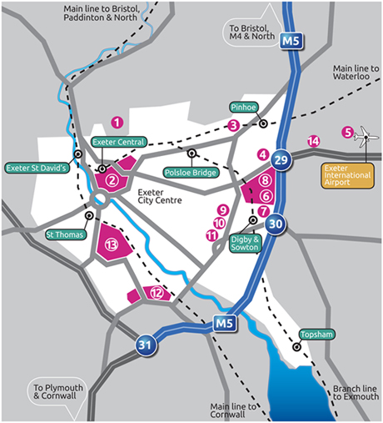
Isca

