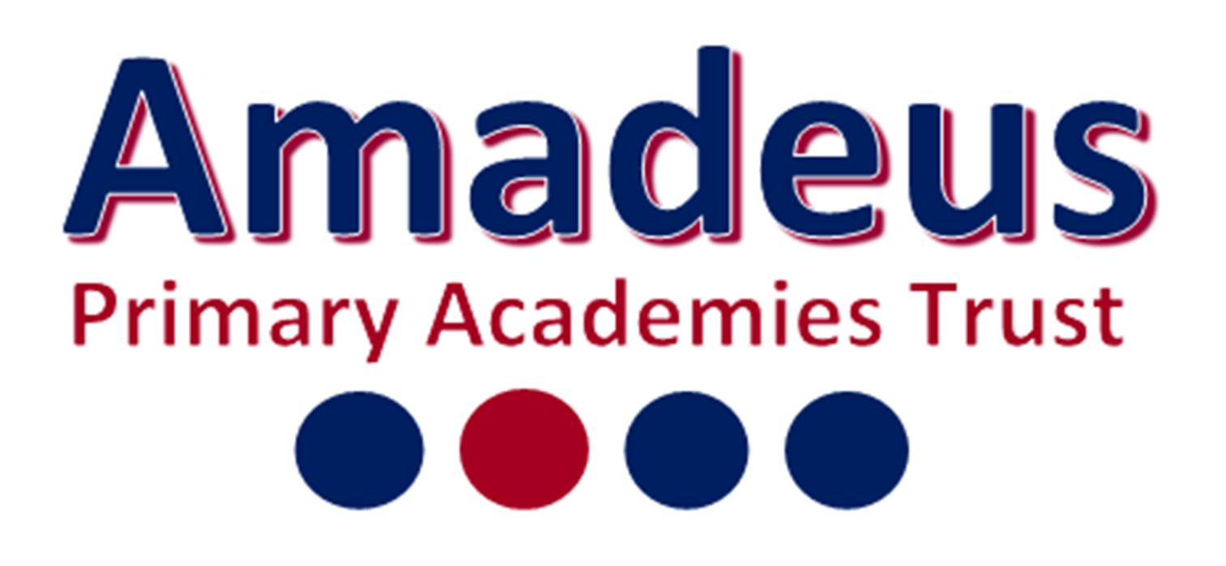

Person Specification
Class Teacher
Holy Trinity Lamorbey CE Primary School

 | ESSENTIAL | DESIRABLE
Knowledge | Knowledge of:  - Primary National Curriculum and EYFS Framework  - Formative and summative assessment  - Safeguarding and child protection  - A range of pedagogical approaches, teaching strategies and techniques for learning | - Expertise or wider experience in any particular subject area (for example sports coach, musician, dramatist, linguist, artist or similar)  - Knowledge and understanding of New Technologies and their embedded role in a learning environment
Experience | - Qualified Teacher Status or equivalent international qualification with appropriate experience. | - Previous employment or training placements in different year groups or educational settings
Ability | - Fulfill all the obligations of the Teacher’s Standards and applicable career stage expectation  - Can work independently and as part of a phase team  - Ability to inspire pupils and enable learning for all  - Manage behaviour positively  - Communicate with all stakeholders from pupils to parents, governors, other professionals and members of the parish and community professionally  - Able and willing to support the Christian ethos of the school  - Ability to speak with confidence and accuracy, using accurate sentence structures and vocabulary  - Ability to choose the right kind of vocabulary for the situation in hand without a great deal of hesitation  - Ability to listen to customers and understand their needs  - Ability to tailor your approach to each conversation to be appropriate to the customer, responding clearly with fine shades of meaning, even in complex situations.
Disposition /  Personal Qualities | - Strong commitment to safeguarding the welfare and wellbeing of children  - Enthusiastic  - Motivated  - Committed  - Resilient  - Creative  - Innovative  - Takes a high degree of personal responsibility and initiative

