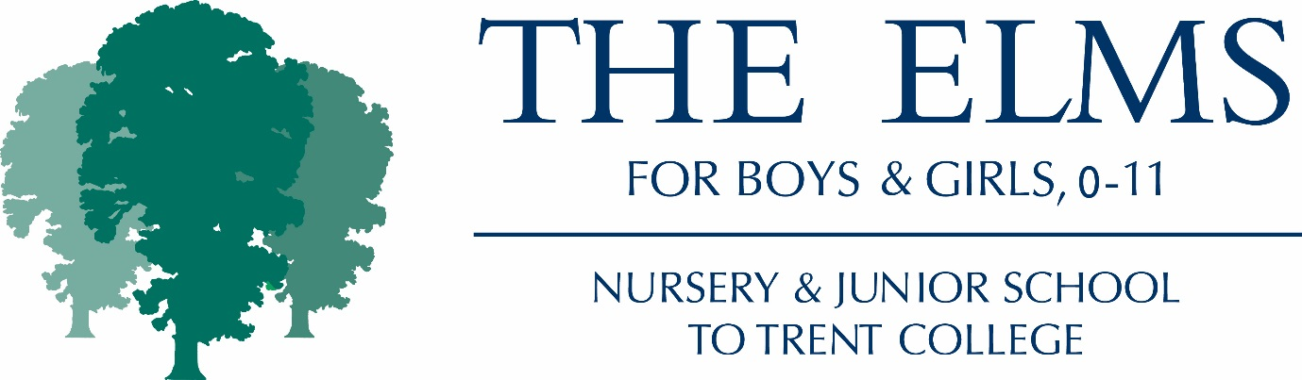

Job Description – Head of Sport at The Elms

- The Head of Sport is responsible for leading all of the teaching and planning and development of sport (all physical education, games, swimming, fixtures) throughout The Elms.
- The Head of Sport is responsible for teaching a full timetable of sport throughout The Elms, including teaching both boys’ and girls’ sport.
- The Head of Sport is responsible for identifying the staffing needed throughout the school for the teaching of sport and working with the Deputy Head Academic to facilitate the timetabling of suitable staff.
- The Head of Sport is responsible for co-ordinating fixtures against other schools for both boys and girls and liaising with the administrator in respect of ensuring the school calendar is up to date and parents / school leadership is given accurate and timely information.

The role of – Head of Sport (Subject Leader - without Classroom responsibility)

- To implement all school policies and procedures as detailed in the staff handbook.
- To be a high quality professional that sets an excellent example in teaching the subject that they lead.
- To have the enthusiasm to share and support other teachers in teaching the subject that they lead.
- To keep up to date with and disseminate best practice in the subject to other teachers.
- To contribute to the School Development Plan by writing, implementing and reviewing a Subject Plan.
- To write and regularly review a policy for their subject.
- To monitor the standards and achievements of pupils within the subject area to ensure continuity and progression throughout the school/Key stage.
- To ensure that planning is up to date and recorded electronically on The Elms Network (L Drive)
- To collect/collate samples/evidence of pupils achievements, (through scrutiny of work and lesson observations) to illustrate an overview of standards and progression in the subject throughout the school.
- To manage a subject budget and purchase/allocate resources to enable the effective delivery of the subject.
- To be able to present their subject file to a member of the Leadership team when required.
- To ensure there is a progressive, up to date curriculum map for their subject area.
- To undertake to run an after-school club as directed by the Deputy Head.
- To contribute to the marketing and promotion of The Elms by participating in Open Days and ‘Special Events’ as they appear in the school calendar.
- To attend Key Stage meetings, staff briefings and whole school staff meetings and INSET as directed.
- To perform playground and after-school duties as directed by the Head / Deputies in line with school rotas.
- To communicate professionally with parents and children about pupils and their progress.
- To write reports and maintain assessment records in line with school policies and procedures.
- To implement the school behaviour policy and maintain good pupil behaviour at all times.
- To nuture and support each child to develop a success and achievement culture within the school.
- To ensure resources / equipment are prepared and available to support learning and foster independence.
- Ensure that teaching is varied, takes into account a range of learning styles and is appropriately challenging to all abilities within the class.
- Carry out any other tasks within their subject area deemed suitable by a member of the Elms’ Leadership Team.

