APPOINTMENT OF SENCO AND INCLUSION MANAGER

COMMENCEMENT: SEPTEMBER 2018

The Principal of Elutec wishes to appoint a highly motivated and inspiring candidate to effectively manage and lead SEND provision across the school. Applications are considered from either exceptional existing or aspiring SENCOs.
We are looking to appoint someone with experience of working with students with a range of additional needs and a knowledge of the SEND agenda. The staff at Elutec are committed to providing high quality teaching and learning for all students and the post represents an ideal opportunity to work in a friendly, positive environment.
You will hold the National SENCO qualification or be working towards completing the qualification. You will be able to effectively lead and manage the team and work closely with parent/carers and professionals.
This is a fantastic opportunity for exceptional teachers.
Elutec UTC
Elutec – the 14-19 University Technical College for East London - opened in September 2014 and aims to be the leading engineering and manufacturing UTC in the UK. Elutec is housed in an impressive new building in Barking and Dagenham, surrounded by a Business and Science Park which is soon to be joined by an exciting new film studio complex. The school has excellent transport links, with Dagenham East tube station a short walk away.

The school’s exceptional sponsors include Ford Motor Company, one of the world's foremost design, engineering and manufacturing enterprises and the Faculty of Engineering at University College London (UCL), ranked as one of the top 20 “super-elite” universities in the world (especially in Elutec's specialist areas of manufacturing and engineering). Elutec is also sponsored by The Centre for Engineering and Manufacturing Excellence (CEME) in Havering, where Elutec was originally located and by Prospects College of Advanced Technology, one of the country's leading education providers of work-force development needs.

Elutec aims to offer learners and employers an outstanding solution to current skills shortages. Our vision is that our pupils will stand out from the crowd and will be educated and coached to win the technical jobs that local employers desperately need to fill. In those jobs they will stand out as competent young engineering and manufacturing technicians. When they pursue further qualifications, they will stand out as those precious few who "know how to make things" as well as design, test, simulate and research them.

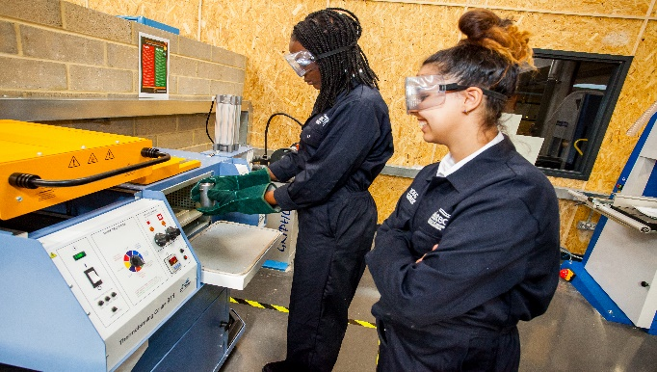

How to apply
Please return your completed application form by email to: g.howard@elutec.co.uk
Closing date: Noon, Monday 21st May 2018
Interview date: Wednesday 23rd May 2018
CVs will not be accepted

Pre-employment checks
Confirmation of appointment is conditional upon a satisfactory enhanced DBS check and occupational health check.

References
Confirmation of appointment is also subject to the receipt of two satisfactory references.

Salary
L1-L4 (depending on skills and experience)

Commencement
September 2018

Visits and informal discussions

If you would like to arrange a visit and/or have an informal discussion about the post, in the first instance please contact Gillian Howard: g.howard@elutec.co.uk

THE POST

Key Role Descriptors for this Post
- To be named SENCO and to Lead and implement the SEND policy across the all through school
- Leading SEND support across the UTC in line with the SEN Code of Practice
- Responsibility for monitoring, supporting and tracking progress of students
- To lead and advise Faculty Leads, Head of Department and their teams in developing of appropriate strategies, methods for teaching and intervention
- Support in the provision and provision mapping of the schools Inclusion department
- To track achievement of academic progress of SEN pupils
- To ensure that provision for SEN pupils is mapped across faculties to accommodate individual student’s needs
- To keep parents fully informed of the progress of the students with SEN
Other responsibilities
- Undertake duties, training and/or hours of work as reasonably required by the role
- To lead and work in partnership with lead practitioners/ Heads of year for support with the transition arrangements for SEN students transferring from KS3 and KS4 to the UTC.
- To promote and maintain effective communications within the SEN/Inclusion department and across the UTC
- All staff have a responsibility for promoting and safeguarding the welfare of the children and young person s/he is responsible for or comes into contact with
- Administration of the SEND list/sims
- To produce an annual SEN report for governors
- To produce department action plans
- To be aware of and assume the appropriate level of responsibility for safeguarding and promoting the welfare of children and to report any concerns in accordance with the UTC’s safeguarding policies and undergo an enhanced DBS
Teachers Standards

Teachers make the education of their pupils their first concern, and are accountable for achieving the highest possible standards in work and conduct. Teachers act with honesty and integrity; have strong subject knowledge, keep their knowledge and skills as teachers up-to-date and are self-critical; forge positive professional relationships; and work with parents in the best interests of their pupils. All teachers must adhere to the Teacher Standards

Person Specification

- Good Honours Degree • QTS (or PGCE+QTS)
- Evidence of Professional Study in the area of SEND
- Evidence of relevant continuing professional development
- Experience of delivering INSET
- Awareness of the barriers that might restrict a pupil’s ability to access the curriculum
- Ability to develop appropriate and creative interventions to allow pupils to manage and overcome these barriers
- Understanding of SEND funding
- Ability to use data and strategic information to raise student attainment
- Potential to set clear expectations, to demand high standards and to hold others to account
- Ability to make sound judgements about standards of teaching observed and give quality feedback
- Experience of partnership working with parents
- Strong interpersonal skills and ability to interact diplomatically
- Experience of working with a variety of SEND in different contexts
- Coordinate and or deliver training
- Experience working with external organisations

Other Requirements

- A passion to help young people become happy, productive, self-confident adults.
- A sense of fun, humanity and collegiality
- Resilience and the ability to work well under pressure.
- The ability to prioritise and to manage one’s own work and that of others

