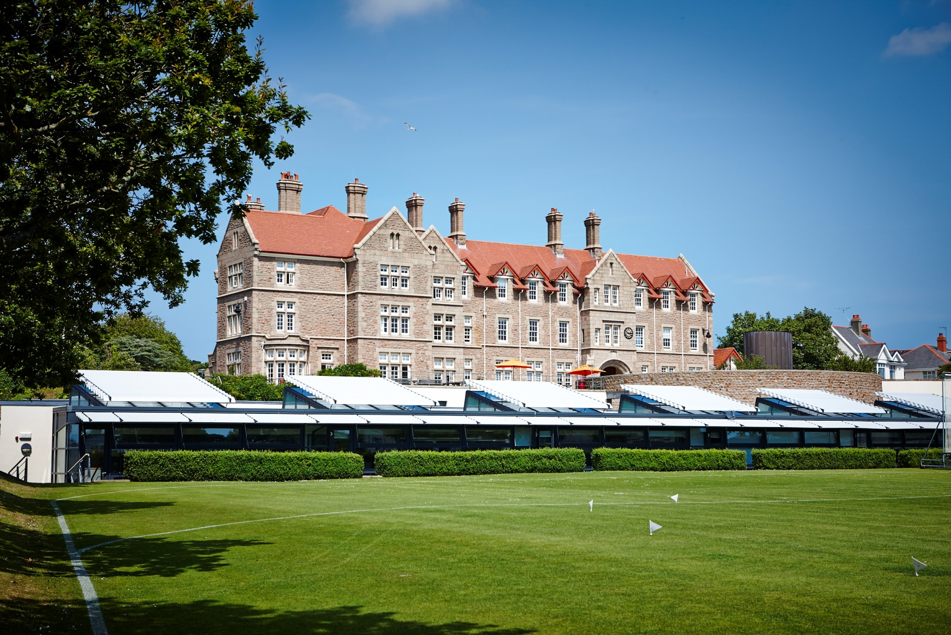

**Head of English**

Applicant Information

**Introduction by Carl Howarth, Principal**

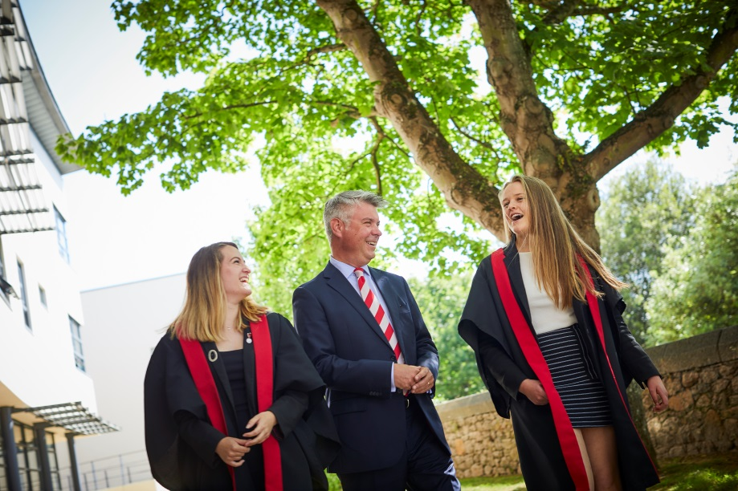Welcome to our information booklet for the post of Head of English. It is designed to give a flavour of life here as a teacher at JCG, provide  information to support your application and, with the College website, provide you with a snapshot of the myriad of varied activities that take place each day in College.  Our website is also useful for information regarding relocation, living and working on our stunning island.

Founded in 1880, JCG has been at the forefront of girls' education in Jersey for over 125 years and has a well-deserved reputation for academic excellence and service to the island community.

Our students thrive on expert teaching, state of the art facilities and a vast range of extra-curricular, enrichment and expedition activities.  They are enterprising, friendly and ambitious and they have wonderful purpose, energy and sense of service to others.  Our staff care and are dedicated, creative and talented. Our exceptional academic results are a testimony to the personal and collective success of all at JCG.  From here, our students go on to study at good universities, both in the United Kingdom and across the world.

Each day we strive to deliver the very best educational experience for our students.  This experience should deliver outstanding academic achievement and, more importantly, nurture someone who is happy, well-mannered and able to find fulfilment in one’s service to others.

Inevitably, an information booklet and website can only partially reflect the reality of College life.  I look forward to meeting short-listed candidates on the 12th of October where interviews will take place at Jersey College for Girls.  At interview, candidates will meet our students and staff, and experience the warmth, vitality and ethos of intellectual curiosity that is JCG.

It is a privilege to lead this remarkable school on such a beautiful island and I would encourage you to apply for this vacancy.



Carl Howarth

**Our Values**

Aspire. Inquire. Excel. Belong.

**Our Vision for member of staff at JCG**

(This vision is not a statement of what is but what we as individuals strive to achieve. As such, the College strives to be the environment to facilitate and support this endeavour.)

Our staff recognise that they are one of their students' greatest influences and are passionate about what they do, drawing on the rich and fulfilling experiences they have in their lives beyond the classroom. They aspire to be the best they can be, are trusted and their professionalism is respected and valued by students, colleagues, parents and the wider community.

Our staff strive to pass on their passion for learning and inspire their students. They are focused on what is best for their students and endeavour to know and understand them.

Each of our staff contributes to a calm, collegiate, happy and purposeful organisation which cares for and invests in us as individuals and valued members of a team. Our staff care deeply for our students, encouraging them to achieve the vision JCG has for its students.

Our staff feel their career aspirations are known, valued and supported; that their professional learning is recognised, nurtured and tailored to them as an individual. Our staff engage with and participate in research and critical inquiry in order to refine their practice. Our staff feel empowered and encouraged to innovate, be creative, curious and to inquire, with space to re-design and re-think how we do things for our students, not only in their studies but in the wider aspects of their lives.

****Our staff seek to excel as educators and in doing so, have a positive impact on our students, our colleagues and our community.

Our staff enjoy working in the exciting, vibrant JCG community, where colleagues and students possess a strong sense of belonging.

**Our Ambition for each student**

****You will enjoy life to the full, value your friendships and achieve balance in your life. You will have a thirst for knowledge and already possess a broad understanding of the cultural, historical, geographical and scientific events and ideas which have fashioned your island and your world, and an eagerness to discover more. You will be a rigorous and imaginative thinker.

You will have a good range of hobbies and interests, including the Arts and sport, which you want to pursue. You will leave us with an excellent record of achievement for an academically-demanding course at university or employment which will lead to a stimulating career. You will have the ambition, motivation and staying power which will equip you to study independently and successfully at either. You will apply for internships, work experience and voluntary work in your holidays.

You will have grown as an individual who is happy, well-mannered and able to find fulfilment in your service to others. You will be thoughtful, open-minded and be able to lead. You will be conscious of the advantages you have enjoyed and of the opportunities and obligations such advantages should bring. You will want to have a positive impact on your community and the world.

****You will have happy and lasting memories of your time at College and an admiration for those people who have nurtured and shaped your learning.

All our efforts and developments are dedicated to achieving this ambition.

**JOB DESCRIPTION**

**Job Title:** Head of English and Media Faculty

**Responsible to:** SLT Line Manager

**Remuneration:** MPS plus SA5

**Time Allowance:** 0.2

The aim of all posts at JCG is to sustain and improve the quality of learning of the students in the College. Teachers work with the Principal, Vice Principal, Assistant Head teachers and other Senior Staff to promote educational opportunities, equality of opportunity and a quality working environment for both staff and students.

**Job purpose**

The prime responsibility of the Head of English and Media is to lead and co-ordinate the work of the subjects within the faculty in order to sustain and improve the quality of learning expected, ensuring high levels of student success. This role also incorporates leading an area of whole College development (to be agreed on appointment).

**Specific responsibilities:**

1. Lead and develop learning in the faculty to ensure the highest levels of student success
2. Lead and develop the faculty staff to ensure optimum performance and effectiveness
3. Manage the organisation within the faculty and monitor the use of resources to ensure cost effectiveness and efficiency
4. Contribute to whole school improvement to ensure exceptional service to students, parents and other stakeholders

**Principal Accountabilities**

1. **Lead and develop learning in the faculty to ensure the highest levels of student success**
   1. To embed the College’s Learning and Teaching policy within the Faculty. To cultivate a culture within the classroom and faculty that enables students to develop strong learning habits, to face difficulties and uncertainty confidently and creatively, and to foster a growth mindset.
   2. Provide dynamic leadership in all aspects of teaching and learning by demonstrating good practice in the classroom, expert knowledge about the curriculum and the theories that underpin students’ learning.
   3. Develop, monitor and review the approach to Whole College Literacy
   4. Lead and develop a consistent whole school strategy to develop specific literacy skills
   5. Liaise with ENCo to ensure individual students are provided with literacy support strategies
   6. Organise an annual event to raise awareness of and engagement in Literacy
   7. Develop an annual programme to promote reading
   8. Advise the Senior Leadership Team on issues related to the curriculum areas.
   9. Plan and ensure that the subject leaders within this curriculum area deliver the various GCSE and A level courses to achieve the highest academic standards.

1.5 Ensure that appropriate documentation such as schemes of learning are available, used effectively and updated where appropriate.

1.6 Assist teachers to develop and implement appropriate student assessment and evaluation practices according to departmental, faculty and College policies.

1.7 Implement a system that effectively monitors and tracks student progress and uses assessment data to ensure all students have individual targets and are supported in all areas of their work.

1.8 Provide support for subject leaders in the compilation and application of ILPs, liaising where necessary with the ENCo.

1.9 Ensure that subject leaders keep up to date with the latest national developments in their subject areas and evaluate their impact upon teaching and learning.

1.10 Ensure that appropriate use is made of the latest developments in the use of ICT.

1.11 Recognise the cross-curricular implications of subjects within the faculty and encourage relevant staff to work together with staff in other faculty areas as appropriate.

1.12 Develop active partnerships with local industries and other educational institutions to enhance the opportunities available to students.

**2. Lead and develop the faculty staff to ensure optimum performance and effectiveness**

2.1 Create and lead a team with a shared sense of identity and vision in this significant curriculum area within the school.

2.2 Set goals that ensure that the expectations and values of JCG are communicated clearly and understood.

2.3 Monitor the effectiveness of individual staff performance through the subject leaders within the curriculum areas, providing support and training as required.

2.4 Seek and support professional growth for self and colleagues.

2.5 Ensure the appraisal system is conducted effectively.

2.6 Facilitate professional mentoring and provide, as required, an appropriate induction programme for NQTs and student teachers.

2.7 Undertake regular self-reviews of teaching practice and accompanying documentation as determined by the evaluation process of the College and faculty.

2.8 Organise and contribute to a full programme of faculty based extra – curricular opportunities for students and staff to develop and improve skills in these curriculum areas.

2.9 Encourage discussion and the sharing of information, ideas and good practice.

2.10 Ensure the profile of the faculty is raised in the College through frequent media releases and internal announcements.

**3. Manage the organisation within the faculty and monitor the use of resources to ensure cost effectiveness and efficiency**

3.1 Ensure that the requirements of all documents, systems and policies are met within the faculty.

3.2 Lead the process of completing DSEFs, the FSEF, exam review analysis documents and all other documents as required, in order to encourage active reflection, analysis and evaluation of current practice in order to improve practice and outcomes.

3.3 Ensure that appropriate material is provided for cover lessons by absent staff.

3.4 Initiate and implement changes and improvements within the faculty where appropriate, within the boundaries of the SDP.

3.5 Liaise with the person responsible for timetabling to produce teaching timetables for staff within the faculty, discussing and negotiating where required.

3.6 Manage and deploy any non-teaching staff within the faculty.

3.7 Ensure subject leaders achieve effective resource management within their curriculum area by preparing and monitoring annual budget plans, controlling expenditure, monitoring textbook distribution and collection and maintaining inventories of stock.

3.8 Ensure the environment including classrooms and displays are current and of a high quality.

3.9 Ensure that regular subject, department and faculty meetings are held and that minutes are recorded and submitted to relevant personnel.

3.10 Attend College meetings, other relevant meetings outside College as required, and provide feedback to faculty staff.

3.11 Line manage the Librarian and oversee the library as a centre to promote literacy and ensure an excellent level of resource to promote scholarly learning.

**4. Contribute to whole school improvement to ensure exceptional service to students, parents and other stakeholders**

4.1 Participate in the construction of the School Development Plan, other College policies and initiatives, and support the same.

4.2 Contribute to parents meetings, the tutorial programme, staff teams, reports and references for students, as appropriate.

4.3 To work closely with other heads of faculty, attend regular Heads of Faculty meetings to help drive teaching and learning initiatives.

4.4 Monitor consistency of departmental report writing according to JCG guidelines.

4.5 Uphold and participate in the arrangements for supporting students in the College.

4.6 Ensure all health and safety regulations are adhered to, both on and off site, and that a regular programme for the inspection and maintenance of equipment is provided.

**Area of Whole College Development:**

A key aspect of the role of Head of Faculty is the leadership of a whole College responsibility. The post holder will through discussion with the AHT (Curriculum and Learning) discern and confirm an area that meets the post holder’s interests and professional areas for development and also meets the needs of the College as expressed in the School Development Plan and Six Year Strategy.

Any other reasonable task as required by the Principal.

Theparticular responsibilities and key tasks above are in addition to those set on in the Teachers Task.

**Person Specification**

An ideal candidate for this post will have:

1. Excellent subject knowledge.
2. A passion for leading and a vision for the development of the English and Media Faculty.
3. Strong interpersonal skills which display high levels of sensitivity, tact and diplomacy in dealing with difficult situations.
4. Evidence of leading whole school initiatives.
5. Good organisational and administrative skills.
6. Strong leadership skills, including extensive experience of leading a high achieving department and an ability to take responsibility and a proactive approach to problem solving.
7. A keen interest in supporting student learning.
8. The ability to work collaboratively, to model good practice and maintain high levels of confidentiality.
9. Experience in actively supporting teaching staff and students in the completion of their work.
10. High levels of skill in working with both individual students and large groups to support student involvement in the life of the school.
11. Energy, vision and enthusiasm to lead the department in the designated areas of responsibility.
12. High level presentational skills when addressing students, parents and teachers.
13. Ability to manage and motivate staff members to focus on what can be achieved.
14. The ability to work under pressure, prioritise and meet deadlines.
15. An ability to demonstrate a strong understanding and commitment to the aims and ethos of Jersey College for Girls.

**This job description is subject to review to ensure it meets the needs of the College.**

**Date :**

**Post holder: …………………………………….. Date: ………………………**

**Principal: ……………………………………….. Date: ………………………**

**The Teacher’s Task**

The DfE (Department for Education) and the representatives of the Teacher’s Unions (Jersey) have agreed the following statement of the Teacher’s Task in order to define more clearly the nature of teachers’ employment. It is their view that in this important work of educating Jersey’s children it is imperative that both teachers and Headteachers recognise the duty they owe to those children and the community. To this end the teacher is expected to maintain a professional commitment to their task and the Headteacher is pledged to a responsible and humane interpretation of this agreement.

The following provides a definition of the Teachers’ Task:

1. Teach effectively to meet the needs of all pupils and to ensure discipline and safety within the school community.

1. Plan, prepare, evaluate and modify as necessary personal teaching methods, work programmes and teaching materials in accordance with the DfE curricular policies and school schemes and standards.
2. Mark and maintain records of pupils’ work in accordance with DfE and school policies.

1. Promote the general progress and welfare of pupils in classes or groups or individually as part of the school’s pastoral and counselling arrangements.
2. Assess and record pupils’ personal and social needs, development, progress and attainment.
3. Provide or contribute to oral or written assessments and report on individual pupils and groups; consult and inform parents, co-operate with appropriate outside agencies in accordance with DfE and school policies.
4. Contribute to and participate in corporate planning, self-evaluation, in-service training and professional development in assigned areas of the curriculum and pastoral arrangements; participate in related staff meetings and school events.
5. Advise colleagues, co-operate with them on teaching programmes, methods, equipment and materials within assigned areas of the curriculum ensuring that appropriate administrative tasks are undertaken.
6. Contribute and participate in the school’s pastoral, tutorial and guidance arrangements and undertake an appropriate share of the organisation and conduct of parental consultation and staff meetings.
7. Contribute as required to the appointment, induction, professional development and assessment of junior colleagues, including new entrants to teaching.
8. Accept an appropriate share of the administrative and organisational tasks within the school, including providing support for teachers, undertaking additional curriculum or pastoral responsibilities or holding senior posts.
9. Ensure the safety and good order of pupils by carrying out an appropriate share of supervisions whenever pupils are authorised to be on school premises or elsewhere when the school is in session.
10. Undertaking an appropriate share of all collective responsibilities including substitution for an absent colleague subject to guaranteed non-teaching time.
11. Supervise support staff as required.
12. Order and allocate appropriate equipment and materials in accordance with DfE and school policies and schemes.
13. Co-operate as required with teachers in other schools and colleges on curricular, pastoral and administrative matters.

**July 2018**

**Why be a teacher at JCG?**

The best testament about what it is like to be a teacher at JCG is the view of the teachers’ themselves. The following quotes have been taken at random from the responses of individual staff to a question in a staff survey.

**Question : What do you most like about your current job?**

'I feel that there is a genuine desire to allow everyone to reach their full potential.'

'Inspiring students to succeed when they thought that they could not. Giving confidence and knowledge to students. Working with similarly motivated colleagues.'

'Opportunities to try something different, be creative. Teaching. Working in a great department. Excellent relationships with staff and students. Seeing students succeed. Running a department, making decisions.'

'The students I am privileged to teach and colleagues I am privileged to work alongside.'

'The students are endlessly engaging and their motivation to learn is exciting. My job offers constantly changing challenges and is certainly never dull! I feel supported by senior staff.'

'The fact that we all work together well as a team and we all support each other.'

'The potential of the students and their ability to embrace innovative teaching ideas and impress you everyday with their ideas and knowledge.'

'Working with the students and being part of what I see as a great team at JCG.'

'The supportive nature of my department and the lovely students who we teach.'

'The feeling that I'm making a positive difference in the classroom and in my wider responsibilities. I also like being part of a large and successful team.'

'Working with such talented and inspirational students.'

------------------------------------------------------------------------------------------------------------------------

Some comments from teachers ranging from those new to the College and those who have progressed their careers here:

**Ed Palfreyman, Head of Lower School, joined the College in the Summer Term 2016 and had this to say about JCG:**

|  |  |
| --- | --- |
|  | I arrived at JCG having taught at other schools across the UK and Jersey, both single-sex and co-educational. I have been impressed by the high levels of motivation in the girls’ approach to their learning. Amongst the staff there is a wide range of expertise and experience, but I can honestly say that I have never been part of such a supportive group of people. Expectations of staff and students are high, but there are structures and support in place to enable every member of the JCG community to reach their potential and to develop their studies and their careers, from tutors and counsellors to co-curricular and extension activities as well as professional development training. |

I am also a parent of a Year 9 student and I have been delighted by the ease with which she has made the transition from Primary to Secondary school. This has been facilitated by a friendly and well-structured transition programme involving both staff and older pupils. The variety of extra-curricular activities on offer has been impressive and she has been made to feel very welcome in clubs from climbing to orchestra, hockey and ‘The Sound of Music’.

**Danielle Mynes, Teacher of English joined JCG in 2017**

I joined JCG in January 2017 having taught in Guernsey for five years. Before that, I trained and taught in Ireland. The moment I stepped into the classroom, the welcome the students gave me was heart-warming. It is not always easy for a class to accept a teacher mid-way through the year and I wasn’t sure how the students would receive me. However, the JCG girls welcomed me with open arms and whilst settling into a new school and starting again brings its own challenges,  the students’ willingness to learn, commitment to progress, and wanting to always do better and improve, is truly the life blood of the school. Their attitude to their studies reminds me of own journey as a student and continues to encourage me in my teaching and learning progression and personal development.

Not only do the students here strive towards being their best selves and whilst we set the bar and expectations high, the students you will encounter are some of the most grounded and down to earth people you will ever meet. Their kindness and wider sense of the world and their place in it,  in conjunction with their recognition of the privileges and opportunities they enjoy as a result of attending JCG, results in these students being the level headed, resilient,  conscientious and compassionate individuals they are today.

The challenges and expectations of JCG are not just limited to the students, but as teachers and role models, we aim to show students that learning can be difficult and requires time and dedication. I believe, especially at A Level, that it is crucial for students to witness the learning journeys of their own teachers, demystifying the barriers to success and revealing in real time how we approach complex tasks.  Simply, excellence requires time, effort, and practice, and we, as a college, demonstrate this to our students daily and hold them to that same accountability and rigour that we hold ourselves to. In doing so, our students relate and connect to their teachers in a much more profound way, allowing us all to tap into our best selves and real potential.

It is a privilege to nurture and teach these young people and to be part of their journey towards adulthood. Our learning should never cease and JCG truly embodies this belief.

**Simon Milner, Head of Sixth Form, started at JCG in 2009**

|  |  |
| --- | --- |
| Teaching at JCG is every bit as rewarding as it is challenging. The students are highly motivated and endlessly engaging; members of staff are passionate, conscientious and supportive of their colleagues. I started at College as a Graduate Trainee teacher of English, and I was welcomed into the profession and given all of the help and guidance that is vital to making a successful start in teaching. Since then, I have had the pleasure of mentoring other trainee teachers, all of whom have flourished in the stimulating professional culture of the College.    JCG is an institution utterly committed to learning. Through rigorous academic study and a dizzying array of co-curricular opportunities, our students develop habits of collaborative inquiry, strategic thinking and cheerful perseverance. JCG students also learn to appreciate the privileges they enjoy and to adopt an ethically responsible perspective: through clubs like Fair |  |

Trade and Amnesty International, students engage actively with social and political issues of global significance. The College is in the business of preparing young people for a life of learning that is only just beginning when they leave us to take their next, exciting steps.

As a teacher at JCG, you are also very much a learner. I have benefited enormously from the developmental opportunities afforded staff at the College. As well as helping me to nurture and sustain my love of the subject that I teach, JCG has allowed me to further my career by taking on responsibilities for areas of the curriculum, aspects of student journalism, and – more recently – for promoting and leading research driven learning. Life at JCG is fast-paced and demanding but the opportunity to thrive and grow alongside the College is one I would urge prospective applicants to seize.

**Caroline David, Head of PSHE, joined JCG in September 2015**

|  |  |
| --- | --- |
|  | “The move to the island for me was a straightforward process and the travel company were great!  I was lucky enough to stay with friends for the first 3 months, to settle into the job and sort out all the essential registration tasks. I have made friends easily and I feel I have achieved a good work/life balance.  Jersey is a great place to live, its near enough to visit the UK to see family, it has beautiful beaches and lots of lovely restaurants. For a small island there is lots going on and I have gained much more than just a great job from the move.  Being a teacher at JCG has renewed my love of teaching.  The College allows me to implement innovative new programmes to affect students outcomes in a positive way. |

We set high expectations here and are concerned with the success of every single student. It is such a privilege to work at JCG, the staff are talented, dedicated and supportive, the students are wonderful young people and the parents are committed and involved.  I believe every day is a new opportunity to learn and my main goal is to prepare my students to be successful for the duration of their school years and  beyond.  JCG is now my second home where I feel welcome and appreciated. I am very happy that I took the plunge, it has been the most positive move I have made in my career and life so far.

**Information on Jersey College for Girls**

**www.jcg.je**

****Please take a look at our [website](http://www.jcg.je) where you should find all the information you need on the College. However, indicated below are some of the things you might want to access immediately.

*On our website, please do look at our:*

[Vision for a student and member of staff at JCG](http://www.jcg.je/) - this outlines what our aspirations are for every student at the College and guides us in our day to day work with the students

Our A level and GCSE prospectuses outline our academic curriculum and are available to read [here](http://www.jerseycollegeforgirls.com/Admissions/School-Prospectus/).

By clicking on ‘[About us](https://www.jerseycollegeforgirls.com/about-us/)’ you will be able to follow links to:

[College Prospectus](http://www.jerseycollegeforgirls.com/Admissions/School-Prospectus/) - this will outline our Values of Aspire, Inquire, Excel and Belong which guide us in everything we do at the College.

[Academic results](http://www.jerseycollegeforgirls.com/About-Us/Academic-Results/) - where you will find a summary and the details of our results.

By clicking on ‘[School Life’](http://www.jerseycollegeforgirls.com/School-Life/) you will be able to follow links to:

[Curriculum](http://www.jerseycollegeforgirls.com/School-Life/Curriculum/Science/) - information on the Faculties and all other aspects of the curriculum.

[Extra-curricular](https://www.jerseycollegeforgirls.com/extra-curricular-clubs-activities-and-fixtures/) - with downloads for the enrichment programme and extra-curricular activities.

****[Living in Jersey](https://www.jerseycollegeforgirls.com/about-us/employment-opportunities/) – information can be found about Jersey from our Relocation Advice from JCG staff Booklet which is featured on our employment opportunities page of the website.

**How to Apply**

****[Employment opportunities](http://www.jerseycollegeforgirls.com/About-Us/Employment-Opportunities/) will give you access to documents outlining what you will need to know about living and working in Jersey. [To see what it is really like to live on a beautiful island, a video](https://www.jerseycollegeforgirls.com/internationalism/) made to promote JCG to International students can be viewed on our International page.

The post is available for January 2019. Salary is in accordance with the Jersey scale of salaries.

Jersey College for Girls is a school that constantly strives to excel in every area of school life and if you would like to be a part of our team please apply through the States of Jersey by going to the [www.gov.je](http://gov.je/Working/JobCareerAdvice/Pages/Jobs.aspx) website.

If you would like to speak with someone about this opportunity please do get in touch with Mr Andrew McGarva, Assistant Headteacher, at [a.mcgarva@jcg.sch.je](mailto:a.mcgarva@jcg.sch.je) or on 01534 516215.

Applications are due by Sunday the 30th of September and interviews will take place on Friday the 12th of October 2018.

Thank you for your interest in this position.