Teacher of French/Spanish
MPS / UPS

September 2018

Application Pack

Welcome to Rivers Academy West London

Thank you for your interest in the post of Teacher of French/Spanish at Rivers Academy West London.

All staff at Rivers Academy share a common drive to equip students with the qualifications, qualities and skills to reach their personal ambitions.

We have the highest aspirations for every student and provide exceptional education and pastoral care for each individual. As a result, children perform tremendously well in external examinations in both Year 11 and Year 13.

We seek to appoint a highly motivated, enthusiastic teacher with a strong commitment to securing the best possible outcomes for the students for whom we work. We are the one chance of success for our students and we are persistent and resilient in overcoming obstacles which our students may face.

We are looking for someone who is passionately interested in teaching and learning who will share our drive to achieve the very best education for students at Rivers Academy. The successful candidate is, or will have the ambition to become, an outstanding teacher.

Visits are welcomed and encouraged

To arrange a visit or for more information please contact:

E‐mail: hr@rivers-aspirations.org

To learn more about us visit www.riversacademy.org
or to find out more about the Aspirations Academies visit: www.aspirationsacademies.org

Yours faithfully,
Andria Singlehurst
Principal

Vision and Ethos
We are passionate about excellence in education, giving students the very best start in life with a firm belief that excellent teaching transforms lives. Our core belief is that for all students to have high aspirations they must believe in themselves, be actively engaged in their learning and see the connection between what they learn today and who they want to become tomorrow.
We teach a highly engaging and challenging curriculum designed to ensure all students develop the knowledge, skills and attributes essential for success in the 21st Century.
We are unapologetically ambitious for every child, no matter what their background, prior attainment or needs. Everything we do at Rivers is driven by this, so that our students can leave us with the best set of qualifications possible and as well rounded young people thereby helping to maximise their life chances.
High Expectations
We expect all students to meet the highest standards, and work with families and the community to ensure that our students meet our high expectations.
Teaching and Learning
Rivers Academy West London teachers provide engaging, challenging and relevant teaching and learning. Our teachers drive new initiatives and exciting new pedagogies within Rivers Academy West London and across the Aspirations Academies Trust.
Our Future Ambitions
Our ‘Outstanding’ March 2015 inspection report was testament to the tremendous dedication of our staff, governors, students and parents/carers. This report represents an important milestone on our journey. Our goal is to raise the Aspirations of the young people with whom we work whilst reaching levels of achievement that would place us in the top 5% of schools nationally.

Who are we looking for?
We are looking for an exceptional individual to play an important role in our unique and growing Academy. The successful candidate will be an excellent teacher of French/Spanish and will also play an important pastoral role in leading an Academic Mentoring (Tutor) group.
They will be a skilled practitioner with the capacity to develop into a lead teacher in the MFL area coaching others to improve their practice. For the right candidate, there is the opportunity to enter the academy as an Aspirant Lead Practitioner, taking on a

signficicant departmental and whole academy responsibility. This can lead to formal accreditation as a Lead Practitioner paid on the Leadership Scale.
It will be an exciting opportunity for an NQT or someone wishing to further develop their career or an experienced practitioner looking to deepen their impact in a new context.
What can we offer you?
With great students, an outstanding and supportive team of staff and an Academy in a well-connected location just 18 minutes on the train from Clapham Junction, Rivers offers an excellent opportunity for an ambitious, talented individual looking to develop their career.

As part of the successful and growing Aspirations Academies Trust we are a part of the newly designated NCTL Teaching School Alliance. You would be joining us at a very exciting time and become part of a vibrant learning community that will offer you fantastic opportunities for CPD, career development, future promotions and for you to be able to make your mark.
The MFLDepartment
The MFL Department forms part of the Communications Faculty and is led by a highly experienced Subject Co-ordinator. The MFL subject area offers French/Spanish. The team is comprised of a range of young exciting practitioners new to the profession and highly experienced teachers with departmental or whole academy responsibilities. The department has big ambitions to drive rapid improvement and become a leading subject area in the academy. Successful candidates for this post will play a leading role in this transformation and become part of a close knit, ambitious team.
We are looking to grow the team and develop a truly inspirational curriculum designed to ensure students leave with excellent GCSE and A-level results. The successful applicant would play a critical role in this on-going work.

Job Description - Teacher of French/Spanish
Department: MFL | Accountable to: Subject Co-ordinator – MFL
Main scale | Employment Type: Full time, paid
Principle Accountabilities
- Establish and safeguard a focus and commitment to high quality teaching and learning that meets the teaching standards and ensures that all students are given every opportunity to gain success in terms of formal accreditation and personal development.

- To agree, monitor, evaluate and be accountable for student progress targets and to make a measurable contribution to whole Academy targets.

- To work collaboratively with partner schools and academies to support the development and maintenance of high quality teaching and learning across the West London District at all Key Stages.

Professional Duties

- To be accountable for student progress and development in French/Spanish and MFLclasses at KS3, KS4 and KS5.

Teaching

- To plan, prepare and teach the curriculum in line with statutory requirements and the academy‛s schemes of work, ensuring teaching of the highest standard.
- To plan and lead intervention as necessary to support students to reach their full potential.
- To ensure that lessons consistently model best practice and their classroom becomes a beacon of excellence.
- To create a stimulating, organised, interactive and informative learning environment that encourages each child to achieve their potential.
- To work co-operatively as part of a teaching team, including planning work for support staff.
- To monitor and assess pupils‛ work, using these assessments to inform planning and set targets that promote continuity and progression.
- To ensure the individual needs of the pupils are met through differentiated work, allowing for the highest standards to be achieved by all.
- To work in partnership with parents and other members of staff to promote the wellbeing and educational progress of each pupil.
- To maintain good order and discipline within the class, in line with the academy‛s behaviour policy.

Learning and Developing

- To actively take part in professional development, sharing expertise and experiences as required.
- To actively extend own professional learning via collaborative study, attendance at INSET and reading to keep abreast of new developments.

Wider Academy Duties

- To contribute to providing a positive and continuous learning culture that promotes achievement, personal well-being and safeguarding among students and academy staff.
- To follow guidance and support from members of the leadership team in relation to utilising opportunities for further career development.
- To be lead a range of extracurricular sports clubs and fixtures as required by the department.
- To undertake training to drive the academy mini-bus to support transport to and from fixtures.
- To work alongside other members of staff to review and innovate the curriculum.
- To develop resources and examples of best practice that can be shared to contribute towards our vision for a seamless transition.
- To follow academy policies under the direction of the Principal and SLT.
- To meet the expectations set out in the National Teachers Standards (Sept 12).
- Undertake any other reasonable professional task as directed by the Principal.

Conditions of Service
General conditions applying to this post are set out in the Trust’s contractual framework for teaching staff.
Special Conditions of Service

Due to the nature of the post, candidates are not entitled to withhold information regarding convictions, cautions, reprimands or final warnings that are not “protected” as defined by the Rehabilitation of Offenders Act 1974 (Exceptions) Order 1975 (as amended in 2013 by SI 2013 1198).

Candidates are required to give details of any convictions in the application process. Furthermore appointment to this position is subject to submission of a certificate issued by the Disclosure and Barring Service that is considered satisfactory by the Trust and confirms the appointee is not included on the Children’s Barred List.

Further pre-employment checks will be undertaken in accordance with the Education (Independent School Standards) Regulations 2014 (as may be amended from time to time) and any additional statutory guidance (e.g. Keeping Children Safe In Education issued by the DfE). Disclosure of a criminal background will not necessarily prevent employment – consideration will be given to the nature of the offence(s) and when they occurred.

Equal Opportunities
The post holder will be expected to carry out all duties in the context of and in compliance with the school’s Equal Opportunities Policies and ensure inclusive practice and equality of opportunity for all.

Person Specification – Teacher of French/Spanish

A – Assessed in Application / I – Assessed in Interview / R – Assessed through references

Criteria | Assessed by
Qualifications and Training
Hold a relevant degree or equivalent qualification. | A
Hold a recognised full teaching qualification (including the holding of qualifications of at least Level 2 in Mathematics and English. | A
Any further relevant training. | A
Experience
At least one year of successful teaching experience with demonstrable impact on student progress. | AIR
Professional Knowledge, Understanding & Skills
Knowledge of curriculum developments related to the post. | AI
Ability to use recent developments to inform own and others practice. | I
Proficient in Microsoft Office applications (Word, Excel, PowerPoint, Internet and email) and in using student record information systems | I
Good understanding of how children learn and how to raise standards of achievement. | I
Ability to interpret and act on a wide range of key data. | AIR
Good administrative and organisational skills. | AIR
Personal and Interpersonal
A passion for education and making a difference with demonstrable commitment to achieving the highest possible standards for all learners and a proven record of enabling learners to fulfil their potential. | AIR
Excellent interpersonal skills and the ability to communicate effectively, both orally and in writing, with all stakeholders demonstrating the ability to command respect from students, parents, colleagues governors and other members of the community. | AIR
Demonstrable resilience evidenced by ability to work effectively and reliably under pressure. | AIR
The ability to adapt to varied roles, responsibilities, schedules and contexts. | IR
Effective in taking the initiative and showing a spirit of adventure to explore and expand their own learning independently beyond the basic mastery of skills. | AIR
Effective reflection - Examine and critique the work or performance of themselves and others to make modifications and continuously improve. | AIR
Effective in managing behaviour and in motivating all learners to make a positive contribution to the learning environment and fulfil their potential for learning. | AIR
Effective ability to assess the emotions of others and adapt words, tone and body language to build strong productive relationships and cooperate with others as an effective member of teams. | IR
Excellent attendance and punctuality record. | R
Strong ability to collaborate with demonstrable capacity to be a good team leader. | IR
Demonstrable effectiveness in promoting equality and diversity through teaching, managing the learning environment and challenging discriminatory behaviour and attitudes | AIR
Commitment to the safeguarding of all learners. | AIR

The Aspirations Academies Trust

The Aspirations Academies Trust (AAT) as a sponsor of primary and secondary age academies in England, is committed to raising students' aspirations so that all young people reach their fullest potential and achieve the success they want for themselves.
The Aspirations Academies Trust in England benefits from QISA's (The Quaglia Institute for Student Aspirations) remarkable record of more than 30 years of research and experience working with students, educators, and schools. Aspirations is the ability to dream about the future while being inspired in the present to reach those dreams. The Aspirations Academies Trust was set up in England with the vision to combine the thirty years of educational research by Dr. Russ Quaglia on student aspirations with effective and innovative school improvement techniques in order to create truly outstanding schools that would fully prepare students to succeed in this exciting world. Central to the philosophy of the Aspirations Academies Trust is the innovative Aspirations Framework developed by the Quaglia Institute for Student Aspirations (QISA) which outlines the belief that for all students to have high Aspirations, three Guiding Principles must be present: Self-Worth, Active Engagement, and Purpose. These Guiding Principles direct the development of educational experiences from the individual classroom to the entire school building. The Three Guiding Principles, in turn, are lived out through 8 Conditions that emphasise relationships, active and engaging teaching and learning, and a sense of responsibility over one's own aims and goals. The 8 Conditions are: Belonging, Heroes, Sense of Accomplishment, Fun & Excitement, Curiosity & Creativity, Spirit of Adventure, Leadership & Responsibility & Confidence to Take Action. Students who have high aspirations believe in themselves, are meaningfully engaged in their learning and the life of the school and work with intention toward their goals.
Our Aspirations Academies have a commitment to make certain that all young people achieve their fullest academic potential and become responsible citizens. To achieve this goal we are dedicated to promoting and putting into practice the Three Guiding Principles and 8 Conditions that foster student aspirations. Each Academy strives to ensure that all students have the opportunity to discover and appreciate their endless promise for a successful future.
The Aspirations Academies Trust considers that its beliefs and principles are applicable and effective with students from age 3 to 18. Each stage of a child's education is extremely important pre-school, primary and secondary and should, where possible be coherent across the phases of education in the practice of developing the principles and conditions central to the beliefs and aims of the Aspirations Academies Trust. For this reason, we support primary, secondary and, where possible, all through (Ages 3-18) academies.
At whatever stage a child joins an Aspirations Academy, whether it is at the age of three or sixteen, the aim is to provide each individual child with the best possible life chance. This is done through the achievement of the highest level of qualifications, the development of skills essential to success in an interconnected and highly competitive world, as well as encouraging the highest aspirations, expecting every student to gain a place at university or enter skilled employment.
Continuous Professional Development
We offer unique and bespoke training for staff at all levels. This includes Senior Leadership Training, Aspirations Training - Level 1 & 2, Polishing Pedagogy, Coaching and Mentoring. Staff will be supported to develop a positive orientation to professional learning as reflective practitioners and will be empowered to take ownership and responsibility for their professional learning and development.
We strive to embed the voice of students (for example, through My Voice, iKnow My Class Surveys and student voice and leadership developments) and the active engagement of students in the process of CPD and staff professional learning.

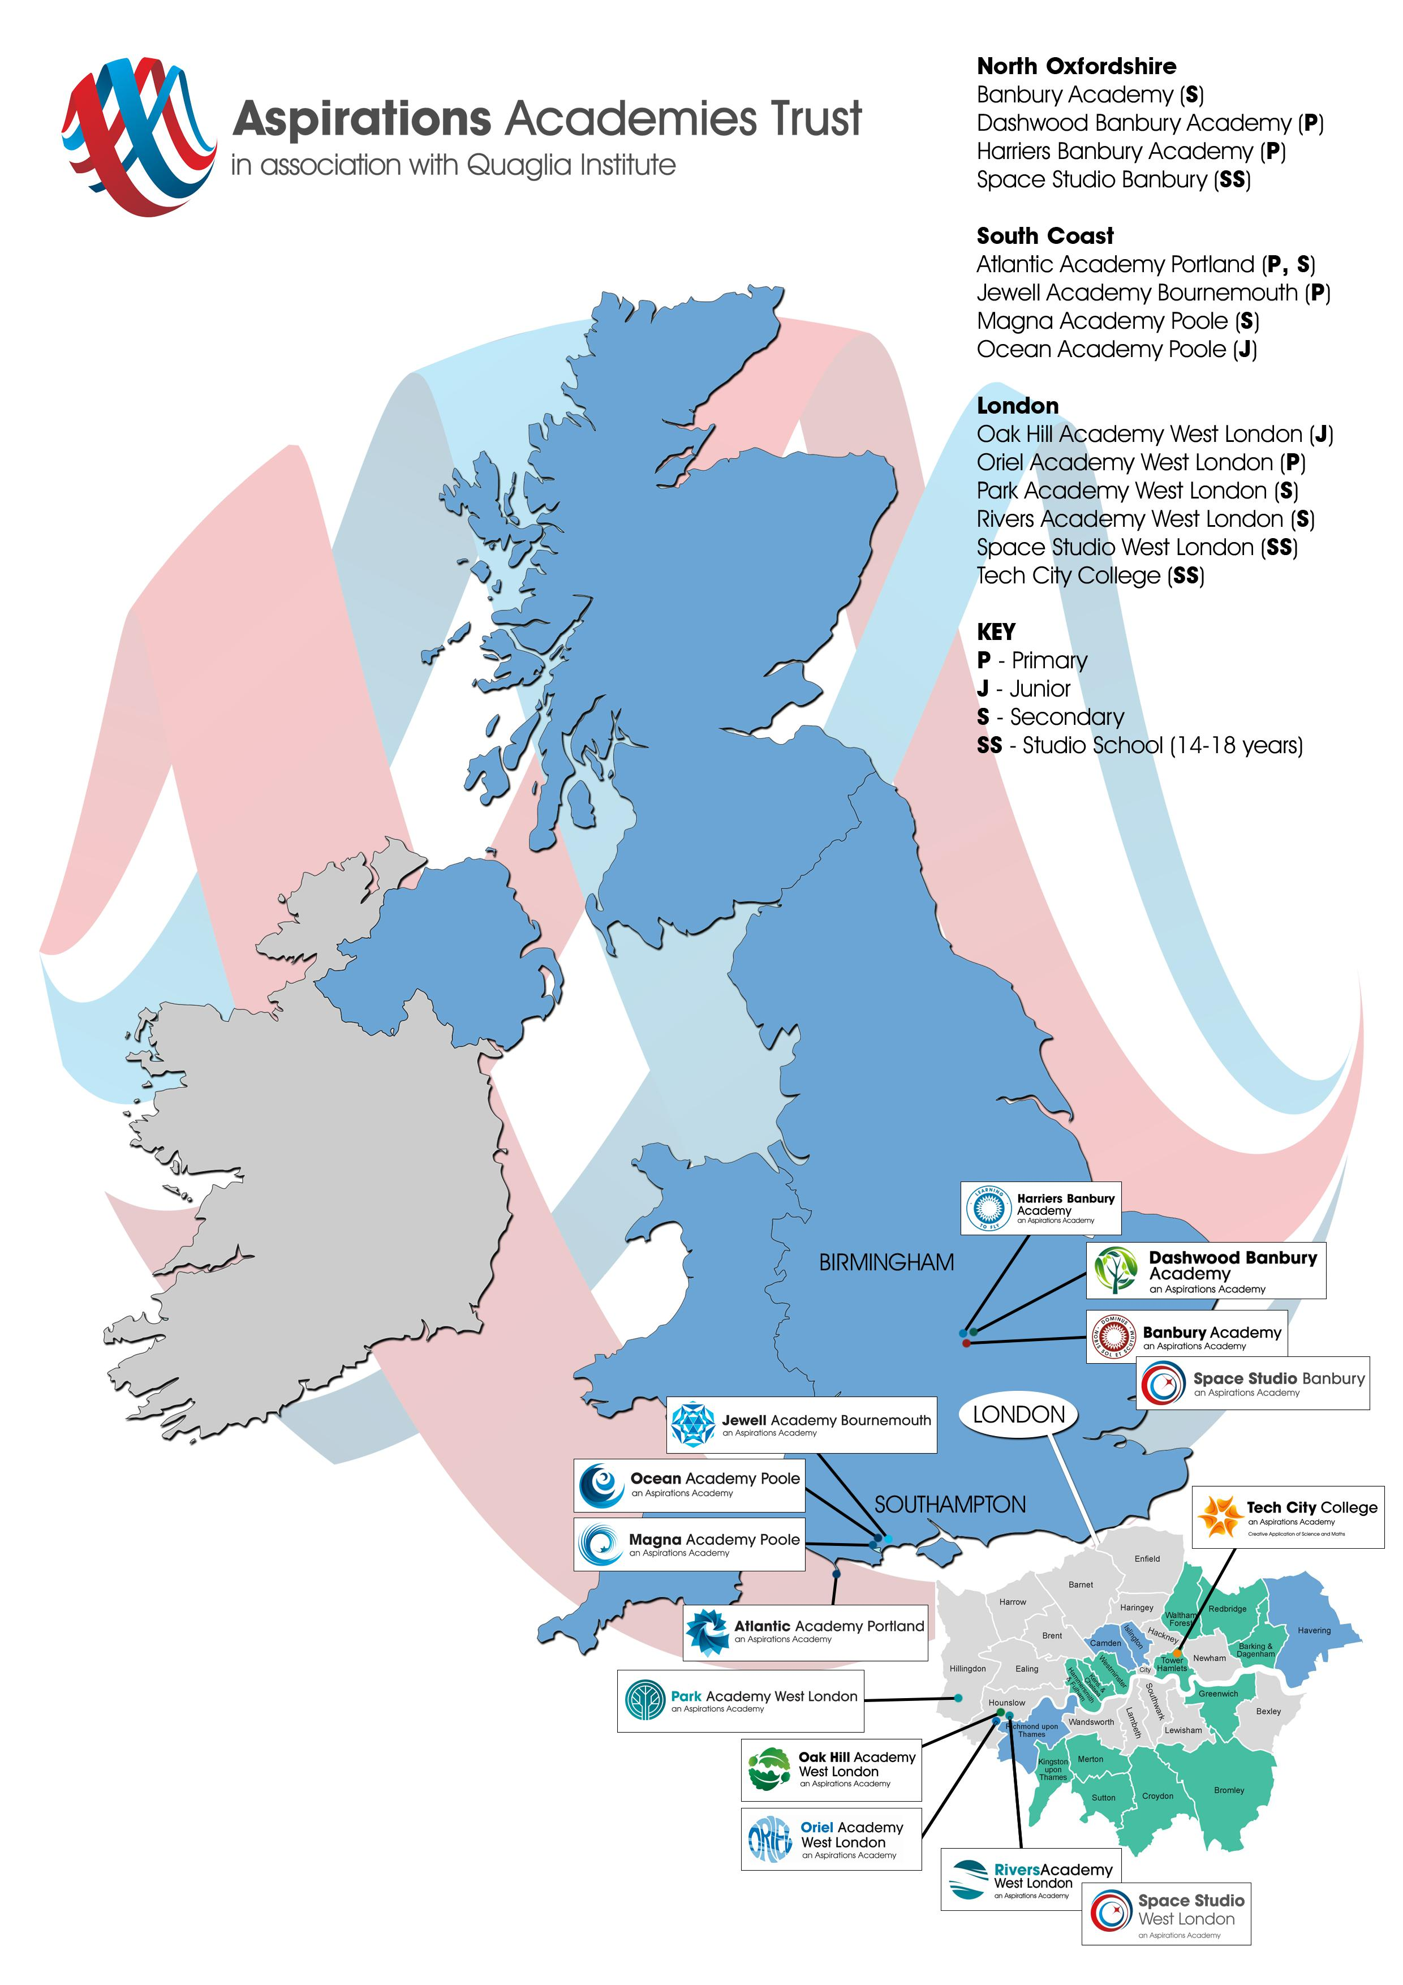

Safe Recruitment Procedure
The AAT is committed to safeguarding and promoting the welfare of children and young people in its academies. In order to meet this responsibility, its academies follow a rigorous selection process to discourage and screen out unsuitable applicants. This process is outlined below, but can be provided in more detail if requested.
Disclosure
This post is classified as one that undertakes regulated activity, and appointment is subject to submission of an enhanced check undertaken by the Disclosure and Barring Service that is considered satisfactory by the Trust. Applicants are required, before appointment, to disclose any conviction, caution or final warnings that are not “protected” as defined by the Rehabilitation of Offenders Act 1974 (Exceptions) Order 1975 (as amended in 2013 by SI 2013 1198). Convictions that are defined in the legislation as “spent convictions” but not “protected” would need to be declared. Non-disclosure may lead to termination of employment. However, disclosure of a criminal background will not necessarily debar individuals from employment – this will depend upon a range of factors including the nature of the offence(s) and when they occurred.
Shortlisting
Only those candidates meeting the relevant criteria indicated in the personal specification will be taken forward from application.
Interview
Longlisted candidates may be subject to a screening interview. Those shortlisted will take part in an interview with questions relating to the job description and person specification and may also have to take part in a selection exercise such as a lesson observation.
Where necessary, candidates will be asked to address any discrepancies, anomalies or gaps in their application form.
Reference checking
At least two references will be requested, normally from the previous and current employers. These may be contacted before the interview and in all case before an offer of appointment is confirmed.

