PERSON SPECIFICATION

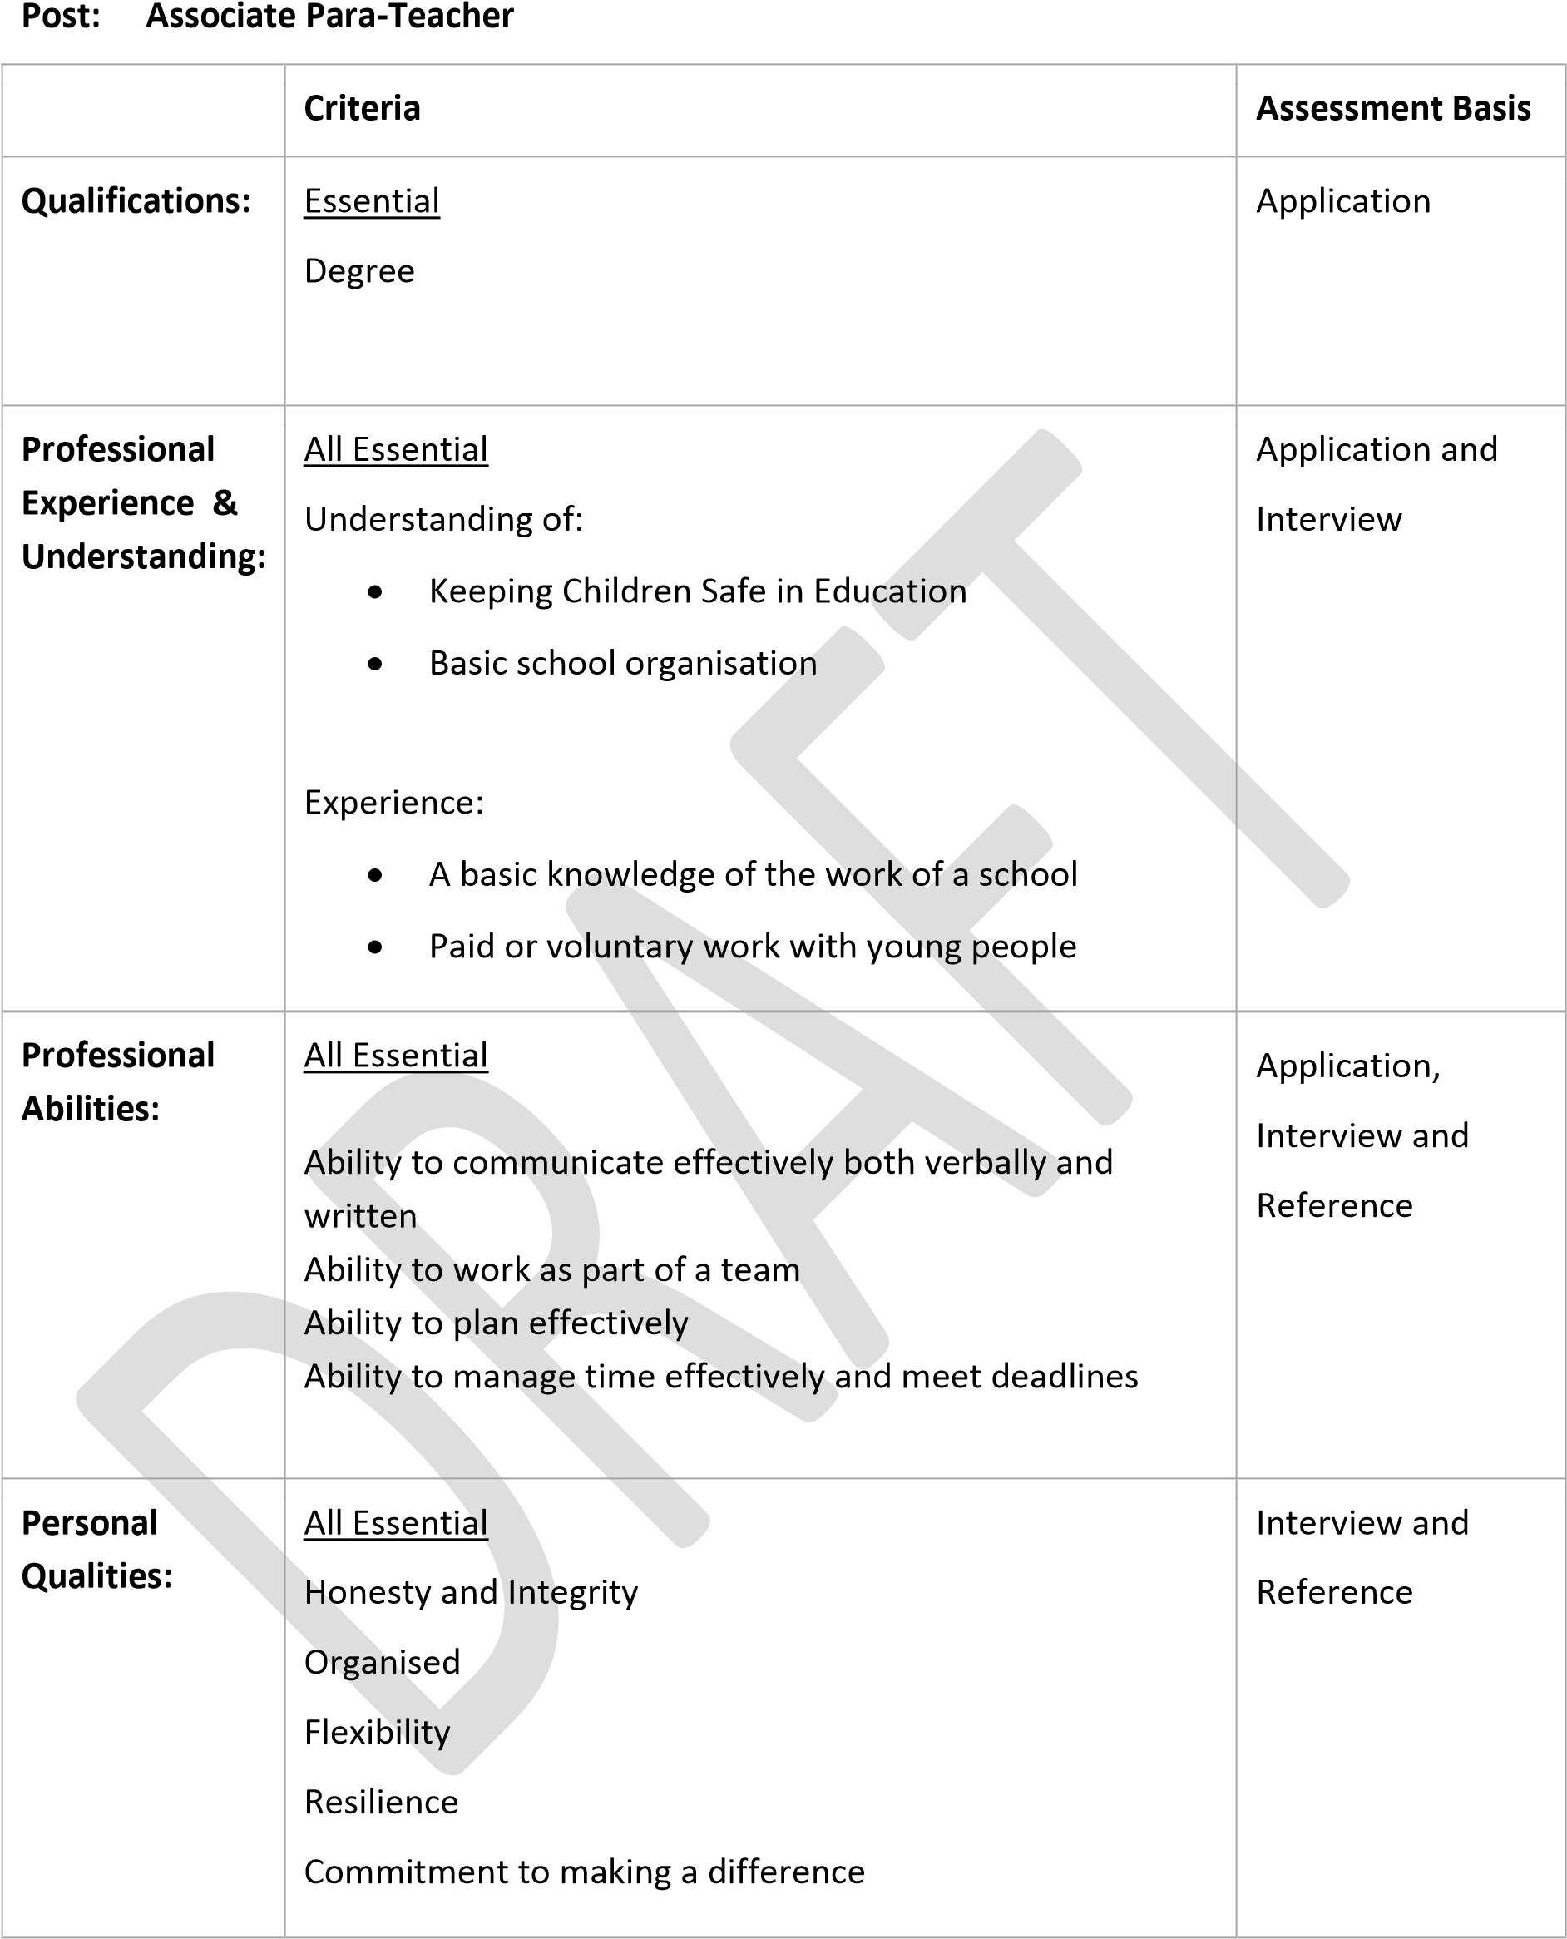
Where the applicant /post holder has a disability every effort will be made to make reasonable adjustments to enable them to carry out the duties of the post.
Business Manager
Page 1 of 1

