May 2018

Dear Applicant

Thank you for your interest in the position of French Teacher at The Thomas Aveling School. Our application pack offers the following information, which we hope will assist you in deciding if you have the right qualities to be a teacher at our school and whether the school is the best place for you to further your development and career.

- Job Advertisement

- MFL at Thomas Aveling
- Job description
- Background to the school
- Aims
- Our results
- School Prospectus
– AVAILABLE ON SCHOOL WEBSITE – www.thomasaveling.co.uk

- How to apply
- Application Form
– AVAILABLE ON SCHOOL WEBSITE – www.thomasaveling.co.uk

We look forward to receiving your completed application.

Yours sincerely
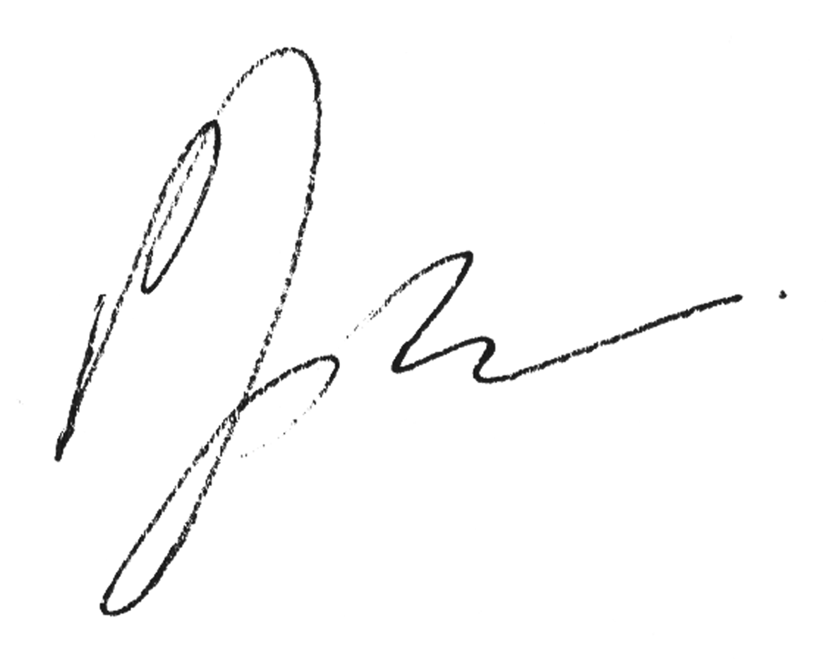

Paul Jackson
Headteacher

Arethusa Road, Rochester, Kent, ME1 2UW
Tel: 01634 844809 Email: office@thomasaveling.co.uk
Headteacher: Mr Paul Jackson Number on roll: 1124

FRENCH TEACHER
From September 2018 - with the possibility of a 1st July start
0.5 to 0.6 FTE, with the possibility of full time if another language offered
Salary: Mainscale/Upper

Thomas Aveling is a popular and over-subscribed school with excellent facilities and this vacancy is your chance to begin or continue your career within a motivated supportive and friendly team who make a valuable contribution to the success of the academy.

This is a part time position to teach French however could be mde full time for suitably qualified person. Full support and induction will be provided, with the opportunity for a 1st July start date.

We seek a candidate who is:

- Enthusiastic, passionate, hardworking and a committed teacher who can instil in our students a love for languages and curiosity towards other cultures and people.

- Willing to work effectively as part of a team and has the ability to motivate and support others.

The successful candidate should be willing to further support our students with extra curricular activities ranging from after school sessions to leading school trips.

“Staff morale and relationships within the school are very positive.”

(OFSTED June 2016)

"The behaviour of pupils is very good. Pupils enjoy school,
have a positive attitude to learning and behave well”

Closing date for applications: 9am on Friday 18th May 2018
Early applications are encouraged and we reserve the right to close the vacancy early if a suitable candidate is found

Letters of application, together with completed application form (available on the school website) giving full details of qualifications and experience to date should be sent to:

Mr P Jackson, Headteacher, Thomas Aveling School,
Arethusa Road, Rochester, Kent, ME1 2UW
or emailed to jshelbourne@thomasaveling.co.uk

The Thomas Aveling School is an Equal Opportunities Employer – committed to safeguarding and promoting the welfare of all students – any offer of appointment will be subject to satisfactory references and an enhanced DBS check will be required for all successful applicants.

THE MFL DEPARTMENT AT THOMAS AVELING

Although small, The Modern Foreign Languages Department at The Thomas Aveling School, is a very strong and solid one. We are seriously committed to raising our students’ academic performance and evidence of this can be found in the very good GCSE exam results across all three languages that every year don’t fail to impress. We use up–to-date resources in order to give our students the best possible academic support and have very high expectations of our students, which we think are necessary in order to prepare them for the new GCSE demands.

Our students have the opportunity to study three languages: French, Spanish and Italian at Key Stage 3 during Term one. From Term 2 onwards students focus on one language only and, if interested, they can continue learning it in Key Stage 4 as a GCSE subject. (The chosen exam board is AQA).

From Key Stage 3 the emphasis is to teach our students how to best approach the four different skills and show them how to manipulate basic sentences and structures, which they can apply to different topics. We also aim to help our pupils to develop independent study skills.

Homework is set weekly at both KS3 and KS4 and aims to provide opportunities for students to practise and further develop their language skills.

JOB DESCRIPTION

Designation: Teacher of MFL
Department: MFL
Responsible to: Subject Leader
Payscale: MPS
TLR: N/A
____________________________________________________________________________________

STANDARDS FOR TEACHERS

Teachers make the education of their pupils their first concern, and are accountable for achieving the highest possible standards in work and conduct. Teachers act with honesty and integrity; have strong subject knowledge, keep their knowledge and skills as teachers up-to-date and are self-critical; forge positive professional relationships; and work with parents in the best interests of their pupils.

PART ONE: TEACHING

A teacher must:

- Set high expectations which inspire, motivate and challenge Pupils

- Establish a safe and stimulating environment for pupils, rooted in mutual respect
- Set goals that stretch and challenge pupils of all backgrounds, abilities and dispositions
- Demonstrate consistently the positive attitudes, values and behaviour which are expected of pupils.

- Promote good progress and outcomes by pupils

- Be accountable for pupils’ attainment, progress and outcomes
- Plan teaching to build on pupils' capabilities and prior knowledge
- Guide pupils to reflect on the progress they have made and their emerging needs
- Demonstrate knowledge and understanding of how pupils learn and how this impacts on teaching
- Encourage pupils to take a responsible and conscientious attitude to their own work and study.

- Demonstrate good subject and curriculum knowledge

- Have a secure knowledge of the relevant subject(s) and curriculum areas, foster and maintain pupils’ interest in the subject, and address misunderstandings
- Demonstrate a critical understanding of developments in the subject and curriculum areas, and promote the value of scholarship
- Demonstrate an understanding of and take responsibility for promoting high standards of literacy, articulacy and the correct use of standard English, whatever the teacher’s specialist subject
- If teaching early reading, demonstrate a clear understanding of systematic synthetic phonics
- If teaching early mathematics, demonstrate a clear understanding of appropriate teaching strategies.

- Plan and teach well-structured lessons

- Impart knowledge and develop understanding through effective use of lesson time
- Promote a love of learning and children’s intellectual curiosity set homework and plan other out-of-class activities to consolidate and extend the knowledge and understanding pupils have acquired
- Reflect systematically on the effectiveness of lessons and approaches to teaching
- Contribute to the design and provision of an engaging curriculum within the relevant subject area(s).

- Adapt teaching to respond to the strengths and needs of all pupils

- Know when and how to differentiate appropriately, using approaches which enable pupils to be taught effectively
- Have a secure understanding of how a range of factors can inhibit pupils’ ability to learn, and how best to overcome these
- Demonstrate an awareness of the physical, social and intellectual development of children, and know how to adapt teaching to support pupils’ education at different stages of development
- Have a clear understanding of the needs of all pupils, including those with special educational needs; those of high ability; those with English as an additional language; those with disabilities; and be able to use and evaluate distinctive teaching approaches to engage and support them.
- Make accurate and productive use of assessment

- Know and understand how to assess the relevant subject and curriculum areas, including statutory assessment requirements
- Make use of formative and summative assessment to secure pupils’ progress
- Use relevant data to monitor progress, set targets, and plan subsequent lessons
- Give pupils regular feedback, both orally and through accurate marking, and encourage pupils to respond to the feedback.

7 Manage behaviour effectively to ensure a good and safe learning Environment
- Have clear rules and routines for behaviour in classrooms, and take responsibility for promoting good and courteous behaviour both in classrooms and around the school, in accordance with the school’s behaviour policy
- Have high expectations of behaviour, and establish a framework for discipline with a range of strategies, using praise, sanctions and rewards consistently and fairly
- Manage classes effectively, using approaches which are appropriate to pupils’ needs in order to involve and motivate them
- Maintain good relationships with pupils, exercise appropriate authority, and act decisively when necessary.

8 Fulfil wider professional responsibilities

- Make a positive contribution to the wider life and ethos of the school
- Develop effective professional relationships with colleagues, knowing how and when to draw on advice and specialist support
- Deploy support staff effectively
- take responsibility for improving teaching through appropriate professional development, responding to advice and feedback from colleagues
- Communicate effectively with parents with regard to pupils’ achievements and well-being.

PART TWO: PERSONAL AND PROFESSIONAL CONDUCT

A teacher is expected to demonstrate consistently high standards of personal and professional conduct. The following statements define the behaviour and attitudes, which set the required standard for conduct throughout a teacher’s career.

- Teachers uphold public trust in the profession and maintain high standards of ethics and behaviour, within and outside school, by:

  - Treating pupils with dignity, building relationships rooted in mutual respect, and at all times observing proper boundaries appropriate to a teacher’s professional position
  - Having regard for the need to safeguard pupils’ well-being, in accordance with statutory provisions
  - Showing tolerance of and respect for the rights of others
  - Not undermining fundamental British values, including democracy, the rule of law, individual liberty and mutual respect, and tolerance of those with different faiths and beliefs
  - Ensuring that personal beliefs are not expressed in ways which exploit pupils’ vulnerability or might lead them to break the law.

- Teachers must have proper and professional regard for the ethos, policies and practices of the school in which they teach, and maintain high standards in their own attendance and punctuality.
- Teachers must have an understanding of, and always act within, the statutory frameworks which set out their professional duties and responsibilities.

OUR BACKGROUND

Thomas Aveling is a great place to work and develop yourself further. The support you receive from colleagues is amazing, both formally and informally. There is a great atmosphere in school where everyone shares in the success of others, wants the very best for our students and really does leave no stone unturned in our support for our students and each other. Please see our last 2 OFSTED inspections for an independent view of what we do at this marvellous school.

The Thomas Aveling School is one of seven secondary-modern schools in the Medway area. We were the first High School in Medway to be allowed to convert to an Academy as a single establishment; this enabled us to spend additional funds on the needs of our school and hence improve achievement faster. We have since merged with another local Academy Trust and are now one of 5 schools in the FPTA Academies Trust. This provides all staff with additional opportunities to mix with colleagues from other schools and take part in cross-Trust initiatives – providing an extra dimension to your development.

Through the selective system, the top 30 percent of potential students are admitted to local Grammar schools through Medway’s selective process rather than to the secondary modern schools. Due to our excellent local reputation, we are regularly oversubscribed by a factor of 3 to 4 applications for every place in Year 7. Despite this, Thomas Aveling was the second best school in Medway last year (Progress 8) and in the top 4% nationally – beating many grammars and comprehensives.

Our increasing success at Key Stage 4 has resulted in our Sixth Form expanding over recent years.

Success in Level 3 courses has risen dramatically to 100% pass rate and average grade has risen from a U(!) to a C grade within the last 5 years.

The school draws its students from across the whole of the Medway area. The majority live in rented accommodation and the proportion from advantaged backgrounds is much lower than average. This is a school where you really do feel that you make a difference every day!

Please visit our website for a flavour of the soul of Thomas Aveling

OUR AIMS

- To embrace students of all abilities, enabling each one to achieve their very best
- To provide inspirational teaching and learning for the young people at our school within a caring environment
- To reward all achievements
- To offer challenging experiences
- To develop qualities of self-discipline, integrity, respect, honesty, trust and compassion
- To develop an effective partnership with all parents
- To encourage links with, and an understanding of, industry and commerce
- To prepare students for the responsibilities, opportunities and experiences of adult life

OUR RESULTS

Key Stage 4 Results 2017

Students achieving a Grade 4 or above in English and Maths = 51%
Students making expected progress or better in Maths = 54%
Students making expected progress or better in English = 49%

Key Stage 4 Results | 2017 | 2016 | 2015 | 2014 | 2013 | 2012
No. of students entered for exams | 183 | 168 | 180 | 178 | 179 | 179
% gaining 5+ A*-C grades | 61.4% | 73.21% | 68% | 86% | 81% | 83%
% gaining 5+ A*-C incl Eng & Maths | 50.0% | 61.31% | 57.7% | 41% | 42% | 45%
% gaining 5+ A*-G grades | 98.9% | 100% | 98.2% | 96.07% | 97.5% | 97%
% gaining 1 A*-G grade | 100% | 100% | 99.8% | 99.44% | 100% | 99%

Key Stage 5 Results

YEAR 13 ATTAINMENT | 2017
A*-B | 50%
A*-C | 100%
A*-E | 100%
APS | B+ 45

Thomas Aveling is proud to have achieved a 100% pass rate across all subjects for the last three years.

HOW TO APPLY

To apply, please complete and forward a School Application Form, together with a supporting statement of no more than two sides of A4, outlining your suitability for the role and stating how your qualifications and previous experience have prepared you for this position.

Your completed application should be returned to:

Mr P Jackson
Headteacher
The Thomas Aveling School
Arethusa Road
ROCHESTER Kent ME1 2UW

Or by e-mail to: jshelbourne@thomasaveling.co.uk

no later than:

Closing date for applications: 9am on Friday 18th May 2018
Early applications are encouraged and we reserve the right to close the vacancy early if a suitable candidate is found
INTERVIEWS anticipated shortly after the deadline

