BUCKINGHAM PREPARATORY SCHOOL

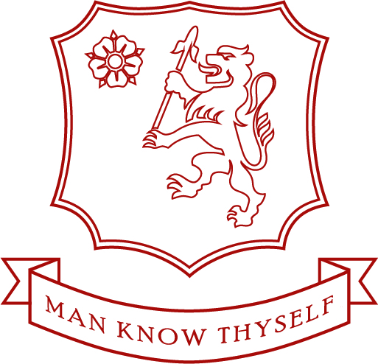

Buckingham Preparatory School is a selective, independent school for boys aged 3–11years. The Buckingham Pre School also caters for girls between the ages of 3 – 4 years.

Our school is a highly academic, achieving school. We educate our boys to the standard required for placements in all of the prestigious local independent and state senior and grammar schools. We are not connected or tied to any one senior school. Our ISI inspection in May 2017 graded our school as “excellent” in every area of our School and Nursery.

Our school buildings have been completed refurbished to produce what is now an extremely well equipped and nicely presented school environment. The school uses smartboards and IT in the forefront of its teaching and practices.

Our school has a pastoral care system second to none. We have a strict class size maximum limit of 18 pupils per class in the Juniors and 16 in the Infants to ensure every child will receive the individual attention and focus they need to succeed. We tailor our curriculum to best suit each child’s personality and needs.

We believe that school life is not simply 8.30am to 4.00pm, but is an all-encompassing part of a child’s life. We run before school breakfast clubs and after school fun clubs, together with homework clubs, sports clubs, music clubs and many of these are free of charge. We have a residential trip every year for every child in Prep, where fun, education, teamwork and friendship are top of the agenda.

The Headteacher is an active member of the school as well as its leader and will be found greeting the boys at the school gate every morning, come rain or shine.

We treat our school community as a large, well-managed, well educated, respectful and encouraging family.

Buckingham Preparatory School is committed to safeguarding and promoting the welfare of children and applicants must be willing to undergo child protection screening appropriate to the post, including checks with past employers and the UK Disclosure and Barring Service.

For more information, please visit our website at www.buckprep.org or come and see the school in person.

