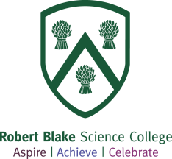

Robert Blake Science College
General Application Information

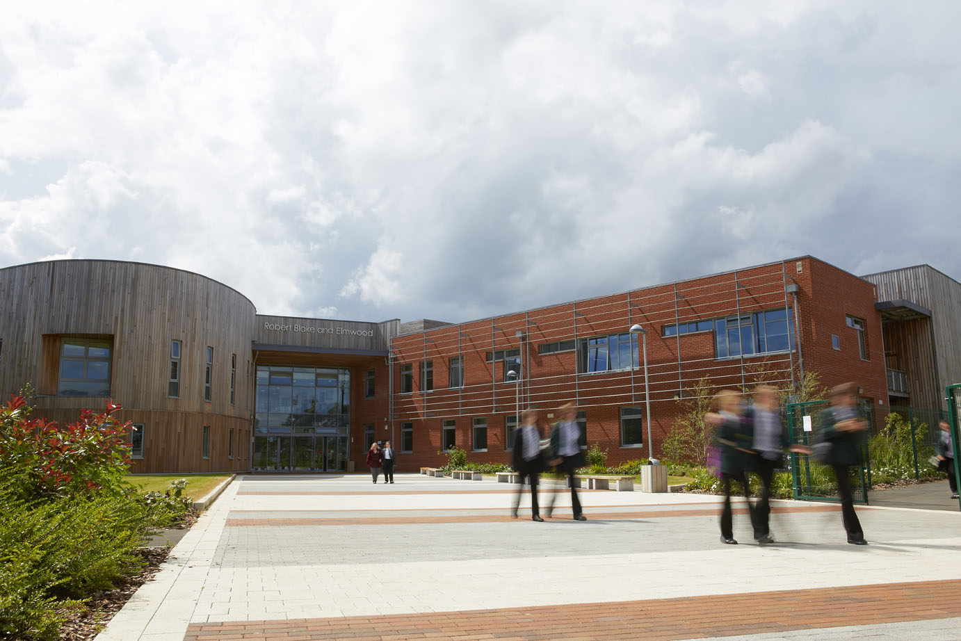

Dear Applicant
Thank you for your interest in a vacancy at Robert Blake Science College. We are looking for staff committed to the school’s ethos of ‘Aspire Achieve Celebrate’. All post holders take a lead role in improving the life chances and accelerating progress for all students regardless of their starting point.
Robert Blake is at an exciting time of change with a new Headteacher in post since September 2016, a rapidly growing student population, state of the art facilities and the prospect of future expansion. There have been changes to key post holders at all levels of the school which will result in an increased capacity to improve. Part of this evolution at Senior Team level has been the recent approval by the Governing Body to restructure, incorporating the addition of a second Deputy and the recent appointments to the new posts of Assistant Headteachers in Maths and English.
The school was graded as ‘Good’ in its most recent section 5 Ofsted inspection in December 2015. There is much to celebrate at the school and we are well placed to improve.
At Robert Blake we value every person in our school community and we aspire to do our very best. We have high expectations of ourselves and our students and celebrate our achievements within and beyond our school community. Successful candidates will need to be committed to the school’s vision and have a relentless drive for improvement.
We have very close links with a number of partners including the COMPASS group of local primary schools and the other secondary schools and FE colleges in the area. These partnerships support our key aims of ensuring that students make the best possible progress in order to achieve the qualifications and experience they need to reach their aspirations.
This pack contains some general information about the school. As separate documents you will find job descriptions and an application form. I would also draw your attention to the school website, which contains a significant amount of additional information about the school.
Applications should be sent or emailed to Salli Bryan (SBryan@educ.somerset.gov.uk)
I look forward to receiving your application.
Yours sincerely,

Miss D Loveridge - Headteacher

The School Context

Robert Blake Science College is an 11-16 comprehensive with an admission number of 166 students per year group, although this is likely to increase. The school currently has just over 800 students on roll and we expect this to continue to grow rapidly over the coming years. We are co-located with Elmwood School which is a secondary provision for students with a range of learning needs including, but not limited to, moderate, severe or profound and multiple learning difficulties, emotional and behavioural issues, communication needs and autism.

The school serves one of the more deprived communities in Somerset in terms of social and economic deprivation. Currently 38.6% of students are FSM (Ever6). We are an inclusive school with relatively high levels of SEN (16.8%) and we have an increasing number of students from minority ethnic groups (10.8%). Our inclusive approach has been one of the driving factors in our co-location with Elmwood in the new building.

We value the individual and due to our size are able to get to know our students really well. We strive to ensure each student achieves their potential through an intensive system of monitoring progress and by challenging and supporting at all levels. Our knowledge of the individual student enables us to provide stimulating and challenging opportunities for the more able and support for the less able.

Robert Blake Science College has been on quite a journey. The school was graded “Requiring Improvement” by OFSTED in 2012. The most recent Section 5 Inspection was undertaken in December 2015 and the school was graded as ‘Good’. Since then the school has and will continue to develop.

The school has an incredibly strong culture of sharing practice and it is this drive for school improvement, through the improving leadership and quality of teaching and learning, that makes Robert Blake such an exciting place to work at this current time.

Accommodation and Facilities
In November 2012 Robert Blake Science College moved into a contemporary new building, one of the last under the Building Schools for the Future programme. The building has been designed to a very high standard and boasts wonderful facilities throughout all areas. It is light, airy, and has been designed to allow a flexible approach to learning.
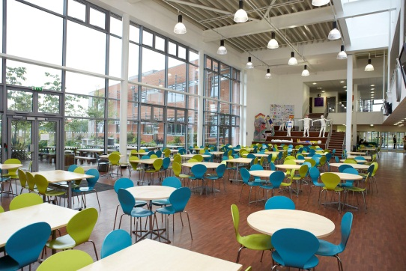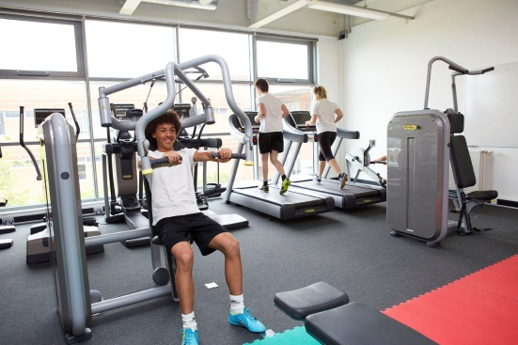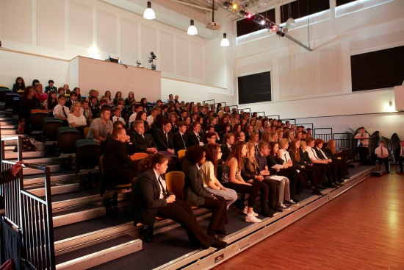

The school currently has a student capacity of around 900, with feasibility studies currently being undertaken across the town with a mind to future expansion due to the changing demographics.

We are co-located on the site with Elmwood Special School, which is part of the Elmwood/Penrose Federation. Robert Blake and Elmwood were on adjacent sites prior to the move and have built up a close working relationship over a number of years. This is a true co-location with some shared facilities in order to achieve economy of scale from the space available to the benefit of both schools. Also on site and accessed through the main entrance is a paediatric health centre funded through the NHS as part of the build.

The school has been built by BAM under a PFI scheme, with BAM FM carrying out all facilities management under the terms of the 25 year contract. Previous school site staff were TUPE transferred to BAM FM in November 2012. Outside of school core hours (7am-6pm) leisure services are managed by 1610, a Somerset based leisure trust.

ICT technical support in the school is delivered by Research Machines (RM) through a managed service contract. Facilities are extensive and include:-
- 2 ICT suites with fixed PCs;
- a Music Technology Studio of iMacs;
- smart boards, short-throw projectors and visualisers to all main learning spaces;
- Laptops and iPads for all curriculum areas

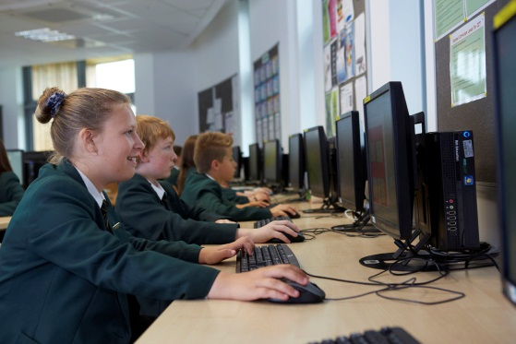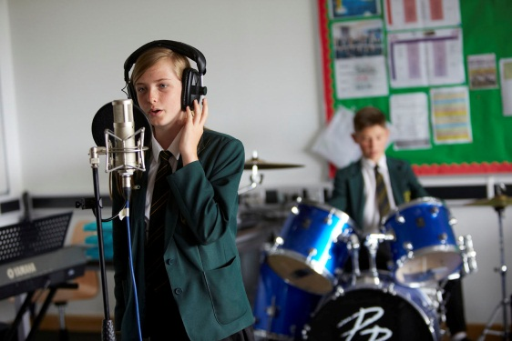

The school’s budget is in a relatively healthy position. Long term planning and investment has protected the budget against the adverse effect of the PFI Scheme. The school will move into the 2017/18 financial year with a healthy revenue and capital balance, together with a rising roll. In addition, the new National Funding Formula due to be implemented in 2018/19 will see an improved allocation for Somerset schools. However, we are always wary of increasing financial pressures on schools.

Partnerships and Collaboration

Robert Blake Science College is firmly committed to working in effective partnership with secondary schools, special schools, and Bridgwater College; sharing learning and resources, extending opportunities for students, and ensuring post 16 progression.

The school works closely with our cluster of primary schools, known as the COMPASS group, to ensure smooth primary to secondary progression and develop a strong culture of achievement. We continue to work on shared projects focussed on developing the effective academic and pastoral transition of students from the primary to secondary phase. We are members of the Somerset Association of Secondary Headteachers (SASH).

We play an active role in the Challenge Partners initiative, working with other schools to constantly support/challenge each other, leading to sustained improvement. We are heavily involved with PiXL programmes, and have recently launched a middle leadership programme – working alongside an external consultant. We have a very strong relationship with TeachFirst, enabling us to recruit and support the development of new teachers into the profession within the subject areas of Maths, English, Science and MFL. To date every teacher coming through the TeachFirst programme at Robert Blake has been judged as outstanding.
We are the only secondary school in Somerset to have been awarded the ‘gold standard’ for our work in supporting NQTs.

The nature of the PFI scheme and the shared use of the facilities on site mean that the maintenance of close and effective working relations with all partners is essential, namely the Elmwood/Penrose federation, Futures for Somerset, 1610 and BAM.

