

Teacher of History

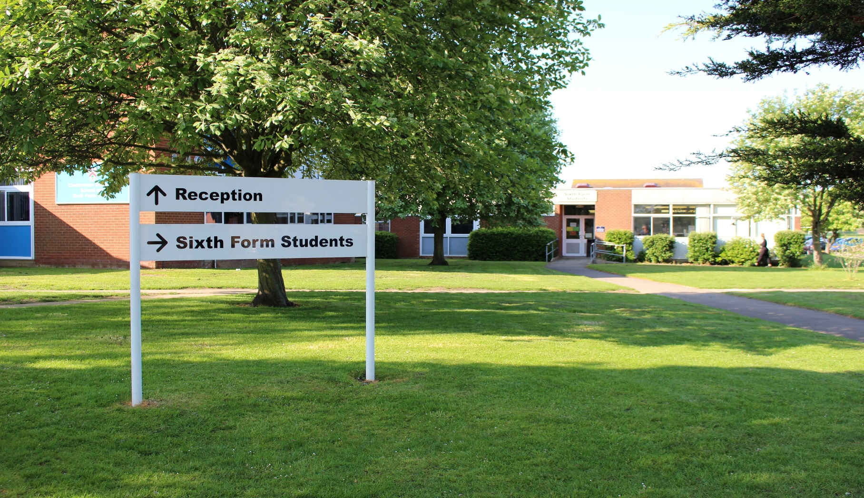Application pack

Cheltenham Bournside School   
and Sixth Form Centre

Be the best you can be

Welcome

Choosing the right school to teach in is a big decision and the aim of this application pack is to provide prospective applicants with sufficient information to decide whether or not Bournside might be a place that they would be happy teaching. I have been fortunate enough to spend the past four years of my career at the school. Bournside is a truly remarkable place and having taught and led in a variety of other schools across the county and country, when I travel to school each day, I know that I am very privileged to be coming to a very special place of work. In the short section that follows, I hope to elaborate on why.

One of the things that makes the school so special is the shared vision that exists between staff, students, parents and governors. This vision is visible the minute you enter the main school Reception and it permeates throughout the school almost everywhere you look. The vision is not simply a series of words, they are a sound piece to many conversations that take place daily within the school. Our vision is very simple: we aim for ‘every student to develop the knowledge, skills and self-confidence to become the best they can be’.

Working in a school is very rewarding and all leaders at the school are absolutely committed to supporting staff and going the extra mile to make a positive difference to their work/life balance and welfare, in many tangible ways.

The school is highly committed to leadership development and we are proud to boast a high success rate of staff being promoted to new leadership positions whilst with us, both internally and externally. This is not by chance. During the past academic year over a quarter of our teaching staff engaged voluntarily in one of six senior leadership development projects, which enabled staff to demonstrate whole- school impact in a particular aspect of our provision. We operate a flexible approach to CPD where staff tailor their professional

hand’, however, this is something that every member of staff who works at the school must embrace and actively promote. If you decide to apply for a position with

us, you will be joining a committed team

of staff who make it

their business to do just that.

Our vision is very simple: we aim

for ‘every student to develop the knowledge, skills and self-confidence to become the best they can be’.

In my conversations with staff and students, there are two things that I refer to frequently: ‘our school’ and ‘pride’. I’m sure you would agree that these go ‘hand in

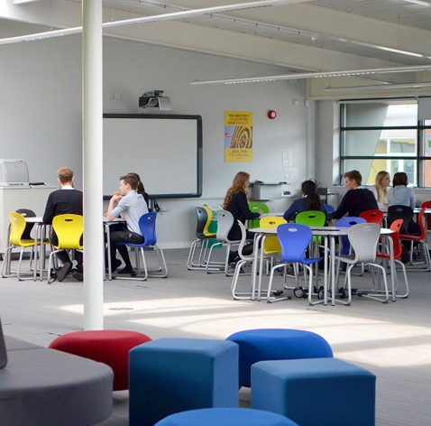

Welcome (cont)

development to suit their individual needs, by selecting from a wide range of available sessions. Last year there were over 130 sessions to choose from, which equates to more than one session every other day!

We are very optimistic about our future. The school is significantly oversubscribed with first choice applications alone and we are known in our local community and across Gloucestershire, for being a very popular and successful school. So much so that we will be planning to expand from 2018. When you walk around our school site it is almost impossible not to be impressed by the high quality resources and facilities that we have. This does not happen by accident. Much time and meticulous planning goes into securing additional funding.

Every member of teaching staff has their own school iPad and our Technology Enhanced Learning programme is currently equipping all students with their own iPad to support teaching, learning and assessment in a world where learning doesn’t just happen sat at a desk.

Having read the application pack and perused the website, if you would like to apply please do so by completing the application form and adding a short supporting letter, sending by email to: **personnel@bournside.gloucs.sch.uk** on or before Monday 16th October by 3:30pm.

The support staff application form can be found on the vacancies page within ‘information’ on the website.

I very much look forward to hearing from you.



**Gareth Burton**Headteacher

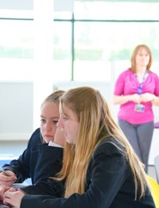

We are very optimistic about our future. The school is significantly oversubscribed with first choice applications alone and we are known in our local community and across Gloucestershire, for being a very popular and successful school.

Our Vision

How would current staff describe Bournside?

We have close to 200 staff working at the school - we asked them all to provide one word that they feel would best describe the school to someone who had never visited us before. Below are their responses, with the most frequent responses represented by the largest.



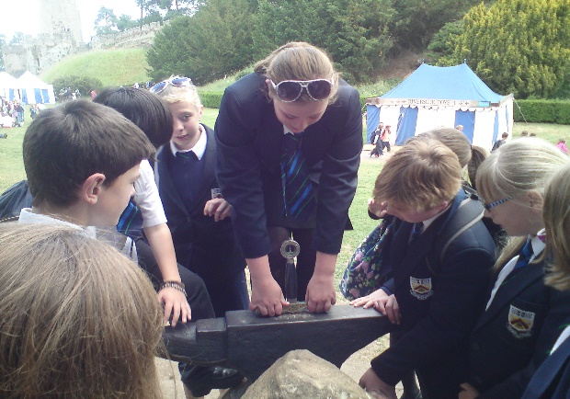

The History Department

This is a highly successful department in terms of value-added and absolute exam results and is consistently amongst the most popular student choices for both GCSE and A-Level students. It is staffed by the Head of History and 4 other teachers, including the 2nd in the department who is also in charge of Politics. There are 4 teaching rooms which are well resourced with computer projectors, DVD players, laptops and a large array of text books.

At **Key Stage 3**, History is taught in mixed ability form groups of approximately 30 students. Pupils are taught about key events in the past, from the Romans through to the present day, using a thematic as well as a chronological approach which aims to develop skills and knowledge in preparation for GCSE. The school operates a fortnightly timetable and students have two 1 hour lessons per cycle in Year 7 and three 1 hour lessons in Year 8 and 9.

In **GCSE History** we follow the Edexcel course and there are 5 examination groups - in both Year 10 and Year 11. There are currently around 120 students in each cohort. We study ‘Crime through time’, ‘The Nazis’, ‘The Normans’ and ‘The American West’. In 2016-2017, a third of students achieved an A*-A and 84% a C or above.

In **A-Level History** we follow the AQA syllabus. We study ‘The Cold War’ and ‘The Tudors’ for our two examination papers and complete Coursework on ‘American Civil Rights’. In 2016-2017, 84% of students achieved an A*-C and many went on to study it at University. In **Politics** we aim to encourage an interest in, and understanding of, the way people are governed. In Year 12 Politics, we look at how we are ruled in the UK; whilst in Year 13 we study key ideologies and develop student’s analytical skills. In 2016-2017 100% passed.

Extra-curricular activities are a vital part of life at Bournside. We have a debating society which has won local as well as national competitions in recent years. We also run a host of national and international trips. Key Stage 3 students have an opportunity to go to the Black Country Museum and Battlefields of France and Belgium. Key Stage 4 students go to the London Dungeons for their study of ‘Crime through time’; and A-Level students get to study Tudor documents, at the National Archives, and are given the chance to visit the Berlin Wall and Sachsenhausen concentration camp to enhance their understanding of the Cold War.

Support as a new member of staff and a Newly Qualified Teacher (NQT)

Beth Warren, our Assistant Headteacher oversees the provision for all new staff joining the school and our superb NQT programme. Below is some information from Beth regarding the high level of importance that we place on supporting new members of staff and NQTs in their transition to Bournside.

* Inclusion Support and SEN
* ICT
* Health and Safety procedures
* Educational visit procedures
* The Learning Centre and the Reading Centre

In addition to this training you will be allocated a mentor – this is likely to be the same person as your line manager. Your mentor will meet with you on a weekly basis for the first month and fortnightly for the next two months. After this, meetings may be monthly or half-termly. Your mentor will ensure that as a new member of staff you have access to a Bournside Staff Handbook and you have somebody to talk with to support you throughout your first year.

Your mentor is the first port of call for support and advice. The job of the mentor is to go through the induction list and ensure that all aspects are covered. Although many of the aspects will have been covered during the induction day it is important that they can be revisited at any point. The meetings should cover aspects of the role; how well you are getting on, what difficulties you might be experiencing and generally ensuring you are supported so you can fulfil your role within the school. Your mentor will also undertake a three-month review with you.

New members of staff

“As part of my role as Assistant Headteacher I oversee new staff induction for your first year of teaching with us.

The purpose of this is to ensure that staff, new to Cheltenham Bournside School, are effectively supported in understanding and coping with your new role.

As a new member of teaching staff you will be invited to an induction day prior to starting at the school. This is a full day of training in the term prior to starting which will provide information and training, and important aspects of school life which are needed immediately by new employees.

Topics included are:

* School Behaviour Code including Rewards and Sanctions
* Being a tutor including assemblies
* Use of Electronic Registration and laptops.
* Procedures in the Sixth Form
* School Management Structure – who to see for what
* Duties
* School communication and meeting systems
* Induction procedures, performance management and professional development
* School Behaviour Code including
* Rewards and sanctionstions
* Being a tutor including assemblies
* Use of Electronic Registration and laptops.
* Procedures in the Sixth Form
* School Management Structure – who
* to see for what
* Duties
* School communication and meeting systems
* Induction procedures, performance management and professional development
* Inclusion Support and SEN
* ICT
* Health and Safety procedures
* Educational visit procedures
* The Learning Centre and the Reading Centre

In addition to this training   
you will be allocated a   
mentor – this is likely to be   
the same person as your   
line manager. The Role of   
the Mentor is to provide   
you with regular   
professional review   
meetings and help to   
oversee the holistic view of   
your progress as a NQT,   
which includes looking at   
teaching, planning, your   
role as a tutor, progress   
made, contributions to extra curriculum provision of the school, marking and they will observe you teaching every 6-8 weeks.

The approach throughout the year should be a collaborative approach. The Newly Qualified Teacher is part of the process of action planning focusing on areas/ activities for development. Your mentor will ensure that as a new member of staff you have access to a Bournside Staff Handbook and you have somebody to talk with to support you throughout your first year.

Your mentor will ensure that as a new member of staff you have access to a Bournside Staff Handbook and you have somebody to talk with to support you throughout your first year

As a new member of staff you will be joining a school that is forward thinking in its approach to Continuing Professional Development (CPD). We have a personalised menu for teaching staff that incorporates a variety of activities that engage staff with sharing best practice and ensuring teaching and learning is the best it can be. These opportunities include whole staff training options, peer observations, teaching and learning forum sessions, personal planning and development time, departmental development time, focused workshops, and time for performance management and review.”



NQT Programme

“I oversee the NQT induction year and I would be your induction mentor for the year. In addition to my support you will be assigned a personal mentor who will be based in your subject area. The purpose of this is to ensure you are, as a new member of staff to Cheltenham Bournside School, effectively supported in understanding and coping with your new role.

As a new member to the teaching profession you will be invited to an induction day prior to starting at the school. This is a full day of training in the term prior to starting which will provide information and training, and important aspects of school life which are needed immediately by new employees. Topics included are:

In my Role as the Induction Tutor I will meet with you to complete your 3 formal assessments that form part of your NQT year. These formal assessments consist of a lesson observation prior to end of term assessment and a formal assessment meeting. As a newly qualified teacher you will also have a reduced timetable for the first academic year.

As a resource we use an on-line tracker aligned with the Teacher Standards which is owned by the NQT and they can use this with their mentor as a tool for recording evidence and tracking areas/activities for development throughout the year.

What our 2015-16 NQTs said:

*“As a well-supported NQT in a vibrant and forward thinking school, I have been given fantastic opportunities to develop schemes of work and provide whole school initiatives to further improve teaching and learning”*

*“I’ve been given the opportunity to develop schemes within my department, also take responsibility of how the department budget is spent and opportunities to contribute to extracurricular school life in a stimulating and supportive environment”*

*“I always knew my NQT year would be hard work, which is why I am so happy that I got the post at Bournside. The level of support has been exemplary. In addition, the students here are fantastic and being a large school means you gain a range of experience.”*

As a new member of staff you will be joining a school that is forward thinking in its approach to Continuing Professional Development (CPD). We have a personalised menu for teaching staff that incorporates a variety of activities that engage staff with sharing best practice and ensuring teaching and learning is the best it can be. These opportunities include whole staff training options, peer observations, teaching and learning forum sessions, personal planning and development time, departmental development time, focused workshops, and time for performance management and review.”



“Whether you would be joining us as an NQT or not, I hope this information has given you a flavour of the support you can expect in your first year at Bournside.”

Job Description

|  |  |
| --- | --- |
| Responsible to: | Head of Department |
| Responsible for: | The provision of a high quality learning experience and high quality teaching and support for students. |
| Purpose: | * To understand and promote the school’s aims and vision, priorities, targets and action plans. * To implement and deliver an appropriately broad, balanced, relevant and differentiated curriculum for students and to support a designated curriculum area or areas as appropriate. * To monitor and support the overall progress and development of students as a teacher/ Form Tutor. * To facilitate and encourage a learning experience which provides students with the opportunity to achieve or exceed their individual potential. * To contribute to raising standards of student achievement and progress. |
| Working time: | 195 days per year. Full-time (1265 hours directed time) |
| Salary/Grade: | Agreed pay scales are used as defined in the School Pay Policy. |

Duties

|  |  |
| --- | --- |
| Teaching and managing student learning including assessment: | * To teach whole classes, groups and individuals, aiming for sustained high quality lessons, which support students making, at least good progress over time, as outlined in the school’s performance management policy. * To ensure that the school’s student academic data system (SISRA) is used effectively to track and monitor student progress, intervening where necessary with any student underperformance. * To ensure that learning outcomes are clear, differentiated and understood by students thus securing progress towards students’ individual targets. * To adopt the school’s agreed routine procedures for the effective start and end of lessons (Main School) (ref Staff Handbook). * To consistently apply the school’s Code for Learning and Ladder of Consequences, establishing and maintaining a good standard of discipline, with positive and productive relationships. * To set and mark work carried out by the students in school and elsewhere and to provide feedback and assessment according to the school’s assessment policy and as requested by external examination bodies. * To provide, or contribute to, oral and written assessments, reports and references relating to students. * To ensure that any relevant cross curricular themes are reflected in the learning experience. * To monitor the academic progress of students intervening when appropriate, following the school’s academic tracking and intervention procedures (ref Staff Handbook). * Whenever possible, to set cover work when absent |
| Behaviour and Safety | * Exercise vigilance and effective duty of care regarding the safety and wellbeing of students at all times. * Adhere to the school’s Health and Safety Policy and Child Protection and Safeguarding policy. * To attend all scheduled duties on time and for their duration exercising prime duty of care for all students in the duty area according to separate guidance. |
| Strategic Planning: | * To assist in the Head of Department’s contribution to the Departmental Response Plan (DRP) and the Head of Year’s contribution to the Pastoral Response Plan, as whole-school evaluation processes. |
| Curriculum Development: | * To assist in the development of appropriate syllabuses, resources, schemes of work, marking policies and teaching strategies in the department and to be specifically responsible for a unit of work or a group of lessons as directed by the Head of Department. * To assist in the broader process of curriculum development |
| Planning and setting expectations: | * To identify clear learning outcomes, content, lesson activities and sequences appropriate to the subject matter and the students being taught. * To set appropriate expectations and targets for learning for individual students, building on prior attainment. * To be aware of students identified as disadvantaged, those who have Special Educational Needs and/or Disabilities (SEND) and other specific student groups (e.g. Upper Ability, EAL, FSM, gender, ethnic minority) and implement appropriate strategies to maximise their progress. |
| Continuous Professional Development (CPI) | * To take responsibility for own CPI and to keep up to date with research and developments in pedagogy and subject. * To take part in the school’s CPI programme. * To comply with the Performance Management and Review Policy. * To ensure the effective and efficient deployment of Teacher Assistant classroom support, where this occurs. * To work as a member of a designated team and to contribute positively to effective working relations within this team and the whole staff body. |
| Self-Evaluation and monitoring: | * To actively respond to observation feedback from classroom observations. * To review methods of teaching and programmes of work. * To take part in the review, development and management of activities relating to the curriculum, organisation and pastoral functions of the school |
| Communications: | * To prepare and present regular informative reports to parents according to the school’s reporting procedures. * To communicate effectively with the parents of students as appropriate with particular reference to the school’s academic, tracking and intervention procedures (ref Staff Handbook) * Where appropriate, to communicate and co-operate with persons or bodies outside the school, always being mindful of PR in relation to the school’s reputation. * To take part in marketing and liaison activities such as Open Evenings, Parents Evenings, and liaison events with feeder schools. * To adopt professional standards in dealings with other colleagues and visitors according to the Consistency Frameworks within the Staff Handbook. * To be an effective role model to all students at all times. * To adhere to the guidelines of the school’s ‘Safer Working Practice Guidelines for Staff’ document. * To attend weekly staff briefings, scheduled staff meetings and other professional meetings according to the school’s published annual calendar. |
| Pastoral System: | * To be a Form Tutor to an assigned group of students. * To promote the general progress and well-being of individual students and of the Tutor Group as a whole. * To liaise with Heads of Year and Assistant Heads of Year to ensure the implementation of the school’s Pastoral System. * To register students, ensure that they arrive punctually to school, that they are dressed appropriately and are equipped to learn. * To accompany students to assemblies. * To monitor the academic and pastoral progress of students intervening when appropriate, following the school’s pastoral tracking and intervention procedures (ref Staff Handbook) * To consistently apply the Code for Learning and Ladder of Consequences through applying the school’s sanctions and rewards system, keeping up to date records with regard to incidents involving students. * To communicate, as the first point of contact, with parents of students over issues related to student progress and behaviour, including participation in the school’s reporting process. * To alert the appropriate staff to problems experienced by students and to participate in the process of resolving these. * To deliver the tutorial programme. |
| Policy awareness and compliance | * To be aware of all school policies and comply with these policies (All relevant policies are available in Public Documents) * Comply with the Teacher Standards (DfE, May 2013) |
| Other specific duties: | * To play a full part in the life of the school community, to support its aims and to encourage staff and students to follow this example, including personal appearance. * To undertake any other reasonable duty as specified by the Head not mentioned in the above. * Additional duties may be expected for those teachers who have achieved threshold standards and therefore accessed the Upper Pay Spine. |



Cheltenham Bournside School and Sixth Form Centre



**Cheltenham Bournside**

**School and Sixth Form Centre**

Warden Hill Road Cheltenham Gloucestershire GL51 3EF

**t** 01242 235555

**e** [personnel@bournside.gloucs.sch.uk](mailto:personnel@bournside.gloucs.sch.uk)