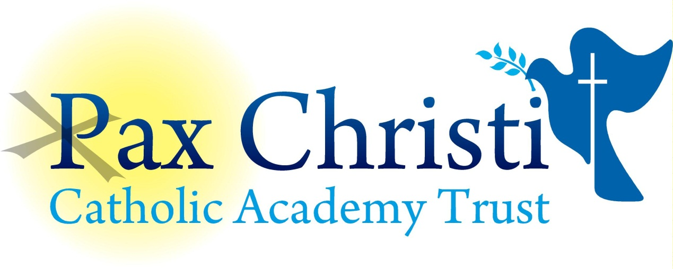

CHRIST THE KING CATHOLIC VOLUNTARY ACADEMY

JOB DESCRIPTION

Data and Exams Assistant
NJE Grade 3

Current Post holder: | Vacancy
Job Description Review Date:  Signed…………………………………………………….. | September 2017  Date……………………………………………….
Job Purpose
The post holder will provide a wide and varied range of clerical and administrative support to the Data and Examinations team. The post holder will be expected to be in school during the two-week period when external examination results for GCSE and A/AS Level results are available to the academy and are released to candidates.

Line Management
Responsible to: Principal, Vice Principal, Data and Examinations Manager

Responsible for: No staff

Specific Responsibilities – Exams
- Input and retrieval of data to and from the SIMS.net database.
- Receipt and despatch of exam materials.
- Secure storage of exam materials.
- Collection and despatch of coursework.
- Organise examination rooms in accordance with regulations, including devising seating plans and liaising with Site staff to ensure the room is laid out appropriately.
- Process results enquiries and requests for return of scripts etc.
- Assist with the arrangements for internal examinations, including the production of the timetable, rooming and invigilation.
- Organise and supervise internal and external exams. This includes ensuring that all required materials and equipment are in the examination rooms and the arrangements for access candidates are in place.
- Ensure the collection and despatch of completed scripts in accordance with regulations.
- Assist with the distribution of results to candidates on results days.
- Check and distribute certificates.
- Assist with Special Consideration processing.
- Assist with the CAT4 process.
- Maintain the exams secure store room, ensuring that signs, stationery and equipment is maintained and replenished as needed.

Specific Responsibilities – Data
- Create and maintain mark books in Go4S.
- Assist in uploading external grades, demographic data, actual grades and other relevant data as needed.
- Assist with the production and distribution of student reports to parents.
- Assist in the census process.
- Assist in creating and populating reports.
- Maintain written processes for specific tasks.
- Order stationery as needed.
- Assist with the creation and changes to student timetables in SIM.net.
- Assist with linking data and exams systems and processes.
- Assist with the upload and maintenance of information from external sources.
- Produce basic analysis of reports data.
- Send reminders for late data and assist where necessary.

Skills and Abilities
The post holder will be expected to demonstrate the following skills and abilities at all times during the discharge of their duties:

- Work on own initiative and to demonstrate the ability to solve unexpected or new problems in a methodical, efficient manner.
- Learn new skills and expand current skill set and to be able to pass on knowledge and techniques to others.
- Demonstrate good general interpersonal and communication skills.
- Deal with conflicting demands and work flexibly.

Whole Academy Responsibilities
- Be a positive influence on the climate and culture of the Academy and show a positive example at all times.
- Support the catholic ethos of the Academy.
- Be aware of and comply with policies and procedures relating to child protection, health, safety and security, confidentiality and data protection, copyright etc. reporting all concerns to line manager.
- Be aware of and support difference and ensure equal opportunities for all.
- Contribute to the overall aims of the Academy.
- Appreciate and support the role of other professionals.
- Attend and participate in relevant meetings as required.
- Participate in training and other learning activities and performance development as required.
- Recognise own strengths and areas of expertise and use these to advise and support others.

General

To work in collaboration with other Pax Christi Academies, sharing good practice and supporting during time of absence and/or heavy workload.
- This job description contains the main accountabilities relating to this post and does not describe in detail all the tasks required to carry them out. All staff are expected to be flexible to ensure the most effective organisation and delivery of services.
- The duties and responsibilities of the post will evolve with the natural development of the Academy and/or Trust. Such changes are, therefore, a normal part of the post and the post holder must be prepared to undertake any other duties commensurate with the general level of responsibility of the post which may be determined from time to time subject to the proviso that any permanent, substantial changes shall be incorporated into the job description and evaluated as such.

