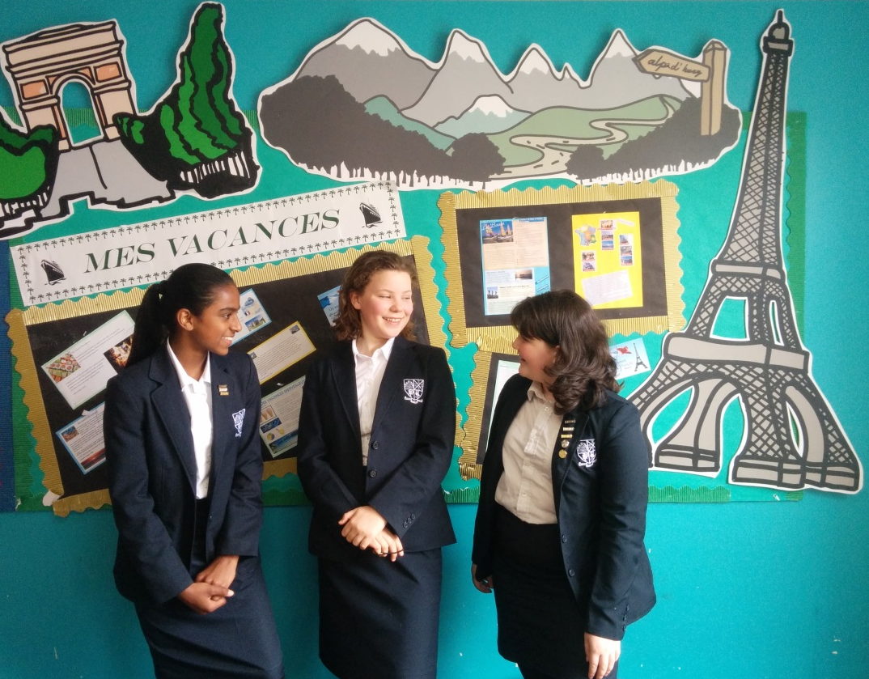

Applicant Information

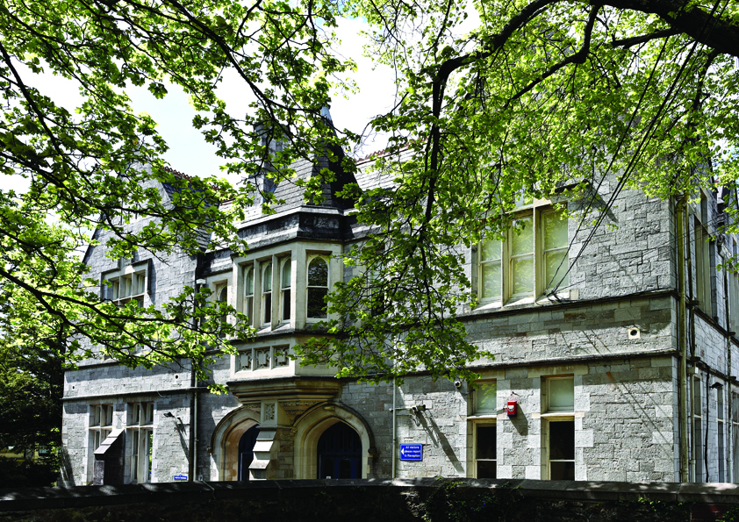

Teacher of French, with German

Permanent - Part time - Required from September 2018

Dear Applicant

I am delighted that you have shown an interest in the Teacher of French and German post at Plymouth High School for Girls and look forward to receiving your application.

Plymouth High is a truly exceptional school; students are challenged to achieve their best and they regularly do. We are very fortunate to work with young people who are gifted and eager to learn. At the heart of our work is a desire for all to achieve the highest possible academic standards and we ensure they are supported to achieve this.
We challenge and we support.

Our motto ‘For life, not school, we learn’ underpins all aspects of our work.
Students are given valuable learning experiences and opportunities beyond the classroom to support their learning and prepare them for the future. We want our students to develop a love for learning which they will continue throughout their lives.

There is much for us to be proud of at Plymouth High, and we are certain that you will see this when you visit. We very much look forward to receiving your application.

Yours faithfully

Mr Shaun Willis
Interim Headteacher

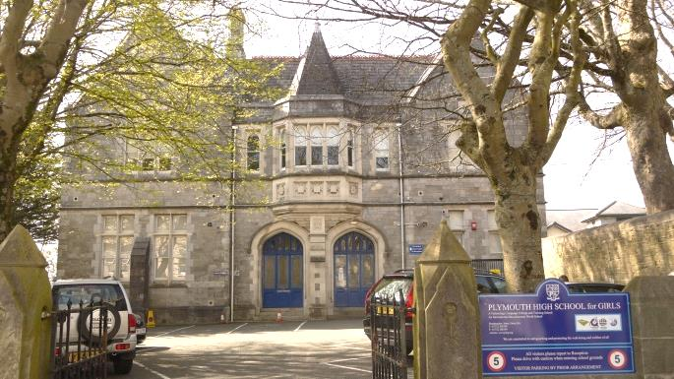
The School

Founded in 1874, Plymouth High School for Girls is a State selective Grammar school that builds on a long tradition of excellence.

Our motto “For Life Not School We Learn” is still relevant today and is at the heart of what drives us forward. It is reflected in the diversity of achievement across the school, which we proudly celebrate. In years 7 to 11 we have around 800 girls on roll. Our Sixth Form is open to both girls and boys and has grown in numbers to over 200.

Plymouth High offers a strong, supportive community, providing a sense of warmth and welcome within a safe, stimulating environment. We aim for our students to be confident, creative and caring young adults who are knowledgeable, inquiring thinkers and innovators. We expect the best from our students and are incredibly proud of their academic achievements.

As our motto indicates, we believe strongly that students should leave us with a real love of learning which will last for life. Our reputation is based upon high quality teaching, excellent support and guidance, and outstanding opportunities provided both in, and outside, the classroom. We give our students the highest level of individual attention they need to reach their goals. As a result the vast majority of our students go on to study at university, including Oxford, Cambridge and Russell Group Universities. The work ethic in the school is very strong, and both Staff and students are committed to the highest standard of teaching and learning.

We believe in the 3 Rs of respect, resilience and responsibility and all our girls, from the time they enter the school in year 7, are given opportunities to develop as leaders. We support every one of our students whatever their unique gifts, talents or needs so that they can achieve the highest standards academically whilst developing excellence in areas of their choice; our outcomes at both GCSE and A Level are indicative of this. Students move on from Plymouth High ready to take their place as active citizens in a global society with a lifelong love of learning

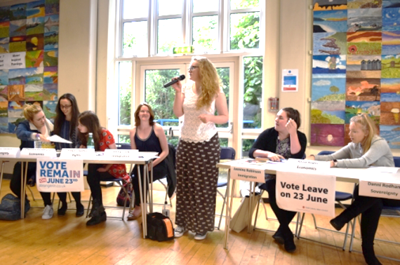
Vision
Plymouth High School aims to be an outstanding Grammar School for the
21st century; remaining true to the philosophy of the school’s motto
‘For Life Not School We Learn’.

A school which:
- Promotes a culture of high aspiration enabling personal and academic success.
- Prepares students to become confident, independent learners.
- Provides an outstanding education for all, the key to this being high quality teaching.
- Provides enjoyment, excitement and challenge for all, stimulating an enthusiasm for lifelong learning so that our students become active citizens, equipped to succeed in a world of rapid change.
Values and Beliefs
All our students are gifted, many with unconventional talents. Our aim is to seek out these gifts and talents, give direction and opportunity for them to flourish and to celebrate success. We are exceptionally proud of our students. They enjoy being at school, are bright and happy and bring unique talents to our community. Plymouth High School provides the freedom and security for our students to be themselves.

Our students:
- Can access a wide range of opportunities which enable them to follow their interests and aspirations.
- Can access a curriculum that is designed to ensure that all of our students experience a broad, balanced and relevant curriculum which is also flexible and evolving, able to meet the needs of all our learners and appropriate for the rapidly changing world in which they live and work.
- Are challenged to achieve their potential and attain the highest standards.
- Are treated as individuals. We support them as they grow into thinking young women, and caring, active citizens.

The Modern Foreign Languages Department

Accommodation
The Department is in one designated area in the main school building and comprises 6 classrooms, and one large shared office. There is a suite of computers in a room next to these classrooms and MFL has priority use of this room. All classrooms have a dedicated staff computer and projector with a white board. There are mini whiteboards, and a set of Chromebooks is available. The school has a large, attractive and central library which is very popular and has many resources.

Staffing
The Head of Modern Foreign Languages coordinates and supports all the language teachers and leads initiatives to develop new teaching strategies which will inspire and motivate students in order to raise attainment. There are 3 other members of the Department who teach French and German, The staff are all very experienced and usually teach at least two languages each. All staff take on a wide range of extra activities and play a strong supportive role as tutors. The departments meet regularly, either individually or together when appropriate.

Curriculum
In KS3
In year 7 main languages are French and German (2 classes of each)
There are 5, one hour lessons a fortnight.
In year 8 the top 2 sets take on the 2nd language, having 3 periods of their 1st language and 2 of their 2nd
The other 2 sets continue with their main language only
In year nine there are 6 periods a fortnight (where the top 2 sets have 3 of their 1st language and 3 of their 2^{nd)}
In KS4 the majority of students study a language and some study 2
There are 5 one hour lessons a fortnight for each language.
The current examination board is AQA
In KS5 we have a German class in each of Year 12 and 13 and share the teaching with DHSB whose pupils join our classes.
There are 7 one hour lessons a fortnight for A level.
The current examination board is AQA

GCSE and A Level results exceed national levels of attainment.

Activities
There is a long established German Exchange to Celle which takes place every other year. This exchange, which is aimed at years 9 and above) has been running for well over 40 years and all the department have taken part at various times in the past.
Every other year there is a trip for the younger years to Monschau, Germany, which is also supported by all members of the department.
In addition to these activities the members of the department also either support or run extra-curricular activities during the lunch hour.
Staff have also led, and taken part in, a wide variety of extra- curricular activities, and also in the trips which take place annually in the Curriculum Enrichment Week each July.

Job Description: Teacher of French, with German
Post Title: | Teacher of French, with German
Purpose | To teach subject as required.  To understand and uphold the values and practice of the professional code for teachers.  To improve teaching by evaluating it, learning from the effective practice of others and taking responsibility for one’s own professional development.  To have a secure knowledge and understanding of the subject(s) they are trained to teach.  To plan, prepare and teach courses and lessons to a high standard.  To have high expectations of all pupils.  To assess, record and report on the development, progress and attainment of pupils.
Reporting to | Head of Modern Foreign Languages
Liaising with | Other members of the Languages Department, as well as Head Teacher, Senior Leadership Team, department leaders, Student Services and relevant staff with cross-school responsibilities, relevant support staff, external agencies and parents/carers
Working time | Part time approximately 30 hours (0.6)
Salary/Grade | According to experience MPS or UPR
Disclosure level | Enhanced and Barring List

Duties and responsibilities

Professional values and practice:
- To have high expectations of all pupils; respect their social, cultural, linguistic, religious and ethnic backgrounds; and be committed to raising their educational achievement.
- To understand how pupils’ learning can be affected by their physical, intellectual, linguistic, social, cultural and emotional development.
- To treat pupils consistently, with respect and consideration and be concerned for their development as learners.
- To demonstrate and promote the positive values, attitudes and behaviour that they expect from their pupils.
- To communicate sensitively and effectively with parents and carers, recognizing their roles in pupils’ learning, and their rights, responsibilities and interests in this.
- To contribute to, and share responsibly in, the corporate life of the school.
- To value the contribution that support staff and other professionals make to teaching and learning.
- To improve their teaching by evaluating it, learning from the effective practice of others and take responsibility for their own professional development.
- To work within the statutory frameworks relating to teachers’ responsibilities.

Knowledge and understanding of the subject(s) the teacher is trained to teach:
- To have a secure knowledge and understanding of the subject(s) they are trained to teach.
- To know and understand the relevant national curriculum programme(s) of study for key stage 3 and where relevant the frameworks, methods and expectations set out in the national strategy and teach their specialist subject(s) competently and independently.
- To understand the cross-curricular expectations of the national curriculum and be familiar with the guidance set out in the national strategy.
- To teach their specialist subject(s) competently and independently at key stage 4 using, as relevant to the subject and age range, the national curriculum programmes of study and related schemes of work or programmes specified for national qualifications.
- To be aware of the pathways for progression through the 14 – 19 phase in school, college and work-based settings and know the progression within and from their own subject and the range of qualifications to which their subject contributes.
- To provide guidance and advice to pupils on educational and social matters and on their future education and future careers, including information about sources of more expert advice.
- To use ICT effectively, both to teach their subject and to support their wider professional role.

Teaching
- To have high expectations of pupils and build successful relationships.
- To establish a purposeful learning environment.
- To set challenging teaching and learning objectives which are relevant to all pupils in their classes.
- To differentiate teaching to meet the needs of pupils, including the more able and those with special educational needs.
- To plan and teach clearly structured lessons or sequences of work which interest and motivate pupils, making learning objectives clear to pupils; employing interactive teaching methods and collaborative group work; promote active and independent learning enabling pupils to think for themselves.
- To select and prepare resources, and plan for their safe and effective organization.
- Where applicable to plan opportunities for pupils to learn in out-of-school contexts e.g. visits, field work, museums.
- To set high expectations for pupils’ behaviour and establish a clear framework for classroom discipline to anticipate and manage pupils’ behaviour constructively, and promote self-control and independence.
- To provide homework and other out-of-class work which consolidates and extends work carried out in the class and encourages pupils to learn independently.
- To use appropriate range of monitoring and assessment strategies to evaluate pupils’ progress towards planned learning objectives.
- To monitor and assess as they teach, giving immediate and constructive feedback to support pupils as they learn.
- To assess pupils’ progress accurately using, as relevant, national curriculum level descriptions, criteria from national qualifications, requirements of the awarding bodies, national curriculum and foundation stage assessment frameworks or objectives from the national strategies.
- To record pupils’ progress and achievements systematically.
- To report on pupils’ attainment and progress orally and in writing, concisely, informatively and accurately for parents, carers, other professionals and pupils.
- To manage the work of teaching assistants or other adults to enhance pupils’ learning.
- To take part in, and contribute to, teaching teams, as appropriate to the school working collaboratively with specialist teachers and other colleagues.
- To advise and co-operate with the head teacher and other teachers on the preparation and development of courses of study, teaching materials, teaching programmes,
methods of teaching and assessment and pastoral arrangements.
- To take on the duties and responsibilities of an Academic Tutor as outlined in the Staff Handbook.
- To participate as required, in meetings at the school which relate to the curriculum,
organisation or pastoral arrangements of the school.
- The postholder must at all times carry out his or her responsibilities with due regard to the Authority’s Equal Opportunities Policy.
- Work at all times within the code of requirements of the Health and Safety at Work Act.
- The postholder must also undertake other duties which may reasonably be given to him / her by the Headteacher from time to time.

This post is subject to the conditions of the latest School Teacher’s Pay and Conditions
Document and Guidance on School Teachers’ Pay and Conditions.

Additional Duties
- To play a full part in the life of the school community, to support its distinctive mission and ethos and to encourage and ensure staff and students follow this example.

OTHER SPECIFIC DUTIES
Whilst every effort has been made to explain the main duties and responsibilities of the post, each individual task undertaken may not be identified. Employees will be expected to comply with any reasonable request from a manager/leader to undertake work of a similar level that is not specified in this job description.

Employees are expected to demonstrate high standards of professionalism; be courteous to colleagues and provide a welcoming environment for visitors.

Person Specification: Teacher of French, with German
 | Essential | Desirable
Qualifications | - well qualified graduate with appropriate  degree  - Qualified Teacher status | - evidence of continuing  professional development
Experience | - excellent subject knowledge  - ability to teach French at KS3, GCSE and A Level  - ability to teach German to KS4 | - experience of delivering INSET or  evidence of professional development  having impacted creatively in the  classroom
Knowledge, understanding  and skills | - good teaching skills and a willingness to  develop them further  - ability to motivate and enthuse, and be creative in teaching  - proven track record of working with able students, achieving positive outcomes  - thorough knowledge of course requirements for all Key Stages  - an understanding of the role of assessment, quality feedback, and student tracking systems in raising standards  - able to identify, using data those who need support and intervene appropriately and effectively to raise attainment  - evidence of good behaviour management  - good organisational and planning skills  - reflective of practice | - a commitment to celebrating students’ achievements, skills and talents, as well as an ability to tackle problems effectively  - an ability to bring new initiatives to the school  - creativity and adaptability  - thorough knowledge and understanding of current education issues national policies, priorities and legislation  - knowledge of IT and use of Google Apps for Education
General  Attributes | - an effective team worker with an ability to develop and maintain positive relationships yet also able to think and work independently and use initiative  - an ability to enthuse, motivate and support colleagues and students and build resilience  - an ability to work effectively under pressure and to deadlines  - willing to try new ideas and test their  effectiveness  - willingness to take on extra responsibilities to develop own career  - commitment to further professional  development  - a flexible approach  - willing to contribute to whole-school  initiatives  - Relates well to pupils, parents and professionals  - Displays an awareness, understanding and commitment to the protection and safeguarding of children and young people. | - a good sense of humour  - energetic and active in their teaching style  - a good communicator  - a willingness to be involved in the school as a community and to contribute to extra-curricular activities
How to apply
All applications should be made on the school’s application form which can then be submitted by email to jchalmers@phsg.org or by post to the school address. The form can be downloaded from the “Vacancies” section of the school website.

Please note that CVs and separate letters of application are not accepted as there is opportunity, and space, on the form to support your application.

Applications for this vacancy must be received by noon on 21st May 2018

If you would like to visit the school of have an informal discussion about the role please contact the Head Teacher’s PA to arrange this: Miss Joanna Chalmers, e-mail jchalmers@phsg.org, telephone 01752208308.
Further information is also available on our website, www.phsg.org or find us on Facebook,
@PlymouthHighSchoolforGirls

The school is committed to safeguarding and protecting the well-being and welfare of children and young people. The successful applicant must be willing to undergo child protection screening appropriate to the post, including checks with past employers and to undertake a DBS Enhanced Check.

