 |  |  | 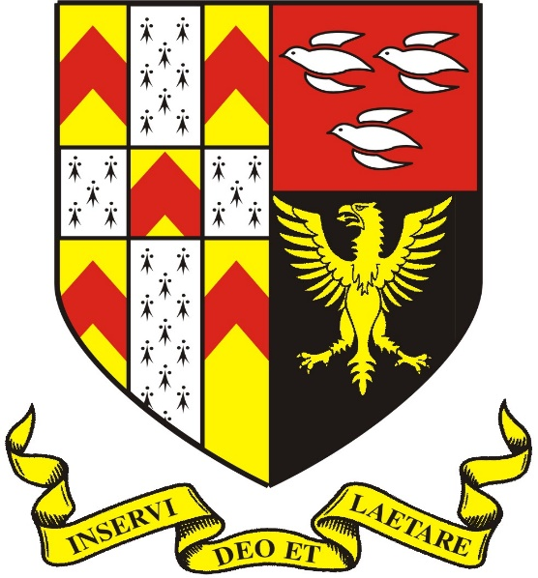
The Friary School

PROSPECTUS BOOKLET

The Friary School

PROSPECTUS BOOKLET

School Aims:

The Friary School’s mission statement calls for: “High achievement through challenge and support for every learner” and this objective is a focal point of everyday school life.

In addition we have ‘The Friary Ethic’ which sets out the six most important priorities for everyone at the school. These are tied into student presentations, assemblies, special events and were voted for by students and staff:

* FRIENDSHIP * ASPIRATION
* RESPONSIBILITY * RESILIENCE
* INDEPENDENCE * YOU

Letter from the Headteacher

Welcome to The Friary and thank you for considering our school for your next step in life. It is not so long ago that I came and looked around the school to see if it was the right place for me, so I can well understand how you are feeling as you make your choice.

Clearly, my choice was that The Friary was the best place. I was impressed by so much as I looked around that it became an easy decision to take on the post and to come to the school. Without doubt, since joining in September 2016, it is a choice that I have never regretted for a second.
 |  |  |  |  | School Name |  |  | Founded
 |  |  |  |  | The Friary |  |  | 1892
 |  |  |  |  | School Motto
‘Inservi Deo et Laetare’
‘Serve God and Be Cheerful’

 |  |  |  |  | Headteacher
 |  |  |  |  | Matt Allman
 |  |  |  |  | Chair of Governors
 |  |  |  |  | Jamie Checkland
 |  |  |  |  | Website
 |  |  |  |  | www.friaryschool.com

The friendly and enthusiastic students helped me to make my choice as I saw this was a school where students wanted to make friends together, work together and learn together. They have been positive about all of the exciting changes happening at the school and have demonstrated a real will to succeed. They are motivated to do well so that they have the best possible choices open to them when they move on at 16, or for most at 18.

Similarly, the teaching staff made my choice straight-forward as they were clearly passionate and committed in doing all they could to help every student to succeed. They wanted to try new things and to take on new ideas so that the school could get better and better. The established staff at The Friary are exceptionally strong and the new staff we brought in for September have fantastic potential. I am fortunate to work with them and their dedication and commitment to the school is ensuring it is one I grow ever more proud of everyday.

You would expect me to say good things about the school and to tell you how important the school is to me. Even so, I can assure you that I am genuinely excited about the chance of you coming to our school. I know that when you visit you will see a school with momentum, energy and drive. One where not only will you get the opportunity to succeed, but where everything will be put in your way to make you succeed.

Matt Allman
Headteacher
School Life Brainstorm

There are a million-and-one things to tell you about daily life at The Friary but if we describe it all here you will be reading for weeks and weeks.

Instead, here is a quick brainstorm of all the exciting venues, events, principles and themes that you can look out for with us:

THE FRIARY (LEARNING) FRAMEWORK… FOCUS WEEKS…
HOUSE SYSTEM … DUKE OF EDINBURGH… FINE DINING…
MULTI-GYM… PRIMARY SCHOOL TRANSITION PROGRAMMES… UNIVERSITY VISITS… SUMMER SCHOOL… SPECIAL NEEDS SUPPORT… UCAS GUIDANCE… ONLINE LEARNING… DANCE STUDIO… THEATRE… RAISING ASPIRATIONS PROGRAMME… SPORTS HALL… SIXTH FORM STUDY CENTRE… SUMMER SIZZLER… RAG MEETINGS… ORCHESTRAL TOURS… PROM… NATIONAL CITIZENSHIP SCHEME… SCHOOL CHOIR… GYMNASTICS… PHOTOGRAPHY… BOOK CLUB… SKIING TRIP… SWIMMING POOL… ICT FACILITIES… ACE MEETINGS… LIBRARY… MASTERCHEF… STEM… SATURDAY SCHOOL… APRENTICESHIP SCHEME… LEARNING HUB… SPORTS TEAMS… LEISURE CENTRE… JAZZ CLUB… INTERNATIONAL STUDENTS… SCHOOL SHOWS… MY FAIR LADY… CHARITY FUND-RAISERS… CAREERS ADVICE… UNIVERSITY PARTNERSHIPS… MENTORING SUPPORT… COMMUNITY PROJECTS… BATTLE OF THE BANDS… SCHOOL TRIPS - HOME & ABROAD… POTTERY… REWARDS SCHEME… CATHEDRAL LINKS… OXBRIDGE ACCESS SUPPORT… HOUSE / SCHOOL COUNCILS… ACCELERATED READING… LAMDA… HOMEWORK CLUBS… PTA… AND MUCH, MUCH MORE…

OFSTED Report (March 2014):

The Friary School was last visited by OFSTED in March 2014 and was judged to be a ‘GOOD’ school:

Leadership & Management | Teaching, Learning & Assessment | Personal Development, Behaviour & Guidance | Outcomes | Sixth Form
GOOD | GOOD | GOOD | GOOD | GOOD

Key comments included:

- The proportion of students achieving five or more good GCSEs including English & Mathematics at the end of Year 11 is now well above national average.

- Teaching is typically at least good and an increasing proportion is outstanding.

- Senior leaders and governors provide good leadership.

- Students report they feel very safe at the school… (and)… Behaviour throughout the school is typically good.
KEY INFORMATION

Admissions  In September 2018 the school will have 210 places available and applications should be made online at www.staffordshire.gov.uk/ admissions or by phone to 01785 278 593.  The School Day  The school runs with a 5 period day which allows us to deliver 27hrs 5mins teaching per week. The school days operates to the following schedule: |  |  |  | Behaviour  We operate a strong system of rewards and sanctions which helps us to maintain high standards of behaviour at school. It works well because it sets out clear expectations and boundaries, and offers a wide range of rewards for those who deliver.  Equally, the system succeeds because our parents support us in what we do; whether that be celebrating with their child as they receive certificates, reward trips or prom vouchers; or talking things through at home when they get comments in their planners, reports or detentions.  Attendance  We cannot help your child to succeed if they are not in school so we have a minimum expectation that every student will be in school at least 95% of the time.  There are occasions when children are not in a position to come to school, and we look to support you at this time. Even so, we use a mixture of rewards, targets and tutor mentoring to make sure your child meets their 95% target.  Equally, we set clear standards on punctuality and again offer a mix of rewards and sanctions to maintain standards.  Safeguarding  The school’s Lead Safeguarding Officer is Mr Ian Rose (Deputy Headteacher) and the Deputy Safeguarding Leads are Mark Drury (Assistant Headteacher) and Steve Neale (Hub Support).  The school takes its safeguarding responsibilities very seriously, ensures we train our staff to a high level and liaises with outside agencies to make sure our students are kept safe.  Our strong provision is maintained by an annual external review to keep us up-to-date and on our toes.
8.45-9.10 | Tutor Time | We run a 2-week timetable (Week A & Week B) as this allows us to fit more into our curriculum and our enrichment period brings a wide range of clubs and active-ities for all ages throughout the school year.
9.10-10.10 | Period 1
10.10-11.10 | Period 2
11.10-11.30 | Break
11.30-12.30 | Period 3
12.30-1.05 | Lunch
1.05-2.05 | Period 4
2.05-3.05 | Period 5
3.05-4.30 | Enrichment
The Student Planner

Every student is provided with their own planner and this is a central pillar for school information, personal planning, homework and home-school communication.

We encourage every student to take great pride in this resource and ask all parents to check and sign it on a weekly basis.

School Uniform

All students are expected to wear full school uniform at all times and to demonstrate pride in their appearance. This includes the controlling of jewellery and extreme hairstyles.

We are fortunate that parents are very supportive in maintaining uniform and, whilst teenagers can try to push the boundaries, we are able to hold a firm and consistent line with our parents behind us.

Curriculum  The school provides a broad and balanced curriculum that thoroughly prepares every student for their exams and life outside of education.  Key Stage Three (11-14) sees a focus on English & Maths but includes learning skills programme, a modern foreign language, traditional academic subjects, and practical subjects including Science, Sport, Design, New Technologies and Performing Arts.  Key Stage Four (14-16) sees a pathway approach designed to steer all students of differing abilities to fulfil their potential. This ranges from Triple Science to withdrawal support, and Masterclasses to high-quality vocational courses.  Sixth Form  The school has an excellent Sixth Form housed in a recently re-furbished Sixth Form Study Centre. The curriculum offers a mixture of A-Level and Level 3 BTEC courses which steer students to university, higher-level apprenticeships or gainful employment.  In addition, Sixth Formers benefit from an extensive enrichment programme which includes Extended Projects, Sports Leaders, Duke of Edinburgh Awards, Young Enterprise, LAMDA and much more.  Aspirations  Every school says they want students to aim high and hit those heights. However, our school informs students every single step of the way and through our wide-ranging Raising Aspirations Programme we seek to avoid hoping for a success, but rather making a success.  This may involve targeted careers talks, parent events, mock job interviews, university trips, apprenticeship programmes or external mentors. Every support is given every time. |  | Personal Guidance  We have a full Personal, Social, Health & Economic Education programme which runs via tutors and ‘drop-down-days’ and covers a wide range of themes ranging from enterprise to sex education, decision-making to self-awareness, healthy choices to careers.  In addition, we have a clear Focus Week programme for tutorials and assemblies which brings fun and imagination to school life. Last year saw bush-tucker trials, pedalling for smoothies, peace competitions for tablets and European face-painting !  Extra-Curricular  We recognise the crucial importance of academic success at school but also seek to capture that primary feeling of: “You’ll never guess what I did at school today”.  Extra-curricular clubs are in abundance at the school and we seek to ensure that every student has the chance to develop their own unique areas to shine. It could be one of the numerous sporting teams, or on the stage of a school show, or in a band or orchestra. It could be computer programming, or being a student leader, or a charity fund-raiser. It could be skiing down a mountain, or ploughing through a Flanders trench, or admiring a Gaudi masterpiece in Barcelona.  Flying high in exam results is vital, but so is flying high in life.  Local Community  Our school prides itself for being at the heart of the local community and we run numerous events to tie into our special city. This could be a fund-raiser for a local charity, carol singing, a service at the cathedral or work with local businesses.  It is the norm to see our city inside our school: from the Rotary’s Interact Club to The George Hotel, from mock job interviews to local university reps, and local primary schools to community support teams.

The Friary Framework  The school operates a clear and consistent system for learning that means your child will enjoy high-quality lessons and a clear learning structure every step of the way.  This package is backed by top-level academic research, is externally verified and is supported by a full training programme so that teaching standards consistently improve in all subject areas. It includes a Plan-Do-Review Cycle which carefully checks that students understand their learning and a student-friendly marking system which tells them how to improve their work.  Homework  We believe that homework is an important part of making sure that students understand their classroom learning, as well as a great opportunity to independently broaden their knowledge and expertise after-school.  Our homework is tailored to support all abilities and is backed up by online materials after-school homework clubs, study support and Saturday School.  Saturday School  Last year, we opened our doors for our new Saturday School (Saturdays 10.00am-12.00pm from February to June) for targeted exam and coursework groups, as well as for general study and homework projects.  The sessions are run in non-school uniform, include refreshments, and at the busiest times see over 100 students voluntarily in school at the weekend boosting their grades.  Parent Communication  Naturally, parents receive formal reports from the school about their child’s progress, but we prioritise a genuine dialogue by working face-to-face to ‘make’ your child succeed.  These meetings run throughout the year and will provide access to class teachers, tutors, pastoral staff, senior staff and governors. |  | Student Support  We have a dedicated team working to support your child on every step of their journey through The Friary.  This team offer a wide range of back-up; ranging from medical care to organisational support and personal education to 1-to-1 mentoring.  Beyond this team, we have the Learning Hub which is a specialist facility targeted at supporting KS4 students in successfully negotiating their GCSEs and provides the personalised support which allows every student to thrive.  Special Educational Needs & Disabilities (SEND)  Every student with specific learning needs benefits from our Class Support Plan package which ensures that each lesson offers them personalised support which is tailored to their individual needs.  This in-class support is backed up by Teaching Assistants, withdrawal programmes for literacy and numeracy, and social and emotional workshops to support day-to-day dealings with others.  The SENCO at the school is Louise Mayland and she can be contacted via school reception.  Student Leadership  The school values the voice of its students and works hard to ensure that they have a genuine say in the development of the school.  Consequently, we have dedicated House Councils which filter into a whole-school Student Council. On top of this structure we have a Sixth Form Leadership Team which includes a Head Boy and Head Girl. Elsewhere, we have charity, sport and anti-bullying reps.  Not only do these student leaders voice their ideas for school improvement but the system also develops skills in decision-making, team-building and assertiveness.

Exam Results Summer 2017

This summer saw strong results across the school and, though there is always room for improvement, there was much to celebrate, and far more tears were of happiness rather than of despair.

Year 11 Results - Summer 2017 - Headline Measurements

The Summer 2017 results saw improvements in both English and Maths with the key measurement of ‘Progress’ seeing English results coming in well above expected progress, whilst Maths results were in line with expected progress:

Measurement | School | National
Progress 8 | +0.312 | -0.03
GCSE English (9-7) | 27.8% | Above
GCSE English (9-4) | 78.3% | Above
GCSE Maths (9-7) | 18.1% | In Line
GCSE Maths (9-4) | 70.2% | In Line
English & Maths (9-7) | 12.4% | In Line
English & Maths (9-4) | 68% | In Line

Year 13 Results - Summer 2017 - Headline Measurements

The Sixth Form measurements are again based around progress and our students achieve very, very similarly to neighbouring schools and get positive grades against their ability on entry:

Measurement | School | National (2015)
Progress Score for Academic (Eg - A-Levels, EPQ, etc) | + 0.02 | In Line
Progress Score for Vocational | + 1.04 | Above
Progress onto Post-18 Placement | 100% | Above

* NB - If you wish to compare local schools go the DfE Performance Tables via Google - you will see we compare well.

Summer 2017 - Headline Grabbers

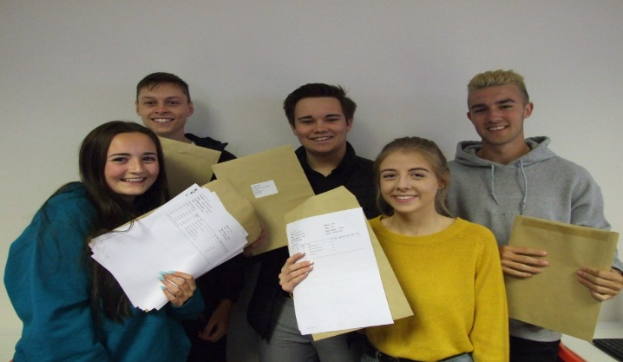  Sixth Form students grab the grades to take them to top universities and apprenticeships across the UK. |  | 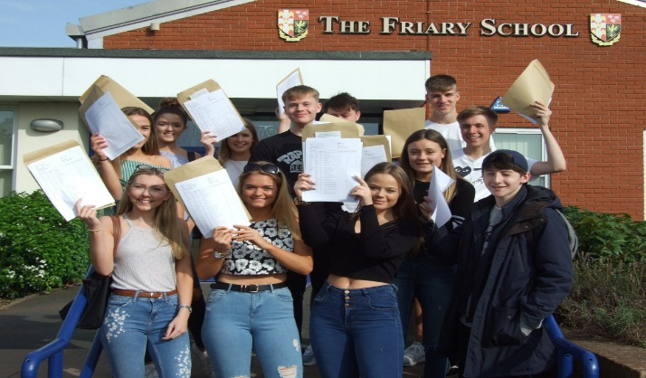  Y11 students grabbed results that compare well with the very best in Staffordshire and we are thrilled many are now in our Sixth Form.
NEW FOR 2017-2018

House System

Many years ago The Friary School operated with a House system and we have brought this idea back to bring more energy, competition and fun into school life.

Our students voted on the new House names and came up with famous people attached to Lichfield: Darwin, Garrick, Johnson and Seward. They then went on to decide House colours, House leadership roles, House trophies and House charities.

All students are placed in a House group and benefit from the same Head of House throughout their time at the school meaning parents have a consistent contact. The House will play a central part in competitions, rewards, rivalries and special events. Even so, not all assemblies are House ones and not all classes are taught
in House groups, especially as students move up the school.

We are all very excited about the new House system and it has rapidly become an integral part of school life. If you join our school then you will very much be signing up for the House system ride.

The Friary Ethic

We wanted to convey a simple message to everyone - students, staff and parents - on exactly what was important at our school: what we considered to be the crucial values that everyone should seek to deliver on a day-to-day basis. This would then become our ‘Friary Ethic’.  Students and staff were presented with different ideas and a vote was held across the school and we came up with our FRIARY values. These are writ large around the school site, in planners, in assemblies and in tutor times. They are what we all hold dear and what we seek to model in all we do.  If you join our school then we would ask you to buy into our Ethic. |  | FRIENDSHIP
 |  | RESPONSIBILITY
 |  | INDEPENDENCE
 |  | ASPIRATION
 |  | RESILIENCE
 |  | YOU

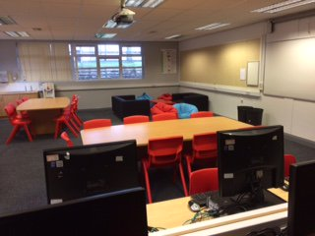  The new SEND facilities are purpose-built to meet the specific needs of our students. |  | SEND Facilities  The Friary School takes great pride in seeking to address the needs of every student - whether they be an academic flyer or a student struggling with literacy and numeracy.  Our new SEND facilities have been designed in-house so that they provide the learning facilities to raise standards for those students with Special Educational Needs & Disabilities and is open for homework and support clubs.  Additionally, the facilities are available for lunch-times for students who feel more nervous amidst the hustle-and-bustle of daily school life.
NEW FOR 2017-2018

Sixth Form

Our Sixth Form already remains a popular choice and is a real strength which compares very well with other local providers. This year will see a further extension of the Raising Aspirations programme - not (like many others) just talking Oxbridge - but rather all post-18 routes whether it be Cambridge (with our Oxbridge support work), Derby or a Higher-Level Apprenticeship.  Additionally, our varied extra-curricular programme now includes partnership work with the PTA and local businesses and the Saturday School provision is increasingly plotting in Sixth Form support to tally with the new mix of academic and vocational routes |  | 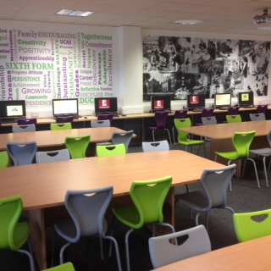  Our refurbished Sixth Form Centre is open from 8.00am-4.30pm daily.

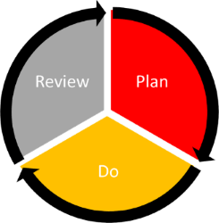 |  | Learning to Learn  All Year 7 students will benefit from a Learning to Learn programme when they join the school. We have a specific way of structuring lessons called ‘The Friary Framework’ (see website) and we recognise that students learn better if they understand where the teacher is coming from in terms of their delivery.  This includes our Plan-Do-Review (PDR) Cycle, our marking and assessment system, and our approach to questioning. Learning at secondary level is different to primary level and, just like when you step into any new job or field, you need to have the training and guidance to fit in and succeed.

After-School & Extra-Curricular Provision

The Friary School has a superb track record in extra-curricular and after-school learning - whether it be regular success in regional and national sporting competitions, or stunning shows and recitals in school and even overseas.

This provision extended last year with Saturday School and a range of external providers - including Superstar Academy and Premier Sports last year.

Our restructured school day - with an earlier 3.05pm finish - was partly set up to allow extra-curricular activities to flourish when there is pressure on the school curriculum to solely focus on academic pursuits. We have no less focus on learning and exams, but we will not countenance pulling out of the activities that make a more rounded child. This year our programme will be extended by More Able Clubs, extended library opening hours, SEND Homework Clubs and more external providers, such as a Dance Academy.

LOOKING AHEAD

Further Building Renovations  The arrival of a new Headteacher in 2016 coincided with a commitment to a major re-development of school facilities.  Last Autumn saw the unveiling of a brand-new Sixth Form Study Centre, the creation of a Learning Hub to provide support for KS4 students, and the refurbishment of three Maths classrooms, and as promised this was just the beginning.  Since then there has been a major overhaul of the site and as you tour the building you will see huge improvements, but there is more to come. |  | 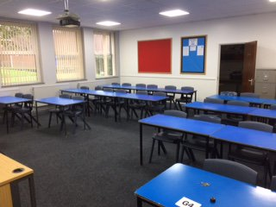  The classrooms are on a rapid cycle of refurbishment across the school site.

Certainly, if you join our school you can expect the facilities to be first-rate and revitalised on a regular basis so there is a reliance on you to take care of our environment and to respect what our site does for you.

Curriculum Development

Our curriculum remains very fluid - especially with the DfE changing Key Stage Four and Sixth Form courses and requirements on a very regular basis - but we are retaining a curriculum model which maintains the strong academic traditions of the school, but also provides a wide range of vocational pathways to support all students in wholly fulfilling their potential.

This will always include courses in the major growth sectors in the UK economy including creative technologies, design, social care and business management.

Further down the school, we will always focus on our learning skills programme to enhance students’ study skills and personal organisation so that they are well-prepped to flourish as they enter their exam courses in later years.

Academy Status  Stafford Local Authority has echoed the government’s plan for all schools to move towards academy status in the near future.  The Friary School is investigating all options and is committed to maintaining the special ethos and standards of the school, whilst also developing the wider partnerships and peer support to continue to maintain the highest education standards for every student.  All parents will be kept up-to-date with developments and any changes will include a full consultation with all stakeholders. |  | All local schools that have not yet converted to academy status are actively exploring their options.

APPLYING FOR A PLACE AT THE FRIARY

Applying as a New Year 7

If you are applying to start as a Year 7 at the beginning of the academic year then all applications must go through the Local Education Authority (LEA).

The main application process is done online at www.staffordshire.gov.uk/ admissions or they can be spoken to by phone on 01785 278 593.

Historically, The Friary School has accepted students from a wide range of primary schools and several of these have been outside of the direct catchment area of the school; for example in recent years, new Year 7 students have arrived from the following:

* Chadsmead, Lichfield | * Chancel, Rugeley | * Chase Academy, Cannock
* Chase View, Rugeley | * Christchurch, Lichfield | * Etchinghill, Rugeley
* Abbots Bromley School | * Gentleshaw, Rugeley | * Greysbrooke, Shenstone
* Hayes Meadow, Armitage | * Henry Chadwick, Hill Ridware | * Highclare School, Birmingham
* Hob Hill, Rugeley | * Lichfield Cathedral School | * Little Aston Primary School
* Western Springs, Rugeley | * St Joseph’s, Rugeley | * Redbrook Hayes, Rugeley
* Scotch Orchard, Lichfield | * St Peter & St Paul's, Lichfield | * St Chad's, Lichfield
* St James', Longdon | * St Joseph's, Lichfield | * St Mary's, Colton
* St Mary's The Mount, Walsall | * St Michael's, Lichfield | * St Peter's, Stonnall
* St Stephen's, Fradley | * The Croft, Armitage | * John Bamford, Rugeley
* Four Oaks Primary School,  Sutton Coldfield | * Mere Green Primary, Sutton  Coldfield | * Whittington Community,  Whittington
* Willows, Lichfield

Applying Mid-Year or as a New Year 8-11

If you are applying for any other age group at any point in the school year then applications must come directly into the school.

The application form is available from the Local Education Authority (LEA) via the link above. Copies of the application form are also available from the school office.

Application Support

If you require any support in completing your application, or wish for an application to be considered then please contact Mrs Charlotte Hearn (Assistant Headteacher) via School Reception on 01543 267 400.

The Friary School,  Eastern Avenue,  Lichfield,  Staffordshire,  WS13 7EW.  Telephone - 01543 267 400  Website - www.friaryschool.com |  | 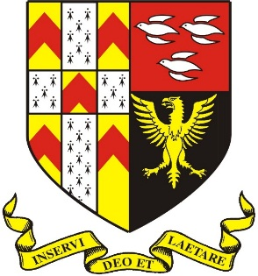

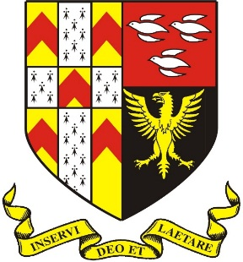

The Friary School, Eastern Avenue, Lichfield, Staffordshire, WS13 7EW.
Telephone - 01543 267 400

