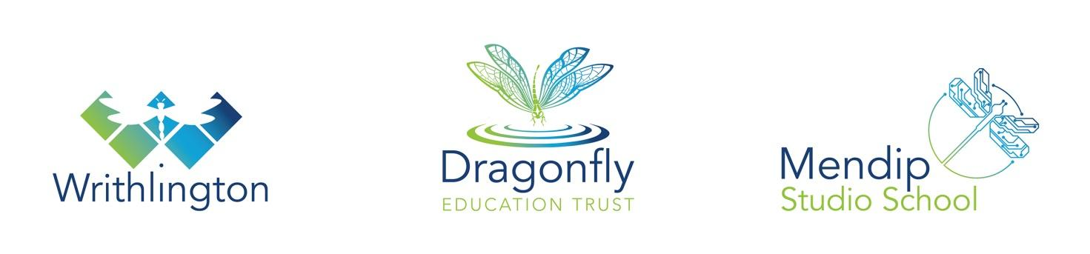

Dragonfly Education Trust

Dragonfly Multi Academy Trust incorporates Mendip Studio School, Writhlington School, and Peasedown St John Primary School. Mendip Studio School and Writhlington School are located on a large modern state of the art campus. Writhlington is a very successful secondary academy with a history of excellent outcomes for learners. Mendip Studio School began in September 2015 and now has 190 students on roll with a STEM specialism. Dragonfly Sixth Form is the largest in the authority with over 300 students and average grades of ABB at the end of Year 13. The Trust coordinates all education provision and ensures that there is a complementary range of courses in the 14-19 age range with good progression for all learners. There are very strong cross-institution academic and pastoral arrangements and at Sixth Form level a strong partnership enables all students to follow any combination of subjects across both Mendip and Writhlington Schools, allied to an Extended Project Qualification.

Mendip Studio School will provide high quality academic provision focusing on STEM subjects, allied to specialist project work with our key industry partners. We are supported by the James Dyson Foundation, ScienceScope, Advetec, The Eden Project, The Royal Botanical Gardens, Kew and Cambridge University along with a number of other high profile organisations. Specialist facilities in the new buildings will replicate industry provision and enable high quality research to be carried out by students.

Department Information

The department is housed in a suite of rooms comprising of

- two specialist ICT suites
- Food/Catering room
- textiles/electronics workshop
- two multi-material workshops

In Key Stage 3 students are involved in project based teaching and learning involving a full range of experiences across the different specialisms of Control Systems, Electronics, Product Design, Textiles, and Food. This allows students to develop a range of skills and competences in a curriculum that is both relevant and engaging.

In Key Stage 4 students have the opportunity to develop their skills further and to specialise in areas of particular interest. GCSE is offered to students of all abilities and has a keen uptake in the Design and Technology. We also offer Level 2 Catering and Hospitality and Engineering.

At KS5 we offer A’level Design Engineering and Product Design. Our results at KS5 are outstanding and uptake is growing every year.

Our specialist rooms and workshops are well equipped and resourced allowing students to access a wide range of specialist industry standard equipment and CAD/CAM/3D Printers with technical support by well qualified and experienced Technicians.

Currently the department has:

- Subject Leader
- An Industry Partner Teacher who works with students one day per week
- Teacher with responsibility for Control Systems
- Two Teachers multi-skilled to teach any of the disciplines through to KS4 and KS5
- Teacher with responsibility for Food
- Three Specialist Technicians

