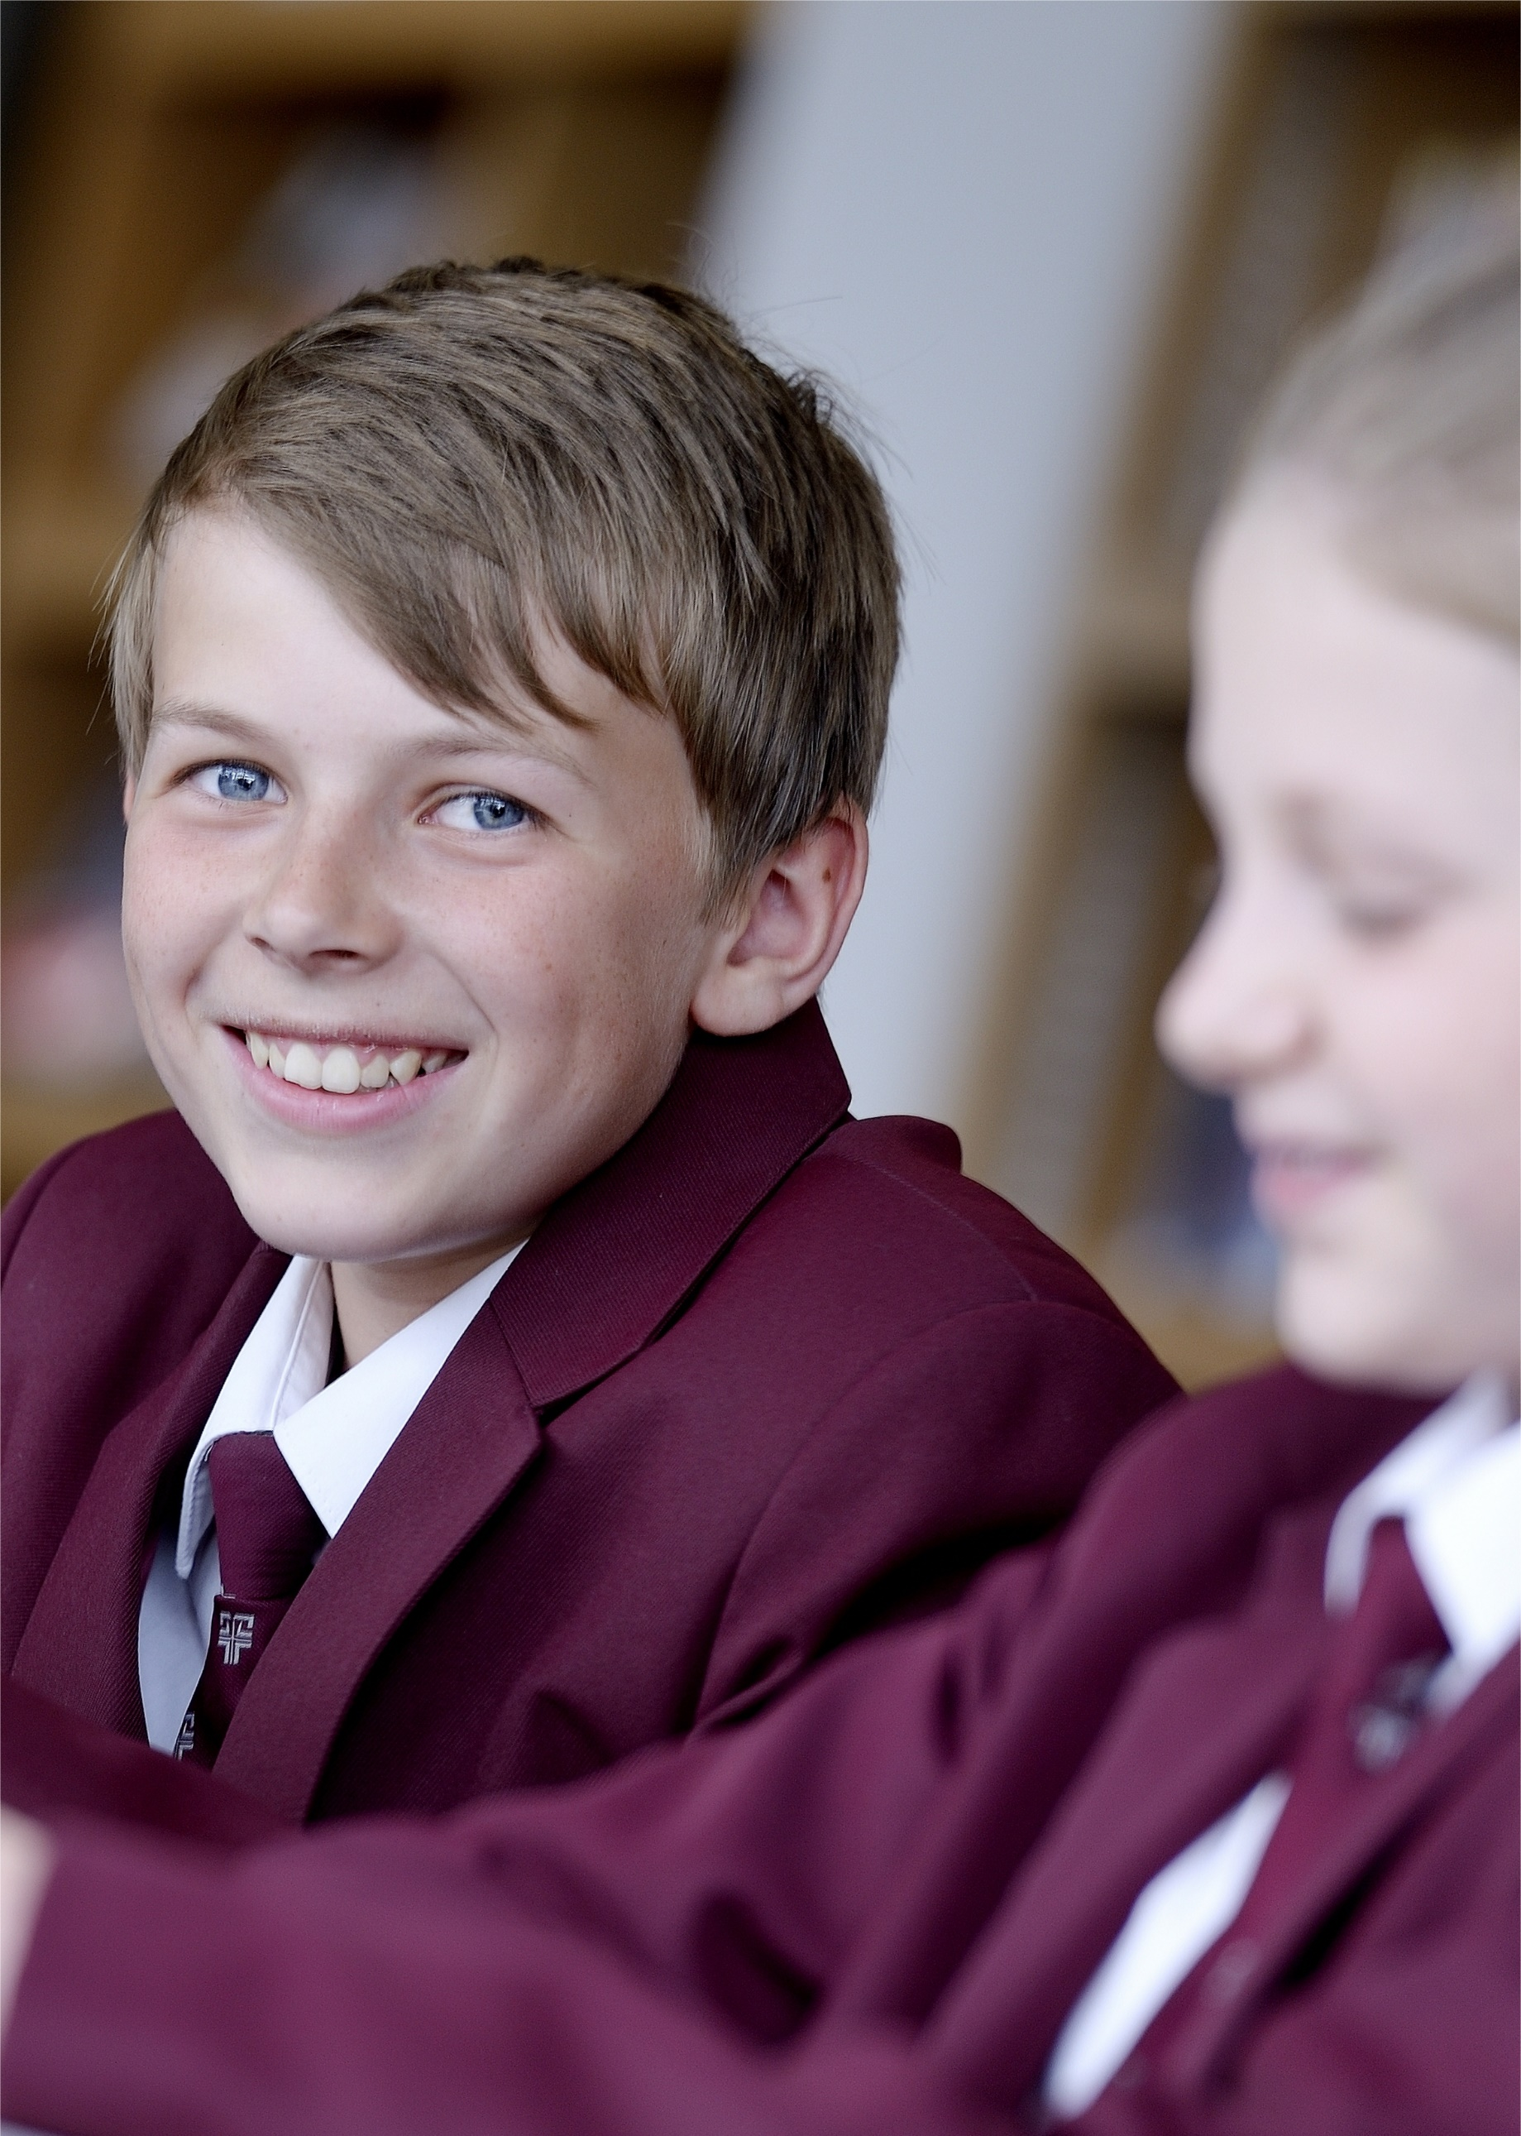
St Michael’s Church of England High School
A Church of England Academy

Excellence within a Christian context

Pupil Engagement Coordinator: Wellbeing
Candidate Information
Therefore, choose
Thank you for your interest in the position of Pupil Engagement Coordinator: Wellbeing currently being advertised at St Michael’s CE High School, a Church of England Academy.
Letter from the Headteacher
St Michael’s is a special place to learn and work with a strong Christian identity. Our mission statement is:
As a vibrant learning community
we choose to serve God
pursue excellence
and
celebrate the uniqueness of each individual
We aim to achieve this mission through a Christian learning experience which focuses on opportunities for growth in body, mind and spirit:-
Where the safety, happiness and wellbeing of pupils are paramount. Where every child matters and more crucially, know that they matter.
Body

High expectations and aspirations in all areas of school life create a disciplined and ordered learning environment where creativity, passion and enthusiasm help to engender a life-long love of learning and secure excellent pupil outcomes.

Mind

Where pupils are supported to find for themselves the person that God wants them to be and really experience the joy and hope of ‘life in all its fullness’.
Spirit

As a thriving, oversubscribed Church of England Academy within the Diocese of Blackburn, our values are rooted in the Christian faith. Serving God, pursuing excellence and celebrating the uniqueness of each individual are at the heart of our distinctive ethos as we strive to ‘be the best that we can be’. We create and sustain our caring Christian community by encouraging positive supporting relationships based on Christian values and striking a genuine balance between the highest academic standards and opportunities for personal growth.
Worship is at the centre of our school life and is usually led by various staff, the Christian Youth Worker and/or pupils, with occasional support from local clergy or visitors. The school Chapel Choir (Hughes Tutorial) and the school Worship Band are regularly involved in worship helping to create a contemporary vibrant experience. Each day begins with a year group worship, assemblies and school prayers. In addition we hold Eucharist services in the school chapel throughout the year both at the start of the day and at lunchtimes. These services are led by various members of the local clergy who are always willing to support the school.
The chapel in the magnificent Armstrong Centre is also used for staff prayers and reflections which take place at the start of each working week. We hope that the school’s distinctive Christian ethos shines through in all aspects of our life and work here. We have numerous student leadership roles within school and an active charities committee. Each year group within school is linked to a particular charity.

The person appointed will play a full and active part in the pastoral life of the school working alongside the pupil managers, the senior teacher for wellbeing and the pupil engagement coordinator for behaviour. All staff take responsibility for behaviour and wellbeing around school on a day to day basis and model the qualities and Christian values we believe are important for self- worth, respect, responsibility and stewardship.
St Michael’s has been in the top 10% of non - selective schools nationally for attainment for the last four years. In 2017 89% of pupils achieved 5+A* - C/ 9 - 4 grades including English and mathematics. However, we are not complacent and are ambitious for further success because of the real life chances these results bring for our pupils.
We want all at St Michael’s to ‘be the best that they can be’. We are confident that our pupils are provided with a rigorous and productive learning environment where they are both challenged and supported. We have talented, dedicated, caring and dynamic staff who are willing to develop innovative approaches to learning and teaching for our young people, provide outstanding care and guidance and support our distinctive Christian ethos.

I hope the information provided on our website gives you a clear flavour of our ethos, of what to expect at St Michael’s and also helps you to prepare for the application process.
I look forward to receiving your application.
Yours sincerely
Jayne Jenks
Mrs Jayne Jenks
Headteacher

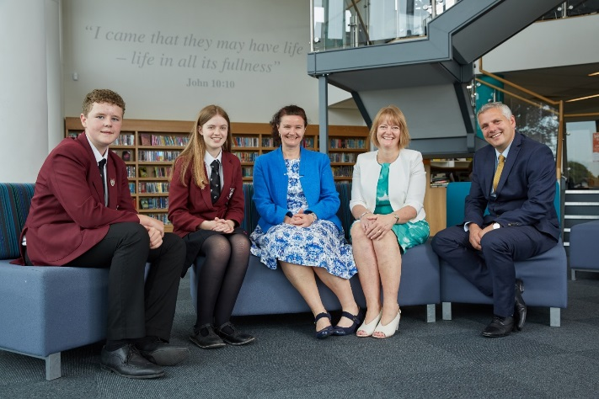

Information about the RE Department Department

Information about the Pastoral System

Pupil Wellbeing
The wellbeing of our pupils is given the highest priority at St Michael’s. We know that for pupils to learn they need to feel happy and be safe. A growth mindset and emotional resilience are promoted, encouraging pupils to live fulfilled and contented lives. The importance of friendship and healthy, active lifestyles is actively promoted. The school works in partnership with parents and outside agencies, where necessary, to encourage pupils to fully embrace the opportunities available to them.
The pastoral team of staff is led by the Deputy Headteacher: Wellbeing. He is supported by a Senior Teacher: Wellbeing, who is also a Pupil Manager. Each year group in school is led by a Pupil Manager, all of whom are teaching members of staff. The Pupil Managers work alongside the two Pupil Engagement Coordinators (one focusing on wellbeing and attendance and one on behaviour), the SENDCo and the Christian Youth Worker.

The Tutorial System
On entry to the school pupils are placed in tutorial groups with an individual tutor; these groups are seen by their tutor each morning. Pupils normally remain in their tutorial groups for their five years at the school. Our most talented singers and instrumentalists from Years 9-11 form Hughes tutorial group and take part in many acts of worship.
The tutor maintains an overview of the progress of each child across the curriculum and delivers the Living Education programme. He or she is in a unique position to ensure that each child is happy, making good progress and contributing to the life of the tutorial and the wider life of the school. The tutor is normally the first person to contact with issues about a child. Through the daily interactions in the tutorial group and the Living Education programme tutors promote the core values of the school and encourage pupils to live within a Christian framework based on respect for others and personal integrity.
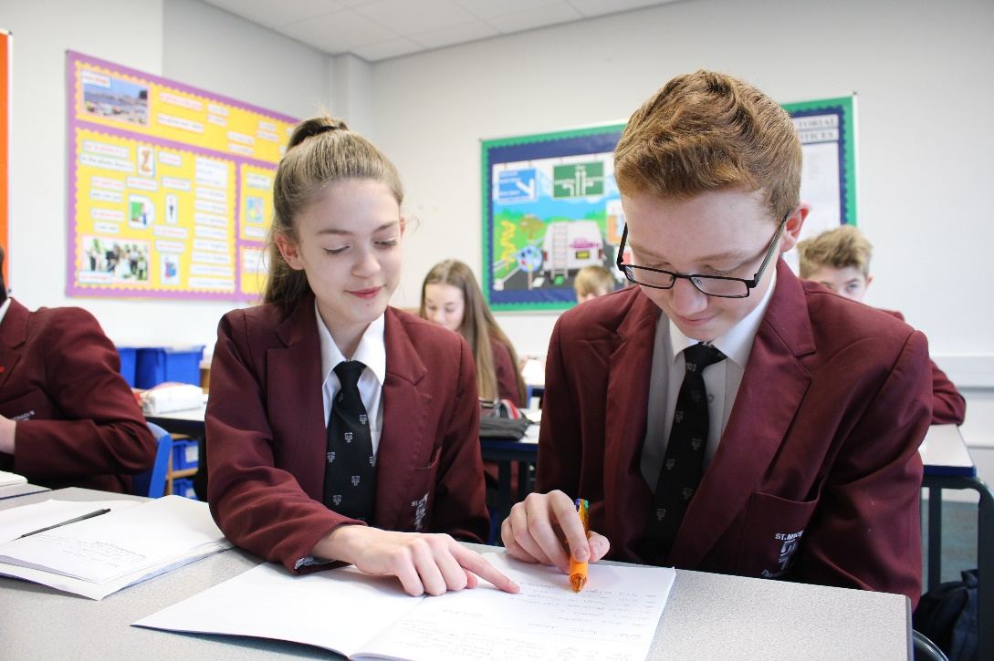
Each tutorial has a 'patron' who is a person, living or deceased, who embodies the Christian ethos and way of life. Tutors are managed by Pupil Managers who have performance as a key focus of their work.

Behaviour for Learning
We believe that children learn best in a disciplined, safe and secure learning environment. Children have the right to learn and teachers have the right to teach without disruption. Everybody has the right to dignity and personal respect. We have very high standards of pupil conduct and disruptive behaviour is not tolerated at St Michael's. Pupils are encouraged to do their best and hard work is recognised in departments and at a whole school level. Praise and encouragement go hand in hand with fair and firm discipline. The ePraise reward system commends pupils for their good work or kind deeds.

Bullying
In keeping with the Christian ethos of St Michael’s CE High School Academy, it is the aim of the school to eliminate all types of bullying. We strive to:
- provide a secure environment for the physical safety of pupils and staff;
- provide emotional security where the uniqueness and intrinsic worth of pupils and staff as valuable members of God’s creation is recognised;
- ensure that pupils have a sense of belonging;
- instill confidence and facilitate a healthy, happy and social learning environment where pupils can enjoy their learning and do the best that they can.
We strive to be fair and just and are vigilant and responsive to bullying behaviour, working alongside parents and carers to give support, counselling, and guidance to victims and transgressors alike. Direct action reminds pupils that all forms of bullying are totally unacceptable and will not be tolerated at St Michael’s.

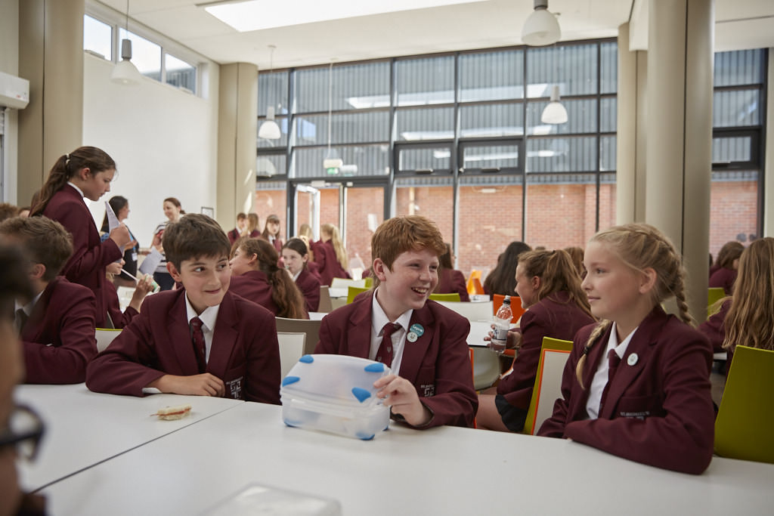
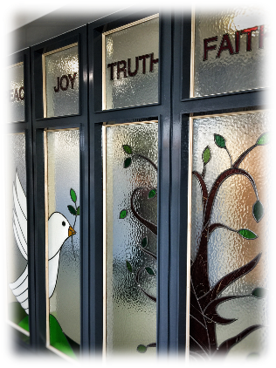
Letter from the Governors

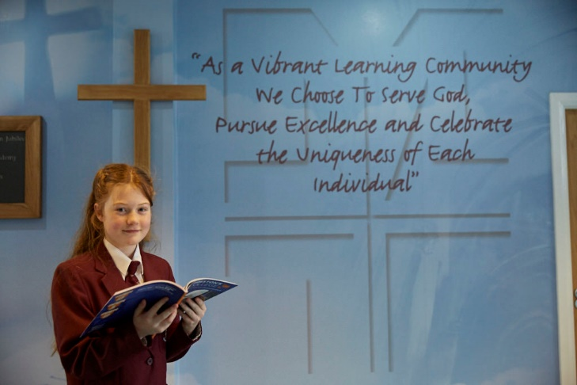

Thank you for requesting details for the post of Pupil Engagement Coordinator: Wellbeing at St Michael’s Church of England High School.

Most of the information you will need is displayed on the school website. However, the governors are proud to emphasise the ‘outstanding’ Ofsted inspection in 2009 and ‘outstanding’ SIAMS inspection in 2014. This was achieved by a whole school community approach of teachers, pupils and governors working together.

The strong academic, sport, and performing arts record is supported by the active Christian ethos apparent throughout the school; providing the opportunity for pupils to grow in body, mind and spirit. Staff focus on continually raising attainment, encouraged by inspiring, forward thinking leadership and management.

The governors will expect the successful applicant to continue to further the excellent achievements, enrichment activities and vision of the school and to support our distinctive Christian ethos.

Thank you for your interest and I look forward to hearing from you.

Yours sincerely

Mr C M Metcalfe
Chair of Governors
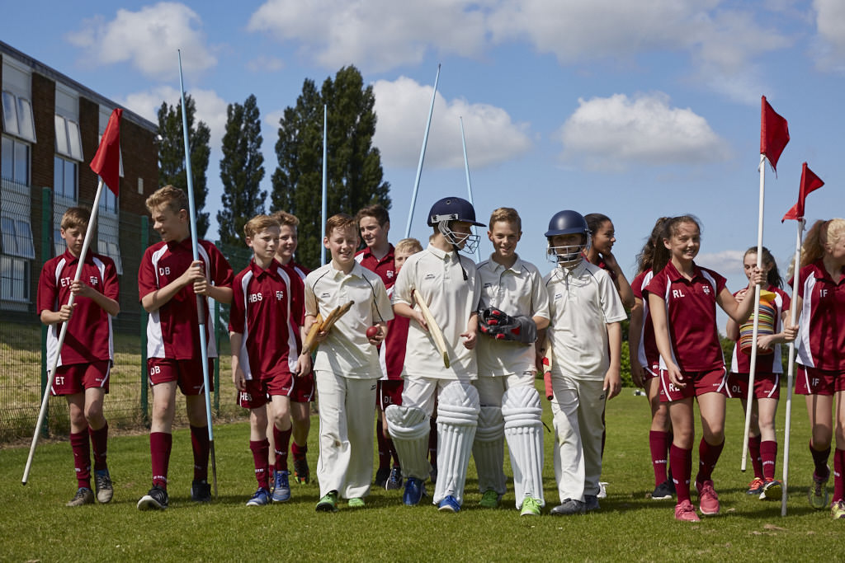
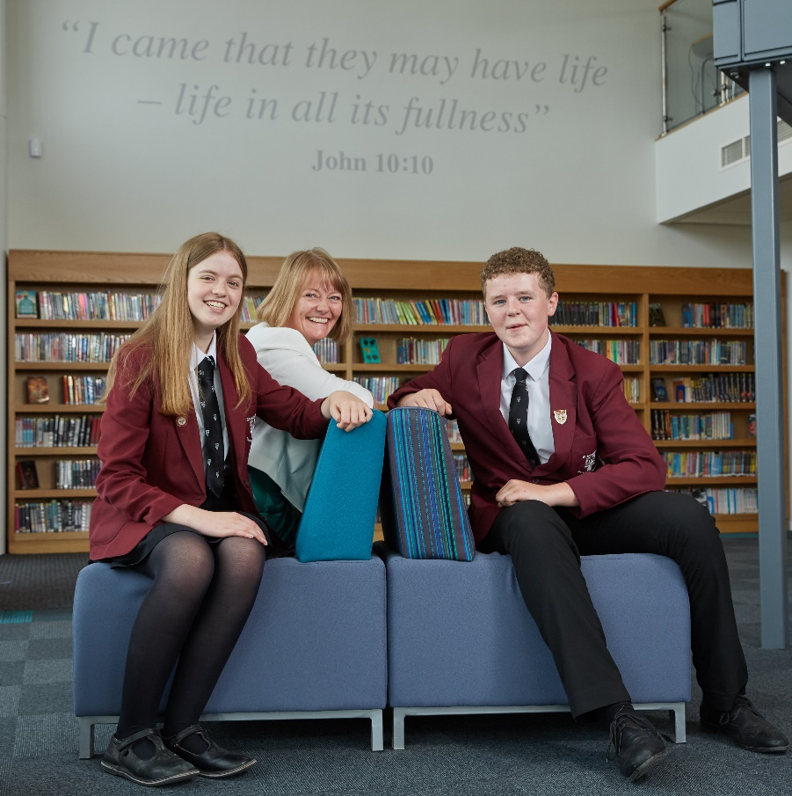
Head Girl and Head Boy Letter of Welcome
We appreciate your interest in the role of Pupil Engagement Coordinator: Wellbeing at St Michael’s Church of England High School. St Michael’s is an outstanding school with exceptionally high standards, allowing pupils to develop both academically, physically, spiritually and socially.
‘Team St Michael’s’ is a significant phrase used within our school life. The ‘team’ encompasses parents, pupils, staff and governors, who all work closely together allowing pupils to, “be the best that they can be”. This ‘team’ helps create a strong pupil teacher relationship which is necessary to create mutual respect and a sense of community. Exceptional examination results already demonstrate that this is in place.
Christianity is at the heart of all that happens at St Michael’s. ‘Excellence within a Christian context’ is the school’s philosophy and this can be seen throughout school. At St Michael’s, pupils’ faith in Christianity is developed and encouraged. Each year group has a weekly worship, tutorial worship and prayers every morning and Christian values are embedded within lessons, helping to produce a compassionate environment.

St Michael’s Church of England High School really is a fantastic place to learn. Pupils experience engaging and productive lessons, which challenge and support us.
‘Celebrating the uniqueness of each individual’ is another key focus, which is already well integrated into school life. We hope the member of staff appointed will be passionate and enthusiastic and eager to become part of ‘Team St Michael’s’.

Yours sincerely
Emily and Lewis
(Head Boy and Head Girl 2017- 2018)

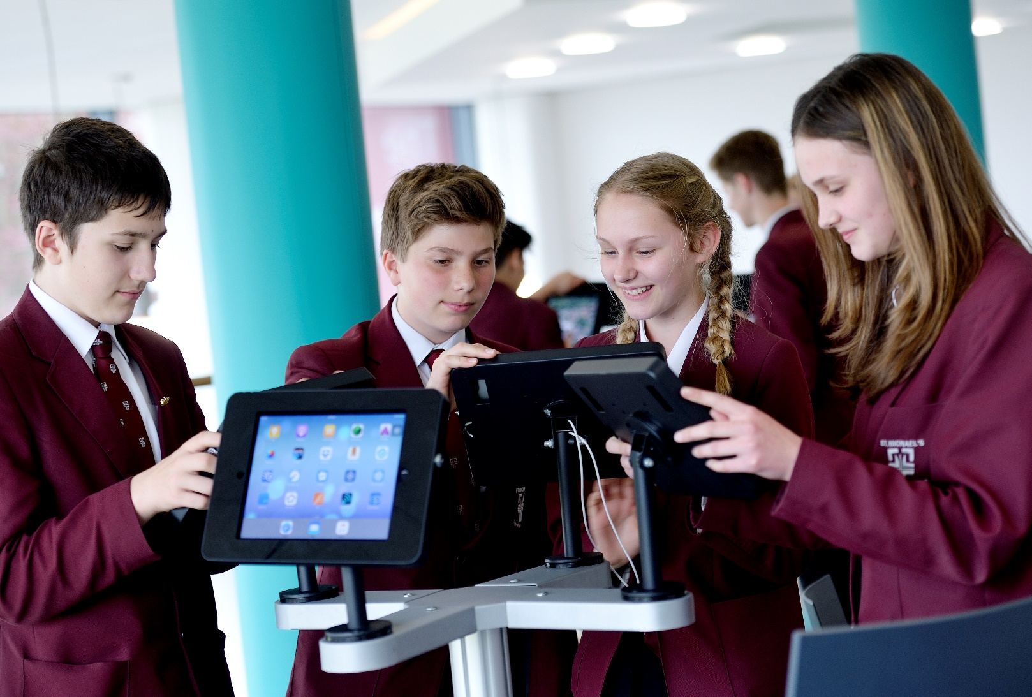
Application: Supplementary Information
Pupil Engagement Coordinator- Wellbeing
Full time, term time plus INSET.
37 hours per week, 39 weeks per year
Grade 7 (£23 935- £27 395 pro rata)

Applicants are asked to provide a fully completed application form and a supporting letter (no longer than 2 sides of A4 in length in Arial point 12) that clearly sets out how your
experience to date prepares you for the advertised post (with reference to the enclosed
person specification).

Closing date for the receipt of completed applications: Wednesday 18 April at 09.00

Interviews: Week commencing: Monday 30 April

Applications should be returned by email to: vacancies@saint-michaels.lancs.sch.uk

Applicants will be asked to produce original certificates for all education qualifications stated in the application form prior to the appointment being confirmed. All appropriate safeguarding and attendance at work checks will be requested.

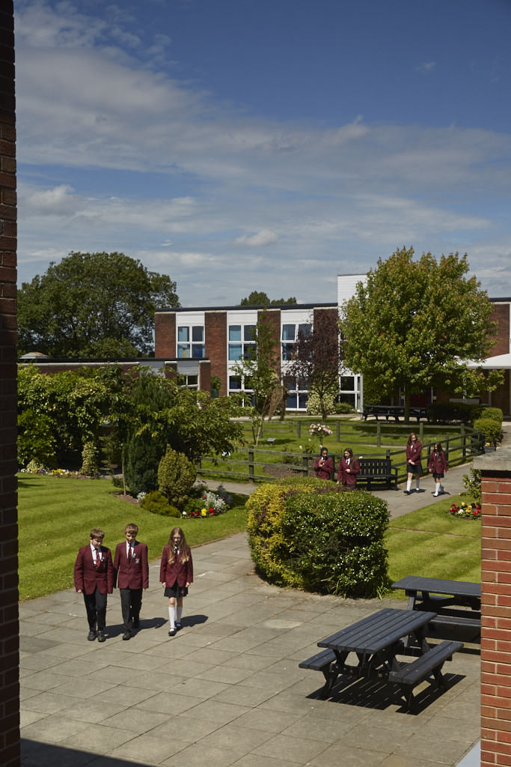
The applicant will be required to safeguard and promote
Pupil Engagement Coordinator: Wellbeing
Person Specification/Selection Criteria
the welfare of children and young people and be faithful to the trust deed.

Note: Candidates failing to meet any of the essential criteria will automatically be excluded
Section A Qualifications, Experience and Professional Development
Training and Qualifications
5 GCSEs at C or above or equivalent, including Maths and English | E | A
Educated to GCE A level or equivalent | E | A
Qualification in relevant children’s services e.g. Diploma in Social Work, Level 4 NVQ, Teaching or Youth Work | D | A/I
Educated to Degree level or equivalent | D | A
Professional Development and Experience
Experience of working with children/young people and/or families within an education or social work setting | E | A/I
Working with vulnerable young people | D | A/I
Working within a multi-agency setting | D | A/I
Section B Professional Knowledge, Skills and Understanding
Emotionally intelligent | E | A/I
Excellent listening and interpersonal skills with an ability to communicate/engage with a range of people showing sensitivity to pupil’s needs | E | A/I
Ability to provide clear professional advice to parents/carers, school staff and other professionals on matters relating to behaviour and wellbeing in school e.g. chairing TAF meetings and liaising without outside agencies. | E | A/I
Ability to work effectively as part of a team, but with the initiative to work independently | E | A/I
Ability to work flexibly and under pressure | E | A/I
Resilience and ability to manage and prioritise workload | E | A/I
Ability to prepare and present reports for staff including Pastoral Support Programmes and Common Assessment Framework forms | E | A/I
Excellent organisational and time management skills | E | A/I
Excellent ICT Skills | E | A/I
Ability to demonstrate a commitment to the Equal Opportunities policies in practical terms in the context of service delivery, employment issues and commitment to customer care practices | E | I
Section C Personal Skills and Attributes
Fully supportive of the Christian ethos of the school | E | A/I
Commitment to equality and diversity | E | I
Commitment to health and safety | E | I
Enhanced DBS Disclosure will be required | E | A/I
Ability to maintain confidentiality and discretion at all times. | E | A/I
Driving license and car | D | A
Smart appearance in accordance with the school dress code | E | I

Section D: Confidential References and Reports

Positive and supportive faith reference from the priest/minister where the applicant regularly worships | D
Positive recommendation from all referees, including current employer | E

KEY
E = Essential
D = Desirable
A = Application
L = Lesson Observation
I = Interview
R = References

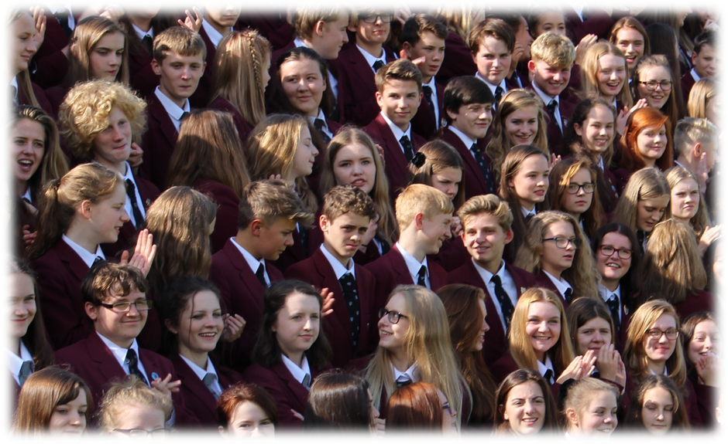

Job Description for Pupil Engagement Coordinator: Wellbeing

Person Specification/Selection Criteria

Responsible to: Senior Leader and Deputy Headteacher: Wellbeing

Our mission statement:
As a vibrant learning community we choose to
Serve God
Pursue Excellence
and
Celebrate the uniqueness of each individual

Under the direction of the Senior Leader and Deputy Headteacher: Wellbeing

- To work in partnership with Pupil Managers, Pupil Engagement Coordinator: Behaviour, Christian Youth Worker and the Senior Leader: Wellbeing to ensure the safeguarding, wellbeing and positive behaviour of pupils throughout the school so that they can ‘be the best they can be’.
- To assist Pupil Managers by occasionally leading assemblies to support the wellbeing and personal development of pupils throughout the school. (See Pupil Manager Job Description)
- To manage the school inclusion unit for a limited time each day. (This is led by the Pupil Engagement Coordinator: Behaviour for the majority of the week)
- Maintaining accurate records of emotional wellbeing and behaviour, tracking patterns and liaising with parents as appropriate.
- Be aware of and comply with safeguarding policies and procedures relating to child protection, health and safety including online safety, confidentiality and data protection, reporting all concerns to the appropriate person.
- To take a lead role in monitoring and improving attendance and punctuality throughout school, supervising the work of the attendance officer, liaising with pupil managers and tutors, parents and outside agencies as appropriate. Arrange meetings, parenting contracts and if necessary, undertake home visits in order to investigate/ assess difficulties and to facilitate contact between home and school.
- To analyse attendance data and produce reports for SLT.
- To be a ‘highly visible’ member of the pastoral team before the start of the day, during lessons, break and lunch times and at the end of the school day.
- To create and support effective home/school partnerships liaising with external agencies as appropriate.
- Communicate with parents to facilitate effective support programmes for pupils.
- Be a first port of call for parents when they call into school without appointments, to meet with them, take note of concerns and action as appropriate.
- To act as mentor to individual pupils and to monitor, review and report on their progress.
- To support all staff in maintaining a positive learning environment.
- Be proactive around school in maintaining high standards of behaviour.

Pastoral wellbeing

- Under the direction of the Deputy Headteacher / Senior Leader, assist in the monitoring of behaviour, maintaining up to date records and reports.
- Implement established programmes of support (e.g. Anger Management / Emotional Wellbeing / counselling) with individuals and/or small groups of pupils as appropriate.
- Support the Deputy Headteacher in the creation and implementation of Common Assessment Framework forms (CAF) liaising with parents and other agencies where appropriate.
- Liaise with the Deputy Headteacher / Senior Leader, and as appropriate, external agencies eg Wellbeing, Prevention and Early Help Team regarding pupils, taking appropriate action as required:
- Investigate incidents fully
- Ensure the completion of accurate student / staff reports
- Assist in implementing restorative justice/mediation work as required
- Assist Pupil Managers in managing students ‘on report’.
- Assist in resolving relationship issues between pupils.
- Organise and participate in study support, lunch time activities and after school sessions as appropriate.
- Assist Pupil Managers in the preparation of documentation and maintain accurate minutes of meetings.
- Promote more effective learning through the development of improved behaviour and social skills.
Supporting the school

- Be supportive of the Christian ethos of the school.
- Attend and participate in meetings as required, before and after the school day.
- Have the ability to work flexibly and effectively as an individual and team member.
- To take a proactive response to Continual Professional Development and be willing to undertake further training if required. e.g. Counselling courses, Mental Health First Aid, DSL training.
- Participate in training, other learning activities and performance development as required
- Assist in the supervision, training and development of staff in relation to the wellbeing of our pupils.
- Any other duties commensurate with the duties/ responsibilities/ grade of the post as reasonably requested by the Headteacher.
Whilst every effort has been made to explain the main duties and responsibilities of this role in school, each individual task undertaken may not be identified. Employees will be expected to undertake work of a similar level which is not specified in this job description.

This job description will be reviewed on an annual basis and following consultation may be changed to reflect or anticipate school, local and national changes in the job requirement which are commensurate with the job title and salary grade.

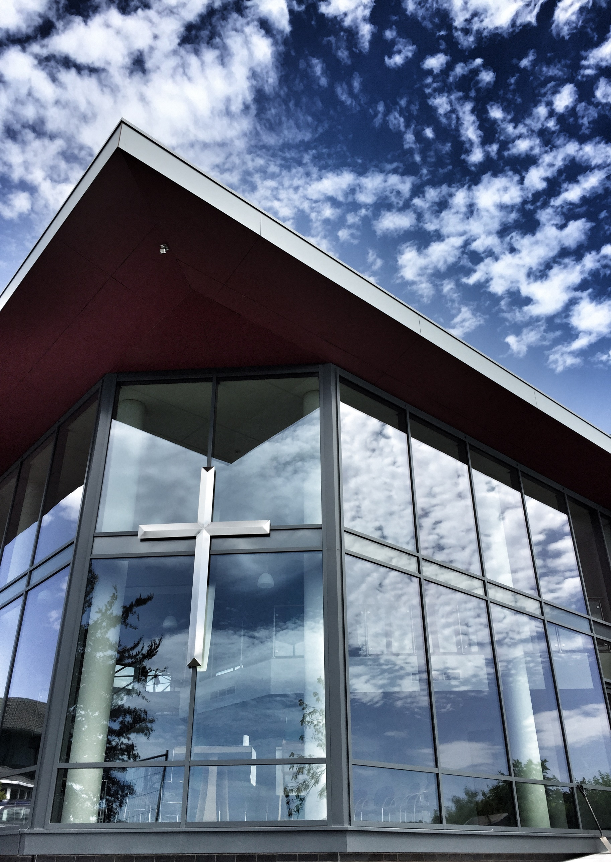
Therefore, choose
St Michael’s C.E. High School
A Church of England Academy
Astley Road
Chorley
Lancashire
PR7 1RS
Tel. 01257 264740
www.saint-michaels.com

