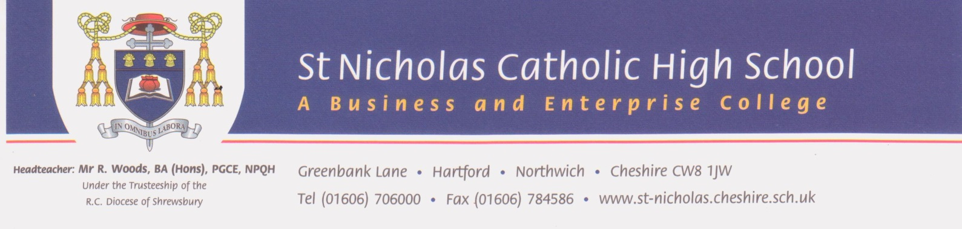
28 March 2018

Dear applicant,

Thank you for your interest in the post of Assistant Subject Leader of Religious Education at St Nicholas Roman Catholic High School.

This is an exciting time for us as we look to further strengthen our flourishing R.E. department here at St Nicholas. We are an excellent Catholic school with a fantastic reputation for the very highest of standards, outstanding students who are eager to learn and exceptional staff who walk the ‘extra mile’ to ensure that every student in our care lives life and lives it to the full.

We are looking to appoint an Assistant Subject Leader of Religious Education with a
passion and vision for learning and teaching in RE across all Key Stages - a highly effective practitioner who will make a difference by inspiring a love of learning in their students. The successful candidate will join a forward thinking and forward looking department who are keen to build upon the many successes within the school’s recent ‘Outstanding’ Section 48 monitoring visit. As a practising Catholic, the successful candidate will be fully committed to the principles and mission of Catholic education.

If you feel that you have what it takes to deliver our vision, please send your applications either via the TES website, by email to h.hughes@st-nicholas.cheshire.sch.uk or by post for the attention of Miss Hannah Hughes. The deadline for applications is Wednesday 25th April at 12 noon, shortlisting 27th April and interviews scheduled for the week commencing 30th April. Tours of the school are available on appointment via Mrs Vicky Hill, PA to the Headteacher at v.hill@st-nicholas.cheshire.sch.uk.

I do hope you will apply for this exciting post which will be excellent preparation for possible future leadership roles. I look forward to receiving and reading your application and I thank you for your interest in St Nicholas RC High School.

Yours sincerely

Richard Woods
Headteacher

