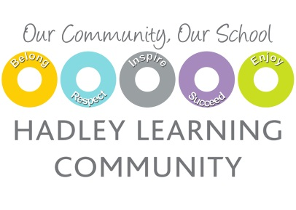

TEACHER OF ENGLISH

MPS/UPR
Required from September 2018

Hadley Learning Community (HLC) is a £70 million school that opened in September 2006 in Telford, Shropshire. The campus consists of a primary, secondary and special school housed within a very unique all through school. The school is fully inclusive and the secondary school is a specialist Engineering College.

In our most recent Ofsted, the school was graded as ‘Good with many Outstanding features’ with the highlight being comments on the outstanding care, guidance and support to all of our students. We are currently placed fourth in the country for the progress our students make which represents the truly amazing staff we have at HLC. The staff and students of HLC take great pride in the superb facilities and work harmoniously together to produce a ‘can do’ culture of high expectations.

We are seeking to appoint an innovative and inspiring teacher of English to join our forward thinking secondary phase from September 2018. This post is suitable for both experienced and newly qualified Teachers.

This is an exciting opportunity for a dynamic, ambitious and energetic individual to teach key stage 3 and 4 and ensure that learning at HLC is exciting and our young people are engaged and motivated to strive for excellence.

You will have use of our health and fitness centre, four-court sports hall and 25-metre indoor swimming pool. We have a nursery on site which several staff use to support their childcare provision. All staff are issued with laptops and our building is fully wireless.

Closing date for applications: 23rd May at 9:00am, Interview will be held 24th May

For an application pack or more information, please contact Veronica Croft at HLC on:
T: 01952 387010
E: veronica.croft@taw.org.uk

