KIRKLEES METROPOLITAN COUNCIL
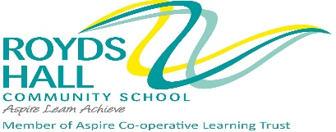
SERVICE- CHILDREN AND YOUNG PEOPLE
PERSONNEL SPECIFICATION

POST TITLE : TEACHER OF FRENCH with SPANISH (MPS) ROYDS HALL COMMUNITY SCHOOL
ATTRIBUTES | ESSENTIAL | DESIRABLE | HOW IDENTIFIED
RELEVANT EXPERIENCE | - Successful French/Spanish teaching or teaching practice experience | - Involvement in the development of innovative approaches to the teaching of French/Spanish | Letter of application  References
EDUCATION AND TRAINING | - Qualified teacher status  - A degree or equivalent qualification in French/Spanish or a related subject area  - A willingness to undertake professional development in the French/Spanish subject specialism(s). | - Recent relevant in-service training | Application form  Application form  Interview  References  Letter of application
SPECIAL KNOWLEDGE AND SKILLS | - Must be able to demonstrate a thorough knowledge of French/Spanish teaching.  - Must have a high level of computer literacy.  - Must be an effective teacher, skilful in communicating with individuals and groups and an ability to relate well to children. | - Willingness to be involved in extra-curricular activities | References  Interview  Application Form
ANY ADDITIONAL FACTORS | - Must be confident, flexible, enthusiastic, approachable and able to inspire others.  - Ability to work as part of a team. |  | Interview  References

