Appointment of

Teacher of Computer Science

For September 2018

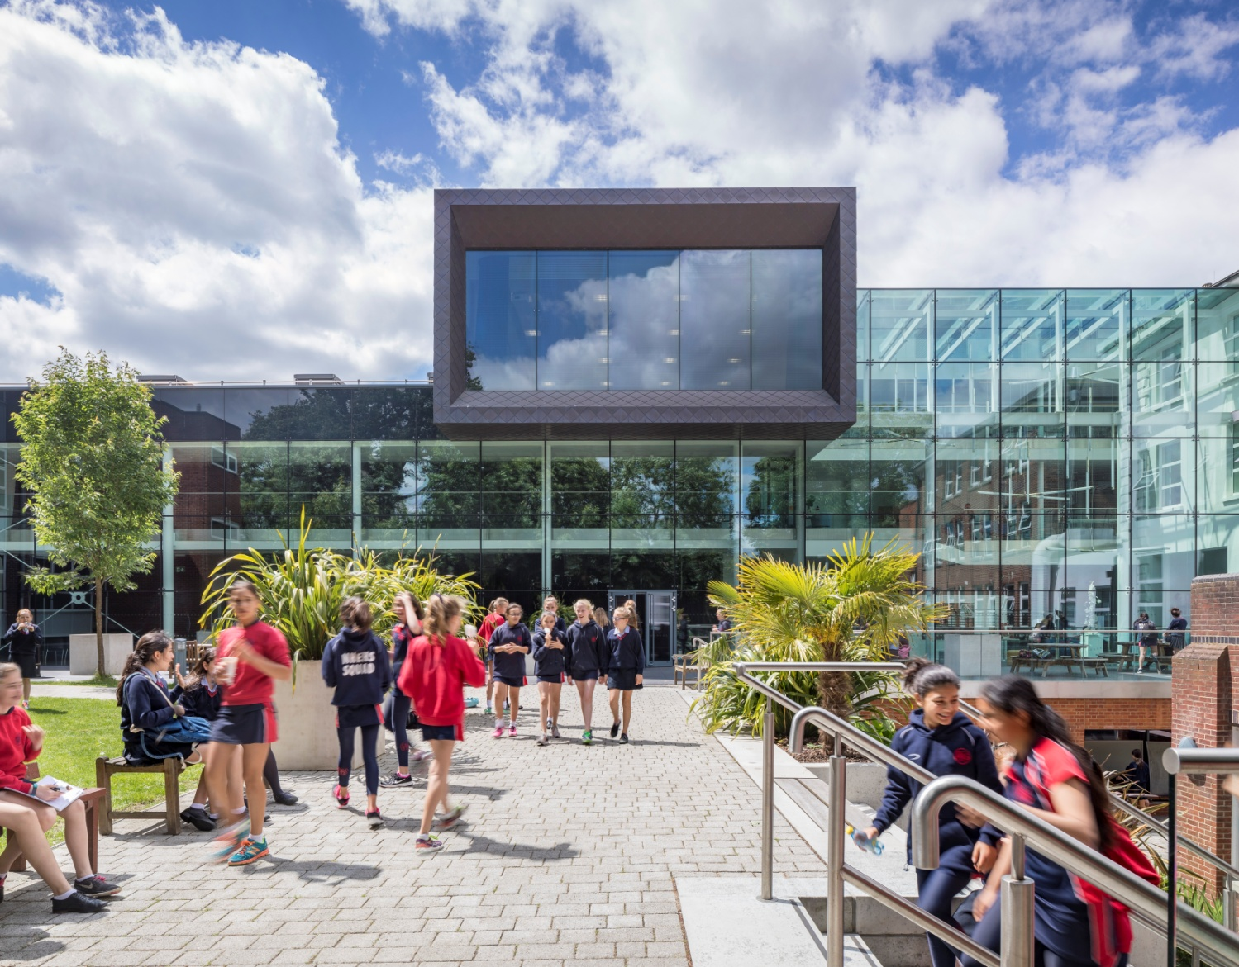

“Teaching here is all about being able to have in-depth conversations with students about your subject and helping to enthuse them with the same passion as you have. Teaching at NHEHS is exactly what I imagined teaching would be like when I got my first teaching job; it’s what teaching should be!”
Liberty: joined NHEHS in September 2017 as a Head of Department
Notting Hill & Ealing High School is one of London’s leading independent girls’ day schools. Founded in 1873 it is the oldest of the 25 schools which make up the Girls’ Day School Trust (GDST) having begun life in Notting Hill and moved to Ealing in 1930. We are an all through school (ages 4-18). Around 300 girls in the Junior School and 600 in the Senior School, including 150 in the Sixth Form, make up a friendly and welcoming community. The Junior and Senior Schools occupy their own parts of the site and in day-to-day terms operate independently. We occupy a site in suburban, leafy, west Ealing with excellent transport links. (We are an easy walk or bus ride from Ealing Broadway or West Ealing stations: District and Central underground lines, mainline trains and Crossrail from 2018.) The school is oversubscribed and a very popular choice at all ages with girls joining us from most parts of West London as well as areas further afield.
NHEHS is an academically selective school. Our girls are ambitious, bright, enthusiastic and eager to learn. In our latest ISI inspection we achieved the highest possible grades across the board and the inspectors noted that ‘the quality of the pupils’ achievements and learning is exceptional.’ Public examination results are consistently outstanding and girls go on to study a wide range of subjects at prestigious universities including Oxbridge. (Latest results and the university destinations of Leavers can be found on our web site.) The school is highly regarded for the way it achieves its outstanding outcomes within a particularly warm and supportive environment, and pastoral care and achieving the best for every girl is at the heart of everything we do.
About the GDST
GDST schools share an ethos and heritage of girls-only education and are members of a unique network which adds value to each school, student and member of staff. Networking opportunities with other teachers across the Trust enable staff to share best practice and develop initiatives that benefit all our schools and students. In addition to supporting the work of individual schools in supplying excellent induction and development opportunities for staff, the GDST network provides access to an extensive training programme. This includes development opportunities (including a Middle Leaders Development Programme and Aspiring Leaders Programme) and to grants for individual courses of study.
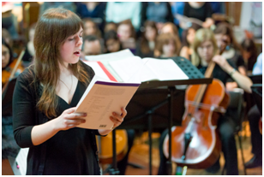
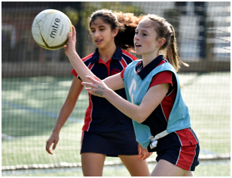
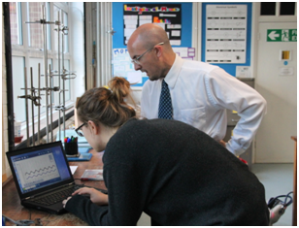

“We are delighted that you are considering NHEHS and hope that you will want to apply for this post once you have found out more about us. Our website, www.nhehs.gdst.net will tell you more about the school and give you a taste of the atmosphere here.”
Matthew Shoults, Headmaster

Teacher of Computer Science

The Post
The post is available from September 2018.
The vacancy provides the opportunity for a well-qualified, inspirational teacher of Computer Science to teach up to A-level, and to contribute to a flourishing department in both its curricular and extra-curricular activities. The ability also to teach Maths or another subject is preferred but not required.

Person Specification
We are looking for a well-qualified graduate of Computer Science or related qualification with a passion for the subject and excellent subject knowledge. She/he will have excellent organisational and time management skills and the ability to produce creative solutions to challenges. She/he will be a good communicator who can enthuse and inspire pupils and will have exciting ideas about the teaching of Computer Science and ways in which girls can be inspired both within and outside the curriculum. The ideal candidate will be fully committed to the vibrant extra-curricular life of the school. Ideally, the candidate will have experience of Python, SQL, HTML, CSS, and JavaScript, though this is by no means a requirement.

The Department
Coding was introduced into the KS3 curriculum six years ago and girls use Small Basic and Python. A Level Computing, which is now Computer Science, was introduced five years ago and three cohorts of students have taken the A Level, which has resulted in the majority of girls opting to take the subject at university. In September 2018, the department changed exam boards from AQA to OCR. The AQA GCSE Computer Science was introduced last year and we currently have sixteen girls in Year 11 and nineteen in Year 10.
Computer Science is taught from Year 7. Year 7 and 8 girls take the course for half a year and have a double lesson each week. Class sizes are about fifteen. Topics studied include a mixture of coding and learning about Computer Science including Small Basic, Python, databases and numbering systems. In Year 8, they choose three creative and technical subjects out of five to study in Year 9. A healthy number of about 50 girls choose the one-year Year 9 Computing course. In Year 9, the girls prepare for parts of the GCSE learning Boolean algebra, computer architecture and coding using Python.

Extra-curricular provision

Trips recently have included the Science Museum and Bletchley Park. The IT Rooms are always busy and clubs, which are run by students as well as staff, include Animation, Robotics (in conjunction with the DT Department) and coding clubs.

Facilities and Equipment

Notting Hill and Ealing High School have an excellent IT Operations team who are always willing to help and work with the Computer Science department to meet rapidly changing requirements. The IT infrastructure which includes the internet and backend services like email and the Firefly portal are managed by the GDST and equipment is refreshed regularly. There are two purpose built rooms, in which the lessons are timetabled and there are laptop trolleys available for classrooms. The air-conditioned rooms have multipurpose desktops so the PCs can be retracted and the rooms used for traditional teaching. Both rooms have Hitachi interactive whiteboards but all teachers are given a touch screen Tablet PC, which can be docked in the rooms and used as an alternative to the white boards. Applications installed on the network include Python, PyScripter, Small Basic, vb.net version 2010 and 2015 and the Adobe Creative Suite CS5.5. The latest Microsoft Office 2016 is also installed and all teachers can have a free copy, which they can download on up to 5 devices at home.

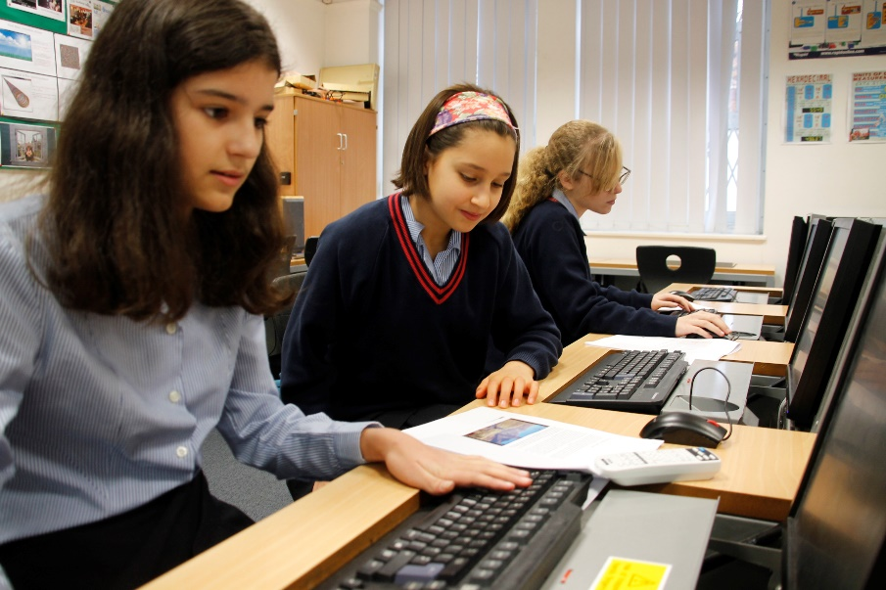

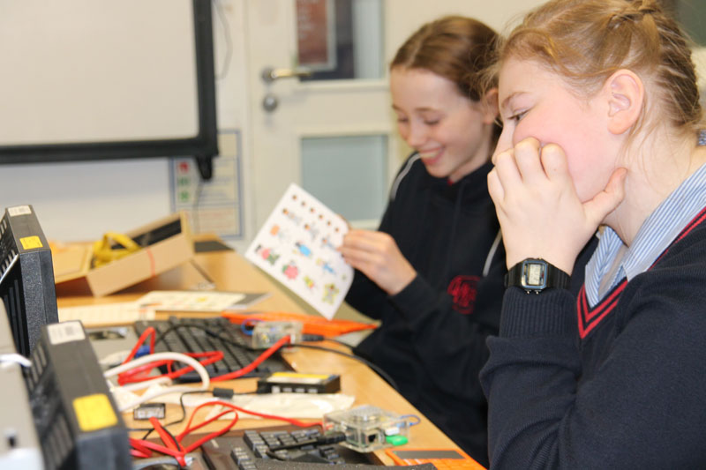

Terms and Conditions of the Post
The GDST offers attractive salaries and pay progression, when compared with the education sector generally, and has its own pay and grading structure, and system of career progression. Leadership and teaching excellence are recognised and rewarded in its schools. The salary reflects London weighting.

Benefits include:
- Membership of Teaching Staff Pension Scheme
- Access to the GDST central training and development programme
- Up to 50% discount on fees for children at GDST schools
- Training grants for obtaining further qualifications
- Season Ticket Loans: Interest free loans for travel are available to staff to enable them to buy annual season tickets
- Computer Loans: Interest free loans are available to staff to enable them to buy a computer for personal use at home
- Cycle Scheme: the School is part of the scheme which enables staff to purchase bicycles and equipment at a tax advantageous rate and pay for the equipment over 12 months
- Lunches: free lunches are provided to all staff during term time
- Four weeks’ study leave for teachers after ten years’ continuous service
- Accredited NQT induction

Application and Interview Process
Applications should be submitted by midday, 7th March at the latest; however, applications may be considered in advance of the deadline. Candidates should complete the application form provided and also include a covering letter and full curriculum vitae with details of qualifications and experience and the names, addresses, telephone numbers and email addresses of two professional referees, one of whom should be the Head of their present or most recent school.
Completed applications should be sent to:

Mr Matthew Shoults
Headmaster
Notting Hill & Ealing High School
2 Cleveland Road, London W13 8AX

or may be emailed to: recruitment@nhehs.gdst.net

Shortlisted candidates will be invited for interview on 15th March. As part of this process, they will be expected to teach a lesson of up to 35 minutes for which a full prior briefing will be given. All applications will be acknowledged and candidates who have not heard from us further within two weeks of the closing date should assume that the post has been filled.
All adults employed at the school are cleared for working with children and young people through the Disclosure & Barring Service. Please see attached full information regarding the Girls’ Day School Trust guidelines on the Safeguarding of Children.

Further information about the school can be found on our website at: www.nhehs.gdst.net
Application Form

