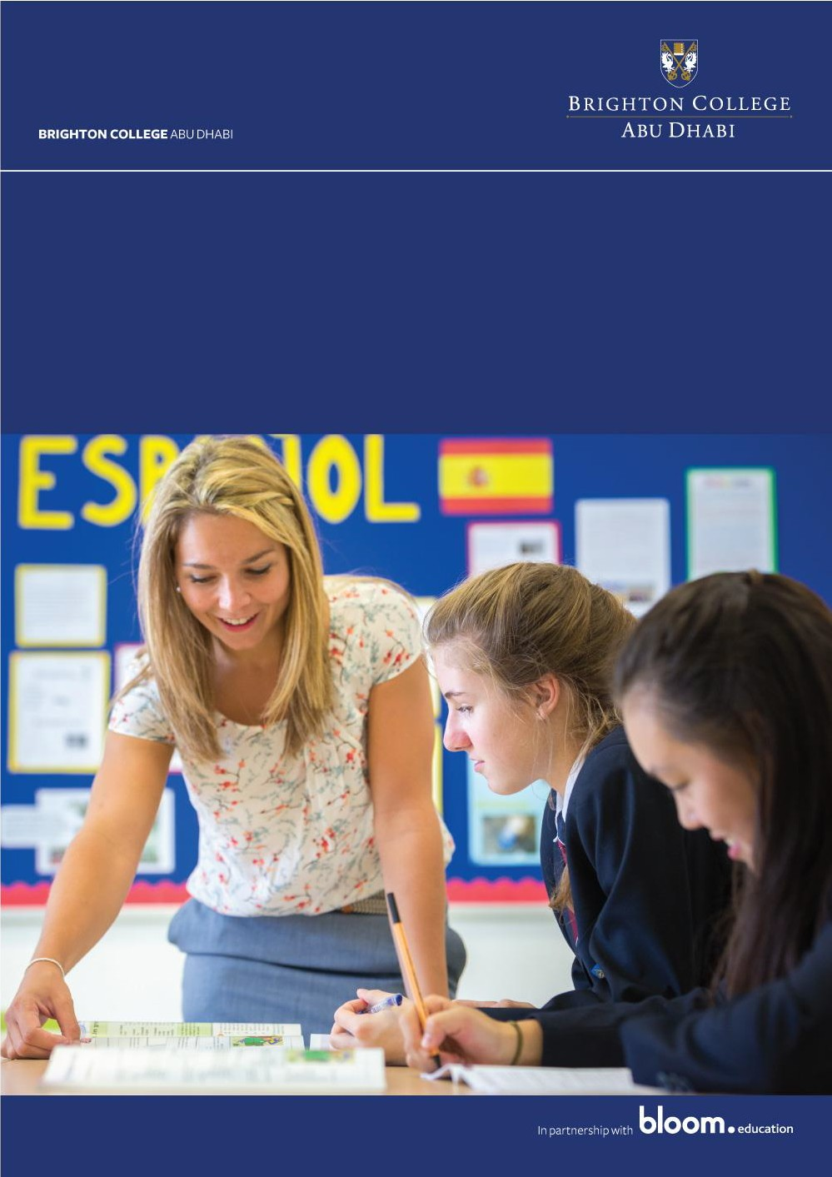

Job Advert
Teacher of History and Politics (Senior School)

Date of advert: April 2018

Brighton College Abu Dhabi wishes to recruit a Teacher of History and Politics.

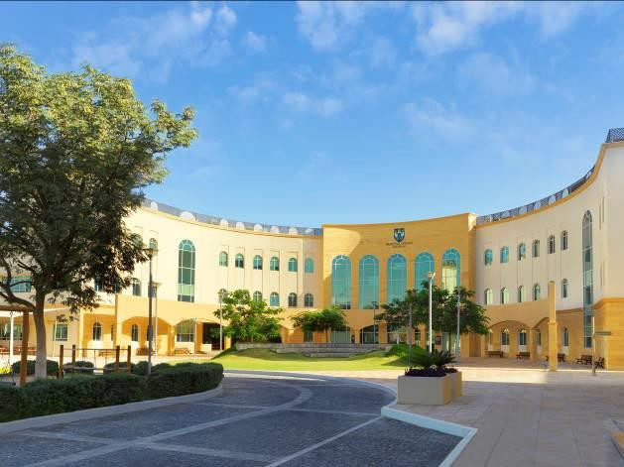
Brighton College Abu Dhabi, the sister school of Brighton College UK, is a leading Independent-style
British International School located
in the United Arab Emirates. With a prime location on Abu Dhabi Island and a purpose built state-of-
the-art campus, which is nearing its sixth anniversary, the school is heavily over-subscribed.

A key component of Brighton’s internationalization is the importance its places upon
ensuring that its sister schools are authentically interpreting its values and ethos. Each
school combines academic excellence with a wealth of co-curricular opportunities, all
underpinned by a deep commitment to the individual needs and enthusiasms of every child, and each values the importance of the individual: every boy and girl in the Brighton family of schools is valued for his or her own sake and encouraged to develop his or her
talents to the full, in a community where there are no stereotypes and where every achievement, however small, is noticed.

Brighton’s success is built upon recruiting genuinely inspirational teachers who can enthuse about their subject and will help to create an exciting and vibrant intellectual environment in which children can explore their interests, develop their existing talents and acquire new ones.

We are currently seeking to appoint experienced, well-qualified, and inspirational teachers to join us for the 2018/2019 academic year. This is a unique opportunity to join an exceptional and hardworking team with the united goal of ensuring that every child reaches their potential both academically and socially, by pushing boundaries and broadening horizons. Our positioning as one of the leading academic schools in the Middle East, are testament to the dedication and hard work of our common room.

Packages are amongst the best globally with an excellent basic salary and comprehensive benefits. We also offer exceptional levels of financial support for Continuing Professional Development.

Senior School

Brighton College Senior School delivers an innovative and exciting curriculum leading to GCSEs and A Levels. Our external examination results in Years 11, 12 and 13 are ‘well above curriculum and world averages’ (ADEC Inspection Report November 2016) and the results from Summer 2017 make us the highest attaining 3-18 British curriculum school in the Middle East. We strive to become the ‘first choice’ school in Abu Dhabi for children aged 3-18 and to be international recognised as world class. We strive to turn out well- educated, globally aware, tolerant and intellectually curious men and women who are ready to take a full, active and positive role in the life of Abu Dhabi, the United Arab Emirates and our world. Central to this vision are our teachers and leaders.

Brighton College Abu Dhabi benefits from a strong partnership with Brighton College, the UK’s top co-educational school, and with Brighton College Al Ain and Brighton College Bangkok. The Brighton family of schools currently educates more than 4,000 pupils.

PERSON SPECIFICATION

■ Essential qualities will include the ability to work collaboratively and to present to parents, pupils and colleagues a warm, engaging and approachable personality.

■ The successful candidate will have a university degree and teaching qualification from a recognised academic institution

■ A distinguished record of teaching

■ A strong record of professional development

■ Excellent knowledge of GCSE and A Level. In particular, knowledge of the Edexcel Government & Politics syllabus with the Global Politics option for Unit 3 is an advantage

■ The successful candidate for this challenging and rewarding position will have at least 2 years’ experience

JOB DESCRIPTION

Responsible for: | Brighton College is a dynamic and exciting school looking for enthusiastic and passionate teachers. This is a unique opportunity to join an exceptional and hard-working team with the united goal of ensuring that every child reaches their potential both academically and socially, by pushing boundaries and broadening horizons.
Consulting with: | All staff.
Reporting to: | Head of History (Senior School)

RESPONSIBILITIES OF POSITION

• To be an ambassador of the College at all times, in school and the United Arab
Emirates
• To teach a maximum of an 80% teaching timetable, carry out duties (up to four per week) and actively support the CCA Programme leading a minimum of two activities per week
• To encourage each pupil to reach their academic potential through enthusiastic and personalised teaching, tailored stretch and challenge, rigorous record keeping and follow up
• To be aware of and comply with all the College policies including those for marking and assessment, teaching and learning and reporting
• To develop and share schemes of work and resources, using the agreed formats
• To assist with covering colleagues as required
• To attend all meetings and INSET as required
• To prepare, invigilate and assess, as required internal and external tests and examinations
• To work within a House team as a Tutor in either Years 9-11 or Years 12&13
• To show an active interest in each child’s personal and domestic circumstances and to foster the personal and social developments of each pupil in your care
• To actively promote the social, moral and cultural ethos of the College community

• To create an atmosphere of support by being aware of, and fully complying with, all the College Polices; including the Code of Conduct, School Rules, and the Anti- bullying Policy
• To be familiar with in all the College’s policies on Health and Safety and be proactive in ensuring the safety of all members of the College community at all times
• To promote exemplary behaviour and a responsible attitude amongst all pupils at all times
• To be aware of and act upon all policies regarding the safeguarding of children
• To promote pride in the College among the pupil body through high standards of dress, behaviour and commitment
• To ensure that all communication is acted upon appropriately and in a timely manner
• To attend Parents’ Evenings, Assemblies, Productions, Sporting and Special Events
• To be responsible for all College resources particularly those in your care, reporting damage or loss to your line manager or the facilities manager, as appropriate
• To contribute to the College website, social media and publications as necessary
• To contribute to the College’s Self Evaluation and Development Plan
• To foster a close partnership with parents, initiating contact in appropriate circumstances and ensuring that there is a record of this
• To be in School prior to 7.00 am and until at least 4:00pm
• To carry out any reasonable professional request made by the Head Master, Head of Senior School or member of the SLT

REMUNERATION

■ An attractive salary

■ Suitable Unfurnished Accommodation

■ School fee remission

■ Private medical insurance for the post holder and his/her dependants

■ Annual return flights to Country of origin for the post-holder and his or her family

All of the above in line with specific school policies

APPLICATIONS

All applications must consist of the following completed documents:

1. Letter of application (maximum one and a half sides of Garamond 12) addressed to Mr
Simon Corns, Head Master of Brighton College Abu Dhabi. This should be attached to your electronic application.

2. Completed teacher application form (available on TES online)

3. CV (maximum 4 sides) naming two referees, one of whom must be your current or most recent employer. This should be attached to your electronic application.

4. Applications must be loaded to the Times Educational Supplement online application site. This will generate a formal application profile.

Please note
We reserve the right to interview and offer to a strong candidate prior to the closing date. It is strongly recommended that candidates submit their applications as soon as possible.

Due to the expected high levels of interest in positions at the School, only candidates selected for interview will be contacted within 21 days of the closing date for applications.

CLOSING DATE
Last date for receiving application will be on 26th April 2018.

Brighton College Abu Dhabi is committed to safeguarding and promoting the welfare of children and young people and expects all staff and volunteers to share this commitment. Please note that should your application be successful, a police check will be undertaken in the country of origin; in the UK, a disclosure will be requested from the UK’s Disclosure and Barring Service.

