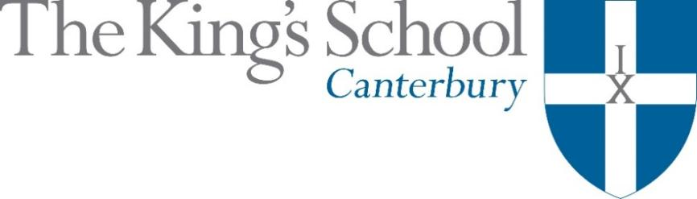

Appointment of a Teacher of Drama and Theatre Studies and Dance
September 2018

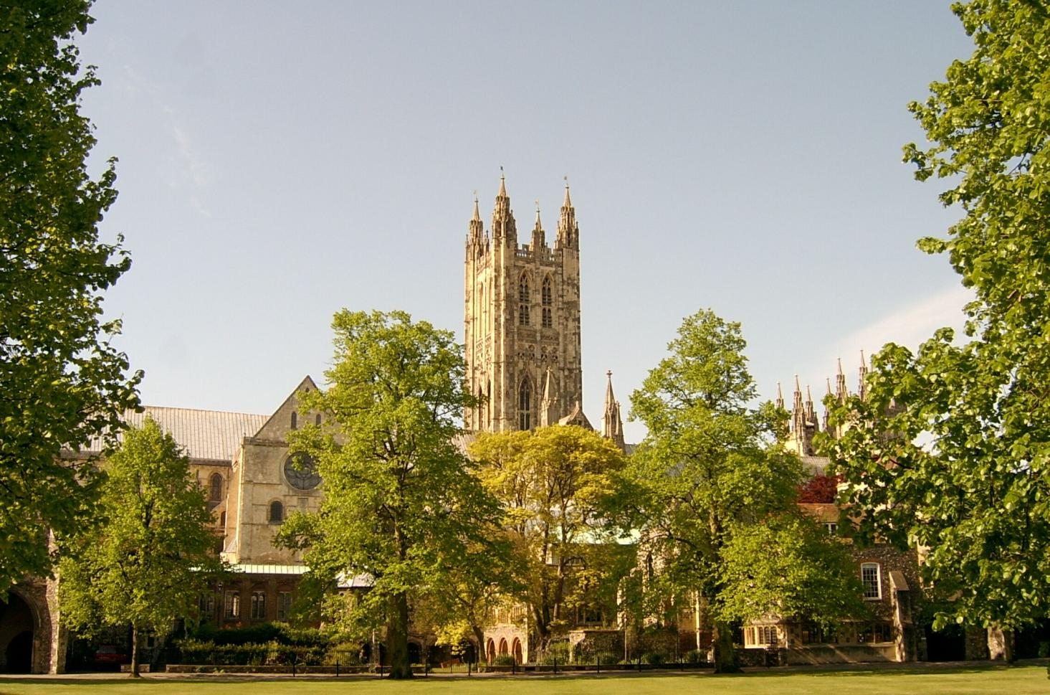

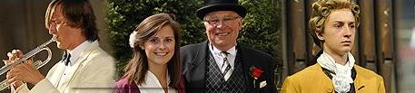
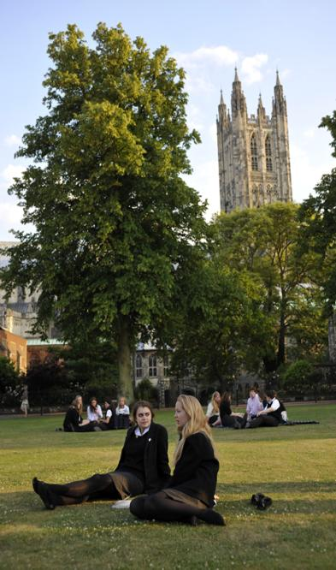
THE KING’S SCHOOL, CANTERBURY is a leading independent co-educational boarding school, situated in the heart of the historic Cathedral city of Canterbury in Kent.

The precincts of Canterbury Cathedral are part of a world heritage site, a centre of pilgrimage and study, and host to over 1 million visitors each year from many different cultures. This international dimension deeply influences the life of the city and the school.

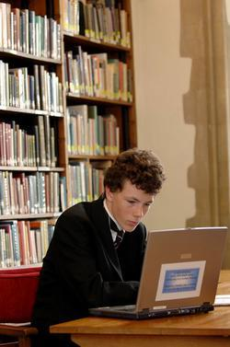
The origins of King’s date back to the arrival of St Augustine in 597 AD and the school’s Christian tradition remains at its heart. Pupils and staff comprise individuals of many different faiths and beliefs. Embracing this diversity, there is a desire to foster fairness, tolerance, courage, perseverance, mutual respect and understanding. The Benedictine tradition of developing mind, body and spirit within a community given to hospitality still influences the life of the Cathedral and the school lives out its life in that context. Thus, academic excellence and scholarship take their place alongside the school’s commitment to physical and cultural endeavour. Sport is strong, with a number of boys’ and girls’ teams at national level. Music and drama are outstanding, both having the finest traditions and producing performances of the highest standards. King’s Week, the school’s own Festival of Creative and Performing Arts, attracts thousands of visitors each summer.

The curriculum at King’s is based upon strong academic roots. It emphasises and relies upon what is best in traditional school education: scholarly excellence supported by a caring pastoral and tutorial system, and a wide-ranging co-curricular programme. The curriculum is continually adapting and reacting to the changing demands of modern education: new subjects are added, new teaching techniques adopted, and there is an increasing awareness of the need to provide programmes of study that match individual needs and skills. The school does not gauge its success by exam results alone but by broader measures of educational attainment and personal development, helping pupils to achieve their potential and equipping them to play an active and responsible role in society as young adults.

The whole school comprises The King’s School, Canterbury (KSC) and The Junior King’s School (JKS). In the former, there are currently 826 pupils at the school, 452 boys and 374 girls, of 78% whom are boarders. There are 6 boys’ boarding houses, 7 girls’ boarding houses and 3 day houses. Junior King’s, the prep school of King’s, occupies a fine rural site on the banks of the River Stour, in Sturry, 2 miles from Canterbury. There are currently 378 pupils at Junior King’s, 209 boys and 169 girls, of whom 20% are boarders.

The King’s School occupies various sites around the Cathedral and its precincts. Many teaching departments and the majority of houses are in the beautiful ancient buildings around Green Court, on the north side of the Cathedral. To the east of the Cathedral, the St Augustine’s site is home to five boarding houses and the magnificent school library. There are two major sites for sport: Birley’s, and the Recreation Centre, both within walking distance of the school.

www.kings-school.co.uk

THE ROLE

We seek applications from highly qualified, experienced and enthusiastic theatre practitioners and dance teachers to teach Drama and Theatre Studies and assist in furthering our Dance programme from September 2018. The applicants should be able to demonstrate a breadth of both teaching and performance styles. Successful applicants will be graduates, required to teach Year 9 to 13, including Drama IGCSE and Theatre Studies A level.
The Drama Department is on the cusp of moving across to our exciting new site ‘The Malthouse’ which comprises a 350 seat versatile theatre, 2 studio teaching and rehearsal spaces (one of these equipped with dance facilities), sixth form teaching areas and other multipurpose spaces. Many pupils are involved in drama on and off the main curriculum. As well as school plays, there are showcases, excellence groups, drama clubs and a range of dance activities and private lessons offered. Drama and dance scholarships are available for prospective students. There are also regular theatre trips to London and The Marlowe Theatre in Canterbury to see productions.
King's Week is the annual showcase for the range of performance work comprising one major senior production and two junior plays. A dance show is also performed by KiDaCo (the King's Dance Company).
Recent productions, many performed outdoors in some of the beautiful settings around the Cathedral Precincts, have included: A Streetcar Named Desire, Romeo and Juliet, Much Ado about Nothing, Joking Apart, Woyzeck, The Merchant of Venice, The Red Shoes, The Lark, Great Expectations and Cyrano de Bergerac. We have also performed full scale musicals at The Marlowe Theatre, including Les Misérables and West Side Story.
Year 9 sets enjoy a half year ‘taster’ curriculum in Drama, followed by the Cambridge International Examinations (CIE) IGCSE in years 10 and 11 for those opting for the subject. The performance coursework component is predominantly presented in the autumn, with preparation for the summer written examination taking place over the subsequent terms. For A Level Theatre Studies, we follow the AQA syllabus. The appointee will share the teaching of both of these levels with the Head of Department. Dance specialists will be required to develop further activities, opportunities for curricular dance and scholarship programmes, alongside assisting with productions in cooperation with the Head of Drama.
The successful applicant will take an active part in the co-curricular life of the school and will direct the Year 9 or 10 play for the King's Week Arts Festival. Performance standards are very high for this event and professional production values are expected.

APPLICATIONS
Applications should be submitted online through the King’s School website (www.kings-school.co.uk – Staff Vacancies), and should include a personal statement for the Headmaster and a CV by 9 am on Friday 3 November. If you have any difficulties accessing the internet please contact the School Office: reception@kings-school.co.uk; 01227 595501.

Those considering applying but requiring more information, can contact the Head of Drama, Rebekah Beattie, for an informal discussion: rjb@kings-school.co.uk.

October 2017

