DEPARTMENT INFORMATION

The English Department currently comprises sixteen members of staff and has established an excellent reputation within the School. The last Ofsted report noted that, ‘The English department is exemplary in its practice and performance.’
The Curriculum Team Leader has overall responsibility for the curriculum and staffing of the Department, supported by a 2 i/c (including KS4 responsibility), and post holders for Key Stage 3 and Key Stage 5. The team leader and responsibility post-holders in the Department work closely together and enjoy joint decision making and planning.

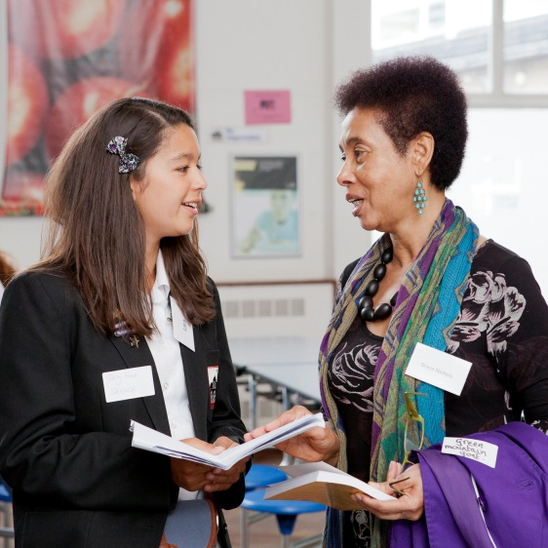
The team is very cohesive, friendly and mutually supportive. There is a great deal of sharing of good practice and new approaches. Staff are well-supported and performance management and professional development are valued. The Department is very well organised and systems are well established and utilised. New members of the Department benefit from detailed, fully differentiated and resourced SoW. All English classrooms are equipped with interactive whiteboards.
Students are taught in mixed ability groups at Key Stage 3, apart from two booster groups in year 8 and 9 to support students with lower literacy skills. At KS4, we teach AQA English Language and English Literature GCSE to students in mixed ability classes. We deliver the AQA B English Literature A-level specification. English is a popular A-level choice and we currently have 3 AS and 3 A2 classes. In most years, students have achieved places at Oxbridge colleges to study English. The English Department has enjoyed significant examination success and results in all Key stages have been very pleasing, including those of SEN and EAL students.
We are proud of our commitment to extra-curricular and enrichment activities, which include:
- National Orwell Youth Prize.
- Performing Shakespeare competition for every student in year 8
- Theatre trips and visiting theatre groups. Including an annual visit for Year 7s to Shakespeare’s Globe.
- Spoken Word Club which perform regularly at external events and participate in a number of competitions.
- Poetry By Heart competition entered by all of Year 10.
- Annual Public Speaking Competition involving every student from Year 7 to 10.
- A variety of trips including International Day of the Girl trip to Royal Festival Hall to listen to journalist Caitlan Moran and Keats’ House.
- Partnership with Sam Enthoven as ‘Patron of Reading’, working to increase reading for pleasure
- Visits from authors and professionals working in English related professions. These have included Mishal Husain, Neil Mullarkey, Nick Hornby, Graham Marks, Sita Brahmachari, John Agard, Velma Pollard and Patience Agbabi
