RT/CLL

March 2018

Dear Candidate

Thank you for your interest in the post of Teacher of Science. Please download all the information you need to apply for the job.

Contents:
- Application form
- Job description
- Person specification

References will be taken up for all short listed applicants. The successful applicant will be required to undertake enhanced DBS clearance.

Completed application forms should be returned to Caroline Collings, at the school, by the closing date Monday 26 March 2018 at 9.00 am. These can be emailed to the school but a signed hard copy will need to be signed if you are shortlisted for interview.

Please make sure you add sufficient postage, we have received applications after the appointment has been made resulting in disappointed applicants.

Applicants who have not been called for interview, within 7 working days following the closing date, should assume that their application has been unsuccessful.

I would urge you to find out more about the school by exploring our website. We are very proud of our achievements and have a committed and talented staff team.

Yours faithfully

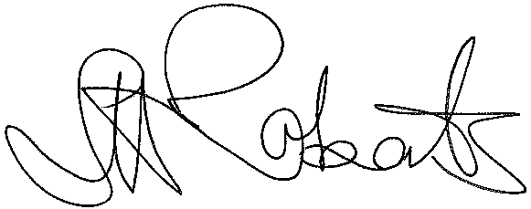

Mrs Steph Roberts
Headteacher

Encl.

