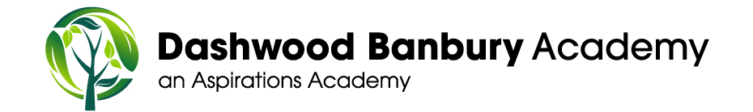
Teaching Assistant Wanted

Are you looking to join an inspirational and motivated team? We have a fantastic opportunity for a Teaching Assistant to join our school and work pupils with special educational needs. We are offering a temporary, full time job role of 8.30 am – 3.30 pm Monday to Friday, term time only plus 3 Inset Days starting as soon as possible.
Dashwood Banbury Academy is part of the Aspirations Academy Trust. We are committed to raising pupil aspirations in order to reach their full potential.
You would thrive at Dashwood Banbury Academy if you are a person who:
- Is passionate about education;
- Works creatively with the curriculum to help all children succeed;
- Loves challenging themselves and others;
- Relishes in opportunities to develop your own practice;
- Enjoys working as part of a team;
- Recognises the importance of great relationships with colleagues, pupils and parents.
We will offer you:
- Enthusiastic, hardworking and well behaved children;
- A supportive staff and Governing Body who have fun at work;
- A progressive, forward thinking Academy Trust;
- A commitment to your professional development;
- Chance to work with experienced staff who can support and mentor you in the role;
- Opportunities to work in our schools within the District if you would like to;
- A welcoming environment where creativity is encouraged;
- A school where core values run through-out the curriculum and support pupils every step of the way.

Dashwood Banbury Academy is a very good school in the heart of Banbury with great facilities. It is close to the town centre and only a 5 minute walk from the train station and a 5 minute drive from the M40. The pupils and staff work together to ensure everyone is achieving and succeeding. It is a fantastic school where pupils make excellent progress and gain valuable life experiences to take with them on their next steps. We would welcome applicants to come and meet the team!
To arrange a visit, contact our Business Manager Ruth Jakeman on 01295 263240.
Application packs can be downloaded via the TES or from our school website http://www.dashwood-aspirations.org/ and should be submitted to rjakeman@dashwood-aspirations.org
The Aspirations Academy Trust is committed to safeguarding and promoting the welfare of children and young people and expects all staff and volunteers to share this commitment. This post is subject to an Enhanced CRB disclosure and references.
Closing date: Friday 22nd September 2017
Interview date: Wednesday 27th September 2017

