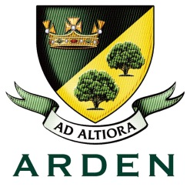

Librarian

 | Essential | Desirable | Evidenced by
Qualifications/ Training/ Competences | - Either a library/information degree or a first degree with a postgraduate library qualification  - Professional qualification in librarianship, information management or information science | - Chartered member of CILIP or working towards chartership | Application form
Relevant experience | - Ability to quick build a rapport with students as well as initiate ways to support young people in finding quality texts which reflect both student needs and reading competence  - Experience of working with children of all ages and ideally those of secondary age  - Experience of self-evaluating learning needs and actively seeking learning opportunities | - At least 2 years experience in a library/learning resource centre | Application form  Letter
Knowledge | - Effective use of ICT and other specialist equipment/resources  - Excellent knowledge of books for young people | - Working knowledge of relevant policies/codes of practice/legislation  - Knowledge of Library Software (Heritage) | Letter
Skills | - Effective communication and negotiation at all levels  - Behaviour management skills  - Ability to work as a member of a team, and to work under pressure and to target  - Ability to manage and disseminate information in a range of different media  - Ability to undertake routine tasks with care and accuracy  - Learning support skills to assist library users  - Initiative, imagination, self-motivation  - A willingness to learn new skills and knowledge | - An understanding of school roles and responsibilities and the position of the part-time school librarian within these
Personal Attributes | - Passion for reading. An enthusiasm for young people’s literature is equally important as experience and will be of great value in developing the library in the Academy.  - Commitment to safeguard and promote the welfare of children and young people |  | Letter

