THE GEOGRAPHY DEPARTMENT

In today's globally interconnected society, it is increasingly important that we understand the world around us. The aim of the Claremont High School Academy Geography Department is to develop inquisitive learners with an understanding of the complexity of interactions across the globe, from the local to the global. Students will investigate both physical and human aspects of Geography to discover their role in our increasingly global world.

THE GEOGRAPHY DEPARTMENT TEAM
The Geography Department is lucky enough to have 7 dedicated teachers with a range of specialisms and well over 80 years teaching experience between them.

PROGRAMME OF STUDY
KEY STAGE 3
Geography at KS3 follows a broad enquiry-based curriculum, where students develop their knowledge and understanding of the world around them as well as key geographical skills, such as map reading and data interpretation. Students investigate enquiry questions such as 'do Geographers ever get lost?', 'what does crime have to do with Geography?', 'what makes the Amazon so important?' and 'how many people is too many people?'
Year 7 Geography – see website for more detail.
Year 8 Geography – see website for more detail.
Contd….
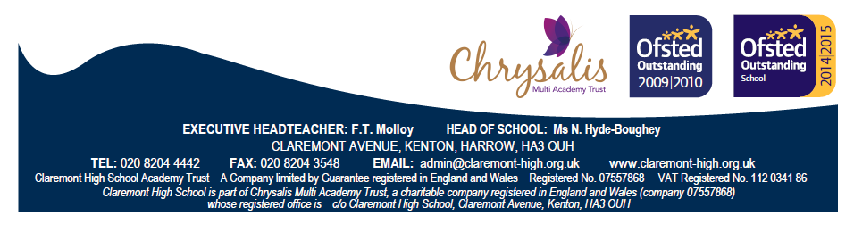

GCSE FOUNDATION YEAR
The GCSE Foundation Year focuses on embedding the key skills learnt in the KS3 curriculum and ensuring a strong foundation for the GCSE course. Students focus on global interactions and the links between human and physical geography. They investigate topics such as ‘Development’, ‘Weather and Climate’ and ‘Unequal Spaces’.
Year 9 Geography – see website for more detail.

KEY STAGE 4
Year 11
The Year 11s are studying the AQA A Geography GCSE course which builds upon the GCSE foundation year to develop students understanding of both physical and human geography and improve their Geographical skills. Topics studied include 'The Restless Earth', 'Coastal Zone', 'The Challenge of Weather and Climate', 'Population Change', 'Globalisation' and 'Urban Environments'. Year 11 students also completed a Controlled Assessment in Year 10, which involved a fieldtrip to Norfolk.

Year 10
The Year 10s are studying new AQA Geography GCSE course which also builds upon the GCSE foundation year to develop students understanding of both physical and human geography and improve their Geographical skills. Topics include ‘The Challenge of Natural Hazards’, ‘The Living World’, ‘Physical Landscapes in the UK’, ‘Urban Issues and Challenges’, ‘The Changing Economic World’ and ‘The Challenge of Resource Management’. Year 10 students will also take part in a fieldtrip to Norfolk in the summer term, which will enable them to prepare for their Geographical Applications exam, which focuses on fieldwork skills and issues evaluation.

KEY STAGE 5

Year 13
In Year 13 A Level the Edexcel Geography course is studied and students benefit from specialist teaching in both human and physical aspects of Geography. The course covers a wide range of topics including natural hazards, climate change, development, poverty, world cities and cold environments. Throughout the course students also develop a wide range of skills that are highly sought after by universities and employers.

During Year 12 students went on a residential fieldtrip to Somerset where they investigate urban rebranding and changing coastal environments.

Year 12
In Year 12 the new A Level Edexcel Geography course is studied. The course covers a wide range of topics in Year 12 including ‘Tectonic Processes and Hazards’, ‘Coastal Landscapes and Change’, ‘Globalisation’, ‘Shaping Places’ and in Year 13 students look at contemporary issues through the study of ‘Physical Systems and Sustainability’ and ‘Human Systems and Geopolitics’. Throughout the course students will take part in various human and physical fieldtrips to prepare for and complete their Independent Investigation.

Extra-Curricular Opportunities
Fieldwork is viewed as an essential part of the Geography curriculum and therefore opportunities have been built into the curriculum to allow students to take part in numerous fieldwork investigations around their local area. Students also have the opportunity to take part in the popular trip to London Zoo, where they develop their knowledge of ecosystems.
The department also runs some VERY popular residential trips in Year 10 and Year 12 – both for coursework/examination preparation. The Year 10 students go to Norfolk to spend a few days on the beach, in the classroom and taking part in extreme activities! Year 12 students also take part in a residential fieldtrip, recent locations have included Nettlecombe in Somerset and Snowdonia in Wales.

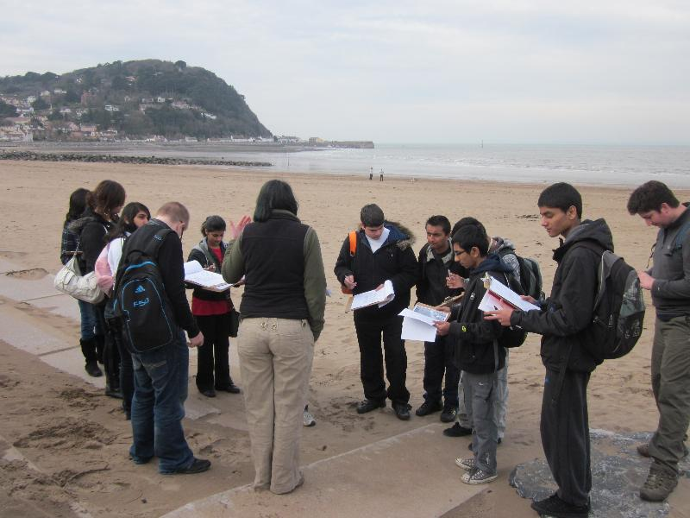
Geography in Action

The Post
The post would be equally suitable for an experienced teacher or for someone at an earlier stage in their career. We would be able to support a Newly Qualified Teacher and we would also be happy to received applications from those looking to train via work-based PGCE route.
The post is offered as a full time role.

