MPLogo_Core_with_Motto_349_Spot

**Head of Mathematics**

**Background**

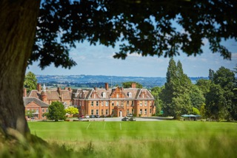

The School

Moor Park is an IAPS, co-educational, boarding and day school of Catholic foundation accepting pupils from 3 months to 13 years of age. Children from 3 months to rising three are catered for in our Tick Tock nursery/child care setting which runs for 50 weeks in the year. Thereafter, children enter the Pre-prep until the end of Year 2. The Middle and Upper Schools complete a Moor Park education before the children leave to the full range of senior schools both locally and nationally, many with scholarships in the full range of disciplines despite being a non-selective school. Last year, 35 children won a total of 35 scholarships and awards, an enviable record. Children have won academic awards to Harrow, Radley and Shrewsbury (amongst others) in the last two years.

Being a boarding school for the 8 to 13 year olds, the school operates on a 24/7 basis during term time and children take advantage of the beautiful surroundings and excellent facilities. The school is built around a magnificent 18th century country mansion in approximately 85 acres of stunning grounds, which include playing fields, woodland and a lake. It is situated just outside the market town of Ludlow in the beautiful Shropshire countryside.

The Job

We are seeking a Head of Mathematics who will fit into our culture of educational innovation and excellence. We are a staff room who value excellent and committed teaching and a school where colleagues value energy, innovation and mutually supportive relationships. You would also benefit from a belief that supporting and developing staff is the key to improving schools. Talent is nurtured at Moor Park and this would be an excellent move for anyone who wished to progress their career or who is simply looking to bring established expertise to a supportive and exciting environment. We are searching for a specialist who will develop this crucial department whilst setting high standards in the classroom for children of all abilities.

The Local Area

Shropshire is an extraordinary place to live and many families have found that they can bring up children in a safe and beautiful environment for a fraction of the cost of living in the South East. Moor Park is close to the historic town of Ludlow, well known for its high-end restaurants and food is a real feature of the area. Outdoor enthusiasts would also enjoy everything on offer. Property prices are still relatively low, for now, and we enjoy good relationships with the local estate agents who would be happy to help with a candidate looking to relocate.

