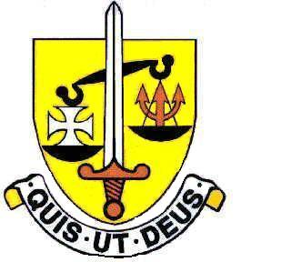
ST. MICHAEL’S CATHOLIC GRAMMAR SCHOOL

JOB DESCRIPTION

- Job Title

Main Scale / Upper Pay Spine Teacher

- Responsibility
The Teacher is responsible to the Headteacher

- Liasion and co-operation

The Teacher will work in liaison, and co-operation with:

- other members of staff;
- members of the Inspectorate, Advisory and Support Services
as necessary.
- Parents, governors and the local community.

- Policy and Legal Framework

The Teacher will work within the framework of:-

- national legislation, including the Education Acts from 1944, 1988 and the Schoolteachers’ Pay and Conditions Act 1987;
- school policies and guidelines on the curriculum and school organisation;
- Diocesan policies, in particular those relating to curricular aims and principles and to equality of opportunity;
- meet the Teachers’ Standards (England).

- Tasks and Duties

The Pay and Conditions Act 1987 lists the duties to be included in all Job Description for teachers. The following statement summaries these:

- Planning

To plan and prepare courses, schemes of work and individual lessons, appropriate to the needs, interests, experience and existing knowledge of pupils.

- Setting and Supervising work by pupils

To teach a class, or classes, sets, groups or individual pupils and to set tasks to be undertaken both at school and elsewhere.

- Marking and Recording

To mark and assess pupils’ work and to record their development, progress and attainment, both at school and elsewhere.

- Discipline and Relationships

To maintain good order, discipline and respect for others; to promote understanding of the school’s rules and values; to safeguard health and safety; and to develop relationships with and between pupils conducive to optimum learning.

- Communication with parents

To build and maintain co-operative relationships with parents and to communicate with them on pupils’ leaning and progress, drawing attention to special skills and talents as well as to problems or difficulties.

- Displays and Environment

To maintain an attractive and stimulating classroom environment and to contribute displays in the school as a whole (with the support of the Clerical Support Officer).

- Overall Policy Review

To take part in the whole-school reviews of policy and aims and in the revision or formulation of guidelines.

- Reports

To provide and contribute to oral and written assessments, reports and references, both at school and elsewhere, relating to the development and learning of individual pupils and groups of pupils.

- Reviews

To evaluate and review one’s teaching methods, materials and schemes of work and to make changes as appropriate.

- Professional Development

To keep up-to-date with current educational thinking and practice, both by study and by attendance at courses, workshops and meetings; and to take part in appraisals and reviews of one’s work arranged by the Headteacher.

- Corporate Life

To take part in the corporate life of the school.

- Cover

To supervise and so far as possible to teach, any pupils whose teacher is absent.

Teacher generic job description/booklets

