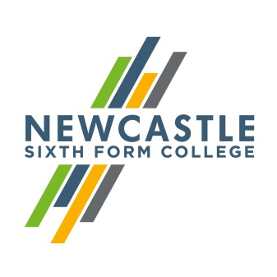
Gerard Garvey
Principal

Dear applicant,
Teacher of English – Fixed Term (until July 2019)
Thank you for showing an interest in our College. I hope you find the information about this post exciting and that it encourages you to apply.
We are absolutely committed to our vision, and determined to create an outstanding College through all members of our College community working hard to achieve it. With an ethos based on aspiration and achievement, Newcastle Sixth Form College will provide the first choice for academic sixth form education in the region. Through high quality teaching and learning in an exciting, dynamic and supportive environment, we will enable our students to realise their potential. If you share this vision, and believe that you share our commitment to making this College a great place to work and learn, I look forward to receiving your application.
As a Sixth Form College, we work exclusively with school leavers to support them in their progression to university or into work. This post is for a teacher of English, primarily English Language at A level but ideally with some experience of English Language at GCSE level. We have a large number of students involved in the study of both English Language. GCSE English Language also forms part of our Access programme for students who do not quite have the grades for A level study. We are looking to recruit an outstanding teacher to help continue the recent positive trends in English Language, covering for the maternity of one of our employees; fixed term until July 2019. We are also keen for all our teachers to be involved in our wider enrichment programme, and we look forward to hearing how you would be able to contribute to this.
I hope that you will visit our website to find out more about the College, and if you wish to visit us to look around informally we would welcome that. If you would like to arrange a visit, please contact Lisajane Clark, on 0191 226 6225.
Yours faithfully,

Gerard Garvey
Principal
Newcastle Sixth Form College, Westmorland Road, Newcastle upon Tyne, NE4 7SA
T: 0191 272 1001 E: enquiries@newcastlesixthformcollege.ac.uk
www.newcastlesixthformcollege.ac.uk

 | Newcastle Sixth Form College  Information for Applicants | 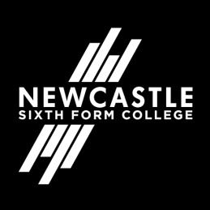

Newcastle Sixth Form College
Newcastle Sixth Form College is a dedicated academic college focusing on the needs of 16 to 18 year olds in a purpose built multi-million pound Sixth Form College. Our breadth of A Level subjects is second to none in the region and our students are nurtured to achieve the best possible results for them to move on to higher education at universities and colleges or into the workplace.
Our culture is based on support and challenge for both students and staff. We provide the highest standards of teaching and learning and a wide range of exciting opportunities for our students to develop their skills, talents and interests while they are with us. We aim to help our students develop a responsible and positive attitude in an all-inclusive environment where different cultures and diversity are embraced. We expect that all students and staff will share in these values.

English Literature Department
The English Literature Department at Newcastle Sixth Form College takes an active approach to teaching and learning, encouraging students to make the most of additional opportunities, including visits from examiners and professional critics.
The department is has an open door policy, which means that they are always available to discuss any issues their students may have. Staff actively promote literacy across the curriculum celebrating events such as World Book Day and Shakespeare Week. One member of the team coordinates Literacy Across the Curriculum and runs a very successful Creative Writing enrichment. A number of students have gone on to study English Literature at university.

Newcastle upon Tyne
Newcastle upon Tyne is the regional capital of the north east and renowned as one of the best student cities in the UK. A vibrant student population and a warm and friendly atmosphere make it a popular destination for students from far and wide.
World-class culture, vibrant nightlife, fantastic shopping, award-winning dining, inspiring heritage and acclaimed architecture are just some of the things you can expect from this exciting city. Newcastle has a population consisting of nationalities from all over the world and offers something for everyone.
Newcastle benefits from a low cost, quick transport link – the Metro, so you can see everything the local area has to offer. Newcastle also has its own international airport and major train station both with excellent links. With so much to do and fantastic transport links to get you there, Newcastle really is a city you’ve got to experience for yourself.

