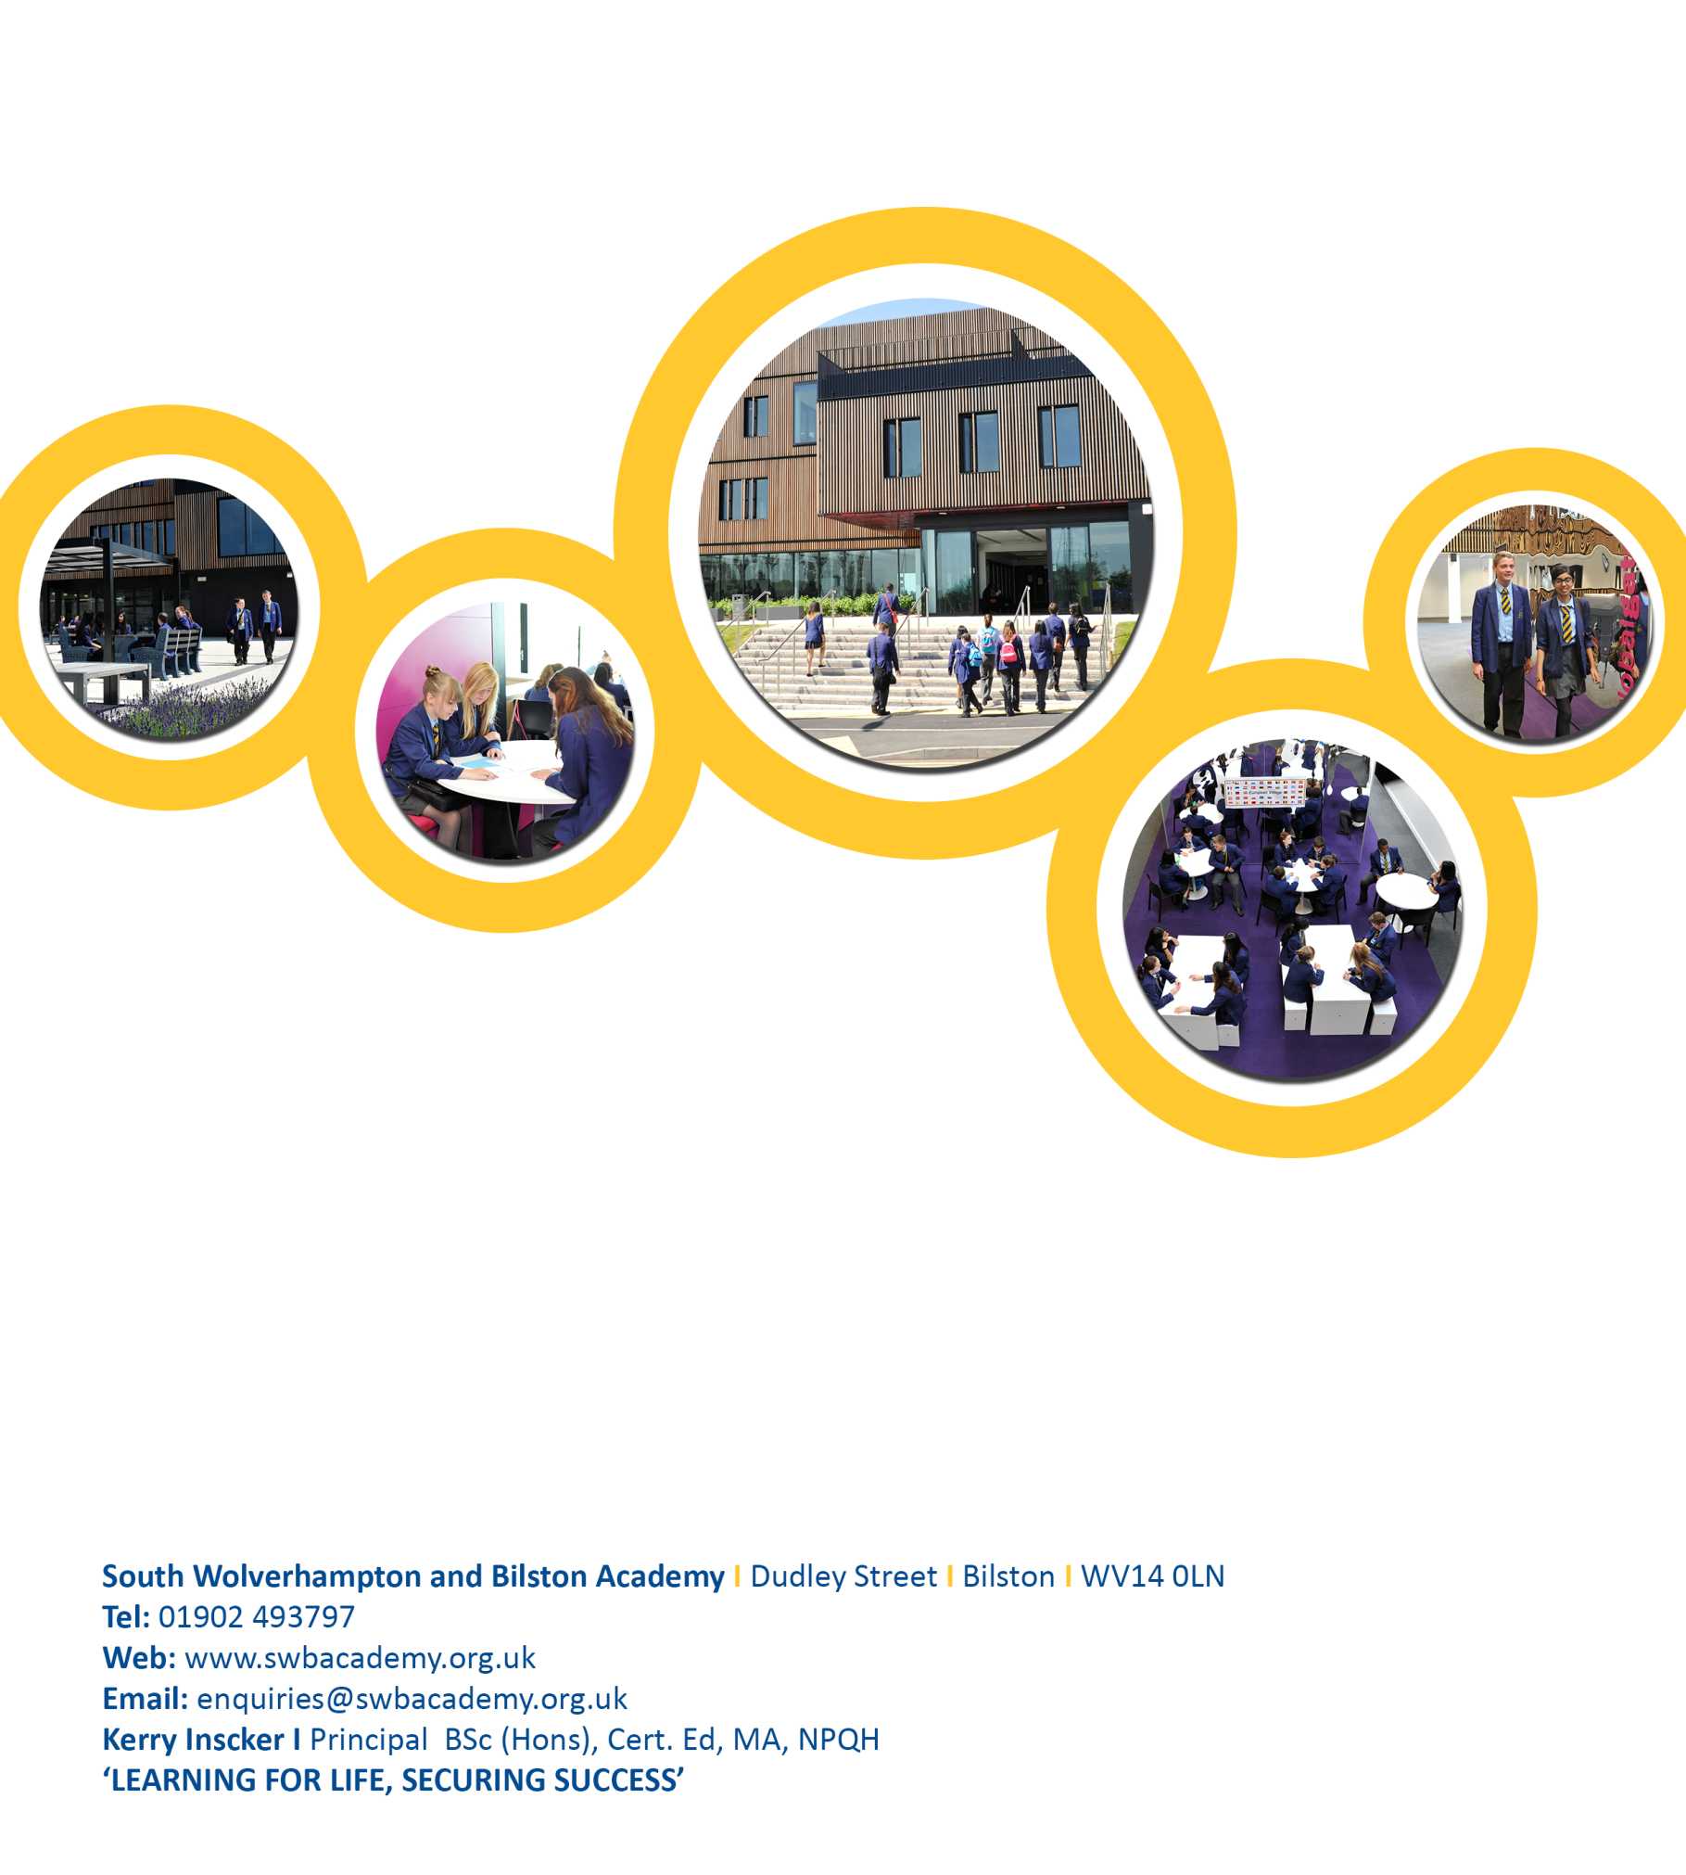

Job Pack
Teacher of English

Dudley Street, Bilston, WV14 0LN
Tel: 01902 493797
Web: www.ormistonswbacademy.co.uk
Email: enquiries@oswba.co.uk
Kerry Inscker I Principal BSc (Hons), Cert. Ed, MA, NPQH
‘LEARNING FOR LIFE, SECURING SUCCESS’

Dear Applicant,

Thank you for your interest in Ormiston South Wolverhampton and Bilston Academy. I am delighted that you are considering our Academy and I hope that you will want to apply for this post once you have found out a little more about us

I urge you to spend time looking at our website, www.oswba.co.uk, as this will tell you a lot about us and give you feel for what our Academy is like.

This is an exciting time to be working with us. We have an oversubscribed school with a diverse and enthusiastic student intake, an outstanding £25 million building with state of the art facilities and a fully supportive Senior Leadership Team.

Our Academy motto is "Learning for Life, Securing success”, which shows our commitment to ensuring all children achieve the best academic results and also master the skills they need to have happy and successful lives. We work hard to ensure that lessons are engaging and motivating, but also that students have lots of opportunities to engage in activities, events and visits outside the classroom. We take the responsibility of educating our students and supporting them to develop into a well-rounded responsible adult very seriously.

Please do contact us for a visit to the school in advance of applying or in advance of the interviews.

Yours sincerely

Mrs K Inscker
Principal

Our Vision and Values

Our vision is to provide outstanding education for all of our students through engaging and inspiring lessons taught by dedicated subject specialists who have the expertise, facilities and resources to ensure every child achieves their potential.

We believe every student should and can master skills in literacy, numeracy and ICT and that these skills should be embedded across all of their subject areas. In addition, we aim to nurture resilience, integrity and high aspirations in every child, enabling them to confidently make their way in the world. Finally, we strive to provide students with access to unprecedented opportunities, giving them access to a huge range of activities and experiences including a broad enrichment programme and visits in the UK and abroad. The range of visits is growing year on year alongside the development of the ‘OSWB Experience’ for all students.

OSWB Academy students are expected to demonstrate outstanding behaviour. Our “Golden Code” clearly signals to staff, students and parents the core values of behaviour which ensure our Academy is a focused, happy place to learn and grow. These are:
- Respect For yourself and for the values and beliefs of others, for our environment
- Engage In learning, in our community, with opportunities and with others
- Aspire To be the best you can be
- Achieve Your potential in all areas

“Learning for Life, Securing Success” – SWB Academy students pride themselves on belonging to a highly successful and vibrant learning community where respect and high expectations mean that they thrive academically, socially and personally.

Job Advert

Job title: Teacher of English (Fixed Term)
Salary: MPS/UPS (One Term)
Date required: Required September 2017
Working Pattern: Fixed Term Post: One Term

OSWB Academy is a vibrant, successful 11-19 Academy. Due to our popularity with parents, making us the first choice secondary school across the area, we are seeking to expand our team of staff as a result of increasing student numbers. We have world class facilities, highly professional staff and students who are keen to learn. The post-holder will have the opportunity to work in a dynamic team who deliver outstanding provision through engaging lessons and exciting enrichment opportunities.

We are looking to appoint an exceptional English teacher to join our dynamic and purpose driven team. You need to be determined to drive up standards, have a positive approach and be committed to making a difference. In return you will get to work in an innovative and supportive Academy.

We are a happy and ambitious Academy, excited about the future of education and determined to become ‘outstanding’. If you want to make a difference to the life-chances of all the students in your care then this could be the post for you.

Further details are available from Luke Green (Operations Assistant) via the contact details below or by email to: LGreen@oswba.co.uk

OSWB Academy is committed to safeguarding procedures and all successful applicants will undergo an Enhanced Disclosure and Barring Service check prior to appointment. This post is exempt from the Academy’s policy on relocation and job share.

Closing Date for Applications;

Monday 21st August 2017 at 9.00 am

Interviews will be held shortly after the closing date.

Please note we will not accept CVs for this post. All applications should be made using an official Academy application form along with a covering letter.

Job Description

Job title: Teacher of English (Fixed Term)
Salary: MPS/UPS (One Term)
Date required: September 2017
Working Pattern: Fixed Term Post: One Term

Job purpose
- To provide high quality English lessons across a range of ages and ability, ensuring excellent outcomes for students.
- To contribute to the rapid improvements within the English Faculty.

Duties
- To plan, prepare and mark class work and homework for all classes according to Academy policy, ensuring all students make at least good progress and are engaged in their learning.
- To create a stimulating and encouraging classroom environment where students are keen to learn.
- To work with the Assistant Principal English to promote English as a highly valued and popular subject, which is also a good option choice for study in the 6th Form.
- To demonstrate high ambition, high expectations and drive in your role at all times.
- To contribute to the wider life of the Academy through acting as a Form Tutor and contributing to the Academy enrichment programme.
- Act as a Form Tutor
- Any other duties which can be reasonably expected as directed by the Principal

Person specification

Qualifications
- Have Qualified Teacher Status (QTS)
- Degree in relevant subject area being taught

Knowledge, skills and experience
- A clear vision for the faculty
- Excellent subject knowledge sufficient to challenge able students and achieve high outcomes at sixth form level in at least one of the faculty subject areas
- Strong awareness of the strategies available for improving the learning & achievement of high, middle and low attaining students
- Experience of leading an area/initiative within a faculty or whole school showing clear impact and excellent leadership and management skills
- A good understanding of curriculum developments in the specific subject area
- An outstanding practitioner, able to use a range of teaching & learning strategies effectively
- A confident & competent user of ICT
- Able to use student level data to raise standards
- Able to communicate both orally & in writing to students, their parents and the wider community

Personal attributes
The successful candidate will have:
- Absolute commitment to ensuring the best outcomes for SWB Academy students
- Enthusiasm and a highly positive outlook
- The ability to work independently and collaboratively as a member of a team
- A willingness to take on or try new approaches & ideas
- A positive attitude towards professional development and their own learning
- Reliability, resilience, honest and integrity
- Good personal organisation skills
- Self-motivation and demonstration high ambition and drive, having and expecting the highest standards, be determined to succeed

How to apply
If you would like to apply for this position you will need to complete an application form. Our application form is available online from our website www.oswba.co.uk or by contacting; Jo Timmis, HR Manager on
01902 493797 or SWBARecruitment@SWBAcademy.org.uk

Application Form

Applications will only be accepted from candidates completing the enclosed application form in full and providing a letter of application.

Candidates should be aware that all posts at the Academy involve some degree of responsibility for safeguarding children and young persons, although the extent of that responsibility will vary according to the nature of the post. Please refer to job description for the post.

Accordingly this post is exempt from the Rehabilitation of Offenders Act 1974 and therefore all convictions, cautions and bind-overs, including those regarded as ‘spent’, must be declared.

The successful applicant will be required to complete a Disclosure from the Disclosure and Barring Service (DBS) at the enhanced level.

We will seek references on shortlisted candidates and may approach previous employers for information to verify particular experience or qualification, before interview.

If you are currently working with children, on either a paid of voluntary basis, your current employer will be asked about disciplinary offences, including disciplinary offences relating to children or young persons (whether the disciplinary sanction is current or time expired), whether you have been the subject of any Safeguarding (child protection) allegations or concerns and, if so, the outcome of any enquiry or disciplinary procedure. If you are not currently working with children but have done so in the past, that has involved working with children, although he/she may, where appropriate, answer not applicable if your duties have not brought you into contact with children or young persons.

You should be aware that provision of false information is an offence and could result in the application being rejected or summary dismissal if the applicant has been selected, and possible referral to the police and/or the Independent Safeguarding Authority.

Invitation to interview

If you are invited to interview this will be conducted in person and the areas which it will explore include suitability to work with children.

In relation to teaching staff, in line with national teacher recruitment guidelines, all candidates invited to interview must bring documents confirming any educational and professional qualifications that are necessary or relevant for the post (e.g. the original or certified copy of certificates, diplomas et cetera). Where originals or certified copies are not available for the successful candidate, written confirmation of the relevant qualifications must be obtained from the awarding body.

All candidates invited for interview must also bring with them the following documents:
- Passport
- Current driving license (including a photograph if applicable)
- A full birth certificate
- A utility bill or financial statement, dated within the last 3 months, showing your current name and address.
- Where appropriate any documentation evidencing a change of name
- Your qualification certificates

Please note that originals of the above are necessary. Photocopies or certified copies are not sufficient.

Conditional Offer of Appointment: Pre-Appointment Checks

Any offer to a successful candidate will be conditional upon the following:
- Receipt of at least two satisfactory references (if these have not already been received)
- Verification of identity and qualifications
- Checks at List 99 and the ISA Children’s Barred List as appropriate
- A satisfactory Enhanced DBS Disclosure
- Verification of professional status such as GTC registration, QTS Status (where required), NPQH
- (for teaching posts) verification of successful completion of statutory induction period (applies to those who obtained QTS after 7 May 1999)
- Where the successful candidate has worked or been resident overseas in the previous five years, such checks and confirmation as the school may require in accordance with statutory guidance
- Satisfactory completion of the probationary period
- Where a candidate is:
- Found to be on ISA Children’s Barred List, or the DBS disclosure shows he/she has been disqualified from working with children by a Court; or
- Found to have provided false information in, or in support of, his/her application; or
- The subject of serious expressions of concern as to his/her suitability to work with children

The facts will be reported to the Police and/or the Independent Safeguarding Authority.

We welcome an opportunity to discuss any difficulty in meeting any of the above criteria and provide advice on arrangements. Tel: 01902 493797.

Completing your Application Form

Applicants are requested to read carefully the following notes and any further particulars for the post before signing the declaration.
- Complete the application form (use black ink if completing the form by hand). Alternative formats, such as CV’s or taped applications are acceptable if you have disability which prevents you from completing the standard application form.
- The recruitment monitoring must be completed in full.
- Add your initial and surname to any additional sheets.
- Return your completed application form and recruitment monitoring form by email or post to the address shown on the job advert by the stated closing date.

Tips for completing Experience section

- The decision to select you for interview will be based on how closely you meet the essential criteria shown on the person specification. Use this as a guide to what skills and experience you need to have. These may have been gained from; paid work, voluntary or leisure activities, work in the home, training and education. If you feel you meet any of the desirable criteria, highlight these too.
- You might find it helpful to do a rough draft first.
- Try to organise your answer into clear concise points to demonstrate that you have the skills desired for the role.
- Accurate spelling, punctuation and grammar help to make a good impression.
- Highlight your transferrable skills. The tasks you have performed in the past may not be exactly the same as those in the job for which you are applying but the skills you use to carry out the tasks are likely to be the same.

Recruitment Monitoring Form

The information you provide on the recruitment monitoring form is confidential and will not be seen by the selection panel or play any part in the selection decision. It will be used as part of aggregated statistics for monitoring purposes only, in order to measure the effectiveness of the Trust’s equal opportunities and recruitment policies.

Acknowledgement and Result of Applications

Your application for the post will only be acknowledged if you enclose with it a stamped addressed envelope. Unless you are invited for interview no further communication will be sent to you.

We look forward to receiving your application.

Rehabilitation of Offenders Act 1974

Certain posts, particularly those that involve working with children or other vulnerable groups, will be subject to a criminal record check from the Criminal Records Bureau before the appointment is confirmed. This will include details of cautions, reprimands, final warnings and convictions, including ‘spent convictions’ under the terms of the Rehabilitation of Offenders Act 1974 (Exceptions) (Amendment) Order 2001.

If the post for which you are applying requires such a disclosure this will be indicated on the supporting information that you have received with this form. Any disclosure will be required only if you are selected as the most suitable applicant for the post. The Trust also reserves the right to contact previous employers of the successful candidate prior to the appointment to confirm employment history.

Data Protection Act 1998

City of Wolverhampton Academy Trust will use the information provided on this form to process your job application. Information will remain confidential and is protected by the provisions of the Data Protect Act 1998. The Act gives you the right to see a copy of the information held about you.

Further information relating to the Data Protection Act 1998 can be found on the Information Commissioner’s Office website at www.ico.gov.uk.

Submission of applications

Completed application forms should be returned with a cover letter addressed to the Principal, by 09:00am on the closing date.

Electronic application forms: LGreen@oswba.co.uk
Postal application forms: Luke Green, Operation Assistant, OSWB Academy, Dudley Street, Bilston, WV14 0LN.

Applications received after the closing date may not be considered. You will be contacted as soon as possible to let you know if you have been shortlisted. The application forms of unsuccessful candidates will be held confidentially in the HR Department and destroyed after six months.

