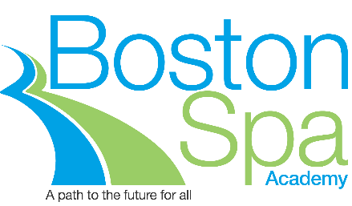

Principal: Mr C Walsh BA (HONS), MA, NPQH Chair of Governors: Mr S Hall

JOB DESCRIPTION

Job Title: School Minibus Driver

Pay Range: A1- A3

Hours 17.5 per week (split shifts)

Responsible to: Assistant / Site Manager

Role:

To work as part of a team to provide transport services to students for the Academy’s school to school transport provision with a morning and afternoon bus run on designated routes around the Leeds/Wetherby area.

The role includes performing routine safety checks on the vehicle.

Duties:

Driving

- Operate one or more of the designated bus routes, collecting children from given pick-up points along the route and delivering them to The Stephen Longfellow Academy (TSLA) on a morning and collecting them from TSLA and dropping them back at the given points on an afternoon.

- Ensure the minibus is kept clean, tidy and in good condition, including, but not restricted to:

- Weekly cleaning of the bus, both inside and out
- Ensuring signs inside the bus are properly attached and in good condition
- Performing regular visual checks of tyres, lights, oil, water and fuel
- Ensuring nay additional work required is communicated immediately to the Site Manager
- Refuelling the vehicle as required

Responsibilities

- Be aware of and comply with policies and procedures relating to child protection, health, safety and security and confidentiality, reporting all concerns to an appropriate person
- Present a positive personal image, contributing to a welcoming environment which supports equal opportunities for all
- Share responsibility for groups of students whilst driving the minibus
- Complete documentation on daily inspections of the minibus
- Liaise directly with parents/carers when necessary

Any Special Conditions of Service:

There is a requirement to submit to an enhanced DBS check. There may be an occasional need to work outside of normal working hours. No smoking policy.

PERSON SPECIFICATION

Qualifications

- Current, clean and valid driving licence which includes either D1 restricted (car licence obtained prior to 1 January 1997), a PCV licence or D1 unrestricted.
- MiDAS certificate (or willing to train)

Skills

- Able to communicate with a wide range of people
- Reliable and trustworthy
- Flexible approach to working
- Sensitive to user needs

Experience

- Previous experience of driving a minibus or similar sized vehicle
- Good geographical knowledge of the local area

Boston Spa Academy is committed to safeguarding children and the successful candidate will be subject to an enhanced DBS check.

Clifford Moor Road, Boston Spa, Leeds LS23 6RW
T: 01937 846636
E: info@bostonspa.leeds.sch.uk
W: www.bostonspa.leeds.sch.uk
@BostonSpaAcademy

