THE KING’S SCHOOL, GLOUCESTER

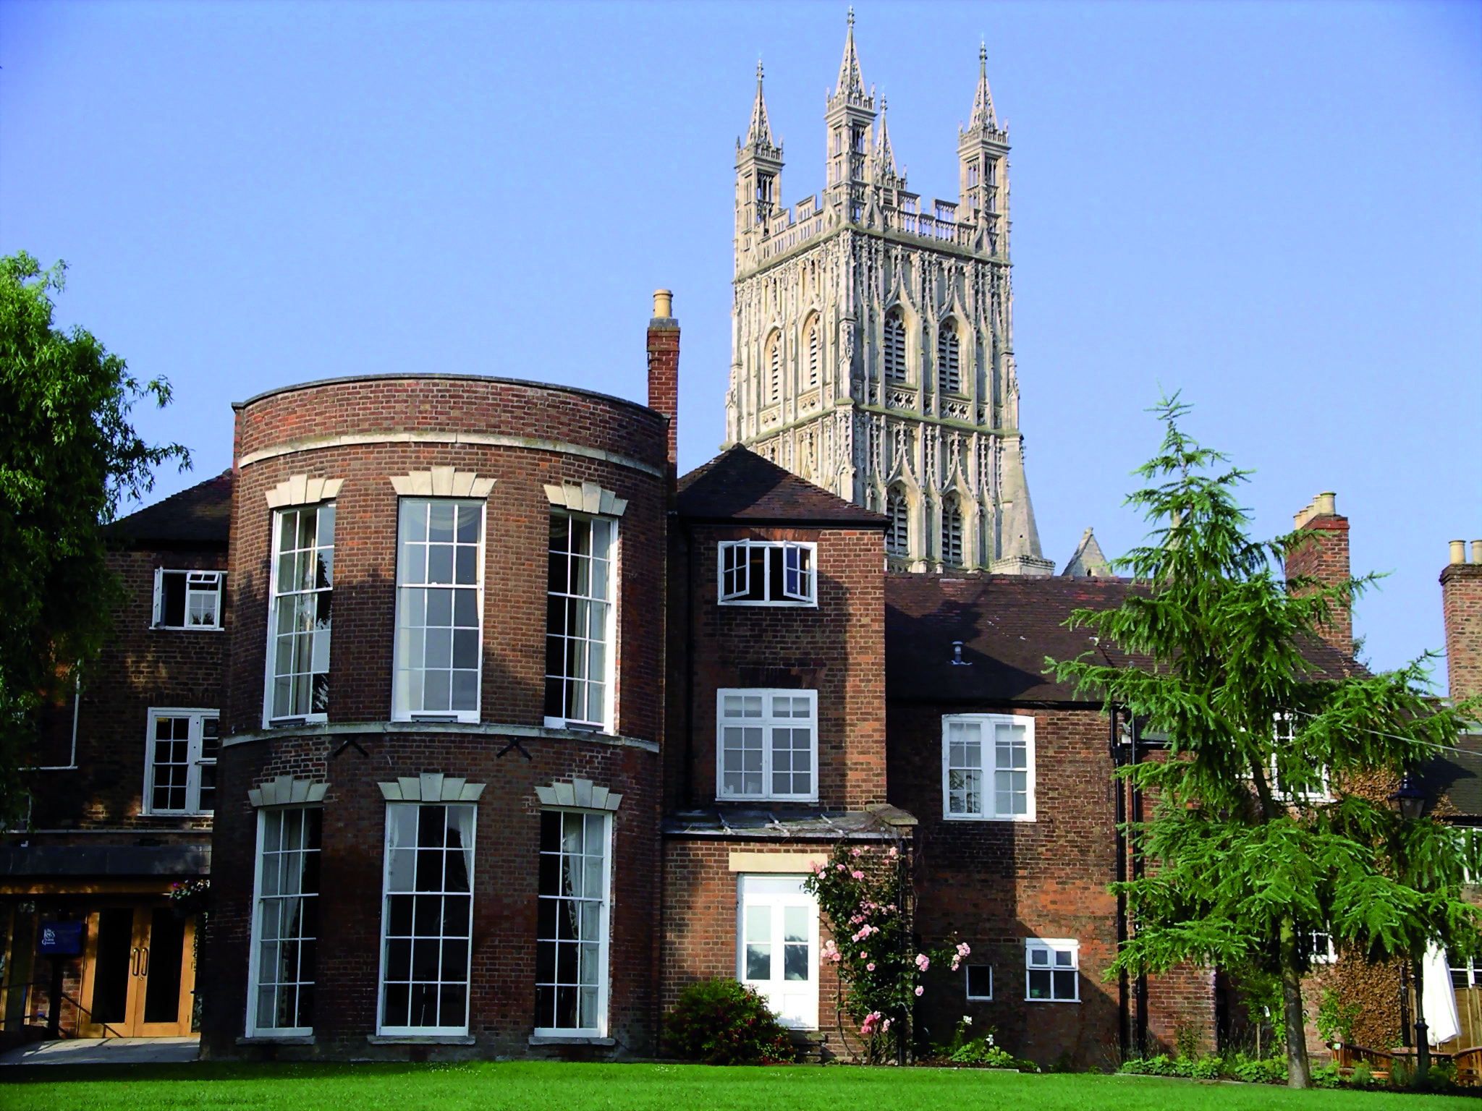

The King’s School, Gloucester is an independent co-educational school of approximately 590 pupils from the age of 3 to 18. Although there has been a school enfolded within the Cathedral for over a thousand years – and possibly even longer – it was refounded in 1541 by Henry VIII, hence the name of the School. The School has, as one of its tasks, the responsibility of educating the Cathedral Choristers. More generally, however, it is dedicated to producing the best in the individual, whether that be through academic work, Sport, Music, Drama or any of the wide-ranging activities that contribute so much to the life of the community.

Situated in the Cathedral Close, the school buildings are an interesting blend of medieval and modern. The King’s Junior School, which incorporates a Nursery, provides the principal route to Senior School, from 11 to 18. However, an even larger number come from a wide range of local schools. Increasingly the School is also seeing good numbers arriving beyond the First Form (Year 7), especially into the Third Form (year 9) and the Sixth Form (Years 12 and 13).

The School’s facilities are shared by pupils across the whole age range of 3 to 18 as well as by the local community generally. Assemblies and worship take place in the Cathedral on a daily basis.

The School has high academic aspirations whilst supporting pupils with specific learning difficulties. The School’s enrichment programme for the Gifted and Talented is much cherished, as is the School’s emphasis on independent learning. Recent academic results are a source of pride and repeatedly the School’s ‘value added’ measure is excellent. This arises out of the School’s ability to treat each pupil as an individual and is a reflection of the mutual support and respect which exists between staff and pupils. This is aided by small class sizes, with no Form or class being larger than 17/18 and many being smaller. Sixth Form classes in particular are invariably in very small groups, somewhat akin to university tutorials.

With its strong choral traditions, the School has a very active Music Department. Drama and Dance are also very strong, with regular productions that have a strong reputation for achieving the highest professional standards.

For its size the School is remarkably successful in sport, fielding teams in Rugby, Cricket, Netball, Tennis, Hockey, Rounders and Golf. Other sports are also encouraged. In recent years a large number of pupils have achieved county and national honours in a range of sports, though it is worth emphasizing that the School’s sporting ethos is chiefly about inclusion and participation at all levels and abilities. Archdeacon Meadow, the main sports field, is Gloucester’s only venue for first class cricket and is adjacent to indoor facilities which include a swimming pool. The School also has a flourishing programme in the Duke of Edinburgh’s Award Scheme and a wide range of trips is offered, both in the region, in other parts of the country and abroad.

In a recent Inspection by the Independent Schools Inspectorate the School was praised for its “excellent pastoral care” and “special sense of identity” and the pupils were found to have “a positive attitude to study and high standards of behaviour”.
APPLICATION AND RECRUITMENT PROCESS

EXPLANATORY NOTE

General

The King’s School, Gloucester is committed to ensuring the best possible environment for the children and young people in their care. Safeguarding and promoting the welfare of children and young people is our highest priority.

The School aims to recruit staff who share and understand our commitment.

All queries on the application form and recruitment process must be directed to the Bursar.

Application Form

Applications will only be accepted from candidates completing the enclosed Application Form in full. CVs will not be accepted in substitution for completed Application Forms.

Candidates should be aware that all posts in the School involve some degree of responsibility for safeguarding children, although the extent of that responsibility will vary according to the nature of the post. Please see job description for the post.

Accordingly this post is exempt from the Rehabilitation of Offenders Act 1974 and therefore all convictions, cautions and bind-overs, including those regarded as ‘spent’ must be declared.

The successful applicant will be required to complete a Disclosure form from the Disclosure and Barring Service for the post.

If you are currently working with children, on either a paid or voluntary basis, your current employer will be asked about disciplinary offences, including disciplinary offences relating to children or young persons (whether the disciplinary sanction is current or time expired), and whether you have been the subject of any child protection allegations or concerns and if so the outcome of any enquiry or disciplinary procedure. If you are not currently working with children but have done so in the past, that previous employer will be asked about those issues. Where neither your current nor previous employment has involved working with children, your current employer will still be asked about your suitability to work with children.

You should be aware that provision of false information is an offence and could result in the application being rejected or summary dismissal if you have been appointed and referral to the police and/or DCSF Children’s Safeguarding Operation Unit are also likely.

Invitation to Interview

If you are invited to interview this will be conducted in person and the areas which it will explore will include suitability to work with children.

All candidates invited to interview must bring documents confirming any educational and professional qualifications that are necessary or relevant for the post (eg the original or certified copy of certificates, diplomas etc). Where originals or certified copies are not available for the successful candidate, written confirmation of the relevant qualifications must be obtained by you from the awarding body.

All candidates invited to interview must also bring with them:

- A current driving licence including a photograph or a passport or a full birth certificate;

- A utility bill or financial statement showing the candidate’s current name and address;

- Where appropriate any documentation evidencing a change of name;

- Where the candidate is not a citizen of a country within the European Economic Area or Switzerland, proof of entitlement to work and reside in the UK.

Please note that originals of the above are necessary. Photocopies or certified copies are not sufficient.

Candidates with a disability who are invited to interview should inform the School of any necessary adjustments or arrangements to assist them in attending interview.

Conditional Offer of Appointment: Pre-Appointment Checks

Any offer to a successful candidate will be conditional upon:

- Receipt of at least two satisfactory references;

- Verification of identity and qualifications;

- A check of the Children’s Barred List;

- A satisfactory enhanced DBS Certificate;

- Verification of professional status such as GTC registration, QTS Status (where required), NPQH;

- Verification of successful completion of statutory induction period (for teaching posts – applies to those who obtained QTS after 7 May 1999);

- Where the successful candidate has worked or been resident overseas in the previous five years, such checks and confirmations as the School may require in accordance with statutory guidance;

- Verification of medical fitness;

- Satisfactory completion of the probationary period.

References

We will seek references for shortlisted candidates and may approach previous employers for information to verify particular experience or qualifications, before interview. If you do not wish us to take up references in advance of the interview, please notify us ASAP.

All referees will be asked if the candidate is suitable to work with children.

The School will compare any information provided by the referee with that provided by the candidate on the application form. Any inconsistencies will be discussed with the candidate.

Criminal Records Policy Statement

The School applies for an Enhanced Disclosure from the Disclosure and Barring Service for all members of staff and volunteers. An Enhanced Disclosure will give detail of cautions, reprimands or final warnings as well as convictions.

It may also contain non-conviction information from local police records which a chief police offer believe may be relevant.

The School will refer to the DCSF document, ‘Safeguarding Children and Safer Recruitment in Education’ and any amended version.

The School complies with the provisions of the DBS Code of Practice, a copy of which may be obtained on request.

Child Protection Policy Statement

The safety and welfare of all our pupils at The King’s School is our highest priority. Our business is to know everyone as an individual and to provide a secure and caring environment so that every pupil can learn in safety. We expect respect, good manners and fair play to be shown by everyone so that every pupil can develop his/her full potential and feel positive about him/herself. Pupils should care for and support each other.

In all matters relating to child protection the School will follow the procedures laid down by our own (or where appropriate the child’s) relevant Local Safeguarding Children Board (LSCB) together with DfE guidance contained in Working Together to Safeguard Children (DfE March 2015) and Keeping Children Safe in Education (DfE September 2016):
https://www.gov.uk/government/uploads/system/uploads/attachment_data/file/550511/Keeping_children_safe_in_education.pdf

This policy is applicable to the whole school community, including those pupils in the Early Years Foundation Stage (EYFS).

All members of staff have a duty to safeguard our pupils' welfare and must therefore familiarise themselves and comply at all times with this policy. All school staff should be aware that safeguarding incidents can happen at any time and anywhere and are required to be alert to any possible concerns. The school has a readiness to engage with and involve safeguarding agencies, taking advice from the LSCB when necessary. It is important for staff to appreciate that safeguarding is everyone’s responsibility and that anyone can make a referral to Children’s Social Care.

Equal Opportunities Policy Statement

The King’s School is an equal opportunities employer.
In order to promote an environment within which the school can call upon the widest possible range of knowledge, skill and experience, as well as ensuring compliance with the relevant legislation and codes of practice, we are committed to achieving and maintaining a workforce which represents the population within our recruitment area in terms of race or colour, nationality or national or ethnic origins, religion or belief, sex, sexual orientation, pregnancy or maternity, marital or civil partnership status, gender reassignment, age, and disability (together known as "Protected Characteristics").
To this end, we shall regularly review the operation of our recruitment, promotion, training and development policies to ensure that no applicant for employment or member of staff is disadvantaged by conditions or requirements which cannot be shown to be justifiable.
No employee or prospective employee will receive unfair or unlawful treatment on the grounds of a Protected Characteristic, because they are perceived to have a Protected Characteristic or because they are associated with someone who has a Protected Characteristic, in particular but not only, in relation to:
- Recruitment and selection
- Promotion, transfer & training opportunities
- Benefits, terms and conditions of employment
- Grievance and disciplinary procedures
- Termination of employment including redundancies
- Conduct at work
- Procedures ensure fair and equitable treatment in relation to admission and assessment of students.

Tel: 01452 337337
Fax: 01452 337319
Email: reception@thekingsschool.co.uk
www.thekingsschool.co.uk

