STUDENT SUPPORT MENTOR

Dear Colleague

Thank you for the interest you have shown in the position of part time Student Support Mentor within The White Hills Park Federation Trust. This is an exciting time for our Trust as we build on our successes and plan for the future.

We believe that the Trust will ensure all students can reach their potential, but also as a Trust we will be innovative and forward thinking in our delivery of education; in many respects the Federation Trust itself is an example of innovative practice.

We can offer you a forward-looking and effective Board of Directors, supportive parents, talented and dedicated professional colleagues and positive, well-motivated students. We pride ourselves on the strong relationships that have been established across all members of our Multi Academy Trust, and the contribution this makes to our improving student outcomes.

We are also keen that all colleagues within the Trust have the opportunity to develop and also progress professionally by experiencing new responsibilities and ways of working. As the Executive Principal I am keen to appoint colleagues who will make the most of the opportunities which a Multi Academy Trust brings; the diversity of experience which can be gained and the benefits which can accrue from working closely with colleagues from two other schools.

I hope that after reading the information you are encouraged to apply for the post of part time Student Support Mentor.

Yours sincerely

Paul Heery
Executive Principal

The White Hills Park Federation Trust
The White Hills Park Federation Trust is a collective group of schools in Bramcote, Nottinghamshire, and aims at bringing the benefits and economies of scale of a large establishment, while remaining as two individual schools, under one management structure and Governing Body. The Federation was founded in 2006 and the Multi Academy Trust in 2012.
Our two schools share one Sixth Form facility, called Bramcote College 6th Form. Students from schools and colleges outside of the Trust also attend the College.
We are located in the heart of Nottingham, within close proximity to the M1 and A52, and within easy reach of Nottingham City Centre as well as rural Nottinghamshire and Derbyshire, including the Peak District National Park.

The Aims of the Trust
Every student’s future is important to us; we will ensure that their potential will be reached and their needs will be catered for.
We recognise that we live in a rapidly changing world where those who can adapt, both as individuals and as communities, will be successful. The Trust will be flexible in order that we lead change as well as reap the benefits which the future will bring. We will also ensure that our students face the future with confidence.
We recognise that change brings opportunity and we will seek continual improvement in the work of the Trust and in the expectations that we have for our students.

Alderman White School
Alderman White School is a successful and inclusive school with a record of good progress, excellent student behaviour and a wide range of enrichment activities.
We have retained our distinct identity as a specialist language school, with students benefitting from a range of languages taught both as part of the main stream curriculum and of the extensive community programme including the Saturday family learning classes. We organise exchanges to Germany and visits to France and Spain.
The school is served by five main contributory junior schools, with a significant number of students from several other primaries within a wider geographical area. There is a high level of co-operation and contact within our 'family' and the school engages with many activities within the wider community.

Bramcote College
Bramcote College (formerly known as The Bramcote School) has a deserved reputation for being a small, inclusive and caring school with strong links with the local community. The school has strong, caring and supportive staff that are committed to raising achievement and the students are keen, loyal and enthusiastic and want to come to school. Young people at Bramcote College are known by their name and their individual potential and needs are supported and encouraged.
We pride ourselves on the breadth and choice of curriculum and of the education and experiences our students have every day. As well as GCSE’s, we can offer school courses and Entry Level qualifications to make the most of our students’ skills, talents and interests. At Bramcote College, we develop the attitudes and skills for every student that support a healthy and fulfilled life together with the confidence for a lifetime of learning.

Bramcote College 6th Form
Bramcote College 6th Form is the Post-16 provider for The White Hills Park Federation Trust. However the College is also open to other students from outside the Trust. The College aims to meet the needs of all students within the Trust; although the majority of courses at the College are traditional A- Levels, the college does provide alternative routes at both GCSE level and A-Level in the form of BTEC qualifications. We also aim to provide a very personalised system both in terms of the curriculum we offer and the guidance we provide. In order to achieve this both teaching and tutor groups are kept small; therefore offering more individual tuition to our students.
We believe that the success of the College rests upon three things: the progress our students make in terms of each individual reaching their potential, the high proportions of students who complete their courses, and also our success in ensuring all students achieve their favoured destination whether this is higher education, training schemes or embarking on their future career.
Of course time in the 6th Form is also about personal development. Our students play an active part in leadership programmes and organising activities for younger students; for example the College students act as House Captains for the Federation Trust House system.

General Information for Applicants
Candidates apply to the Trust and may work at more than one site. However, support staff will have a ‘home’ school within the Trust.
All offers of appointment are subject to:
- At least two satisfactory references (requested prior to interview)
- A satisfactory Enhanced Disclosure and Barring Service (DBS) check
- Proof of the candidate’s identity and their right to live and work in the UK
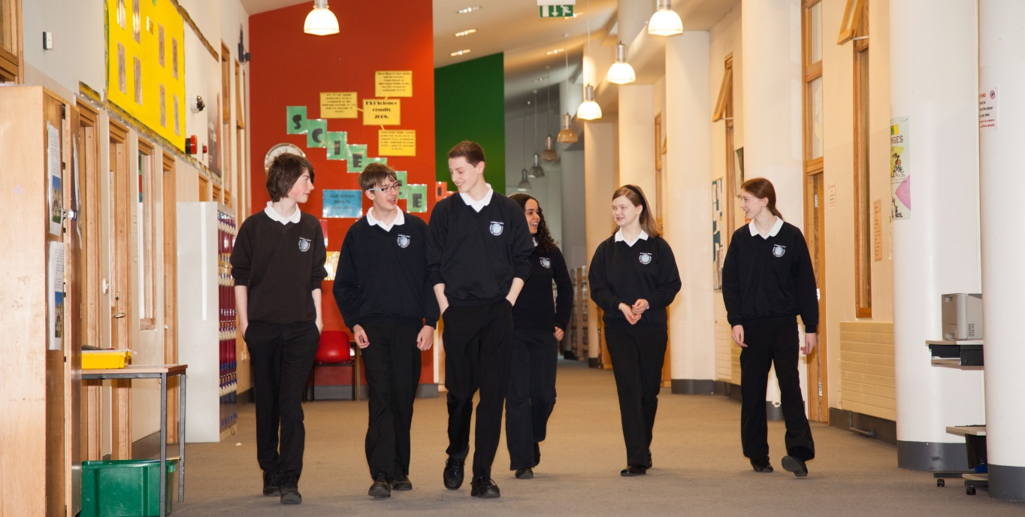
- Verification of qualifications and professional status

Please note: Applications should comprise the standard application form (attached) and a letter of no more than two sides of A4 explaining why you are a suitable candidate for the position of part time Student Support Mentor at The White Hills Park Federation Trust.
You may choose to include a CV if you feel that it will provide us with important information about you that we will not see from your letter or application form.
Applications should reach us by 10:00 am on Thursday, 19th July 2018. Shortlisted candidates will be invited to interview by letter or email.
Applications should be returned to recruitment@whpfederation.org.
If you have not heard from us in regards to an interview by two weeks after the closing date please assume that you have not been successful on this occasion. We do not inform candidates not shortlisted for interview.

Equal Opportunities
The White Hills Park Federation Trust is committed to equal opportunities and fair treatment of its staff and all applicants, on the principle that no one is discriminated against on the basis of his or her actual or perceived race, ethnic or national origin, caste, nationality, religion or belief, gender reassignment, sexual orientation, disability, marital status or civil partnership, pregnancy or maternity or age. All employees and students will be treated and valued equally.

The White Hills Park Trust

Job Description : Student Support Mentor
Location: Trust role
Salary: Grade 3 Pt 14 – 18 £17,681 to £18,870

GENERAL INFORMATION

The following information is provided to assist staff joining the Trust to understand and appreciate the work, content of the post and the role they are to play in the organisation. Whilst every effort has been made to outline all the duties and responsibilities of the post, a document such as this does not permit every item to be specified in detail. Broad headings have been used which assume all the usual associated routines.

PURPOSE OF THE POST

To provide a key role by assisting the Assistant Headteachers in supporting the welfare and progress of all students.

KEY AREAS:

- Support students either in or out of the classroom to ensure their welfare and educational progress.
- Act as mentor for individual students for example setting and monitoring targets, providing advice and
guidance.
- Provide support in dealing with incidents or emergencies which arise during the school day; for example
acting as investigating officer, providing support to students, resolving issues between students.
- Contact parents and other relevant agencies under the direction of the Senior Leadership Team.
- Supervise individual or small groups of students when accessing activities outside of their normal timetable.
- Provide support for the Leadership team around the school.
- Provide a good role model for students and staff.
- Motivate students by personal influence and concern for individual needs and development.
- Safeguard the Health and Safety of self and others in accordance with the Trust’s Health and Safety Policy.

DUTIES AND RESPONSIBILITIES:

- Be an active member of the Student Support Team, working with teaching staff in ensuring quality learning.
- Play a key role in behaviour management for example acting as investigating officer for student related incidents, and ensure such investigations are thorough and well documented.
- Support the work of teachers by monitoring the progress of individual students, implementing specific targets including IEPs.
- Support the Trust Behaviour policy by managing appropriate documentation e.g. detention letters, rewards.
- Support the welfare of students taking regard for the needs of the individual student.
- Assist in the induction of new students to the school.
- Organise the work for any students with fixed term exclusions.
- Assist in the organisation and delivery of parent consultation evenings.
- Manage appropriate activities for students when under your supervision.
- Make arrangements for parents to be informed when concerns arise over individual students or where praise should be encouraged.
- Attend multi agency meetings as appropriate.
- Assist in out of school activities e.g. school visits.
- Assist in the organisation of rewards using information provided by the data team.
- Assist with assessing, recording, and reporting a student’s progress and attainment.
- Inputting data into Go4Schools and CPOMS and maintain appropriate records.
- Contact parents and other agencies as required by the Senior Leadership Team.
- Provide guidance and counselling to individual students as appropriate.
- Ensuring that all staff receive the information they need in order to carry out their duties effectively.

Develop Personally and Professionally through

- Reflection on own practice and private study.
- Participate in the Trust’s appraisal programme.
- Participate in appropriate in-service education programmes.

Relationships

To be responsible to:
- The Head of School with line management through the Assistant Headteachers.

To co-operate with:
- The Governing Body, making such reports as required.
- External professionals such as Educational Psychologists.
- All colleagues, both teaching and support staff.
- LA, advisers.
- Unions and other organisations representing teachers and other persons on the staff.

This role is a Trust position and the post holder may be required to hold a comparable post on another site within the Trust, if the situation arises.

The job description may be subject to amendment or modification, should circumstances change, but any changes will be discussed with you in the first instance. Should a disagreement arise, you will be afforded the opportunity of a meeting to resolve the matter with your Line Manager who may involve officers of the CYPS Personnel Department as appropriate. You may wish to be accompanied at this meeting by a representative of your Trade Union if you so wish.

In addition to the duties specified you may be asked to undertake any other duties which may reasonably be regarded as within the nature of the duties and responsibilities/grade of the post as defined, subject to the proviso that normally any changes of a permanent nature shall be incorporated into the job description in specific cases. To provide flexibility and to meet the priorities of the Trust during times of peak work flow you will be asked to support other members of the Trust team undertaking duties that may be below your current grading.

The job description does not form part of the contract of employment.

Date Job Description Revised: June 2018

By Whom: Executive Principal

Person Specification
Attributes | Essential | Desirable | Criteria used for  Assessment
Experience  Experience of working with young people.  Experience of working in a Secondary School. | * | *  * | A  A
Qualifications  To be educated to at least GCSE or equivalent.  To have a specific professional qualification relevant to some aspect of the role. | * | * | A  A
Skills and Knowledge  Knowledge of how schools operate and the need for discretion and confidentiality.  An understanding of how young people learn and to improve student learning.  Good interpersonal skills, able to communicate orally and in writing.  The ability to motivate young people.  Good organisational skills. | *  *  * | *  * | I / R  I  A / I  I / R  R
Personal Qualities  Able to work as part of a team but also be a self- starter and be able to set personal goals.  The ability to get on well with students, to be an advocate for young people. | *  * |  | I / R  R
Equal Opportunities  The candidate will need to evidence a commitment to safeguarding and protecting the welfare of children/young persons.  Awareness, understanding and commitment to the pursuit of equal opportunity, in terms of service delivery and employment practice.  Awareness of disability discrimination policy. | *  *  * |  | A / I / R  A / I  A / I
Working Practices  Be willing to undertake training to enhance service delivery and self-development.  Willingness to share information and expertise with other staff.  Undertake First Aid Training. | *  *  * |  | A / I  A / I  A / I

