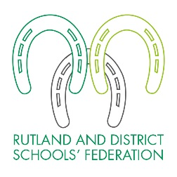
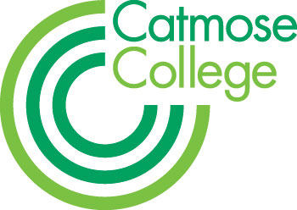
TEACHER OF RELIGIOUS STUDIES
MPS + Federation Benefits
As soon as possible
Full or Part Time applications considered

We are looking for a well-qualified and highly motivated teacher of Religious Studies, who has a love of their subject, any specialism considered. There is the possibility of teaching Philosophy & Ethics at A Level at our partner sixth form, Harington School.

We welcome applications from either NQTs who will be well supported by experienced mentors and through our teaching school alliance or from more experienced candidates where there are exceptional opportunities for further professional development and promotion.

The successful candidate will be joining a strong and supportive team of specialist teachers who take pride in achieving the best outcomes for all students. Catmose College is an over-subscribed 11-16 academy based in a new £26m building in Oakham, Rutland. The College was graded as ‘Outstanding’ by Ofsted in all four categories and overall in February 2012. We have outstanding facilities throughout, with purpose-built laboratories offering excellent teaching resources and access to numerous iPads, laptops and computers; the College is able to offer a truly outstanding technology-led learning environment.

Catmose College is part of the Rutland and District Schools’ Federation which currently consists of Catmose College, Catmose Primary and a Preschool provision. We are also proud to include Harington School, an academic sixth-form, in the Trust. This provides wider opportunities for staff, giving them broader experience across different organisations, including the opportunity to teach A-levels in an academically able environment, should their skills and experience be appropriate.

For successful candidates there are exceptional opportunities for further professional development and promotion across the Federation. Teachers are able to enjoy many additional benefits that come as part of working within the Federation. These include, amongst others:

• Teachers at the top of scale may receive up to a 2% pay award annually for good performance, in addition to any incremental pay progression;
• Relocation support for hard-to-recruit subjects;
• Vast range of staff training including a funded Masters scheme;
• Outstanding facilities;
• Primary and secondary form teaching opportunities;
• Staff laptops;
• Priority admission for children of staff to the College and Primary.

HOW TO APPLY
Application forms and information are available online at www.catmosecollege.com or by emailing the College on office@catmosecollege.com

- You should write a letter of application on no more than 2 sides of A4.
- You should complete all sections of the application form.
- On the form clearly state the names, addresses, telephone numbers and email addresses of two professional referees; it is our usual practice to ask for references before shortlisting and always to ask for references before interviews.
- It is a condition of employment that you have a successful DBS check made and can provide proof of identity and qualifications gained.

Please note that due to the high number of applications we receive for positions, your application is unlikely to be considered if you do not follow these requirements. CVs are not accepted. The closing date is Monday 25 September 2017. You should send your application to Stuart Williams, Executive Principal, Catmose College, Huntsmans Drive, Oakham, Rutland, LE15 6RP. Applications can also be emailed to office@catmosecollege.com

If you have not heard from us by Friday 29 September 2017, please assume that on this occasion your application has not been successful. Please enclose a SAE if you would like your application acknowledged.

