Dear Colleague,

Thank you for taking the time to find out more about the role of Teacher of Design and Technology (Maternity Cover) at Haverstock School. We hope very much that you enjoy reading the information provided and that you decide to apply for this role.

I became Headteacher of Haverstock in September 2017 and have been working with my team of committed colleagues to improve the school from the ‘Requires Improvement’ Ofsted judgement in January 2017. We were delighted with this summer’s set of results, with large gains across the board. We expect our Progress 8 Score to have moved from ‘significantly below average’ to ‘average’ and we have seen similar improvements in the Sixth Form. The school is increasingly self-confident and I hope that you are attracted to become part of a team who are on a journey of rapid improvement.

We are committed to supporting teachers to be as effective in the classroom as they can be without burning them out. Our centralised behaviour systems mean that disruption is rare - teachers are not expected to run detentions or follow up on behaviour beyond short ‘resolution’ meetings with students who have not met our high expectations. Teacher loadings have been reduced, with 40 periods per fortnight for Main Scale colleagues and we have introduced a range of CPD which is driven through faculty meetings, whole school input and a new group of Lead Learning Practitioners to help develop the quality of teaching and learning sustainably rather than quick wins or short-lived initiatives. Lesson observations are not graded but you will receive ‘little and often’ qualitative feedback to support the development of your practice.

The Design and Technology Department at Haverstock has a proud history, with the best GCSE results we have ever had last year, first class resources and fantastic facilities. The department has two fully equipped workshops, one with metal working facilities, a computer and electronics room and a food technology room. There are two fully stocked technician rooms, food and D&T, managed by two technicians, with all the bells and whistles to make practical lessons sing. Alongside the Head of D&T, there are two full time staff within the department.

Students in KS3 follow the National Curriculum over two years, with students receiving three hours per fortnight of curriculum time in Year 7 and Year 8. KS3 students work with different materials (wood, metal and plastic), electronics, CAD/CAM, technical drawing and food and nutrition. The focus at KS3 is to build the student’s practical skills and confidence to use their knowledge of a range of different materials, properties and processes, designing skills both by hand and on the computer and their analytical thinking to problem solve and evaluate. Level 2 courses start in Year 9 where we offer OCR Cambridge National Certificate in Engineering Design. Students have six hours per fortnight of curriculum time. We are introducing A-level Design Engineering (OCR) in September 2019. All KS5 courses have 10 hours of curriculum time.

The department runs a Designers and Makers club, where we find different competitions for students to work on and enter. In the past these have included Design Ventura run by the Design Museum, engineering and architecture competitions and VEX IQ robotics. This is by no means an exhaustive list and the D&T department is always looking to expand the competitions and to increase the range of trips it can offer.

The closing date for applications is Monday 15th October at noon and interviews will be held later that week. We regret that we are only able to contact short-listed candidates but please do forewarn your referees of the possible request for a reference. Please note - references will be requested prior to interview unless indicated on application form not to do so.

Thank you, again, for requesting information about becoming a Design Technology Teacher (Maternity Cover) at Haverstock School. If you would like to find out more in advance of applying, please don’t hesitate to contact jobs@haverstock.camden.sch.uk to arrange an informal discussion or visit to the school. We very much look forward to receiving your application.

Yours sincerely
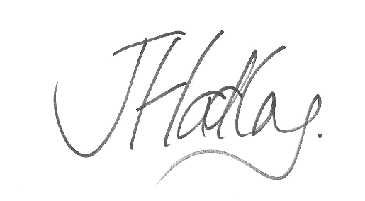
James Hadley
Headteacher

