Housekeeping Assistant

Candidate briefing pack
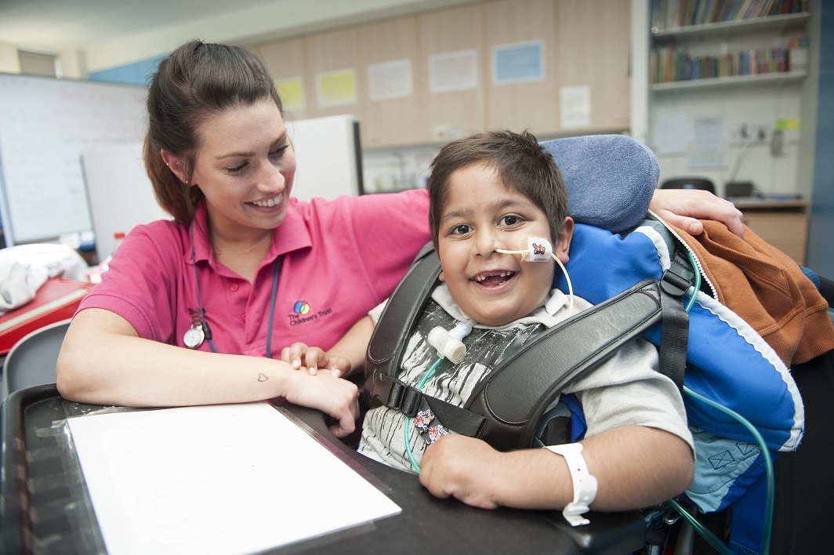

Dear Candidate
Thank you for your interest in becoming our new Housekeeping Assistant at The Children’s Trust. There are a variety of shifts available please indicate on your application form which shifts you would be interested in – Day, Evening or Weekends.
The Children’s Trust is the UK’s leading charity for children with brain injury. We are unique, with an international reputation for the work we undertake to improve the lives of the children and families with whom we work. We provide information and support to thousands of children with brain injury and their families annually, through education, care, therapy and research. We provide expertise and experience in meeting the needs of children and young people with acquired brain injury, neuro-disabilities and complex health needs.
As a Housekeeping Assistant, your role will be supervised by the Housekeeping Supervisor and will report the Housekeeping Lead. Your role will be to provide a high standard of housekeeping and accommodation service across site. You will provide excellent levels of cleanliness that are consistent throughout the site; working either the day, evening or weekend shift.
You will be a natural and enthusiastic housekeeper working not only as part of a team but also individually.
This is a chance for an outstanding candidate to make a significant and lasting difference to the lives of thousands of children and families.

Kind regards

The Charity
The Children’s Trust is the UK’s leading charity for children with brain injury and complex health needs.
The charity provides rehabilitation, medical care, special education, community services and expert information.
Our key services are:
- Rehabilitation for children with Acquired Brain Injury (ABI)
- A residential non-maintained special school for children with Profound and Multiple Learning Difficulties (PMLD)
- Support for children with ABI and their families in the communities across the UK, through our Brain Injury Community Services.
- Online information and support via our publications and braininjuryhub.co.uk

Our residential services based at our national specialist centre in Tadworth, Surrey, work in partnership with the NHS and local authorities to provide a step-down pathway of care between hospital and home. The centre is entirely child and family focused to ensure that their needs are appropriately supported.
In the community, we provide clinical support to complement local services and give children and young people with ABI the best chance of succeeding at home and in school.
We are the only paediatric centre with a national specialised commissioning contract (through NHS England) to provide brain injury rehabilitation for children with severe brain injury. Our other services are funded through local health commissioners (such as clinical commissioning groups), social care and education authorities, together with the millions raised through voluntary fundraising.
Thanks to the generosity of The Children’s Trust’s supporters, our 24 acre Tadworth site features a modern hydrotherapy pool, accommodation for parents, specially adapted equipment, soft play areas and a wheelchair-accessible treehouse.
We run a non-maintained residential special school for children with PMLD. The Children’s Trust School supports children and young people from 3 to 19 years old and is dual-registered with
the Care Quality Commission (the school residential houses) and Ofsted.
The Children’s Trust is a charitable organisation with approximately 595 committed staff
and 560 volunteers with a range of expertise across nursing and care, education,
therapy, operations and centralised support functions such as finance, HR, fundraising
and communications. A number of these staff are based off site around the UK as
part of our community work or in our charity shop.

Job Description

Job Title | Housekeeping Assistant (Day or Evening or Weekends)
Supervised by | Housekeeping Supervisor
Reports to | Housekeeping Lead
Direct reports | n/a
Location | Based in Tadworth Court
DBS | Enhanced

Job Purpose
To provide a high standard of housekeeping ensuring excellent levels of cleanliness are consistent throughout the site and that infection control procedures are met across site. The role holder will work either the day; evening or weekend shift.

As part of the site services team the role holder will be expected to liaise with managers and staff across the Trust. The role holder is expected to work closely with the other members of the facilities team and assist in covering in the laundry, in the deep clean team or other works as and when required.

Duties and Responsibilities

Site wide general housekeeping service – ensure that the housekeeping services is of an acceptable level and is consistent across site.
  - To carry out a cleaning service in allocated buildings/rooms/areas ensuring that daily tasks are completed according to the standard operating procedures in relation to the cleanliness/hygiene standards.
  - To follow infection control procedures whenever carrying out duties and ensure procedures are followed should there be an infection control outbreak
  - To liaise with the Housekeeping Supervisor and House Staff on a daily basis – carrying out special requests in relation to Housekeeping
  - To ensure safe storage of cleaning materials and equipment and sufficient stock is maintained – informing the Housekeeping Supervisor of stock requiring ordering
  - To assist in the cleaning of communal areas on a daily basis and cleaning of carpets, curtains and high dusting on a rotating schedule.
  - To ensure that any repairs required to fixtures and fittings are reported to the designated Facilities Helpdesk as soon as possible and any issues are reported to the Housekeeping Supervisor.
  - To assist in routine housekeeping audits as outlined in the planned preventative maintenance (PPM) schedules and ensure any works are to agreed service levels
  - Prioritise work to complete assignments in a timely manner
  - Assist other members of the Site Services and Facilities teams as required.

Central Laundry Services/Staff Accommodation – where resourcing requirements are required to assist in the provision of these services
  - Where required work with the Housekeeping Lead/Laundry Operatives to process the laundry in a timely and efficient manner according to the standard operating procedures ensuring that cleanliness and hygiene standards are met and maintained in the central laundry.
  - Where required any repairs required to fixtures and fittings are reported to the designated Facilities Helpdesk as soon as possible.
  - Where required assist the Housekeeping Supervisor/Assistants to ensure that accommodation is prepared to agreed standards for guests/staff to move in.
  - Where required carry out the final check of accommodation on a changeover day to ensure minimum standards have been met and guests are able to move in.
  - Highlight any issues regarding tenant occupation to the Housekeeping Supervisor and in their absence to the Housekeeping Lead (as appropriate).

Training & Development – in conjunction with the Housekeeping Lead through training and development and customer liaison maintain a high standard of cleanliness
- To attend team meetings with housekeeping and laundry staff
- To attend mandatory training sessions and gain the required certification.
- To develop self to improve personal performance within the department.
- Meet regularly for performance and development review, identifying learning objectives and setting targets; identifying opportunities for professional development.
- To read all policies and procedures relevant to working practice and to keep up to date with policy changes as they occur.

Health and Safety - the role requires a significant degree of manual handling and working with house services/laundry equipment
  - To be responsible for your own health and safety.
  - Co-operate with your manager and colleagues on health and safety matters.
  - Maintain knowledge of COSHH requirements
  - Do not interfere with anything that is provided to safeguard health and safety.
  - To comply with the Trust’s Health and Safety Policy and Procedures.
  - Participate in risk assessments and audits as required and ensure that all works carried out are in compliance with assessments.
  - To ensure manual handling procedures are adhered to and regularly reviewed.
  - To attend all mandatory training sessions relevant to the role

Person Specification

Selection Criteria
Education & Qualifications | - GCSE English (grade C or above) or equivalent – desirable  - NVQ Level 2 in Housekeeping Services (or willingness to work towards)
Experience | - Able to work as part of a team  - Understanding of working within a caring environment  - Health and safety aware  - Previous experience in a housekeeping/cleaning role (ideally from a NHS/Schools or equivalent background)
Skills & Abilities | - physically fit for moving, lifting and cleaning  - friendly and caring  - understanding of children’s needs  - able to take responsibility for their own work  - flexible and adaptable  - able to follow instructions and procedures  - To be able to communicate effectively with line manager and all staff  - Strong organisational skills
Knowledge | - Knowledge of Health & Safety  - Knowledge of Infection Control within a house services environment  - To have a knowledge of Health and Safety requirements when handling and storing cleaning materials - Desirable

Safeguarding

The Children’s Trust is committed to safeguarding and promoting the welfare of children and young people. To achieve our commitment, we will ensure continuous development and improvement of robust safeguarding processes and procedures that promote a culture of safeguarding amongst our workforce.

The Children’s Trust has policies on safer recruitment, the recruitment of ex-offenders and criminal record checks, please refer to the Resource Team for further information.

Equality and Diversity

The Children’s Trust recognises the value of diversity and is committed to equality of opportunity. We expect staff to be treated with dignity and respect and solely on the basis of their merits, abilities and potential regardless of age, sex, sexual orientation, marital or civil partnership status, disability, race, nationality, ethnic origin, religion or belief as stated in the Equality Act 2010. We expect all staff to share this commitment and promote equality and diversity amongst their teams.
Values

Our ambition is to provide a professional service where the children and families are at the centre attention of what we do or us to be able to use this opportunity and to achieve this vision & ambition. We require all of our staff to be actively promoting and sharing our values that bring us closer to achieving our goal.

