Headteacher Application Pack –
St Margaret’s Primary Academy
Letter from Steve Lancashire, Chief Executive, REAch2 Academy Trust

Dear Candidate
Thank you for your interest in this role within the REAch2 Academy Trust.
This is a hugely exciting time for our family of schools. The Trust has been recognised by the Department for Education as being well placed to raise standards and achieve excellence for pupils in a growing number of schools nationwide. We are presented with a rare opportunity to make a real difference to the lives and life chances of so many primary school children – many of whom haven’t previously received the educational opportunities they deserve.
The Trust includes schools at all stages of development, from those requiring significant improvement through to existing outstanding schools. As a Trust we are clear about the importance of achieving long term sustainability for our schools. Our vision is to enable individual academies to flourish with real autonomy, whilst also ensuring a strong ethos of support and collaboration across our schools.
Teachers within REAch2 belong to a national community of professionals, and benefit from a wide range of networks and development opportunities across the Trust. In time, our best teachers are able to work across schools, develop specialisms and step up to leadership roles within and beyond their own academy. The Trust provides a strong culture of collaboration and support, together with high expectations for staff and pupils alike.
Those we recruit are able to demonstrate that they share our values, are highly motivated to work with colleagues within and beyond their school to continuously develop their skills and pursue professional excellence, and are committed to providing the highest standards of teaching for all children. If that is you then we would be delighted to receive your application.
Steve Lancashire

Chief Executive, REAch2 Academy Trust

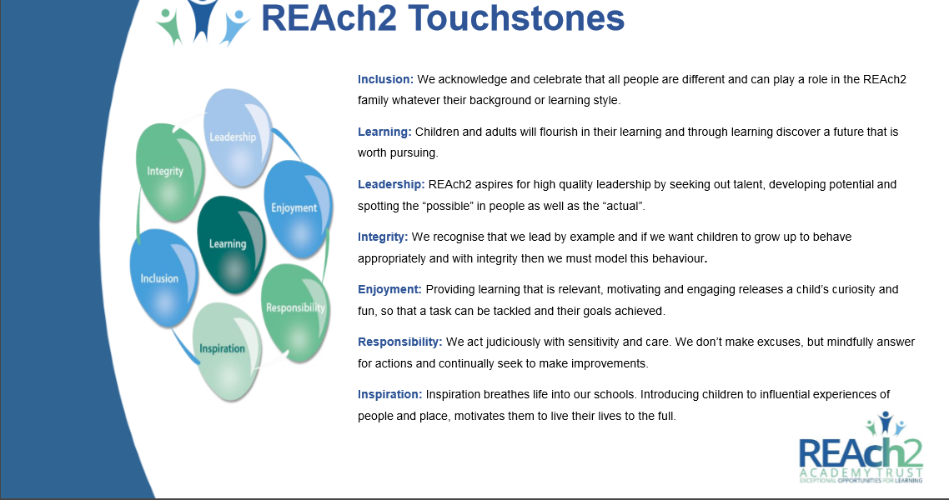

The role
Headteacher – St Margaret’s Primary Academy, Lowestoft, Suffolk
Salary: £55, 600 - £64, 417 (L15 – L21) Dependent on experience
Do you want to have an enduring impact on children’s education?
Do you want to provide exceptional opportunities for learning?
We are looking for a passionate and inspiring leader with a clear strategic vision for improving the school's effectiveness and raising standards and expectations through strong and exceptional leadership and management.
St Margaret’s Primary Academy is committed to developing lifelong learners who are responsible citizens that have limitless possibilities for their future. St Margaret’s caters for children between 3 and 11 and at present there are over 400 children on roll. Our purposeful, relevant and enquiry-based curriculum provides all our children with the skills and experiences to allow them to embrace an ever changing world.
The school was recently judged to ‘require improvement’ by OFSTED, with three areas graded ‘good’, and we are working hard to ensure that we are judged as a ‘good’ school for the next inspection. We need a committed headteacher who will continue to build on the current successes and develop a clear strategic vision for improving the school's effectiveness and raising standards. You will be passionate and committed to bring about the necessary changes and will relish the challenges ahead.
We can offer:
- A busy and friendly school (extract from 2018 Ofsted report: ‘Pupils are keen to learn and show consideration for one another’)
- Supportive colleagues
- An exciting challenge where you can truly make your mark
- The benefits of being part of the forward thinking REAch2 Academy Trust - one of the most successful primary Trusts in the country

- A wide range of professional development opportunities and the opportunity to work with some inspirational educational professionals
- Strong induction/ onboarding and high levels of support from the regional team

You will need to be a strategic leader who:
- is a dynamic, motivational leader with a proven success record of improving teaching and learning
- leads by example and has a track record of raising standards and levels of achievement
- is able to inspire and motivate staff
- is an excellent, engaging communicator who will develop strong relationships with children, parents, staff and the wider community

The application
You are invited to submit an application form.

REAch2 Academy Trust have an Equal Opportunities Policy for selection and recruitment. Applicants are requested to complete and return the Equal Opportunities Monitoring form separately with their application.

In accordance with our Safeguarding Policy the successful candidate will be required to have an enhanced DBS check.

To arrange an informal discussion please contact the Regional Director – Gill Ellyard (Gill.Ellyard@reach2.org)

Completed application forms and equal opportunities monitoring forms should be sent to:
Caroline Bellett (HR Business Partner: East Anglia) e-mail: caroline.bellett@reach2.org

The application process and timetable
Application deadline: | Monday 24th September (10am)
School Visits: | Please telephone Caroline Bellett (HR Business Partner: EA) for an appointment – 07341 774559
Assessments & Interviews | Thursday 27th September 2018
Contract: | Permanent
Salary: | L15 – L21
Job starts | January 2019

The candidates selected for interview will be informed after shortlisting and full details of the interview programme will be provided.

Job Description – Headteacher
Post: Headteacher
Salary: L15 - L21
Responsible to: Regional Director

Core Purpose
The Headteacher shall carry out the professional duties as described in the School Teachers Pay and Conditions Document and would be expected to have considered these in relation to the Academy.
The Headteacher is accountable to the Local Governing Body and Regional Director for ensuring the educational success of the school within the framework of the Academy’s strategic plans. The Headteacher will provide professional leadership and management to the school and must establish a culture that promotes excellence, equality and high expectations of all pupils.

Responsibilities
To be accountable to the Regional Director for:
- The effective implementation and embedding of the agreed school vision, principles and policies within the school;
- Providing leadership across all aspects of the internal organisation: professional leadership, management and control of the academy;
- Creating a culture of constant improvement and being an inspirational leader, committed to the highest achievement for all in all areas of the school’s work;
- The Headteacher will have line management responsibilities for the Deputy Headteachers/Assistant Headteachers in the school;
- Promote excellence in teaching and learning, ensuring a continuous and consistent focus on pupils’ achievement and development (whole-person as well as academic);
- Ensuring that a high quality educational experience is available for all children and young people;
- Creating a positive culture of support and high expectations, in order to achieve the school’s Strategic School Development Plan, raise standards and improve the quality of teaching;
- Ensuring that teaching in all year groups is improving;
- Ensuring that all children make good progress including where there are barriers to learning, through clear, consistent and excellent systems and provision for all, actively promoting inclusion;
- Ensuring effective and appropriate pastoral support is available to children in the academy;
- Through robust and effective monitoring and evaluation, identify and act on areas of improvement in relation to the curriculum and assessment;
- Keeping informed of developments within the National Curriculum and other relevant curriculum development sources, to ensure that the curriculum is rich, relevant and inspirational and contributes to outstanding educational and whole-person outcomes;
- Ensuring creativity, innovation and the use of appropriate new technologies to achieve excellence;
- Developing an inclusive and supportive approach so that the academy is a place where all young people and the wider school community feel welcome.

Developing Self and Working with Others
- Treat everyone within the academy fairly and equitably;
- Develop a culture of personal responsibility that recognises both excellence and supports appropriate strategies to deal with under-performance in accordance with Trust Appraisal and Capability policies and procedures;
- Ensure a high standard of professional development for all staff and for self, including attending all mandatory training events;
- Work with the SLT to recruit and retain staff of the highest quality, in line with Trust policy and safer recruitment procedures;
- Work with senior colleagues to deploy all staff effectively in order to improve the quality of education provided;
- Regularly monitor the budget for the school and the use of resources;
- Manage and organise the school environment efficiently and effectively to ensure that it meets the needs of the curriculum and health and safety regulations;
- Ensure that the allocation and use of accommodation within the school provides a positive learning environment that promotes the highest achievement for all;
- Work with REAch2, the Regional Director, SLT and School Business Manager to maximise the level of external funding that is attracted to support the academy’s development;
- Promote, embed, secure and monitor all agreed school policies.

Securing Accountability
- Work with the Local Governing Body (LGB) to enable them to meet their responsibilities;
- Ensure that individual staff accountabilities are clearly defined, understood and agreed and are subject to rigorous review and evaluation;
- To develop a school ethos which will enable everyone to work collaboratively, share knowledge and understanding, celebrate success and accept responsibility for outcomes;
- Develop and present a coherent, understandable and accurate account of the academy’s performance to a range of audiences including governors, parents and carers;
- Reflect on personal contribution to school achievements and take account of feedback from others.

Strengthening Community
- Build a school culture and curriculum which takes account of the richness and diversity of the academy’s communities;
- Ensure learning experiences for pupils are linked into and integrated with the wider community and within the REAch2 community of schools;
- Create and maintain an effective partnership with parents and carers to support and improve pupils’ achievement and personal development.

Shaping the Future (Strategic Leadership)
- Work with the SLT and the LGB to develop the shared vision and strategic plan for the academy, which is responsive to the community it serves. At the core of this should be the educational and personal development of the pupils;
- Work with the Regional Director, Governors and staff to define and implement the academy’s vision and strategic direction so that it is understood and acted upon by all stakeholders;
- Work within the school community to translate the vision into agreed objectives and operational plans, which will drive forward and sustain school improvement;
- Ensure the sustained raising of aspiration, achievement and attainment, is met through an inclusive, sustainable and innovative lifelong education environment;
- Ensure the school achieves its performance targets;
- Demonstrate the vision and values of the school in everyday work and practice;
- Motivate and work with others to create a shared culture and positive climate;
- Promote the academy and develop effective and productive relationships with a wide range of stakeholders;
- Secure the commitment of parents and the wider community to the vision and direction of the academy;
- Challenge, motivate and empower others to attain ambitious outcomes;
- Working with the Regional Director, develop strategies for school readiness in Early Years and a positive transition across Key Stages and into both primary and secondary education for children and parents.

Leading Learning and Teaching
- Drive and inspire a passion for learning in every member of the school community;
- Provide a model of outstanding practice to all staff in teaching and school leadership;
- Secure and sustain effective teaching and learning throughout the academy by ensuring sound strategies are in place for monitoring and evaluating the quality of teaching and standards of pupils’ achievement, using benchmarks and setting targets for rapid improvement of all children including those in vulnerable groups;
- To build a collaborative learning culture within the school and actively engage with other schools within the wider REAch2 family to build effective learning communities;
- Work with all staff to build effective teams;
- Sustain their own enthusiasm and motivation and develop and sustain that of other staff;
- To ensure effective planning, allocation, support and evaluation of work undertaken by teams and individuals, ensuring clear delegation of tasks and devolution of responsibilities;
- Develop and maintain effective strategies and procedures for staff induction, professional development and appraisal as below;
- Effective and consistent implementation of the Teachers’ Appraisal Policy and other systems of quality assurance and professional development of teachers;
- Motivate and enable all staff to carry out their respective roles to the highest standard, through high quality continuing professional development based on assessment of needs and identified through the appraisal process;
- Develop and maintain respect across all stakeholders, inspiring individuals to contribute positively to shared ideas and plans for the academy and the wider REAch2 family;
- Under the direction of the Regional Director, develop capacity, through coaching and mentoring members of the SLT;
- Keep abreast of educational developments and best management practice in order to introduce appropriate innovation and contribute to joint practice development.

Managing the Organisation
- Produce and implement clear, evidence-based improvement plans and policies for the development of the school and its facilities;
- Advise Governors on the formulation of the annual budget in order that the school secures its objectives;
- Receive and approve the academy budget in order to ensure that the academy meets its objectives;
- Manage the academy’s financial and human resources effectively and efficiently to achieve the school’s educational goals and priorities;
- Seek opportunities to invite parents and carers, community figures and those from the wider REAch2 family, business or other organisations into the school to enhance and enrich the school and its value to the wider community.

Equal opportunities
- Take responsibility, appropriate to the post, for tackling unlawful discrimination amongst all groups in line with the Equalities Act 2010.

Safeguarding children and Safer Recruitment
- Have due regard for safeguarding and promoting the welfare of children and young people and to follow all associated child protection and safeguarding policies as adopted by the academy;
- Ensure that all policies and procedures adopted by the LGB are fully implemented and followed by all staff;
- Act in the role of designated safeguarding lead and fulfil all associated duties as outlined in keeping Children Safe in Education 2016 (or any subsequent updates);
- Ensure that sufficient resources and time are allocated to enable the designated person and other staff to discharge their responsibilities, including taking part in strategy discussions and other inter-agency meetings, and contributing to the assessment of children;
- Ensure that all staff and volunteers feel able to raise concerns about poor or unsafe practice in regard to children, and such concerns are addressed sensitively and effectively in a timely manner in accordance with agreed whistle blowing practices.

Health and Safety
- Work in compliance with the academy’s Health and Safety policies and under the Health and Safety at Work Act (1974), ensuring the safety of all parties with whom contact is made, such as members of the public, in premises or sites controlled by the academy;
- Ensure compliance with procedures is observed at all times under the provision of safe systems of work through a safe and healthy environment and including such information, training, instruction and supervision as necessary to accomplish those goals.

Data Protection
- To ensure compliance with the General Data Protection Regulations (2018), Data Protection Act (2018) and the Freedom of Information Act (2000).

Person Specification: Headteacher
Knowledge/Qualifications and Experience | Essential | Desirable
Graduate with Qualified Teacher Status | *
NPQH (or equivalent) achieved or underway |  | *
Evidence of further qualifications |  | *
Significant experience at HT/HoS level |  | *
Understanding of leading an academy | *
Experience of leading an academy |  | *
Understanding of the challenges of leading a large school | *
Experience of developing a differentiated and creative curriculum to pupils with a diverse range of social, emotional, cultural, intellectual and physical needs | *
Ability to use a range of evidence, including performance data, to support, monitor, evaluate and improve aspects of school life, including challenging poor performance | *
Ability to engage the school community in the systematic and rigorous self-evaluation of the work of the school | *
Evidence of recent professional development that prepares for this post | *
Experience of monitoring and improving the quality of teaching and learning | *
Experience of having led, or made a significant contribution to, the success of a school, through its leadership, pupil outcomes and ethos | *
Experience of supporting staff to optimise attainment and progress of pupils | *
Evidence of an ability to plan strategically, build and communicate a coherent vision in a range of compelling ways | *
Extensive experience of working with children with significant barriers to learning |  | *
Knowledge of legislation relating to managing a school including Equalities legislation | *
Skills and abilities and professional attributes
Proven ability to inspire, lead and participate actively in building and sustaining a learning community and network with others within and beyond the school | *
Understanding and ability to communicate and successfully implement strategies across all aspects of the school including accountability, learning, curriculum, administration and communication | *
Proven ability to deliver a collective vision and shared purpose | *
Outstanding teaching | *
Experience of effectively managing the impact of change on organisations and individuals | *
The ability to deliver effective strategic financial planning, financial management including budgetary control and value for money | *
An understanding of and competent use of ICT including emerging technologies to aid and promote the quality of teaching, learning and administration | *
Excellent organisational skills | *
Well-developed interpersonal and communication skills and ability to use new and emerging technologies to secure impact | *
Clear understanding of the ethos and strategies required to establish consistently high standards in outcomes, progress, attitudes and behaviour | *
Able to meet national standards for Headteachers | *
Demonstrate a personal enthusiasm and commitment to leadership aimed at making a positive difference to children and young people and raising standards | *
Demonstrate personal and professional integrity, including modelling values and vision | *
Evidence of a commitment to safeguarding and promoting the welfare of children and young people | *
Commitment to promote and support the aims of REAch2 | *

Simply Making Possibilities Achievable

The school
Location
- St Margaret's Primary Academy, Church Road, Lowestoft, Suffolk, NR32 4JF
- E-Mail: admin@st-margarets.suffolk.sch.uk
- www.st-margarets.suffolk.sch.uk

- Telephone: 01502 530130

