King James’s School – The Languages Department

Languages Team Staffing

Alexander Gibson Head of Department & Teacher of French & Spanish
Naomi Pinkney Second in Department & Teacher of French &Spanish
Pascale Bradbury Teacher of French
Ailsa Griffiths Teacher of French
Philip Coxon Vice Principal, Teacher of French

Accommodation

The Languages area consists of three main rooms. All are equipped with Promethean Interactive Whiteboards.
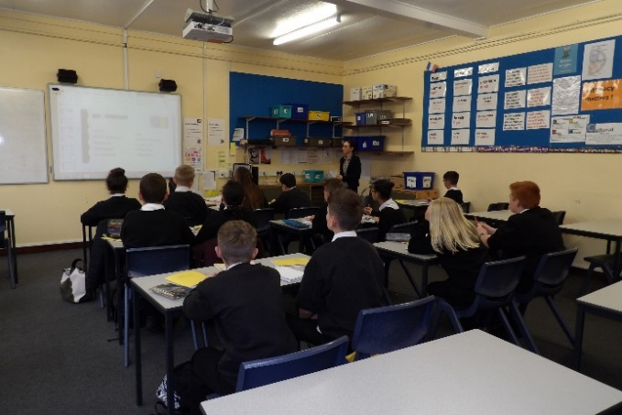
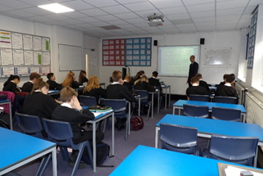

Curriculum

The languages taught are French and Spanish. Both languages are taught throughout the school, and are compulsory in Key Stage 3 except to a small number of children identified after Year 7, they are taught Literacy skills in the Loft. Both subjects are options in Key Stage 4.

Students are taught in mixed ability classes in Year 7, and are setted thereafter. Two groups of the most able linguists do Spanish, in Years 8 and 9.

In Year 10, students can chose either French or Spanish to GCSE.

Resources

In French, the main text books in Key Stage 3 are Acces, Studio 1 and Studio 2 Rouge and Vert and Studio 3 Vivia 1, 2, 3 for Spanish. In Key Stage 4 the main course books are AQA Studio for French and AQA Viva for Spanish.

In Key Stages 3 and 4 the course books are supplemented by a wide variety of internally produced material and Boardworks resources on the Interactive Whiteboard.

KS4 Results

The results are:-

French | A* | A | B | C | D | E | F | G | U | Total
2014 | 0 | 7 | 11 | 19 | 19 | 4 | 0 | 0 | 0 | 61
2015 | 4 | 8 | 9 | 25 | 10 | 2 | 0 | 0 | 0 | 58
2016 | 6 | 7 | 7 | 19 | 3 | 0 | 0 | 0 | 0 | 42
2017 | 5 | 3 | 11 | 11 | 4 | 1 | 0 | 0 | 0 | 35

Spanish | A* | A | B | C | D | E | F | G | U | Total
2014 | 0 | 3 | 8 | 6 | 3 | 0 | 0 | 0 | 0 | 20
2015 | 3 | 5 | 8 | 5 | 2 | 0 | 0 | 0 | 0 | 23
2016 | 5 | 3 | 11 | 11 | 4 | 1 | 0 | 0 | 0 | 35
2017 | 4 | 4 | 1 | 7 | 1 | 0 | 0 | 0 | 0 | 17

Extra-Curricular Activities

The Department runs regular revision sessions to help students achieve their potential. These are usually held after school.

The Languages Department run an annual trip to either France or Spain. The trips are cultural and also involve language lessons.

KS4 are able to be involved in one day courses for French or Spanish organised by Leeds or Manchester University.

January 2018

