Richard Lee

Primary School

Letter of Welcome

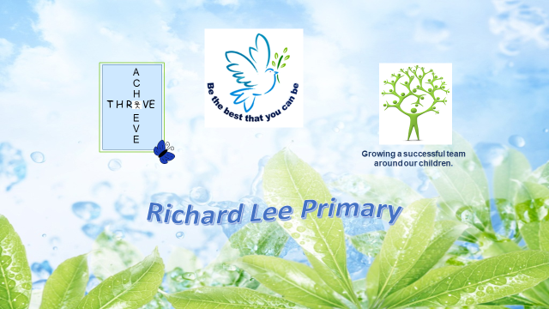
April 2018

English Lead

TLR2b

Thank you for downloading information about the English Lead role at Richard Lee. I hope you find the information here useful. look forward to hearing from you,

Carol Brammer

Head Teacher

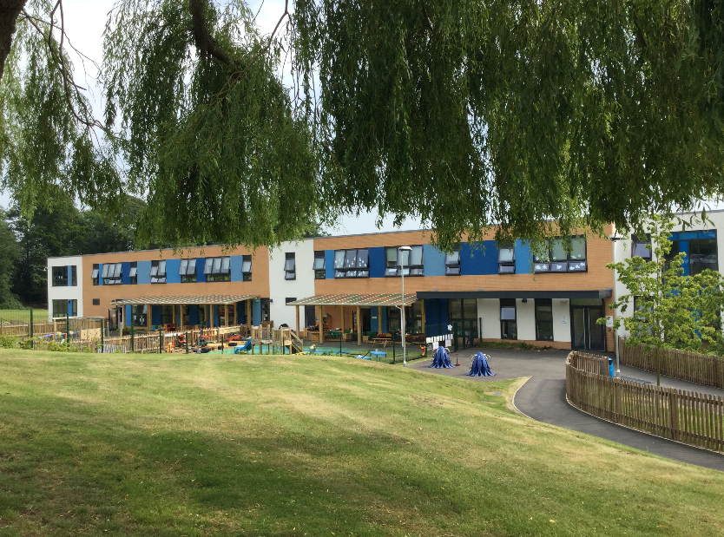
About Us
Richard Lee is 3 form entry primary school, with 550 pupils on roll. We have a beautiful new school building (October 2015) as a result of the DFE priority school build scheme. We are in Wyken, Coventry.
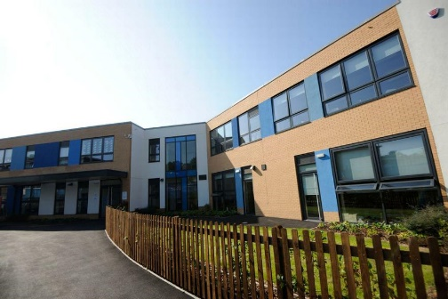

At Richard Lee, we promote an inclusive environment where children enjoy school and where they are encouraged to be the best they can be. Children tell us they feel cared for and valued.
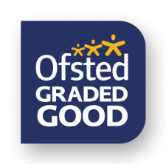
We pride ourselves on being a vibrant and creative place of learning for children and adults. Our focus this year has been ‘Achievement, Aspiration and Well Being for All’. Our recent Ofsted inspection in March 2018 recognised:-

- Pupils receive a broad and balanced curriculum that promotes a strong and thorough understanding of the subjects and the topics that they study.
- Pupils have positive attitudes to learning. They believe it is vital to be resilient and not give up and are happy to try new ways to learn.
- The head teacher has created a strong staff team. Together with governors, they have high aspirations for pupils and their outcomes.
- The good teaching promotes reading and writing skills well, inspiring older pupils with a love of reading.
- Pupils are proud of their school. They are caring towards one another. They conduct themselves well around the school and are polite and welcoming.
- Pupils who have SEN and/or disabilities learn well and show positive attitudes in lessons. Teachers plan activities that support their learning…Additional adults are well deployed. They offer help judiciously so as to build independence and to avoid pupils becoming over-reliant on them.
- Governors are highly effective and thorough in carrying out their duties.
- In the Early Years “Adults encourage appropriate child-led play sessions. Adults interact with the children and know when to intervene and ask questions to extend their learning. Children are happy, valued and cared for.

We are pleased that the report recognises many strengths of the school and also gives key areas for development and improvement.

We acknowledge learning happens most rapidly when based on real experiences. We therefore pride ourselves on the wide range of facilities and opportunities we provide; a music and drama studio; a fantastic hall for PE, forest school woodland area, the multi purpose ‘Acorn Room’ with its write on flexible use tables and dedicated IT laptops and ipads for children and staff.

Our vision of children as active learners who are developing confidence in their own abilities is summarised in our statement “Be the Best you can Be”

At Richard Lee we endeavour to create a place where children become…

Confident Communicators

Successful Learners

Caring Individuals and Friends.

Where we ALL strive to

“Be the Best we can Be”

At Richard Lee we aim to ensure that we have a school ethos,
approach and learning community:-
- Where learning is fun
- Where learning awakens curiosity and sparks imagination
- Where learning provides opportunities
- Where learning is collaborative and builds friendships and teams
- Where learning looks to the future and builds on the past
- Where learning creatively uses and embeds technology
- Where learning goes beyond the walls of the classroom
- Where learning uses mistakes as a way of deepening understanding
- Where learning leads to achievement, success and well being
- Where learning is a stepping stone to…….

English is a key curriculum subject. It is also the means through which wider curriculum areas are successfully accessed and learning pursued and therefore its importance is vital in helping our children learn, achieve and understand the world. There is no one right way and at Richard Lee we are working to develop, know and craft both our understanding and our practice as teachers so that our children are confident and enthusiastic learners.
At Richard Lee we have layered our understandings of learning in English through a variety of inputs. This includes:-
- Read Write Inc phonic programme
- Reading Recovery Practices
- Reciprocal Reading
- Interventions – Rapid Read
- Talk for Writing – Pie Corbett
- Big Write
- First Steps Resources (SW Austrailia)
- Alan Peat Resources – Grammar
- RWI Spelling
- Oracy projects – NELI (Nuffield Early Language Intervention)
- Project based learning – Currently working with RSC on a Shakespeare project.
At a wider level as a school we have developed the work of :-
- John Hattie – Mindframes for Teacher learning
- Thrive Approach (Social Emotional and Mental Health programmes). Key staff have been trained in these areas and support across the school.
- Isabella Wallace – ‘Talk less Teaching’ approaches.
- Colourworks - http://www.thecolourworks.com/

At Richard Lee we believe it is not the children who need to enjoy their time at school but also the staff and parents. We, therefore ensure that we address well-being for everyone.
Please look at our website to get a flavour of our school, its ethos and potential.
http://www.richardleeschool.com/

