

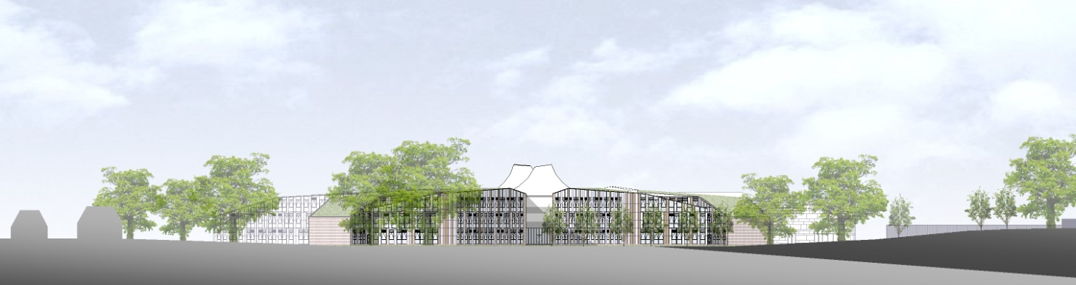

# ST. BARTHOLOMEW'S SCHOOL

# TEACHER OF COMPUTING

Full-time, permanent

# Required for 1 September 2018

**Andover Road**

**Newbury RG14 6JP**

**Tel: 01635 521255**

**Fax: 01635 576320**

**Email:** [**recruitment@stbarts.co.uk**](mailto:recruitment@stbarts.co.uk)

[**www.stbarts.co.uk**](http://www.stbarts.co.uk)

Dear Colleague,

Thank you for your interest in the position of Teacher of Computing at St Bartholomew’s School. I hope that the details contained in this pack will provide you with a clear picture of this post and give you a flavour of the school and its values. This post really is an exciting opportunity for the successful candidate who will be joining a highly achieving faculty in the school with outstanding facilities.

St Bartholomew’s prides itself on its academic success. For the last 3 years St Bart’s has secured the best GCSE and A level results in West Berkshire state schools. This year 81% of students achieved 5 or more grade A*- C grades at GCSE including English and Mathematics at level 4 or better, and 36% of all grades were A*/A. 85% of our students achieved both English and Mathematics at level 4 or better. A level results were strong with 80% off all grades A*- C. Students outcomes, as measured from their starting points, were in the top 25% nationally and the overall school performance was rated as ‘Excellent’ by ALPS. Whilst in 2016 our Progress 8 score was 0.42 putting the school in the top 8% of state schools nationally.

This is an important appointment for the school at an exciting time when we are working towards becoming outstanding. At St Bartholomew’s we all work together as a team to share good practice, and really develop outstanding teaching and learning to ensure every student makes expected or greater than expected progress. Every member of staff is part of an Action Research Group and you will also contribute to whole school development in this way. The staff at St Bartholomew’s care very much about the community and are ambitious for the school in terms of learning and enrichment opportunities for all the students.

Teaching at St Bartholomew’s School is a rewarding experience. Our students are eager to learn, well behaved and proud of their school, and this was reflected in our last Ofsted inspection which judged students’ behaviour and safety as outstanding. As a school we are committed to ensuring that all the students and staff realise their full potential. Students leave the school as good citizens and this is underpinned by an exceptional house system and a vast range of extra curricular activities.

The professional development of staff is a significant factor in ensuring that we achieve our aim of improving on our previous best and there are rich professional development opportunities at St Bartholomew’s (see CPD offer on our website under Job Opportunities). Our induction and NQT programme for new staff is supportive and thorough and coaching is available for all staff across the school upon request. We also support staff in study for Masters’ Degrees and in undertaking National College for Teaching leadership programmes.

All staff are issued with their own laptop and the Governors currently kindly offer a subsidised meal at Activity time. All faculties have their own workrooms.

I know that anyone applying for this post will find working at St Bartholomew’s very rewarding, and the Governors and I look forward to hearing from you if you feel you have the qualities and experience we are looking for.

If you would like to have a discussion with me or the Head of Business, Computing and Society about this post or require any further information, please contact Human Resources, on the above number or [recruitment@stbarts.co.uk](mailto:recruitment@stbarts.co.uk).

Yours faithfully,

Julia Mortimore

Headteacher

**THE FACULTY**

The post is an exciting opportunity to contribute to the future development of this already high achieving school and Faculty. Computing is a well-established subject within the school at KS3, KS4 and post 16. A number of Technicians support the teaching of the courses in the faculty.

The following courses in Computing are currently offered:

##### Key Stage 5

* Advanced GCE Computer Science (OCR)
* Level 3 BTEC IT (Edexcel)

##### Key Stage 4

* GCSE Computer Science (OCR)

##### Key Stage 3

Currently all students have 1 period per week of Computing in years 7 and 8 and next year will be offered in year 9 as a practical option.

By joining the Business, Computing and Society Faculty you will have the opportunity to not only teach Computing and IT, but also to work alongside our colleagues in Business, Economics, Law and Health and Social Care. All Teachers in the Faculty have their own classroom, which are equipped with enough computers for each student to have their own work station. Teachers are equipped with a laptop which can be linked to an interactive whiteboard, and this will contain all the appropriate software you will need to develop inspiring lessons.

The Faculty is split into Computing and IT, Health and Social Care, Law, Business and Economics. In Health and Social Care, students follow the L2 and L3 EdExcel BTEC courses, and in Business students study GCSE & A level Business Studies, L2 and L3 BTEC Business Studies and A level Law and Economics.

Teaching within the Faculty is in mixed ability classes which vary in size, but have approximately 26 students at Key Stage 3 and typically between 15-20 students at Key Stages 4 & 5. Many classes are supported by our Faculty Teaching Assistant and we also work very closely with Teaching Assistants from Personalised Learning who will frequently support students within lessons.

As well as the day to day teaching the Faculty runs a number of clubs and activities, such as Young Enterprise, Shares for Schools and a Robotics competition. We have been well placed in regional competitions for Young Enterprise, and the Shares for Schools students came 3rd nationally in 2014.

**THE POST**

* We are seeking to appoint a suitably qualified inspiring Teacher of Computing to join the Business, Computing and Society Faculty with effect from 1 September 2018 on a permanent basis.
* The position is full-time.
* Applications are welcome from newly qualified and experienced teachers.

###### THE SALARY

* The successful candidate will be appointed to the main or upper pay scale in accordance with her/his experience and qualifications.

**HOW TO APPLY**

Full post details, an application form and instructions on how to upload your completed application are available via the Contact & Apply / Job Opportunities section on the School’s website:

[**www.stbarts.co.uk**](http://www.stbarts.co.uk)

(Please note that curriculum vitae and covering letters cannot be accepted)

Successful candidates will be subject to a DBS enhanced check along with other relevant employment checks.

## Closing date: Sunday 14 January 2018

Thank you for considering St Bartholomew’s School.

Julia Mortimore

Headteacher