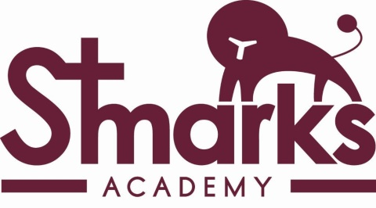

ST MARK’S CHURCH OF ENGLAND ACADEMY
Acacia Road, Mitcham, Surrey CR4 1SF
020 8648 6627
www.stmarksacademy.com

Assistant School Business Manager

SO2 Point 32-34
£30,676 - £32,368 FTE Per annum (£28,255-£29,813 pro rata)

35 hours per week, 42 weeks per year
To commence 23rd October 2017

Due to the retirement of the current post holder, an exciting opportunity has arisen for an Assistant School Business Manager to join our friendly team at St Mark’s CofE Academy. The post holder will be required to deliver a comprehensive finance, HR and administrative service and will assist the Director of School Business, working closely and collaboratively with other departments within the Academy.

To take on this exciting new role you will need to be a good communicator, who’s observant, organised with excellent attention to detail. Experience of providing a high level finance and administrative service is essential. Aspiring School Business Manager’s will be fully supported to gain the Certificate in School Business Management qualification.

Further details on how to apply are on our website
http://www.stmarksacademy.com/vacancies.html

Please contact Sherlyn Navalta, Director of School Business to discuss the role on
snavalta@stmarksacademy.org.uk or by calling 020 8648 6627

Closing Date: Friday 15th September 2017, 12pm
Interviews: Friday 22nd September 2017

St Mark’s C of E Academy is committed to safeguarding and promoting the welfare of children and young people and expects all staff and volunteers to share this commitment. This post is subject to an enhanced disclosure from the Disclosure and Barring Services (DBS Check).
St Mark’s C of E Academy is an Equal Opportunities employer and does not discriminate on grounds of gender, race, age, disability or marital status.

