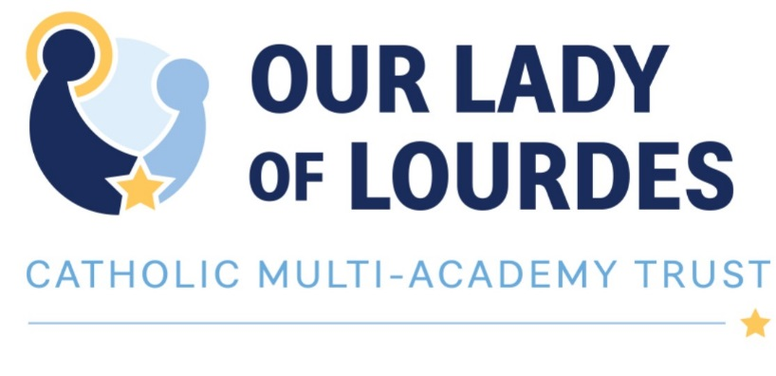

CHRIST THE KING CATHOLIC VOLUNTARY ACADEMY

JOB DESCRIPTION

Learning Support Assistant
Band 2
Term Time Only

Current Postholder: | Vacancy
Job Description Review Date: | October 2018

Job Purpose
The post holder will work as part of a multi-disciplinary team to support students to reach their full potential.

The Post holder will work with a range of students, many of whom will be from disadvantaged backgrounds and/or will have a special educational need. The variety of issues covered will be varied, including punctuality, absence, specific learning needs, challenging behaviour and low esteem.

The Post holder will carry out a range of duties designed to enhance existing provisions, support learning, increase participation and encourage social inclusion.

Line Management
Responsible to: Principal, Inclusion Manager
Responsible for: N/A

Specific Responsibilities
- Under the guidance of the Line Manager and/or the Classroom Teacher develop appropriate strategies, options and alternatives to overcoming barriers to learning.
- Monitor and record the effectiveness of the support provided.
- Develop appropriate relationships with students to engage them in learning and support their progress.
- Liaise with families and carers to share information about the students’ needs and progress as and when appropriate.

- To support and encourage the needs of vulnerable students, including those with special educational needs and/or disabilities.

- Develop and organise relevant activities to create a stimulating, safe and secure environment to engage students in order to support learning.
- Liaise with all relevant staff and external professionals to ensure understanding, support and commitment to the approaches and strategies being utilised.

- Support students in being able to comply with the Behaviour for Learning Policy at all times.
- Arrange and run activities designed to support vulnerable students before and after school and during lunch breaks.
- Support learning and development needs both during lessons and lunch/break times.
- Assist teaching staff with the planning of learning activities.
- To work collaboratively with the Inclusion Team to ensure that students are assisted in making and exceeding expected levels of progress.

Skills and Abilities
- The ability to communicate, influence, persuade, motivate and engage with a wide range of children/young people, their families and carers in order to achieve maximum engagement by all to support the student in achieving their full potential.
- Good general interpersonal and communication skills.
- A strong knowledge and understanding of child protection, health, safety and security, confidentiality and data protection, copyright etc.
- The ability to use ICT for administration and student learning.
- A commitment to learn new skills and expand on current skill set and demonstrate a willingness to pass on knowledge and techniques to others.
- The ability to deal with conflicting demands and work flexibly.
General

- Be a positive influence on the climate and culture of the Academy and show a positive example at all times.
- Support the Catholic ethos of the Academy.
- Be aware of and comply with policies and procedures relating to child protection, health, safety and security, confidentiality and data protection, copyright etc. reporting all concerns to their line manager.
- Be aware of and support difference and ensure equal opportunities for all.
- Contribute to the overall aims of the Academy.
- Appreciate and support the role of other professionals.
- Attend and participate in relevant meetings as required.
- Participate in training and other learning activities and performance development as required.
- Recognise own strengths and areas of expertise and use these to advise and support others.
- To work in collaboration with other Our Lady of Lourdes Academies, sharing good practice and supporting during time of absence and/or heavy workload.
This job description contains the main accountabilities relating to this post and does not describe in detail all the tasks required to carry them out. All staff are expected to be flexible to ensure the most effective organisation and delivery of services.
The duties and responsibilities of the post will evolve to meet changes in financial regulations, statutory requirements or the natural development of the Academy and/or Trust. Such changes are, therefore, a normal part of the post and the post holder must be prepared to undertake any other duties commensurate with the general level of responsibility of the post which may be determined from time to time subject to the proviso that any permanent, substantial changes shall be incorporated into the job description and evaluated as such.

