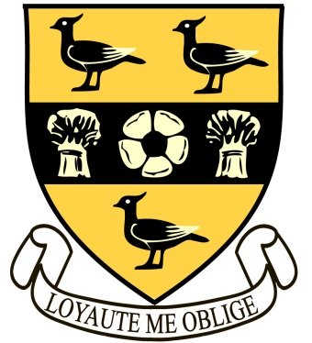
Thetford Grammar School

Applicant information:

MFL Teacher – German and French

Thetford Grammar School returned to independence in 1981, since when it has established itself securely as one of the leading East Anglian day schools, academic standards matched by a lively extra-curricular programme.
Thetford Grammar School is a school of 220 boys and girls. The Main School is two form entry, including a Sixth Form. The size of the school undoubtedly enables pupils working in small classes to thrive academically and is of real benefit in pastoral terms. The school is known for its friendly and relaxed atmosphere, which does not however prevent us from setting high standards of personal behaviour and attainment across a full range of classroom and extra-curricular activities. Drama and music, sport and the Duke of Edinburgh Award Scheme contribute to such extra-curricular activity which is important to pupils and staff alike.
Pupils travel from a wide catchment area to attend the school. Refurbishment and building have over the last few years improved the facilities of the school and we are determined to maintain and improve a strong local reputation which has been built up over several centuries. At the core of any such development must be the appointment of staff that are well qualified, at ease with, and enthusiastic about, working within education.
The School is well situated in East Anglia within reach of Norwich, Bury St Edmunds and Cambridge. London is easily accessible by road and rail. There are close air links at Norwich and Stansted airports. A wide range of housing is available in the area to suit all needs. This is an area of natural beauty with the raw nature of the Fens and the spectacular coastline of Suffolk and Norfolk both nearby.
The modern languages department currently offers French and German to A Level, following the AQA specifications. All pupils start French in the Junior School and German in Year 8. In Year 9 they opt to continue either one or both languages to GCSE.
The department operates a busy exchanges and visits programme and we are looking for a well-qualified linguist who shares our enthusiasm for travel. This is an energetic department and there would be plenty of scope for candidates with other languages, to offer an after school club for the more gifted linguists. The post will certainly involve teaching up to GCSE French (possibly higher) and A Level German (another language may also be considered) and there may well be A Level French teaching for a suitable candidate in the future.

