
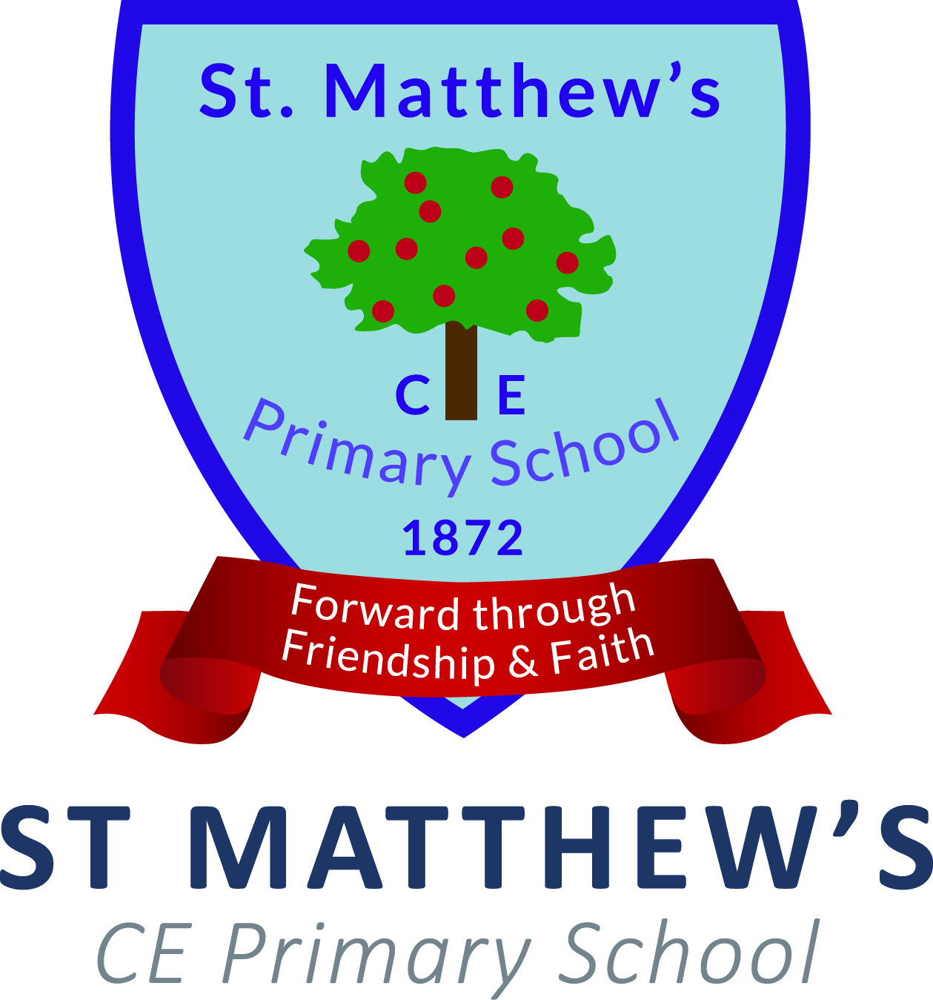

St Matthew’s CE Primary School
Job Description
Post Title: | Key Stage 1 Phase Leader
Responsible to: | Head of School
Pay Spine  Terms and Conditions | TLR 2b  Teacher’s Pay and Conditions
1. Key Areas of Responsibility | The main focus of this post relates to improving teaching and learning in Key Stage 1 and teaching an assigned class of pupils.  Core Tasks:  - To improve teaching and learning in Key Stage 1 which provides a level challenge for pupils at all levels and raises expectations and aspirations.  - To lead Key Stage 1 phase meetings and attend senior leadership team meetings to enable effective communication  - To lead a curriculum area (negotiable)  - To teach an assigned class of pupils
2. Leading teaching and learning | Core tasks:  To work with the Head of School in improving teaching and learning in an assigned phase by:  - Monitoring teaching across Key Stage 1  - Implementing CPD on an individual level and phase level to improve teaching  - Monitoring achievement across the Key Stage 1 and being accountable for pupil outcomes  - Implementing performance management within the phase, setting challenging achievement targets and holding teachers to account  - Tracking improvements against agreed criteria, identifying success  - Reporting to the Senior Leadership Team on progress being made against short term, medium term and long term goals  - Liaising with Inclusion Manager in the school to help improve teaching and learning within the phase  - Liaise with other similar Key Stage leaders within the Trust to share best practice and develop Trust policies.
3. Leading phase meetings | Core tasks:  To work with the Head of School in ensuring there is effective communication between the assigned phase and the senior leadership team  - Leading team meetings for development purposes and management meetings to ensure effective communication  - Being an active part of the senior leadership team, ensuring that the vision and expectations of the school are clearly embedded within Key Stage 1  - Implementing staff development programmes to improve teaching to support these pupils  - Setting challenging targets and holding leaders and teachers to account on improvements being made  - Ensuring that day-to-day school life runs smoothly across the Key Stage through effective management, organisation and communication.
4. To lead a curriculum area | - Write an action plan to improve teaching and learning in an assigned area of the curriculum  - Monitor and track progress towards improvements  - Work with the leader responsible overall for the curriculum to ensure that expectations within the curriculum match the needs of the learners in the school
Professional Development | The post-holder will expected to take part in extensive professional development alongside the school’s CPD programme. This should include:  - How to become an outstanding leader of learning  - Ability to support and challenge and hold staff to account  - Ability to measure effectiveness and set priorities
Line Management | - All teaching staff in Key Stage 1  - Leading a curriculum area  - Be a professional tutor for newly qualified teachers
Safeguarding | - To comply with all the Trust’s Safeguarding Policies and Procedures, prioritising the safety of all pupils, staff and members of the school community

St Matthew’s CE Primary School
Person Specification
 | Essential | Desirable
Qualifications | - Qualified Teacher status  - Registered with the GTC | - Evidence of continuous INSET and commitment to further professional development  - Attendance of NCSL relevant courses to develop leadership skills
Experience | - Minimum of four years experience of teaching at Primary School level as a qualified teacher at the time of application | - Teaching across the whole Primary age range;  - Supporting teaching to improve quality of teaching and learning  - Leadership of a core curriculum area  - Experience as a member of a Senior Leadership team
Knowledge and Understanding | - Pupils educational development;  - A thorough knowledge and understanding of standards that pupils need to achieve by the end of the key stage you are applying to lead;  - The planning and preparation of children’s’ learning  - The monitoring, assessment, recording and reporting of children’s progress;  - Effective teaching and learning styles.  - Effective leadership of a team in securing high achievement | - Leading learning across the school  - Strategies to improve teaching and learning in the core subjects
Skills | - Ability to prioritise and work ‘smartly’ and be well organised  - Communicate high expectations through challenging targets  - Promote the school’s aims positively, and use effective strategies to monitor motivation and morale;  - Develop good personal relationships within a team;  - Establish and develop close relationships with parents, governors and the community;  - Communicate effectively (both orally and in writing) to a variety of audiences;  - Create a happy, challenging and effective learning environment;  - Work as part of a team and as a team leader;  - Act as a good role for all the Federation;  - Confident in using ICT. | - Proven success in motivating a team
Personal Characteristics | - Approachable  - Warmth of character  - Enthusiasm and energy  - Committed and willing to succeed  - The ability to communicate at all levels  - Positive approach to working with children  - Empathetic  - Organised and flexible  - Patient  - Resourceful

The post will be measured on the basis of outcomes. In particularly, a successful post holder will be able to achieve:
- Pupils learn exceptionally well and as a result acquire knowledge quickly and in depth and are developing their understanding rapidly in a wide range of different subjects across the curriculum.
- Pupils develop and apply a wide range of skills to great effect, including reading, writing, communication and mathematical skills across the curriculum that will ensure they are exceptionally well prepared for the next stage in their education, training or employment
- Much of the teaching in all key stages and most subjects is at least good.
- All teachers have consistently high expectations of all pupils.
- Drawing on excellent subject knowledge, teachers plan astutely and set challenging tasks based on systematic, accurate assessment of pupils’ prior skills, knowledge and understanding.
- The assigned curriculum area provides highly positive, memorable experiences and rich opportunities for high quality learning, has a very positive impact on all pupils’ behaviour and safety and contributes very well to pupils’ achievement and to their spiritual, moral, social and cultural development.
- The pursuit of excellence in all of the school’s activities is demonstrated by an uncompromising and highly successful drive to strongly improve achievement, or maintain the highest levels of achievement, for these pupils over a sustained period of time.
Current responsibilities
The above job description is to be incorporated runs in parallel with the job description of a class teacher.
Teaching
This is a teaching post and the post-holder will be expected to teach an assigned class of pupils.

