Bury Church of England High School
Haslam Brow, Bury, BL9 0TS
: 0161 797 6236 : offman@burychurch.bury.sch.uk : www.burychurch.bury.sch.uk

HEADTEACHER: Revd Craig Watson MA BSc (Hons) NPQH
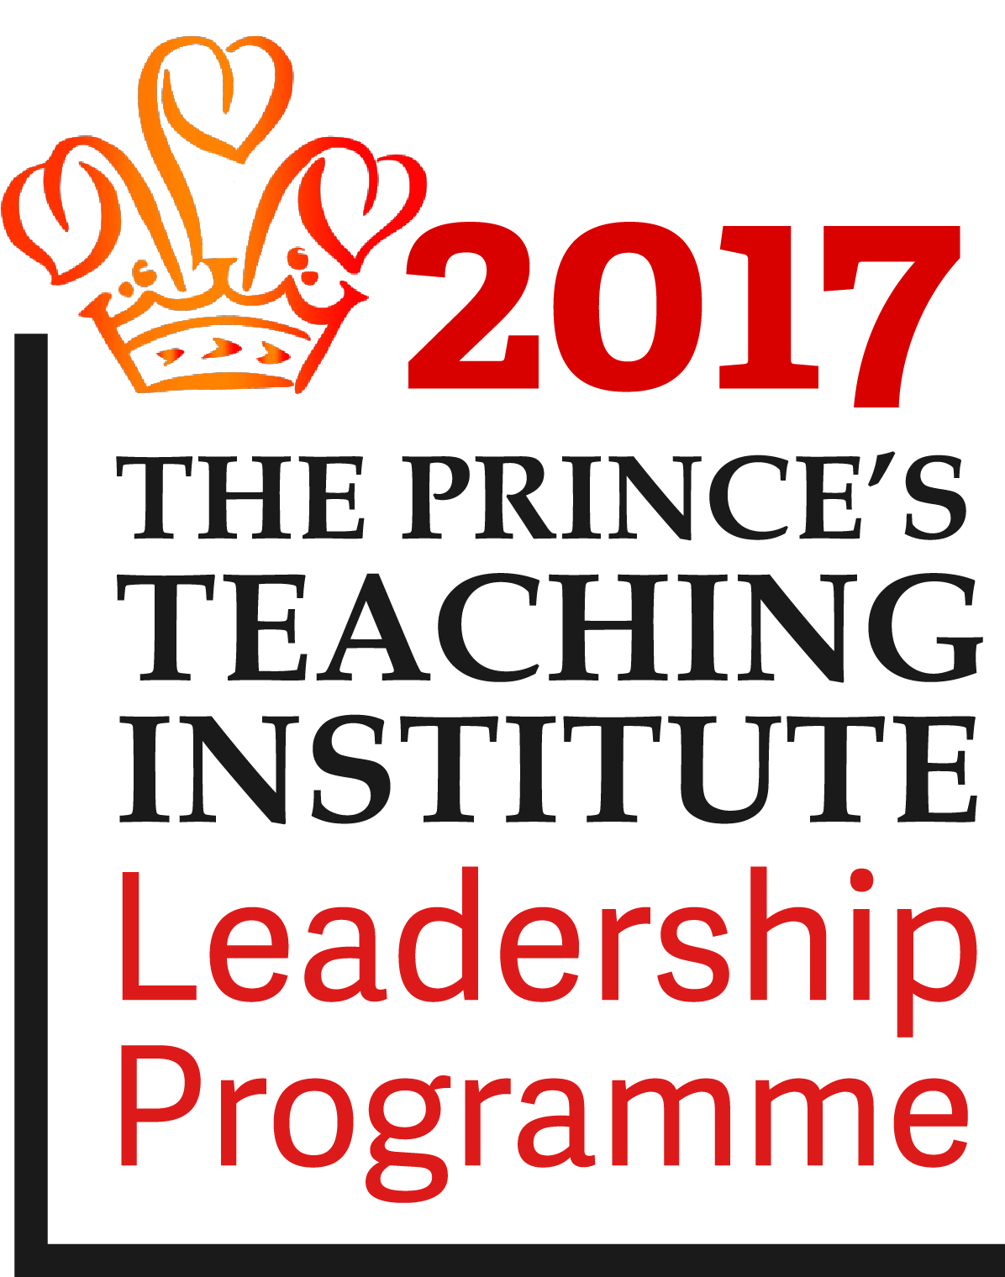

June 2018

Dear Applicant,

Teacher of Science (Chemistry)

Thank you for your interest in Bury Church of England High School. I hope that the information provided here gives you what you require at this stage as you consider whether or not to apply for the post.

The school is full and annually oversubscribed with capacity for 817 pupils on roll. The attendance rate is 95% and unauthorised absence 1.07%. Parents tell us that they choose to send their children here mainly because of the school’s high academic standards, caring Christian ethos, orderly and work centred atmosphere, very good working relationships between staff and pupils and the emphasis we place on promoting the progress and achievement of the individual child. Parents are very supportive of the school.

We are proud of the school’s good practice and high standards of achievement. Like any school we also have our challenges, but through our collective efforts Governors, staff, parents and community partners are committed to improving the effectiveness of the school yet further. Our aim is to provide a high quality educational experience for our pupils as we help to prepare them for adulthood and lifelong learning.

We sustain high levels of attainment, which exceed national standards and expectations. Performance in the end of Key Stage 3 assessments is consistently good and GCSE results are well above local and national averages. We enjoy a very good local reputation and strong relationships with the Churches, LA, community organisations, business, primary schools and colleges.

The school's Christian foundation dates back to 1748 and the present buildings opened in 1964 with a Sports Hall added in 2004 and further adaptations more recently. We occupy an open site including extensive lawns, playing fields and tennis courts close to Bury town centre. The school is a Church of England voluntary aided school where the Governors are the employer and staff have National Society contracts of employment.

The Governors seek to appoint well qualified, innovative and committed individuals who will support the values, aims and ethos of the school and work hard with us to help realise our vision.

We place great emphasis on helping staff settle happily and purposefully with us. Careful attention is paid to their induction and subsequent professional development. The successful applicant can look forward to joining a strong and supportive team of dedicated and hard working colleagues.

The closing date for applications is noon on Monday 18th June 2018. We will inform shortlisted candidates by letter, or it may also be by telephone so please make sure that you include your contact telephone number in your form.

I look forward to receiving your application.

Yours in Christ,

Rev’d. C Watson
Head Teacher

BURY CHURCH OF ENGLAND HIGH SCHOOL,
Haslam Brow, Bury BL9 0TS (Tel: 0161 797 6236)

11-16 Mixed Comprehensive School
NOR: 817

TEACHER OF CHEMISTRY
Teachers’ Pay Scale

Required for 1st September 2018

The Governors seek to appoint a well-qualified, innovative and committed teacher to the Science Department in this heavily oversubscribed, historic, high achieving, Church of England school. We are situated on the edge of the west pennine moors with easy access to both stunning countryside and the vibrant city life of Manchester.

You will be expected to motivate and excite pupils so that they can learn effectively and achieve high standards.

You will be supported through our teaching school network, Ripley Teaching School Alliance, and by a staff committed to growing outstanding professionals.

You must have a degree in a physical Science discipline and the ability to teach Chemistry to GCSE is essential.

You will be expected to teach the full ability range across Key Stage 3 and 4 and have a good understanding of the application of ICT skills in teaching Science.

We would welcome applications from both experienced teachers and those who will be newly qualified in September 2018.

You must actively promote the Christian ethos and contribute to building the caring Christian community of the school.

Our school is committed to safeguarding and promoting the welfare of children and young people and expects all staff to share this commitment.

Appointment is subject to a satisfactory enhanced disclosure from the Disclosure & Barring Service.

Application forms and further details are obtainable from The School Office, Tel: 0161 797 6236 or via the school website: www.burychurch.bury.sch.uk and returnable to Rev C Watson, Head Teacher, Bury Church of England High School, Haslam Brow, Bury, BL9 0TS or via e-mail to: offman@burychurch.bury.sch.uk by noon Monday 18th June 2018.

Interviews will be held on Friday 22nd June 2018.

Job Description

Job Title: |  | Teacher of Chemistry | Job Holder
Department/Group: |  | Science | Responsible for: | Teaching Science to all ages and abilities
Level/Salary Range: |  |  | Reporting to: | Head of Science
Safer Recruitment Statement
Bury Church of England High School is committed to safeguarding and promoting the welfare of children and young people and expects all staff and volunteers to share this commitment.
All staff at Bury Church of England High School are required to:
- Work towards and promote the School Vision and current aims outlined in the School Improvement Plan;
- Support and promote the Christian ethos of the school;
- Support and contribute to the achievement of the five Every Child Matters Outcomes;
- Support and contribute to the school’s responsibility for safeguarding students;
- Undertake professional development activities to enhance personal development and job performance;
- To maintain high personal professional standards of attendance, punctuality, appearance, conduct and positive relations with students, parents and staff and other stakeholders.
Main Objectives of Role:
Responsible and accountable for all aspects of Teaching and Learning for their classes in the Science Department. To actively promote the Christian ethos of the school, including the delivery of collective worship as part of the Tutor role. To contribute to the Care Support, Guidance and Well Being provision of the school as directed. To deliver PHSCE and other aspects of Teaching and Learning as required. To manage behaviour issues arising from these areas of responsibility.
Job Description
This appointment is subject to the current conditions of employment of teachers contained in the School Teachers’ Pay and Conditions Document, the Education Act 1997, the required standards for Qualified Teacher Status, other current educational legislation and the school’s articles of government.
This job description may be amended at any time following discussions between the Head and the member of staff, and will be reviewed annually. The classroom teacher will:
Set high expectations which inspire, motivate and challenge pupils
- To establish a safe and stimulating environment for pupils, rooted in mutual respect;
- To set goals that stretch and challenge pupils of all backgrounds, abilities and dispositions;
- To demonstrate consistently the positive attitudes, Christian values and behaviour which are expected of pupils.
Promote good progress and outcomes by pupils
- To be accountable for pupils’ attainment, progress and outcomes;
- To be aware of pupils’ capabilities and their prior knowledge, and plan teaching to build on these;
- To guide pupils’ to reflect on the progress they have made and their emerging needs;
- To demonstrate knowledge and understanding of how pupils learn and how this impacts on teaching;
- To encourage pupils to take a responsible and conscientious attitude to their own work and study;
Demonstrate good subject and curriculum knowledge
- To have a secure knowledge of Science and the related curriculum areas, foster and maintain pupils’ interest in the subject, and address misunderstandings;
- To demonstrate a critical understanding of developments in Science and its curriculum areas, and promote the value of scholarship;
- To demonstrate an understanding of and take responsibility for promoting high standards of literacy, articulacy and the correct use of standard English.
- To deliver high quality learning experiences in other subjects such as PHSCE as required.
Plan and teach well-structured lessons
- To impart knowledge and develop understanding through effective use of lesson time;
- To promote a love of learning and children’s intellectual curiosity;
- To set homework and plan other out-of-class activities to consolidate and extend the knowledge and understanding pupils have acquired;
- To reflect systematically on the effectiveness of lessons and approaches to teaching;
- To contribute to the design and provision of an engaging curriculum within Science and other areas as required.
Adapt teaching to respond to the strengths and needs of all pupils
- To know when and how to differentiate appropriately, using approaches which enable pupils to be taught effectively;
- To have a secure understanding of how a range of factors can inhibit pupils’ ability to learn, and how best to overcome these;
- To demonstrate an awareness of the physical, social, and intellectual development of children, and know how to adapt teaching to support pupils’ education at different stages of development
- To have a clear understanding of the needs of all pupils, including those with SEN; those of high ability; those with English as an additional language; those with disabilities; and to use and evaluate distinctive teaching approaches to engage and support them.
Make accurate and productive use of assessment
- To know and understand how to assess Science and other required subjects such as PHSCE and any Science curriculum or other curriculum areas as required, including statutory assessment requirements;
- To make use of formative and summative assessment to secure pupils’ progress;
- To use relevant data to monitor progress, set targets, and plan subsequent lessons;
- To give pupils regular feedback, both orally and through accurate marking, and encourage pupils to respond to the feedback;
Managing behaviour effectively to ensure a good and safe learning environment
- To have clear rules and routines for behaviour in classrooms, and take responsibility for promoting good and courteous behaviour both in classrooms and around the school, in accordance with the school’s behaviour policy;
- To have high expectations of behaviour, and establish a framework for discipline with a range of strategies, using praise, sanctions and rewards consistently and fairly in line with school policy;
- To manage classes effectively, using approaches which are appropriate to pupils’ needs in order to involve and motivate them;
- To maintain good relationships with pupils, exercise appropriate authority, and act decisively when necessary.
Fulfil wider professional responsibilities
- To make a positive contribution to the wider life and Christian ethos of the school;
- Develop effective professional relationships with colleagues, knowing how and when to draw on advice and specialist support;
- To take responsibility for improving teaching through professional development, responding to advice and feedback from colleagues;
- To communicate effectively with parents/guardians, the community, business and industry as necessary.
Personal and professional conduct
- To treat pupils with dignity, building relationships rooted in mutual respect, and at all times observing porper boundaries appropriate to a teacher’s professional position;
- To have regard for the need to safeguard pupils’ well-being, in accordance with statutory provisions;
- To show tolerance of and respect for the rights of others
- To actively promote the Christian ethos of the school;
- To have proper and professional regard for the ethos, policies and practices of the school and maintain high standards in their own attendance and punctuality
- To have an understanding of, and always act within, the statutory frameworks which set out teachers professional duties and responsibilities.
In addition the classroom teacher will:
- Contribute to the development and implementation of policies and practices which reflect the school’s commitment to high achievement through effective teaching and learning, improvement planning, self-evaluation and appraisal;
- Have an enthusiasm for the subjects taught, which motivates and supports other staff and encourages a shared understanding of the contribution the subjects can make to all aspects of pupils’ lives;
- Contribute to the monitoring of progress and the evaluation of the effects on teaching and learning by working alongside colleagues, participating in the quality assurance systems, analysing work and outcomes;
- Attend meetings as directed by the Head of Department/Head/Designated SLT member in line with school policy;
- Promote and encourage out of classroom activities through visits, exchanges, extra-curricular activities and clubs.
- To embed learning within a global context, including using and engaging with the school’s partnerships around the world;
- To dress in a manner that; reflects the high standards of teaching and learning of the school (including wearing academic dress whenever requested if entitled to do so), is acceptable to the Head and that is appropriate to the delivery of the subject and other contexts as needed.
All Staff at Bury Church of England High School will:
- Continue personal development as agreed;
- Engage in professional development as agreed;
- Follow and actively promote the school’s policies;
- Engage actively in the performance review process;
- Acknowledge that whilst every effort has been made to explain the main duties and responsibilities of the post, each individual task undertaken may not be identified;
- Within the School’s Health & Safety Policy to ensure a safe working environment for all staff and students;
- Be expected to comply with any reasonable request from a manager to undertake work of a similar level that is not specified in this job description;
- Be courteous to colleagues and provide a welcoming environment to visitors and telephone callers
The school will endeavour to make any necessary reasonable adjustments to the job and the working environment to enable access to employment opportunities for disabled job applicants or continued employment for any employee who develops a disabling condition. This job description is current at the date shown, but following consultation with you, may be changed by Management to reflect or anticipate changes in the job which are commensurate with the salary and job title. This job description allocates duties and responsibilities but does not direct the amount of time to be spent on carrying them out and no part of it shall be so construed. The above responsibilities are subject to the general duties and responsibilities contained in the statement of conditions of employment.
Postholder: |  |  | Date:
Head: |  |  | Date:
Last Updated: | June 2018
Person Specification for the post of Teacher of Chemistry
Note to Applicants: Please provide evidence and examples in your application of how you meet the required criteria

EXPECTED REQUIREMENTS |  | METHOD OF ASSESSMENT
1.SKILLS AND KNOWLEDGE
1.1 | Ability to work effectively within a team environment, understanding teaching roles and responsibilities | Interview/Reference
1.2 | Ability to promote a positive ethos and role model positive attributes | Interview/Reference
1.3 | High level teaching and organisation skills | Application Form/Lesson
1.4 | Willing to participate in Corporate Worship | Application Form/Lesson
1.5 | Sound understanding of current issues relating to Science education | Application Form/Interview
1.6 | Ability to form and maintain appropriate relationships and personal boundaries with staff, parents, children and young people | Application Form/Interview/Lesson
1.7 | Good time management & personal organisational skills | Application Form/Lesson
1.8 | Able and willing to deliver Collective Worship | Application Form/Interview
1.9 | Good interpersonal and communication skills | Application Form/Lesson
1.10 | Able to improve their own practice through observations, evaluations and discussion with colleagues. | Application Form
1.11 | Excellent people skills | Application Form
1.12 | Ability to work with others to achieve targets | Application Form
1.13 | Knowledge of current Science curriculum developments in KS3-5, including assessment for learning | Application Form/Interview
1.14 | Awareness of current significant initiatives in education and their implications for Science | Application Form/Interview
1.15 | Ability to create a challenging and effective learning environment | Application Form/Interview/Lesson
1.16 | Able to work effectively with student teachers | Application Form
1.17 | Understanding of strategies for raising the achievement of students of all aptitudes and abilities | Application Form/Interview
1.18 | Pupil Care – An awareness and application of the Every Child Matters Agenda. | Application Form/Interview
1.19 | Valuing Diversity – Listen, support and monitor diverse contributions without prejudice.  Challenge behaviours and processes which do not positively advance the diversity agenda  Recognise people’s strengths, aspirations and abilities and help to develop their potential.  Understand how Valuing Diversity can improve our ability to deliver better services and  reduce disadvantage. | Interview/Reference
1.20 | Ability to teach Chemistry | Application Form/Interview
2.EXPERIENCE/QUALIFICATIONS/TRAINING ETC
2.1 | Qualified Teacher Status | Application Form
2.2 | Honours degree in a Physical Science or related discipline | Application Form
2.3 | Successful recent experience of teaching Science at KS3 and KS4 | Application Form/Reference
2.4 | Willingness to participate in relevant training and development opportunities | Application Form/Interview/Reference
2.5 | Proven skills in working with a wide range of pupils | Application Form/Lesson
2.6 | Understanding of emotional intelligence and motivational skills | Application Form/Interview/Lesson
3.WORK RELATED CIRCUMSTANCES – PROFESSIONAL VALUES & PRACTICES
3.1 | High expectations of all pupils; respect for their social, cultural, linguistic, religious and ethnic background and a commitment to raising their educational achievements | Interview/Reference
3.2 | A clear vision for the teaching of Science in a Church School context and strategies for achieving it | Application Form/Interview
3.3 | A belief in comprehensive education and a commitment to equal opportunities, involving parents, Governors and the local community | Application Form
3.4 | Willing to actively support the school’s Christian ethos | Application Form/Interview
3.5 | Demonstrate and promote the positive values, attitudes and behaviour they expect from the pupils with whom they work | Interview/Reference
3.6 | Awareness of how to relate collective and corporate worship to the Church community and the wider community | Application Form/Interview
3.7 | A high level of commitment and enthusiasm for Science | Application Form/Interview
3.8 | Flexible, approachable and able to listen | Application Form
3.9 | A good attendance and punctuality record | Application Form/Reference
3.10 | A sense of humour and a passion for teaching | Application Form/Interview/Lesson
3.11 | Enthusiasm for working with children and young people | Application Form/Interview/Lesson
3.12 | A global dimension to the delivery of the role | Application Form/Lesson/Interview/  Reference

DESIRABLE REQUIREMENTS |  | METHOD OF ASSESSMENT
1.SKILLS AND KNOWLEDGE
1.2 | Knowledge of AQA GCSE syllabus, baseline assessment and value added measures | Application Form/Interview
1.3 | Ability to build good relationships with parents and the wider community to provide information about the curriculum and harness support for raising achievement | Application Form/Interview
1.4 | A knowledge and understanding of STEM, its importance in Science education and a willingness to participate in such activities. | Application Form/Interview
1.5 | Evidence of continuing development of skills and knowledge as an Science teacher | Application Form/Interview
2.EXPERIENCE/QUALIFICATIONS/TRAINING ETC
2.1 | A Chemistry Degree | Application Form
2.2 | Relevant Higher Degree | Application Form
2.3 | A desire to progress in his/her career. | Application Form
2.4 | An ability to innovate | Application Form/interview
2.5 | Experience of organising trips, visits or exchanges | Application Form
2.6 | ITT mentor trained | Application Form
2.7 | Experience of managing change | Application Form
2.8 | Able to demonstrate sustained good performance at GCSE | Application Form
2.9 | Experience as an external examination moderator | Application Form
2.10 | Proven ability to engage and enthuse pupils. | Application Form
2.11 | Experience of an Ofsted inspection | Application Form
2.12 | A willingness to contribute to extra-curricular activities, particularly in Science through STEM, CREST or similar. | Application Form
2.13 | Successful recent experience of teaching Science at A level | Application Form/Reference
3.WORK RELATED CIRCUMSTANCES – PROFESSIONAL VALUES & PRACTICES
3.1 | A commitment to raising standards within the Science department | Application Form
3.2 | A candid but compassionate approach to all working relationships | Application Form
3.3 | An understanding of our inclusion ethos and commitment to caring for all members of the school community | Application Form
3.4 | Evidence of valuing extra-curricular Science activities | Application Form/Interview
3.5 | Evidence of active Christian commitment | Application Form/Interview

